**UTAR signs MoU with Dr Wu Lien-Teh Education Society and launches Dr Wu Lien-Teh Centre of Research in Communicable Disease**

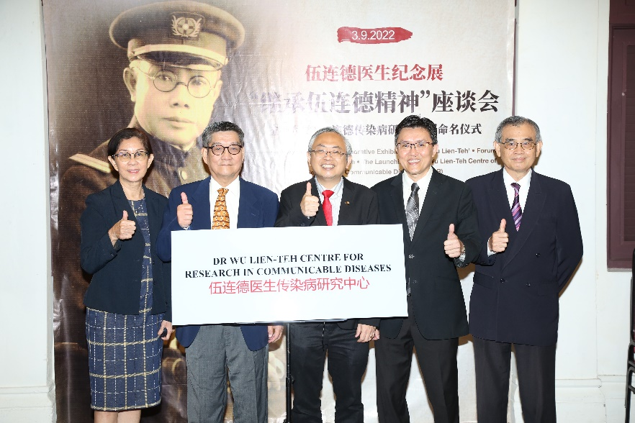

From left: Cheng, Koh, Prof Dato’ Ewe, Prof Goi and Prof Cheong during the plaque unveiling ceremony

UTAR and Dr Wu Lien-Teh Education Society, Malaysia signed a memorandum of understanding (MoU) on 3 September 2022 at The Kuala Lumpur And Selangor Chinese Assembly Hall (KLSCAH). The signing ceremony took place in conjunction with the Brilliance of Wise Men (V) Exhibition and the Opening Ceremony of “Commemorative Exhibition on Dr Wu Lien-Teh”.

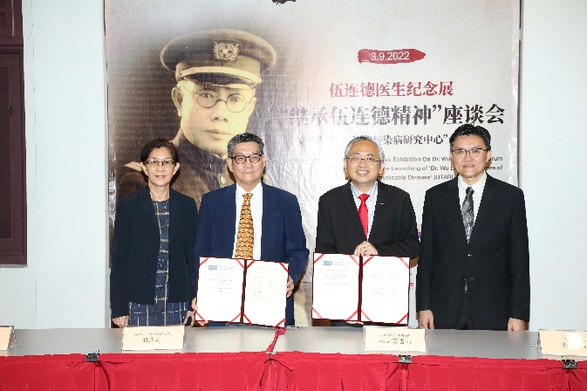 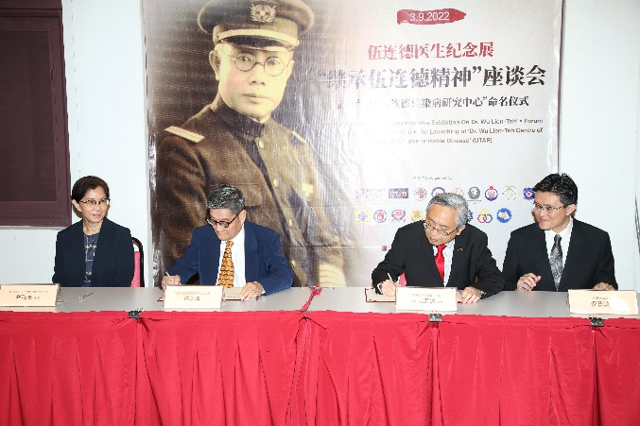

UTAR and Dr Wu Lien-Teh Education Society, Malaysia representatives signing the MoU

The MoU was signed by UTAR President Ir Prof Dato’ Dr Ewe Hong Tat and Dr Wu Lien-Teh Education Society, Malaysia President Koh King Kee, and witnessed by UTAR Vice President for Internationalisation and Academic Development Ir Prof Dr Goi Bok Min and Dr Wu Lien-Teh Education Society, Malaysia Secretary General Cheng Swee Kee.

Under the MoU, both parties will jointly organise and conduct the Dr Wu Lien Teh memorial lectures at the Dr Wu Lien-Teh Centre for Research on Communicable Diseases (Dr Wu Lien-Teh CRCD, UTAR) on infectious diseases and their prevention in association with the FMHS Biannual Conference. Both parties will also co-organise webinars, lectures or seminars and conduct community educational activities.

After the MoU signing ceremony, the launch of Dr Wu Lien-Teh Centre for Research in Communicable Disease (Dr Wu Lien-Teh CRCD, UTAR) took place and a plaque unveiling ceremony ensued.

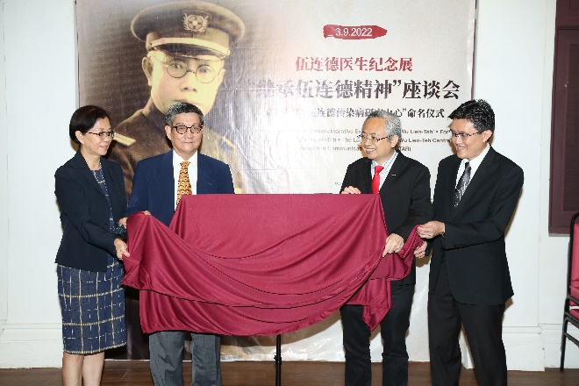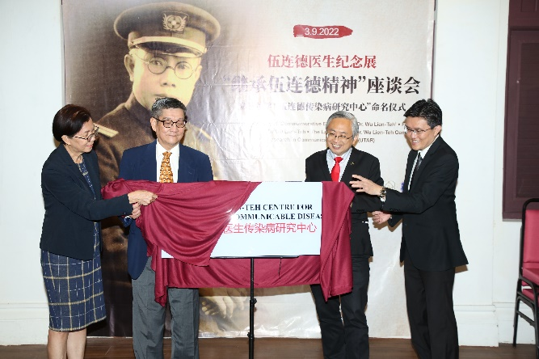

From left: Cheng, Koh, Prof Dato’ Ewe and Prof Goi unveiling the plaque

The event then continued with a forum on the Legacy of Dr Wu Lien-Teh. A total of four speakers spoke at the forum; Faculty of Medicine and Health Sciences Dean Academician Emeritus Prof Dr Cheong Soon Keng presented on Inherit the Spirit of Dr Wu Lien-Teh: The Establishment of Dr Wu Lien-Teh Centre for Research on Communicable Diseases (UTAR); University of Malaya Emeritus Prof Dato’ Dr Tan Chong Tin presented on The Legacy of Dr Wu Lien-The; Secretary General Dr Hor Chee Peng representing President of the Dr Wu Lien-Teh Society Dato’ Seri (Dr) Anwar Fazal presented on Remarkable Contributions of Dr Wu Lien-Teh, Reflection of His Legacy to Our Present Times, and T&CM Centre Director-cum-Principal Practitioner Assoc Prof Dr Te Kian Keong presented on Dr Wu Lien-Teh with China and Chinese Medicine. The forum was concluded by Koh.

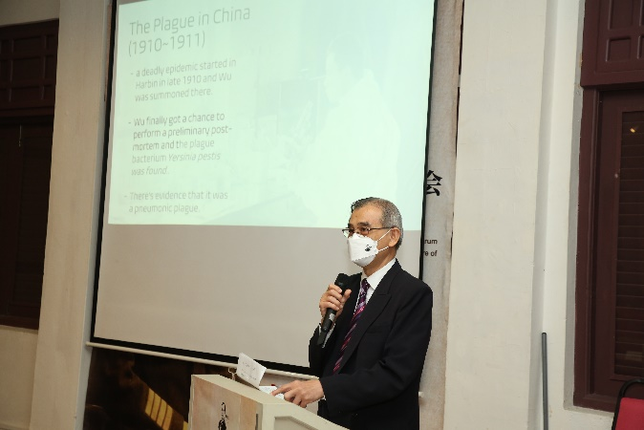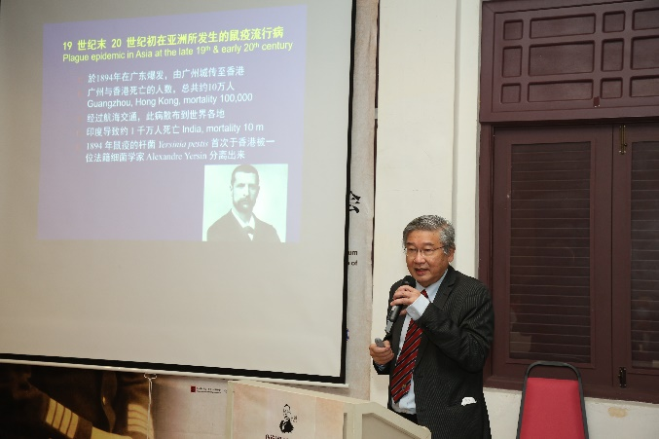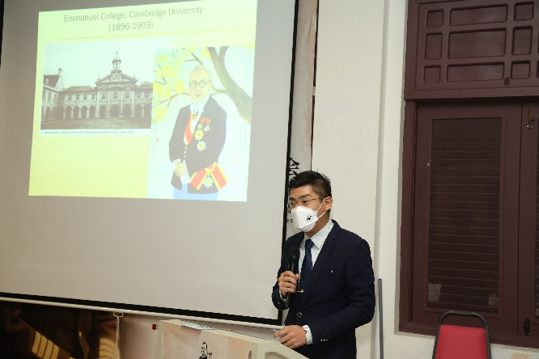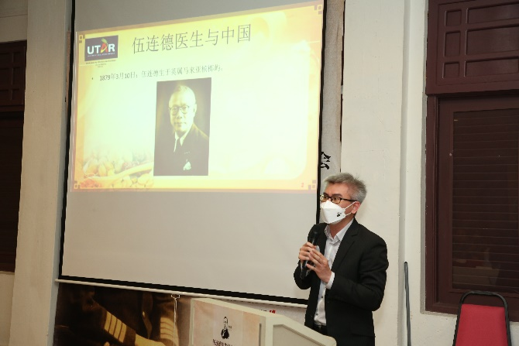

Clockwise from top right: Prof Dato’ Tan, Dr Te, Dr Hor and Prof Cheong sharing the Legacy of Dr Wu Lien-Teh at the forum

The opening ceremony of “Commemorative Exhibition on Dr Wu Lien-Teh” was graced by the Ministry of Health Malaysia, Director of Traditional and Complementary Medicine Division Dr Goh Cheng Soon. Also present to witness the opening ceremony were Academician of the Chinese Academy of Engineering, President of the Chinese Academy of Medical Sciences and Peking Union Medical College and Vice President of Chinese Medical Association, China Prof Dr Wang Chen; President of the Malaysia-China Friendship Association (PPMC) Dato’ Abdul Majit bin Ahmad Khan; Founder of Malaysia Tan Kah Kee Foundation Dato Tan Yew Sing; Cultural counsellor of the Embassy of the People’s Republic of China in Malaysia Zhang Zhen and many more.

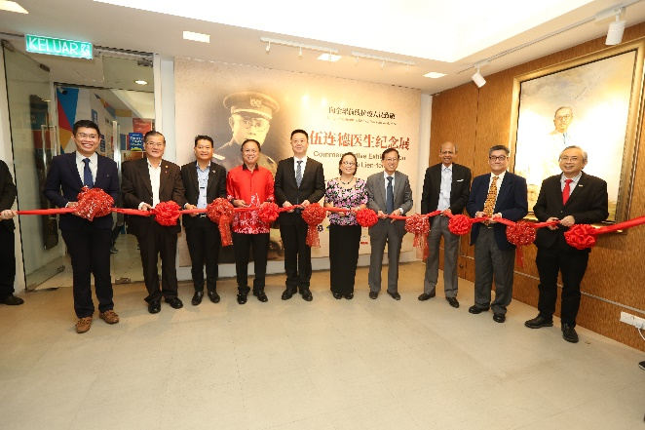

The launch of Commemorative Exhibition on Dr Wu Lien-Teh took place at the Gallery of Tan Kah Kee Foundation

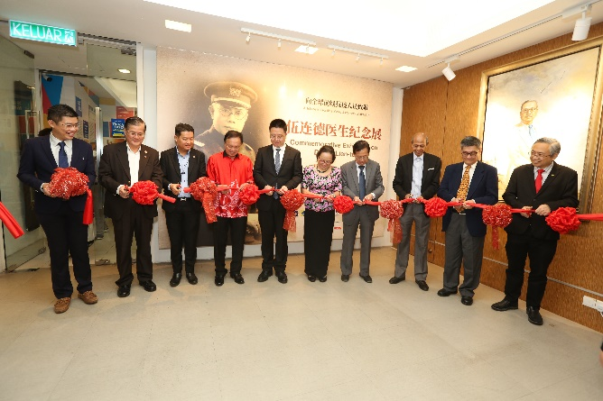

Dr Goh (fifth from right) gracing the launching ceremony

UTAR congratulates Tan Kah Kee Foundation for the successful event and is grateful to be a part of it as the co-organiser.

**About Dr Wu Lien-Teh**

Dr Wu Lien-The was a physician renowned for his work in public health. He was particularly known as the ‘Plague Fighter’ who stamped out the Manchurian plague of 1910–11. He was also the first Malaysian and the first Chinese-heritage person nominated to receive the Nobel Prize in Medicine in 1935. His other claim to fame is as the inventor of the Wu mask, the precursor of today’s N95 mask.

