Carnival promotes French language and culture
UTAR Centre for Foundation Studies (CFS) of Kampar Campus held a French Carnival at the Heritage Hall Building on 2 September 2022. The main objectives of the carnival were to promote French culture and language as well as discuss career opportunities. Over 100 participants attended the carnival.
Invited to grace the carnival were delegates from the Embassy of France, Head of Education Department (Cultural Department) and speaker Anaïs Dechamps accompanied by Project Manager of Educational Cooperation (Cultural Department) Oriane d’Escrivan.
The delegates were welcomed by CFS Kampar Campus Director Ts Tan Lee Siew, CFS Kampar Campus Deputy Director for Student Affairs and Development Lim Khiew Loon, CFS Kampar Campus Deputy Director for Academic Phang Ying Ning, Organising Chairperson and UTAR academic S. Yuvashini, and organising committee.

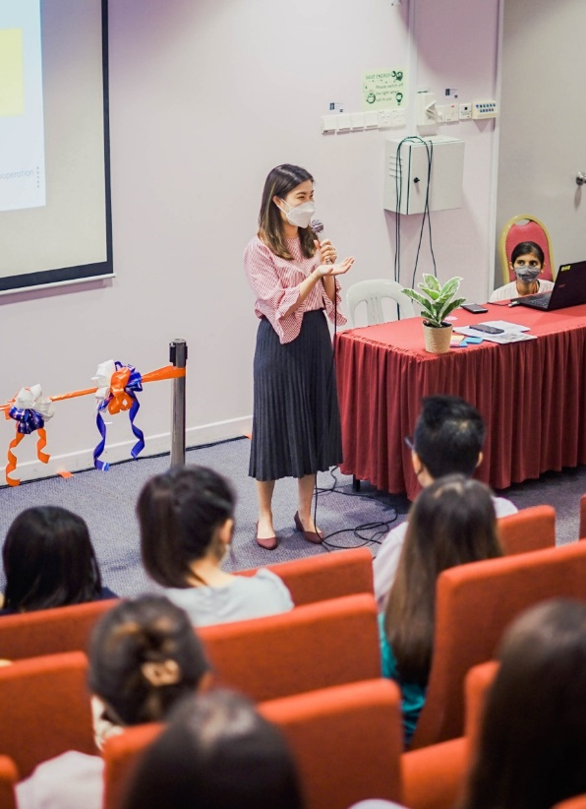
Ts Tan giving a cordial welcome to the attendees

The carnival began with an opening ceremony where Ts Tan was invited to deliver a welcome speech. She expressed her appreciation and said, “A warm welcome to our guests from the Embassy of France and the attendees. It is a positive sight to see students signing up for foreign language courses and events because learning foreign languages is beneficial in many ways. I am proud to be able to hold activities such as this carnival which aligns with UTAR’s focus on global and cultural exchange to promote mutual understanding among diverse communities.”
To mark the inauguration of the French Carnival, a ribbon-cutting ceremony was conducted by both parties.
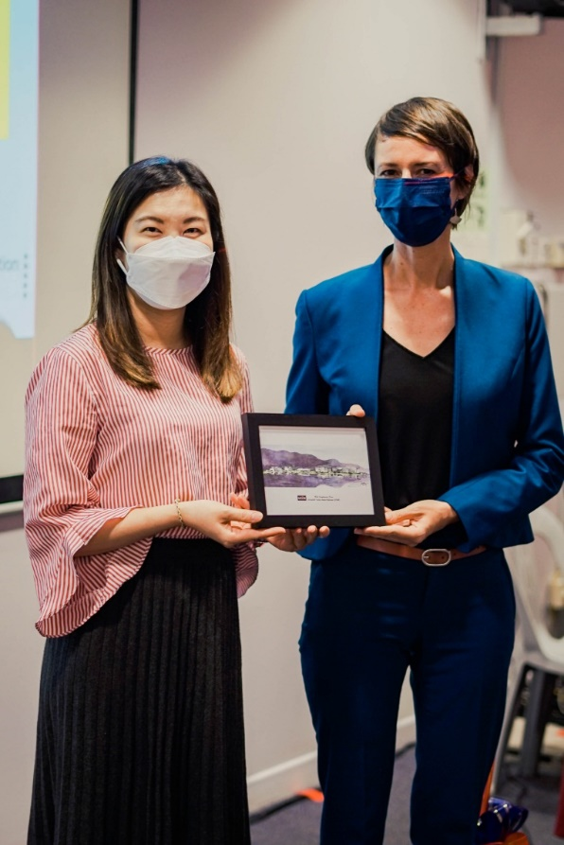
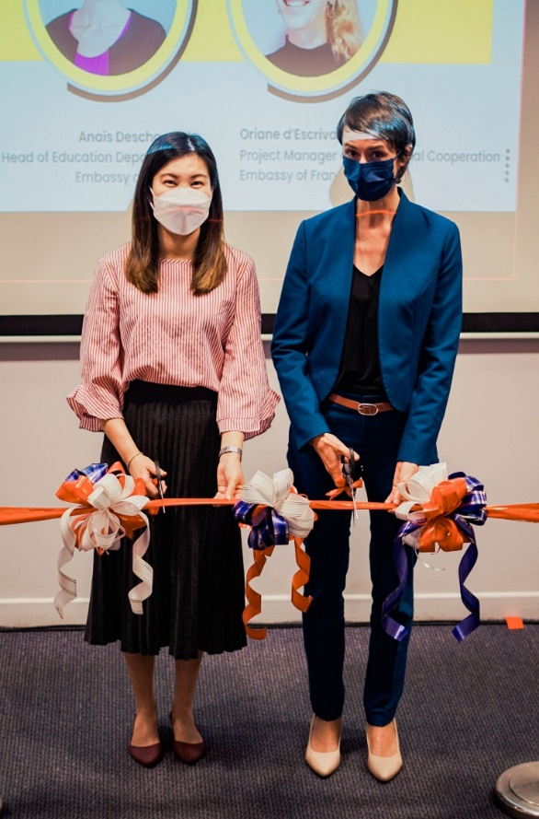
Ts Tan (left) and Anaïs marking Ts Tan (left) presenting welcome gift to Anaïs
the beginning of carnival

Anaïs started by introducing the organisational structure of the French Embassy and the matters they manage such as French language education, VISA application, French citizenship application and France-Malaysia Politics. The main goals of the French Embassy are to build amity among countries, promote French culture and language, support education and research, and bolster economic developments between countries. She added that many countries including Canada and Mexico are members of La Francophonie; their goals are generally the same as the French Embassy.
A short quiz session was held to revise attendees’ understanding of the French Embassy’s structure and goals.

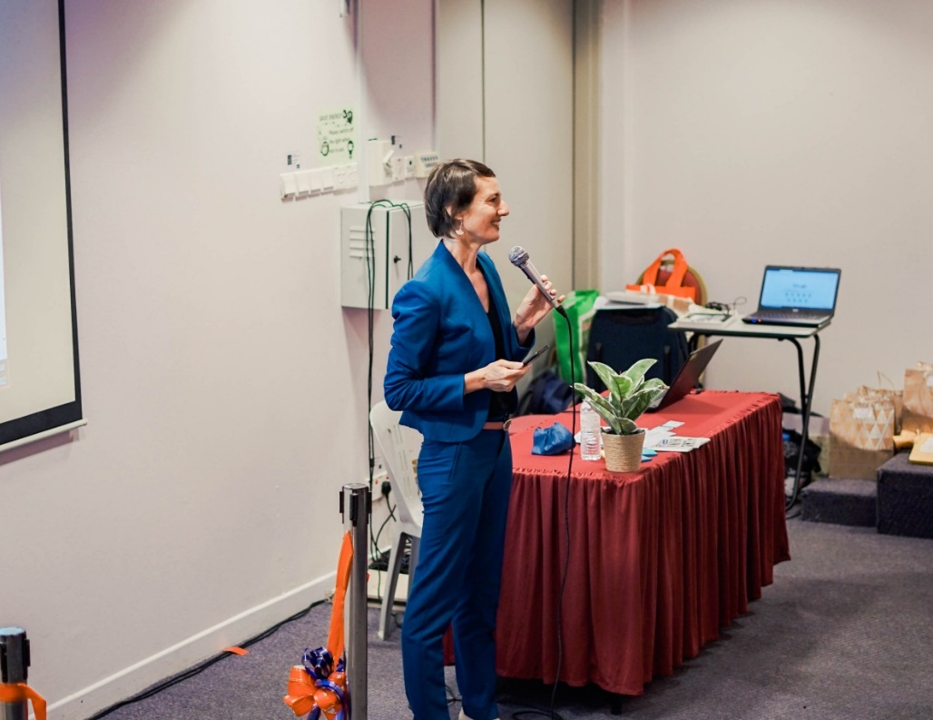
Anaïs presenting key structure of French Embassy during talk session

“French is the second most spoken language in the world after English. Africa is popular in the business context and its major population speaks French as a second language compared to other countries. One instance is the Malaysian company PETRONAS; they often engaged in business interaction with Africa. French and other languages are assets that enable not only business interaction, but also communication in many countries. Speakers also get to understand more about others’ mindsets as they learn more about other cultures,” Anaïs emphasised. She mentioned that learning French even facilitates the learning of languages including Spanish, Portuguese, and Italian since there are linguistic similarities between them and the French language.
Furthermore, she stated that learning French for the first time may be difficult due to the grammatical structures such as masculine and feminine articles. Speakers are most likely able to learn faster from that point onwards. An educator also plays a crucial factor in learning French because the educator has the responsibility of making a lesson fun. She mentioned that French Embassy has been frequently making educational plans to improve the learning process.
Project Manager of Educational Cooperation (Cultural Department) Oriane even joined in and offered advice. She said, “Making plans and methods in study is important, nevertheless, one should always have adequate rest in order to learn more efficiently.”

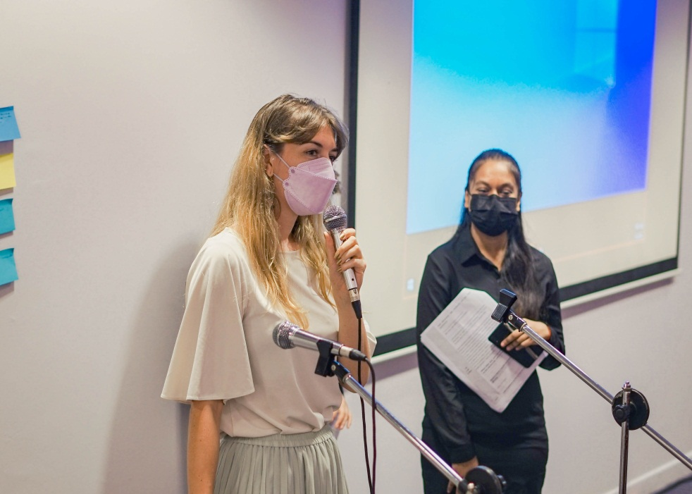
Oriane (left) offering valuable advice to the attendees

The talk concluded with Anaïs giving recommendations to French-learning sources and French language educational institutions along with an elaboration on DELF certificate which is offered by the French Ministry of Education to non-French individuals to certify their French language skills.
Various booths were set up to promote the learning of the French language and culture. They offered games, photography session, extra information on the Embassy of France and selling of food and drink.
The carnival saw song performances between the opening ceremony, talk session and closing ceremony. The songs were sung in the French language by UTAR students.

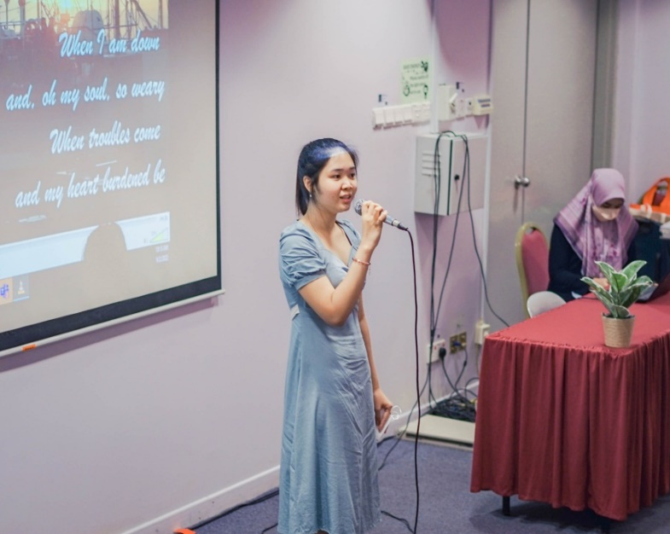
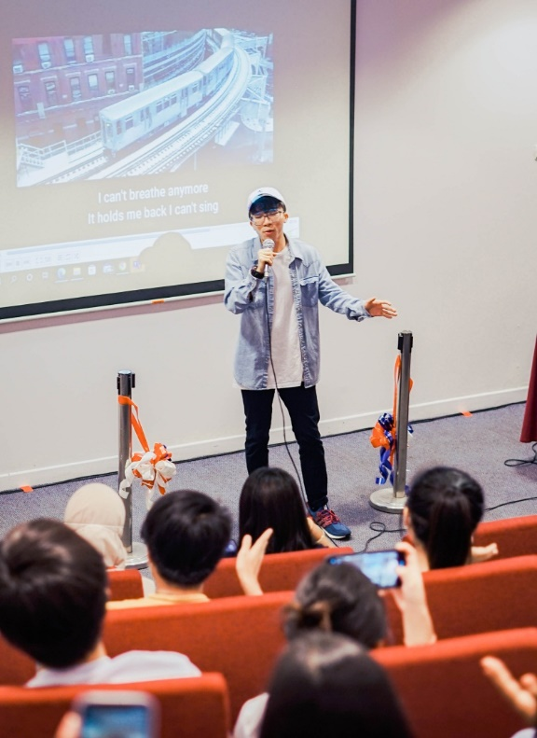

Wondrous performances by UTAR students

Finally, a closing ceremony signalled the end of the carnival with prizes presented to the singers and quiz winners. An exchange of token of appreciation between the representatives of CFS and the French Embassy was observed.

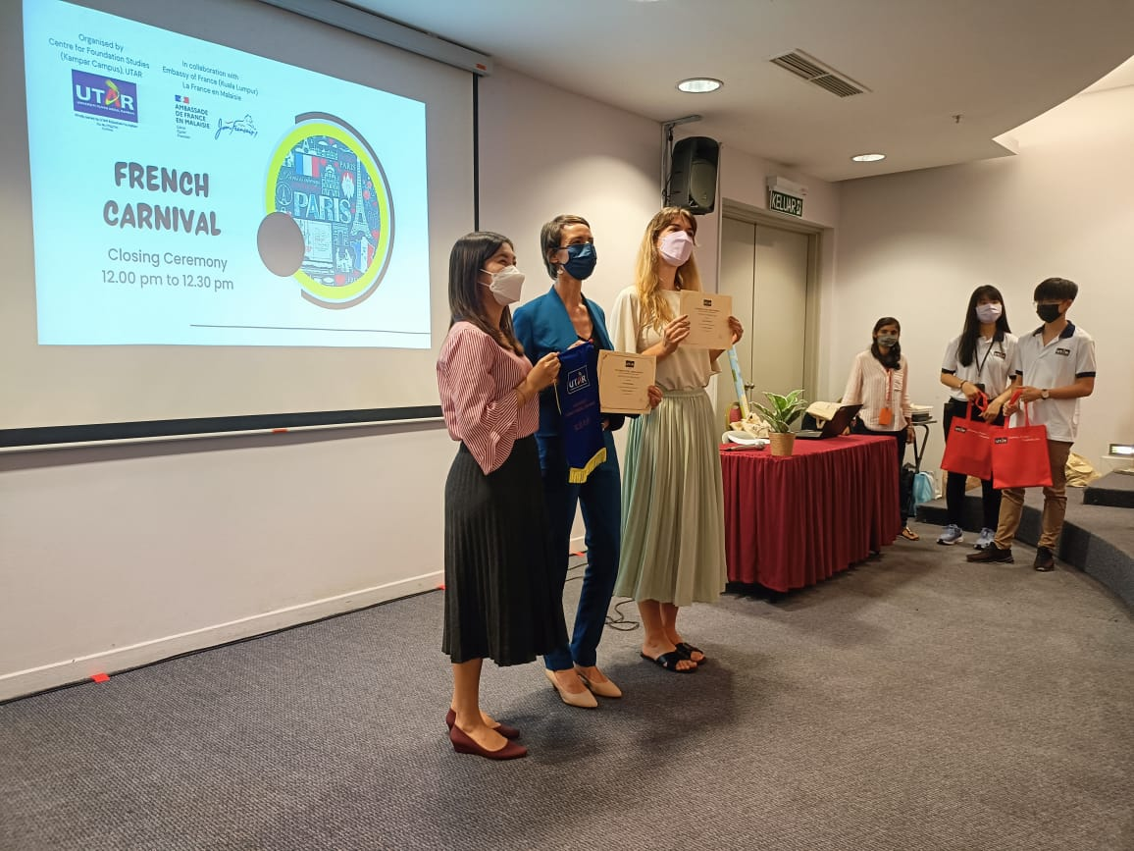
Ts Tan (far left) presenting tokens of appreciation to Anaïs and Oriane (far right)

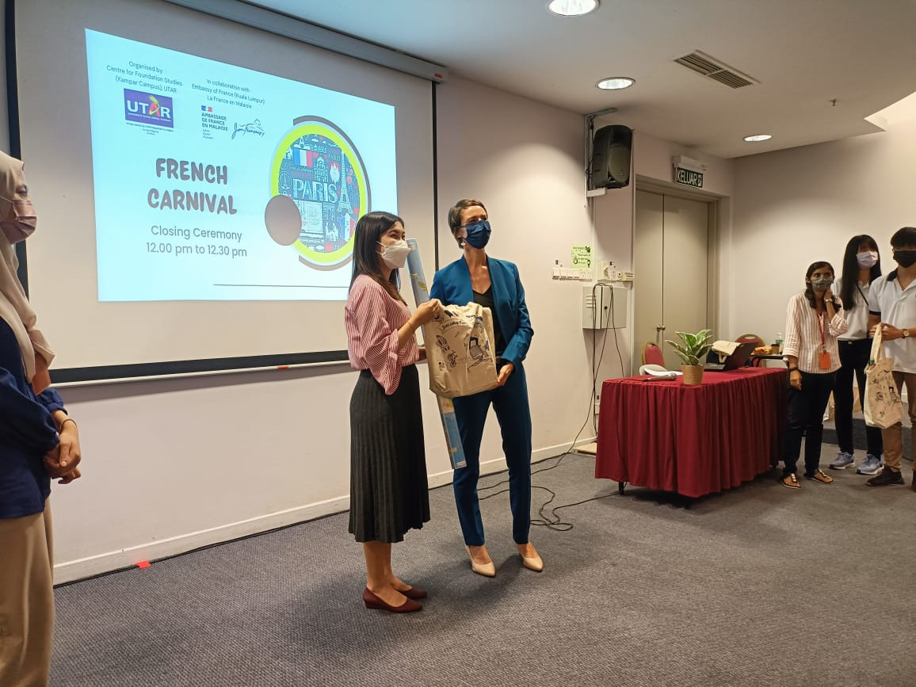
Ts Tan (left) receiving a token of appreciation from Anaïs

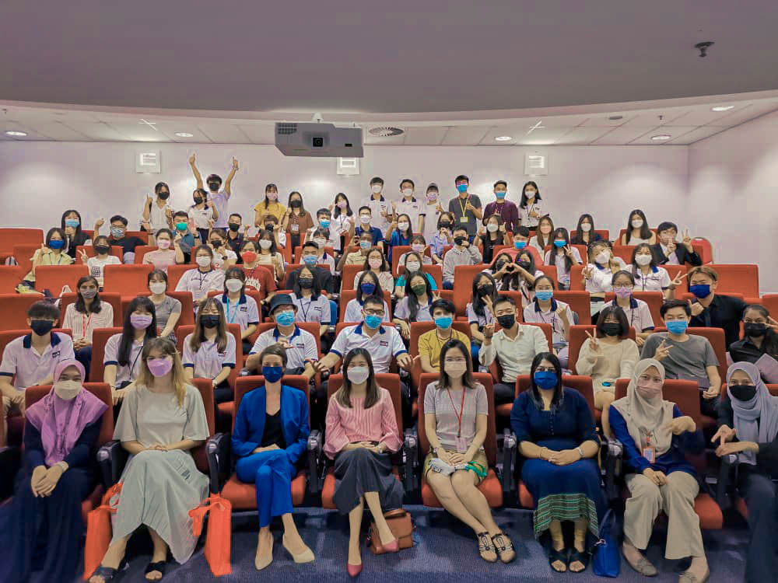
Front row: Oriane (second from left), Anaïs (third from left), Ts Tan (fourth from left), Phang (fourth from right), Yuvashini (third from right), organising committee and UTAR students with participants of the French Carnival

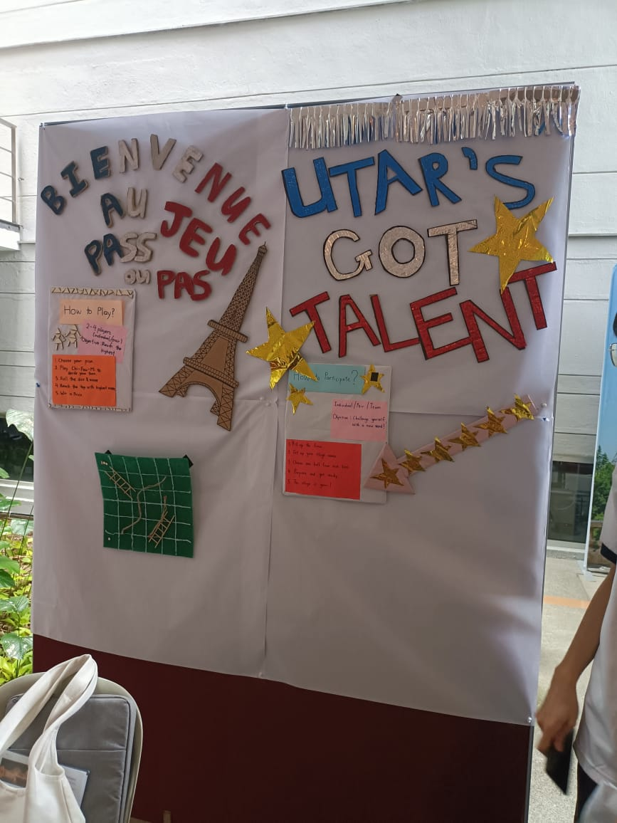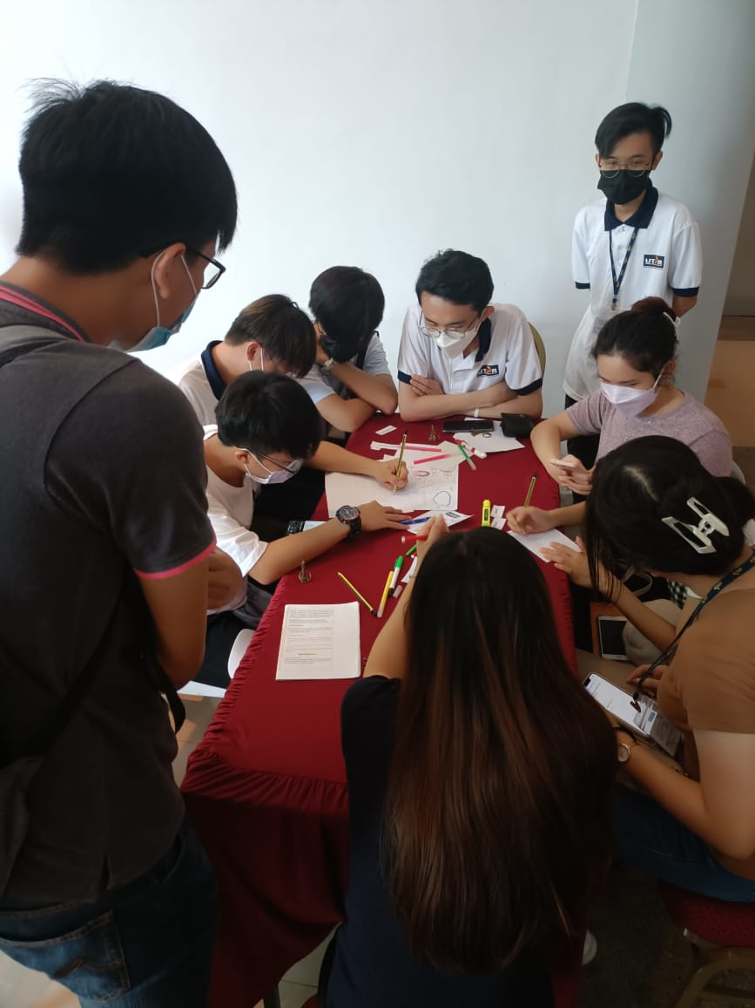
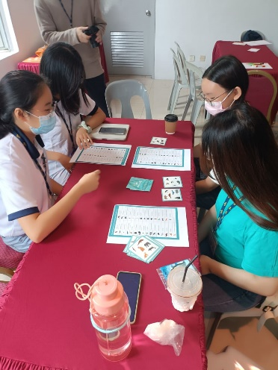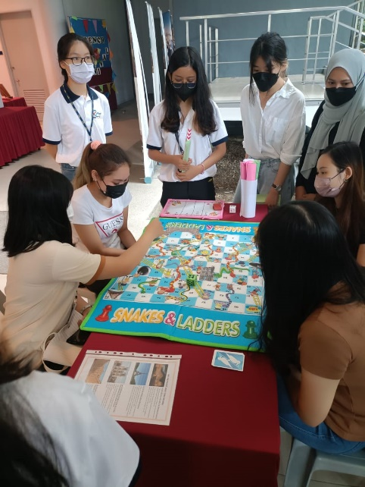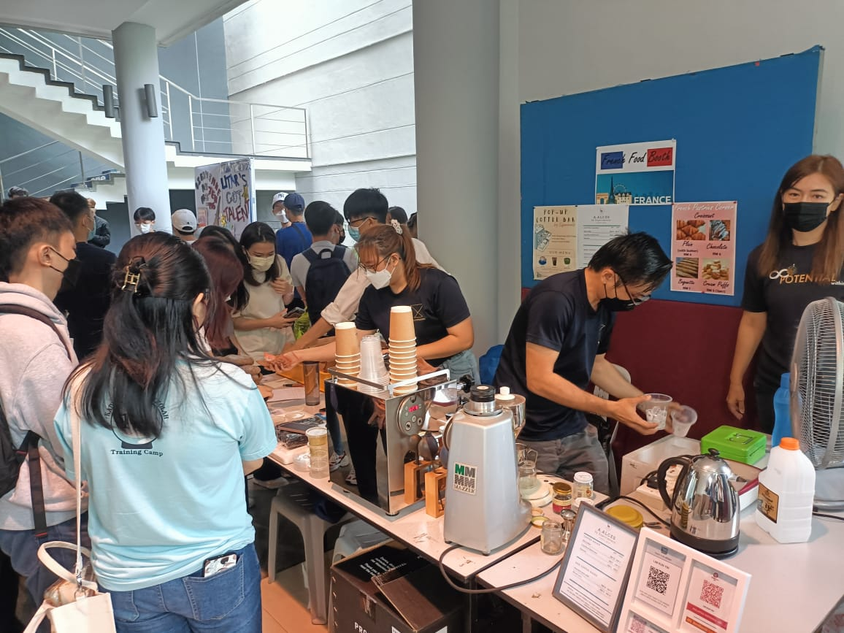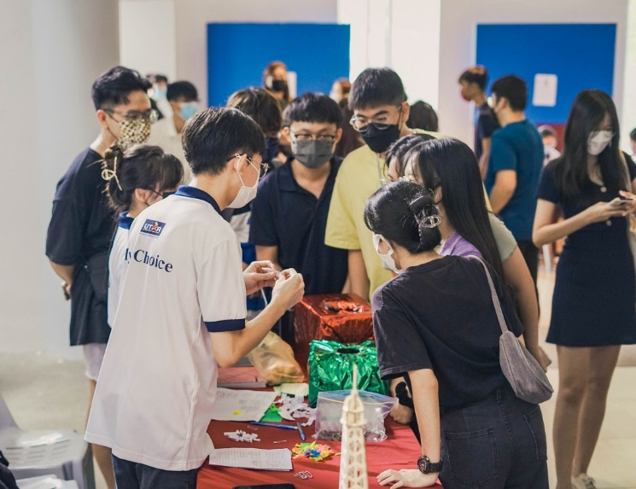

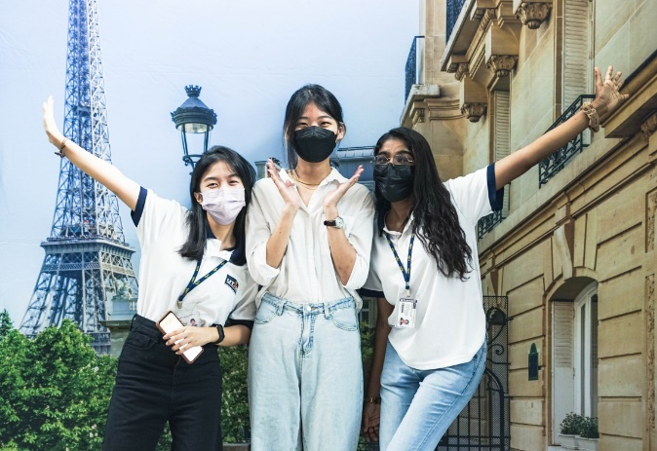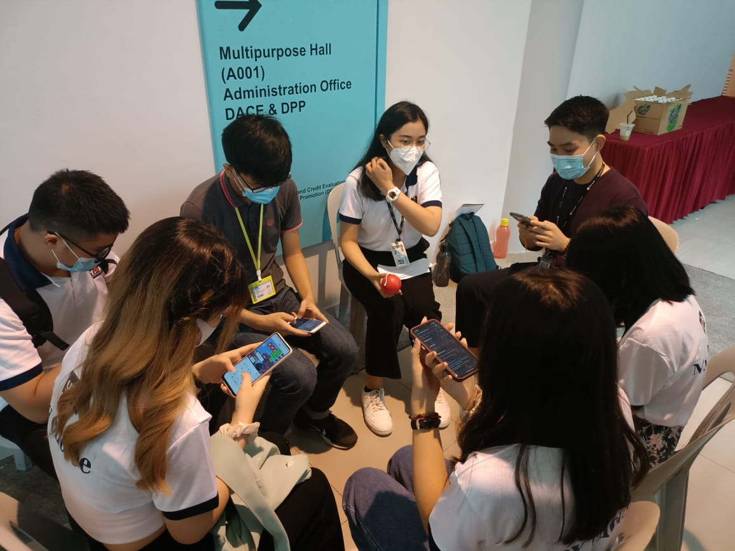
Various booths offering games, photography sessions, and food and drinks

