UTAR Scholarship Award Presentation Ceremony for June 2023 intake
The UTAR Scholarship Award Presentation Ceremony for June 2023 intake was organised by the Department of Scholarships and Financial Aid (DSFA) on 25 July 2023 at Sungai Long Campus and on 26 July 2023 at Kampar Campus. A total of 532 external and internal scholarship recipients attended the ceremony held at both campuses.
Present at the ceremony were UTAR President Ir Prof Dato’ Dr Ewe Hong Tat, UTAR Vice President for Student Development and Alumni Relations Prof Dr Choong Chee Keong, Faculty of Accountancy and Management (FAM) Dean Dr Pok Wei Fong, Lee Kong Chian Faculty of Engineering and Science (LKC FES) Deputy Dean for Student Development and Industrial Training Assoc Prof Ts Dr Lee Kim Yee, Institute of Chinese Studies (ICS) Dean Assoc Prof Dr Chong Siou Wei, Division of Programme Promotion (DPP) Deputy Director for International Student Recruitment and Business Development Ms Irene Wong Hong Lei, Faculty of Business and Finance (FBF) Dean Assoc Prof Dr Au Yong Hui Nee, Faculty of Engineering and Green Technology (FEGT) Deputy Dean for Student Development and Industrial Training Dr Tan Kok Tat, ICS Deputy Dean for Student Development and Industrial Training Dr Ling Liong Ngo, and DPP Deputy Director for Malaysian Student Recruitment Mr Tan Choon Wah.
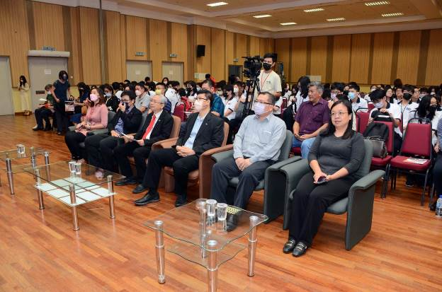
From right: Dr Pok, Dr Chong, Prof Choong, Prof Dato’ Ewe, Dr Lee and Ms Irene with scholarship recipients and parents
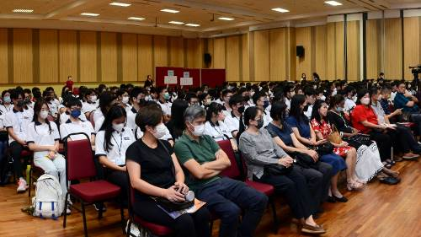
Parents (front row) and students during the ceremony
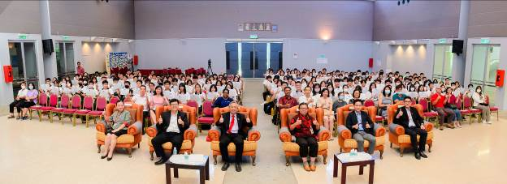
Front row, from left: Dr Ling, Prof Choong, Prof Dato’ Ewe, Dr Au Yong, Dr Tan and Mr Tan with scholarship recipients and parents during the ceremony
The ceremony at Sungai Long and Kampar Campuses began with a performance by the UTAR Sungai Long Chinese Orchestra Club and UTAR Kampar Campus Music Club respectively.
In his speech, Prof Dato’ Ewe said, “I would like to express my heartfelt congratulations to the distinguished students. Your tireless efforts, unwavering determination, and thirst for knowledge have propelled you to the pinnacle of success. You are the embodiment of the transformative power of education, and I have no doubt that you will continue to achieve greatness in your respective fields.”
He added, “As a University by the people and for the people, UTAR has consistently garnered support and contributions from the community. In line with our commitment to give back to society, UTAR has actively provided scholarships and loans to students facing financial constraints. As of 2023, UTAR has awarded over RM185.4million as internal scholarships and over RM14.3million as internal loans to deserving students.”
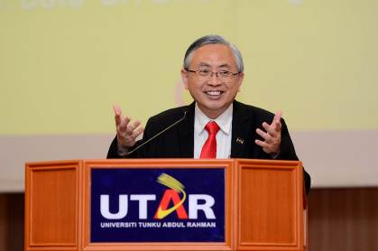
Prof Dato’ Ewe giving his speech
Bachelor of Chemical Engineering with Honours student, Matthias Thong Yi Fan, who is a recipient of the UTAR Scholarship for Top Achievers said, “I am overjoyed to receive this scholarship, as it not only lightens my parents’ financial burden but also serves as motivation for me to excel in my studies. However, the real value of this scholarship goes beyond the monetary sum we are receiving. It lies within the opportunities for exposure and contribution to society, as well as the character and responsibility we develop.”
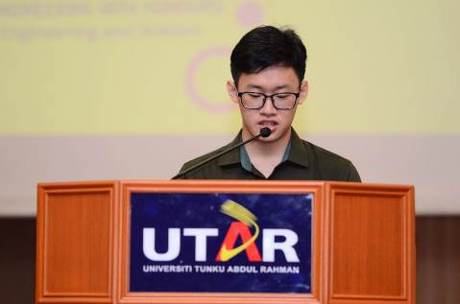
Matthias Thong Yi Fan
Bachelor of Chemical Engineering with Honours student, Wong Jing Xiang, the recipient of the Yayasan Tan Sri Lee Sin Cheng Scholarship said in his speech, “I am grateful to IOI Group and Yayasan Tan Sri Lee Sin Cheng for the invaluable support provided through the scholarship. Their financial assistance has alleviated the burden of having to pay the tuition fees, allowing me to fully immerse myself in my studies and explore additional learning opportunities. I discovered this scholarship through UTAR’s official website and UTAR email.”
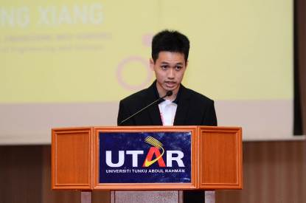
Wong Jing Xiang
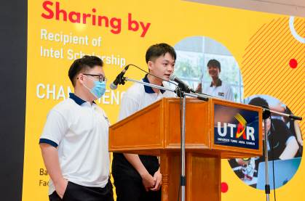
From left: Lee and Cham thanking UTAR and Intel for the scholarships
Another student Lee Yan Shen from Kampar Campus said, “I am immensely grateful for the opportunity to apply for the scholarship. It taught me a valuable lesson about seizing opportunities, and ultimately, I succeeded in being awarded the scholarship from Intel. Overwhelming feelings of joy and gratitude fill my heart because this scholarship not only relieves my financial burdens in pursuing my degree but also provides additional resources for my personal growth.” Lee is currently a third-year, first-semester student studying Electronics Engineering.
Additionally, Cham Cheng Lim from Kampar Campus, also enthused, “I would like to extend my sincere gratitude to Intel Corporation. Your belief in my potential and your generous support have made a profound impact on my life. I am honoured to be chosen as a recipient of this scholarship, and I am committed to making the most of this opportunity.” The Electronic Engineering student Cham, added, “I would like to express my heartfelt appreciation and gratitude for the exceptional care and support that UTAR extended towards the welfare of students, demonstrated through the generous scholarship opportunities provided.”
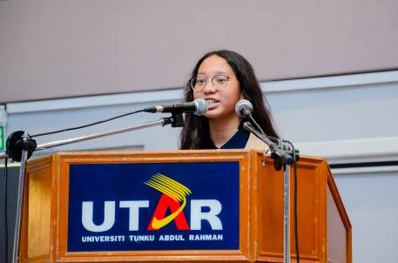
Ainaa Arissa expressing her gratitude to UTAR for providing her with this opportunity
Last but not least, Ainaa Arissa binti Zamri said, “I am overwhelmed by the tremendous support and opportunities that this scholarship has provided me. The most distinct one is I am truly motivated to pursue my studies here at UTAR. I see this scholarship as an incentive for me to take my studies seriously; not only to maintain my scholarship, but also to gain knowledge. As a result, I am sure that every knowledge that I learn here will be helpful to me in the future when I am in the work field; even better, make a positive impact on society.”
Gratitude and congratulatory video messages from the scholarship recipients’ families and various UTAR deans and directors were also played at the ceremony. The ceremony ended with a group photo session.
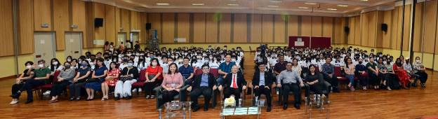
Seated front row, middle: Prof Dato’ Ewe with parents, students and staff
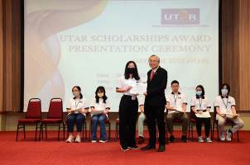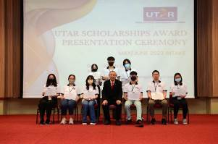
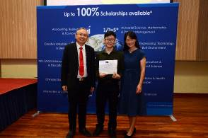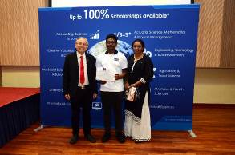
Scholarship recipients with Prof Dato’ Ewe
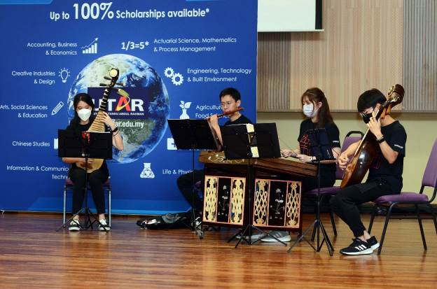
Performance by UTAR Chinese Orchestra Club of Sungai Long Campus
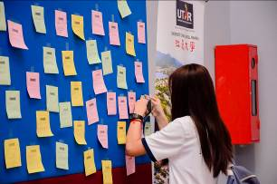
Students putting up their gratitude messages during the event
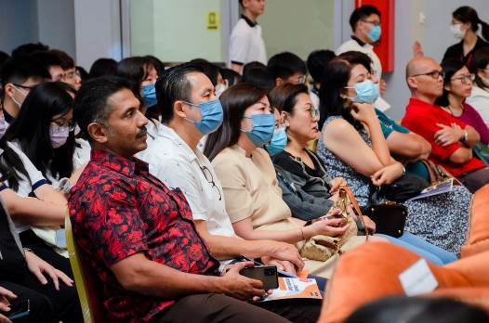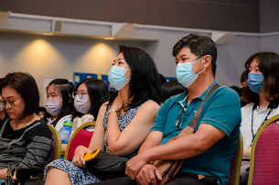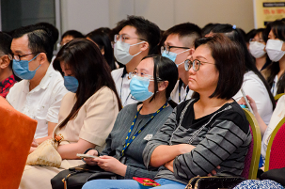
Parents accompanying their children at the scholarship presentation ceremony
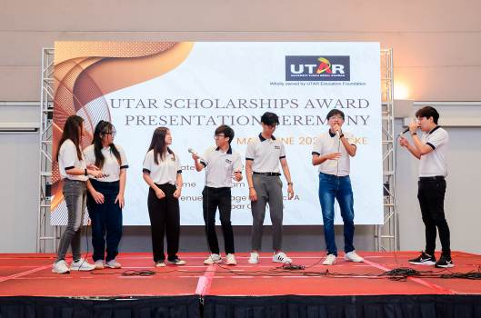
UTAR Kampar Campus Music Club students performing Acappella performance for the audience
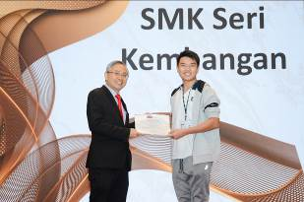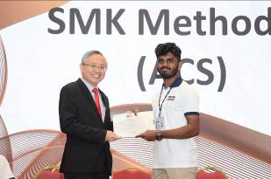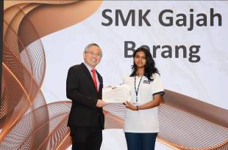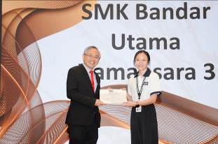
Prof Dato’ Ewe (left) presenting the scholarships to students in Kampar Campus

S

