**School Engagement Project @ SMK Methodist (ACS) Kampar**

On 21 July 2023, over 100 students from Form 1 to Form 3 of SMK Methodist (ACS) Kampar had a day of fun and learning at the English workshop titled “The English-Race” organised by UTAR Centre for Foundation Studies (CFS) of Kampar Campus. The workshop was facilitated by CFS Kampar Campus academic Tulasi a/p Subramaniam and assisted by CFS Kampar Campus academic Shubagaran a/l Sanmuga Sundram, as well as three teacher interns from UTAR Faculty of Arts and Social Science, Goh Poh Shen, Chow Wing Sum and Ng Yi Ru.

The workshop aimed to promote English language learning among secondary school students and enhance their English language skills through various interactive and engaging activities.

The students were divided into several groups and had to complete tasks at five exciting game stations: Scrambled Letters, Complete Me, Hidden Words, Sentence Builder, and Team Cheer. The workshop required the students to use their vocabulary, grammar, spelling, and creativity to complete the tasks. The group with the highest score at the end of the workshop walked away with a prize.

The workshop was further enriched by the insightful talks delivered by the teacher interns on public speaking and improving conversational techniques. The talks provided the students with tips and strategies on how to speak confidently and effectively in different situations. The students also had the opportunity to practise their speaking skills through role plays.

The workshop was well-received by the students, who expressed their enjoyment and appreciation for the event. Lim Kit Yee from Class 3A shared, “The team cheer activity is really fun and memorable! All the members of the team expressed their ideas.” Thishan a/p Thini from Class 3A said, “The workshop is fun, I learned the importance of teamwork. This is the first time I led a big group of students from different ages. I hope that this kind of workshop can be conducted again in the future.”

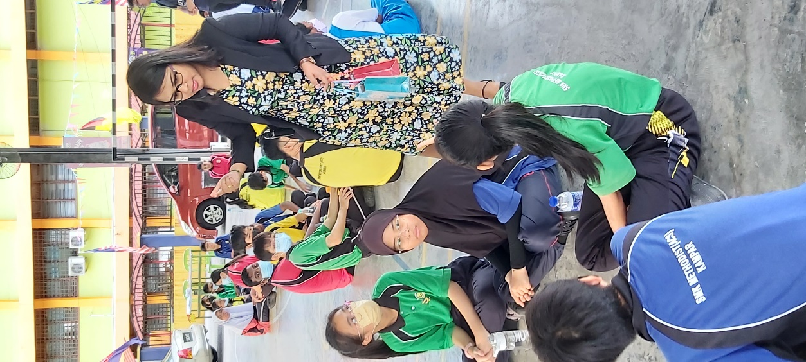

Students participating in “The English-Race” workshop

Students completing the task at the game station

Goh (left) conducting an interactive session during his talk on public speaking

Ng conducting her talk on conversational techniques

Hardave Singh, the Principal of SMK Methodist (ACS) Kampar (right) presenting the prize to the leader of the winning team

CFS Department of Management and Accountancy (Kampar Campus) Head Tsen Tzu Yee (right) exchanging souvenirs with Hardave Singh, the Principal of SMK Methodist (ACS) Kampar

Students shared their thoughts after the event

Group photo after the event