**Writing and Publishing Articles using Bibliometric Analysis**

The Centre for Accounting, Business, and Finance (CABF), a research centre under the Faculty of Business and Finance, organised a talk titled “Writing and Publishing Articles using Bibliometric Analysis” on 14 September 14, 2023 via the Microsoft Teams.

Dr Ramlan bin Mustapha, a Senior Lecturer from the Academy of Contemporary Islamic Studies (ACIS) at Universiti Teknologi MARA was invited to deliver this insightful sharing.

Dr Ramlan said, “The bibliometrics is a set of techniques used for the quantitative analysis of scientific and technical activities. It serves as a powerful tool for identifying core research areas, prominent authors, and their relationships by examining all publications within a specific field. This method not only enhances the quality of research papers but also assists authors in identifying relevant literature, evaluating the impact of their work, and comparing their contributions with those of other researchers in the same field.”

He added, “The bibliometric analysis offers several advantages. It is user-friendly, eliminating the need for extensive field studies. It is efficient, allowing researchers to publish their work in prestigious journals like Scopus and Web of Science. Furthermore, various software tools make the process accessible, especially for individuals who may not possess a strong statistical background.”

“The origins of bibliometric analysis can be traced back to 1934 when Paul Otlet first coined the term. His pioneering work laid the foundation for this field, which is now embraced across various disciplines worldwide”, enthused Dr Ramlan. He further highlighted despite bibliometrics being in use for decades, many researchers are still exploring its full potential.

During the presentation, Dr Ramlan elaborated on the strengths of bibliometric analysis, highlighting its quantitative nature, capacity to handle extensive datasets, objectivity, reproducibility, and its ability to offer valuable insights into research topics. In addition, he also provided a step-by-step demonstration of the processes involved in bibliometric analysis. “The steps involved data retrieval from sources such as Scopus, data analysis using tools like Excel and VOSviewer, and the presentation of trends, productive countries and institutions, co-authorship networks, and more”, he said.

Before ending his sharing session, he demonstrated these concepts by showcasing several research papers that employed bibliometric analysis, illustrating its relevance and applicability to both empirical and theoretical research.

In summary, Dr Ramlan’s discussion of bibliometric analysis showcased its value in academic research. This approach can significantly influence research, aid decision-making, and contribute meaningfully to academia. As researchers further explore its potential, bibliometric analysis is poised to become even more essential in shaping the future of research and publishing.

The session concluded with an engaging Q&A.

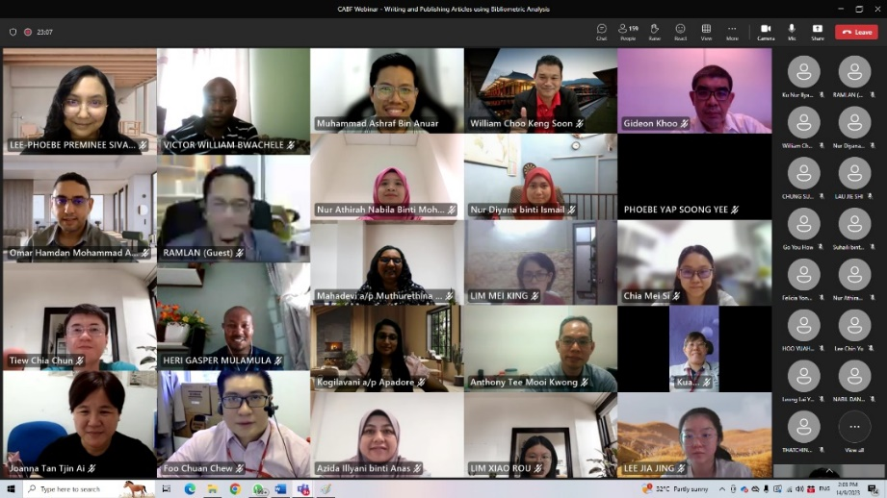

The group photograph at the end of the session