**UTAR Scholarship Award Presentation Ceremony for January 2024 intake**

The UTAR Scholarship Award Presentation Ceremony for the January 2024 intake was organised by the Department of Scholarships and Financial Aid (DSFA) on 21 March 2024 at KAG01, UTAR Sungai Long Campus and on 27 March 2024 at the Heritage Hall of UTAR Kampar Campus. A total of 101 external and internal scholarship recipients attended the ceremony held at both campuses.

Present on both occasions was UTAR President Ir Prof Dato’ Dr Ewe Hong Tat. At the Sungai Long Campus, UTAR President was accompanied by Lee Kong Chian Faculty of Engineering and Science (LKC FES) Deputy Dean for Academic Development and Undergraduate Programmes Assoc Prof Ir Dr Gobi Vetharatnam, M. Kandiah Faculty of Medicine and Health Sciences (MK FMHS) Deputy Dean for Academic Development and Undergraduate Programmes Assoc Prof Dr Leong Pooi Pooi, Faculty of Accountancy and Management (FAM) Deputy Dean for Academic Development and Undergraduate Programmes Dr Ng Kar Yee, Faculty of Creative Industries (FCI) Deputy Dean for Academic Development and Undergraduate Programmes Assoc Prof Mr Thinavan Periyayya, Institute of Chinese Studies (ICS) Deputy Dean for R&D and Postgraduate Programmes Assoc Prof Dr Chin Chong Foh and Centre for Foundation Studies (CFS) of Sungai Long Campus Deputy Director for Student Affairs and Development Ms Pua Gaik Hong.

Meanwhile, in Kampar Campus, UTAR President was accompanied by UTAR Vice President for Student Development and Alumni Relations Prof Dr Choong Chee Keong, Faculty of Engineering and Green Technology (FEGT) Dean Ir Prof Dr Ng Choon Aun, Faculty of Business and Finance (FBF) Dean Assoc Prof Dr Au Yong Hui Nee, Faculty of Arts and Social Science (FAS) Deputy Dean for Academic Development and Undergraduate Programmes Ts Dr Khor Kheng Kia, Institute of Chinese Studies (ICS) Deputy Dean for Student Development and Industrial Training Dr Ling Liong Ngo, Faculty of Information and Communication Technology (FICT) Department of Computer and Communication Technology Head Ts Dr Chang Jing Jing, CFS Kampar Deputy Director for Student Affairs and Development Mr Lim Khiew Loon, and Division of Programme Promotion Kampar Deputy Director Mr Tan Choon Wah.

*More photos of the ceremony in Kampar are* [*here*](https://www.facebook.com/media/set/?vanity=UTARnet&set=a.841968217969695)*.*

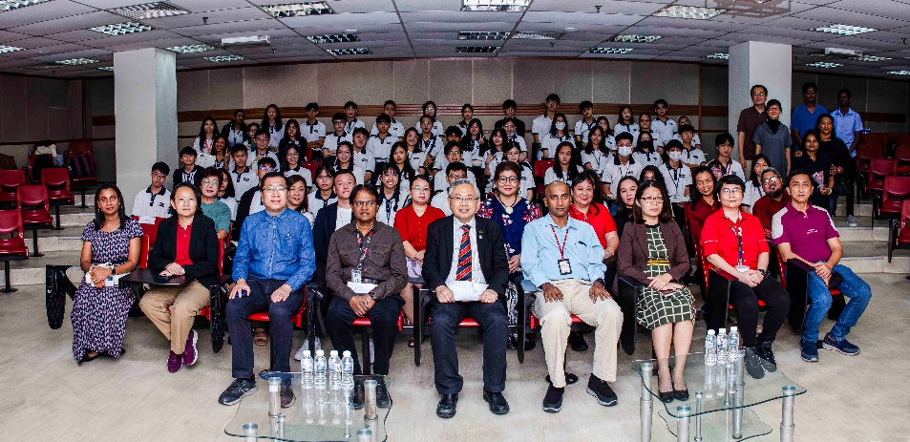

Front row, second from left: Dr Ng, Dr Chin, Mr Thinavan, Prof Dato’ Ewe, Dr Gobi, Dr Leong and Ms Pua with scholarship recipients and parents at Sungai Long Campus

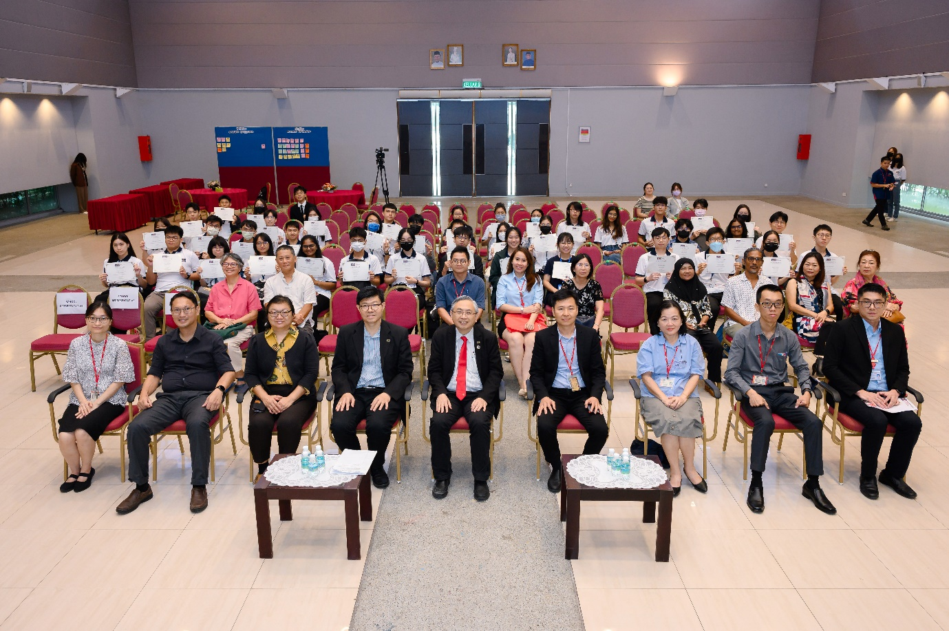

Front row, from left: Dr Chang, Dr Khor, Dr Au Yong, Prof Choong, Prof Dato’ Ewe, Prof Ng, Dr Ling, Mr Lim and Mr Tan with scholarship recipients and parents at Kampar Campus

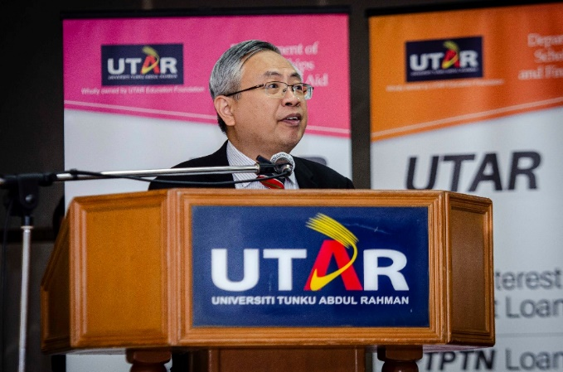 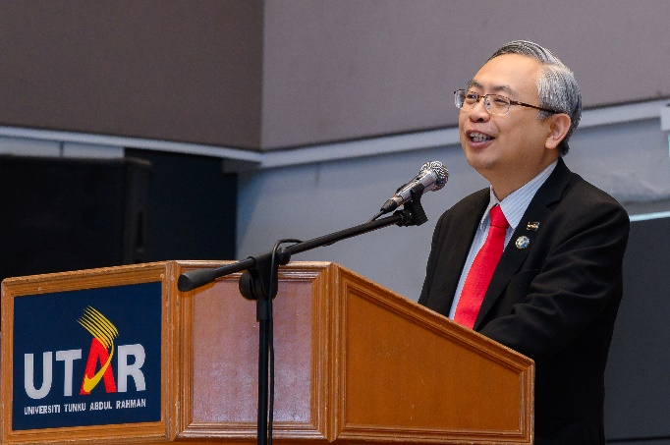

Prof Dato’ Ewe delivering his speech at UTAR Sungai Long Campus (left photo) and UTAR Kampar Campus

In his speech, Prof Dato’ Ewe said, “These scholarships are not merely financial rewards but also recognition of your academic accomplishments. The scholarships you receive today symbolise more than just a reward for your efforts, they represent a responsibility to utilise your education for positive societal impact. Each of you has a promising future ahead, and the education you receive will unlock countless opportunities.”

He added, “The pursuit of knowledge should extend beyond the attainment of a degree or scholarship. Continue to challenge yourselves, seek fresh perspectives, embrace intellectual growth and uphold your commitment to lifelong learning. Education is a journey, and success will be measured not only by personal achievements but also by the positive impact you have on others.”

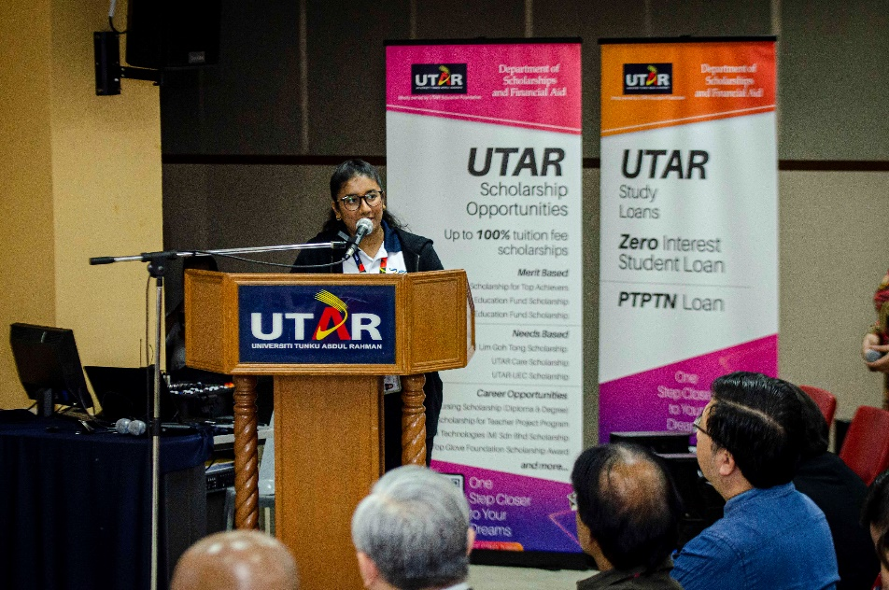

Varshene thanking UTAR for enabling her to pursue her dreams

FAM Bachelor of Accounting (Honours) student, Varshene Priyha Moorthy, who is a recipient of the UTAR Scholarship for Top Achievers said, “This scholarship has opened doors I never thought possible, empowering me to pursue my dreams with unwavering determination and purpose. It has instilled in me a sense of responsibility, not only to excel academically but also to make a meaningful difference in the world around me.”

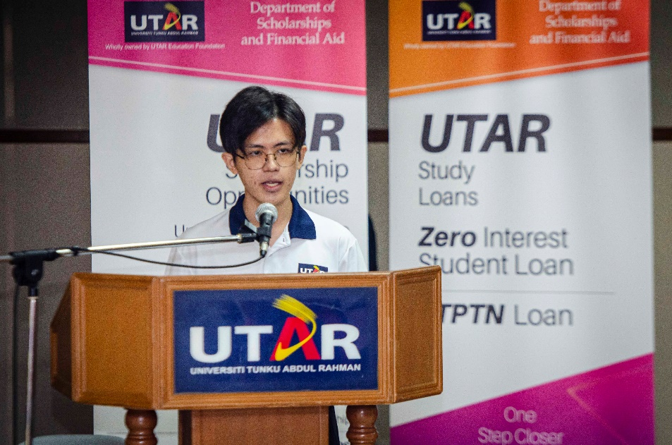

Jonathan Seo explaining how education enables him to make a difference in life

LKC FES Bachelor of Electrical and Electronic Engineering with Honours student, Jonathan Seo Ming Hann, the recipient of the Penang Future Foundation Scholarship said in his speech, “Receiving this scholarship has opened doors I never thought possible. This scholarship is not just about furthering my education; it’s about fulfilling a dream and making a difference. I am committed to making the most of this opportunity and giving back to the community.” He concluded his speech by saying, “Seize every opportunity that comes your way. Believe in yourself and never give up on your dreams. Together, we can make a positive impact on the world.”

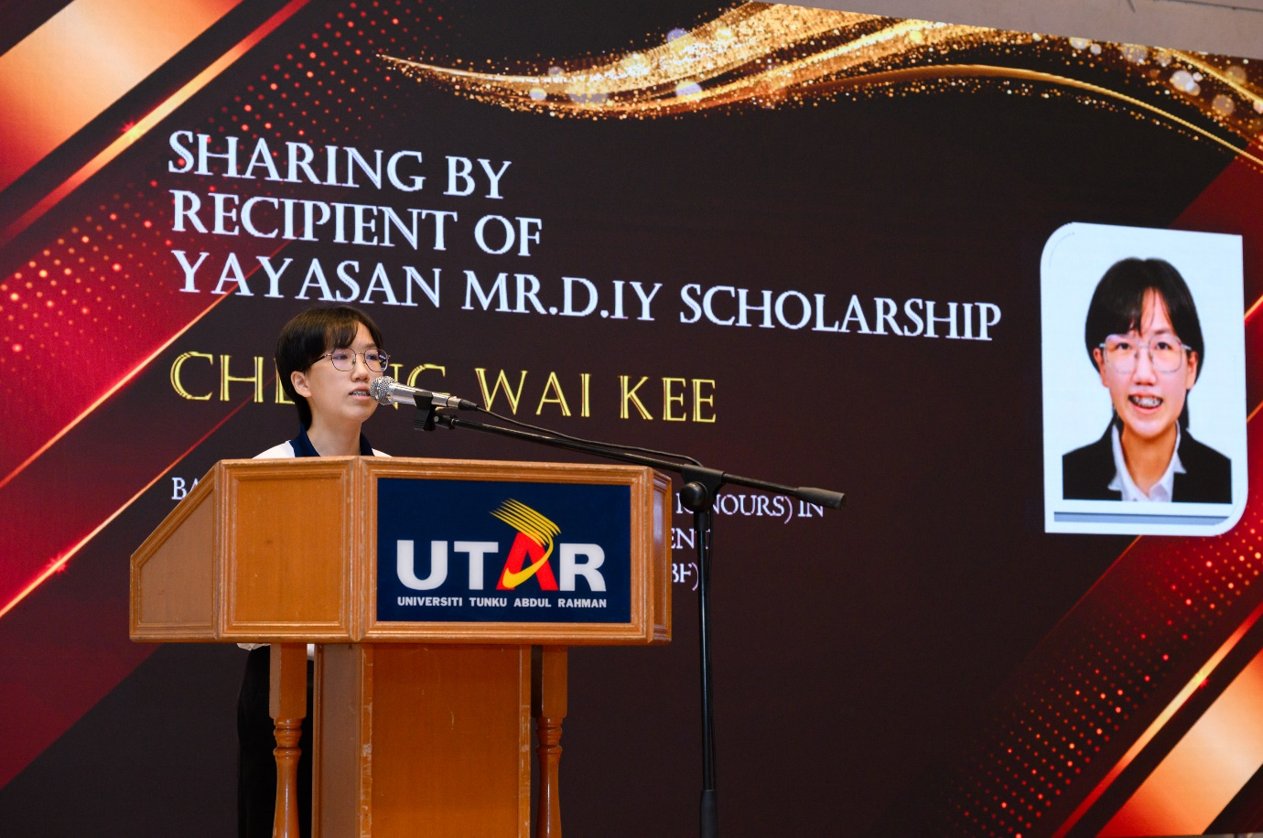

Cheong sharing her delight in moving a step closer to her dreams

Bachelor of Business Administration (Honours) in Logistics and Supply Chain Management student Cheong Wai Kee, who received the Yayasan Mr DIY Scholarship, expressed, “The support and assistance provided by Yayasan MR. DIY have brought me one step closer to my dreams. Knowing that UTAR and Yayasan Mr DIY stand by me, ready to offer encouragement, instils a sense of assurance within me. Their support has made me realise that I am not alone in this journey. Beyond financial aid, their spiritual support, understanding, love, and affirmation have played a crucial role in shaping my character. As a result, I am determined to emerge as a more courageous and resolute individual, steadfastly pursuing my dreams and goals.”

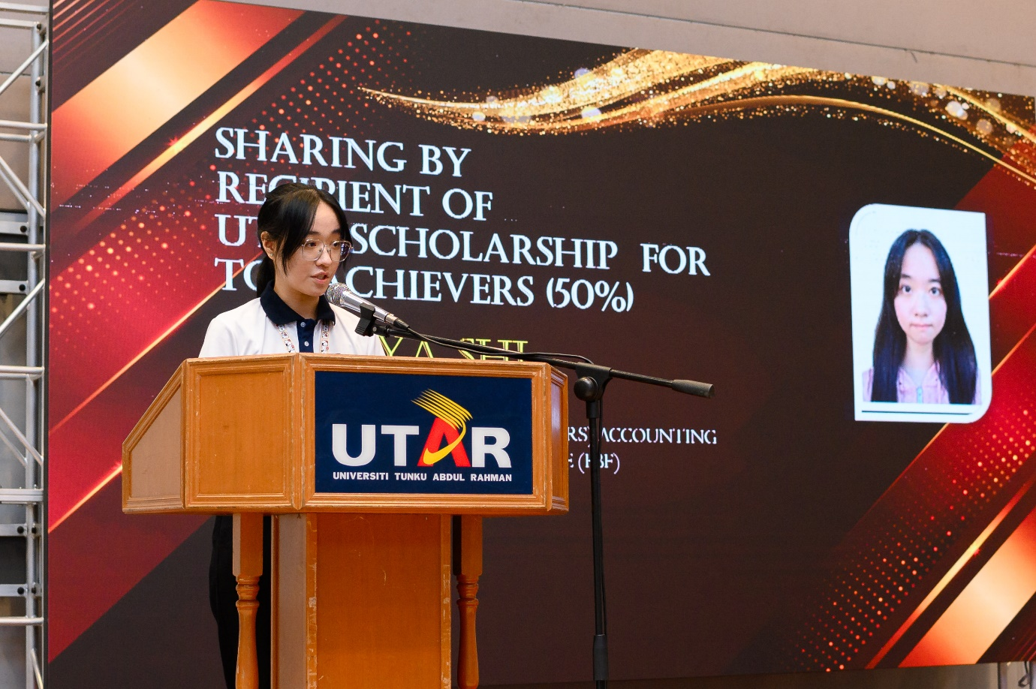

Ngoi expressing her gratitude for the scholarship

Ngoi Ya Shi, a Bachelor of Commerce (Honours) Accounting student and recipient of the UTAR Scholarship for Top Achievers said, “Being a UTAR scholarship holder had a profound impact on my life. It has alleviated my financial burden of pursuing higher education and provided me with a sense of security and stability. This allows me to focus wholeheartedly on my studies and co-curricular activities. Furthermore, it has implanted in me a sense of responsibility and gratitude, motivating me to strive for excellence in all aspects of my life. Beyond the financial assistance, being a scholarship recipient has opened doors to countless opportunities. It has provided me with access to invaluable resources, mentorship, and networking platforms that have greatly enhanced both my academic path and personal development. With this scholarship, my passion for learning is being fuelled. I am committed to making a positive impact on the community.”

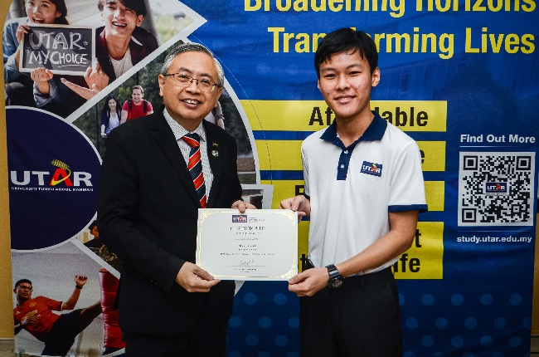 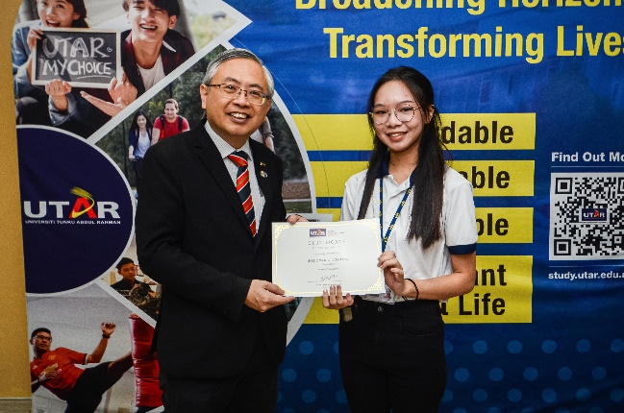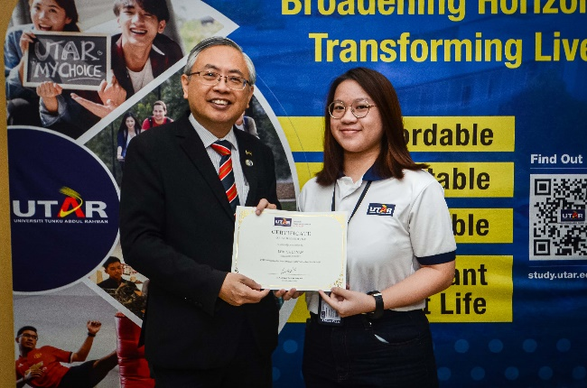 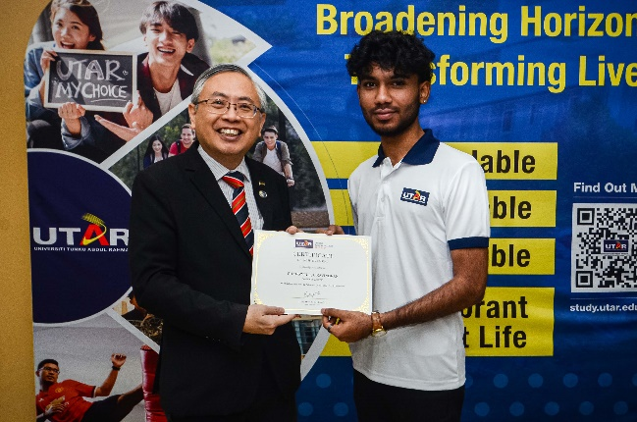

Prof Dato’ Ewe (right) presenting the scholarships to students

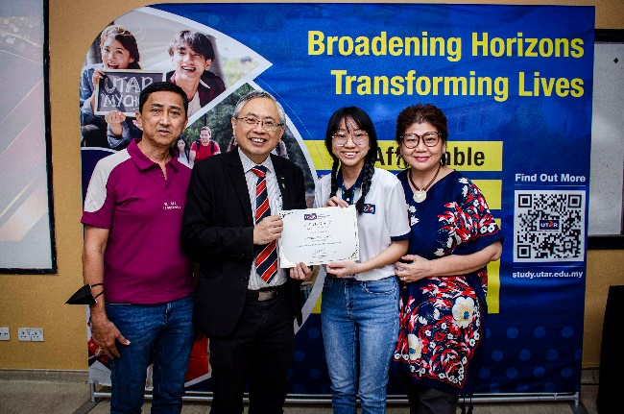 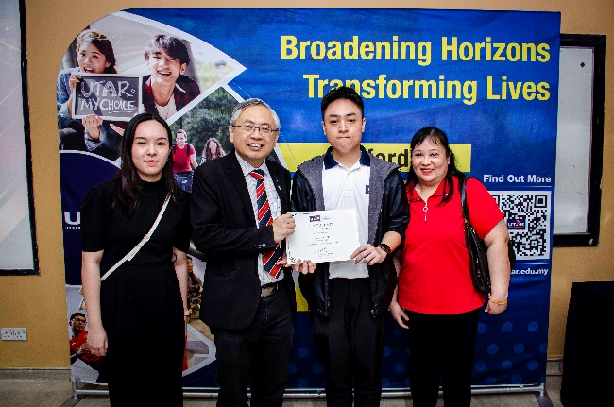

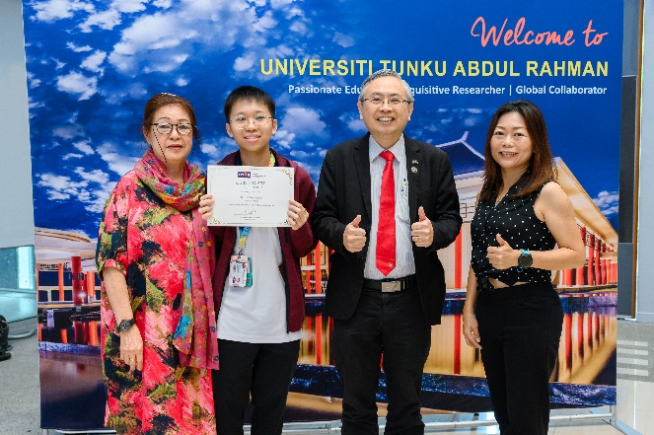 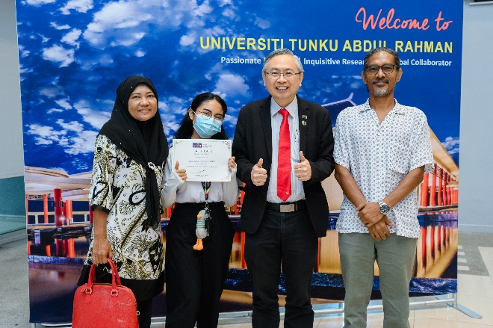

Scholarship recipients and parents with Prof Dato’ Ewe

Gratitude and congratulatory video messages from the scholarship recipients’ families and various UTAR deans and directors were also played at the ceremony. The ceremony ended with a group photo session.

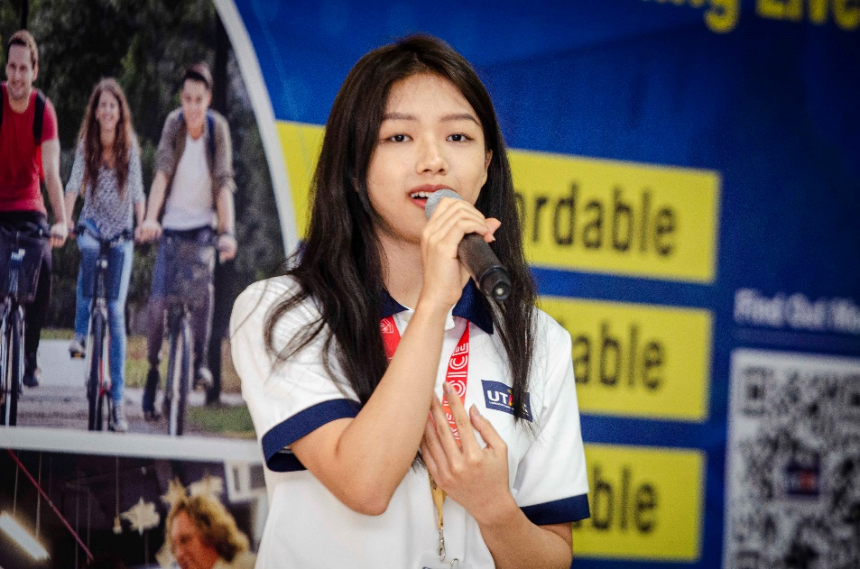

Song performance by UTAR Unified Examination Certificate (UEC) Scholarship recipient Kee Chian Yue

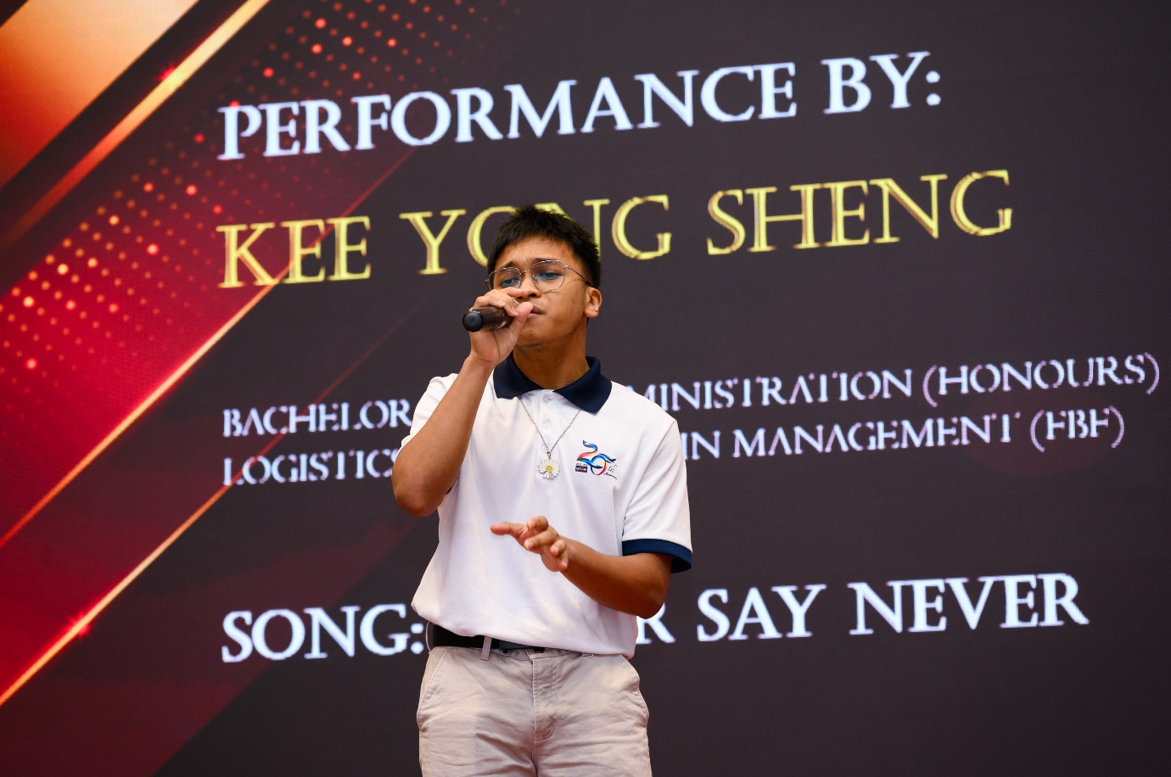

Song performance by Bachelor of Business Administration (Honours) in Logistics and Supply Chain Management student Kee Yong Sheng

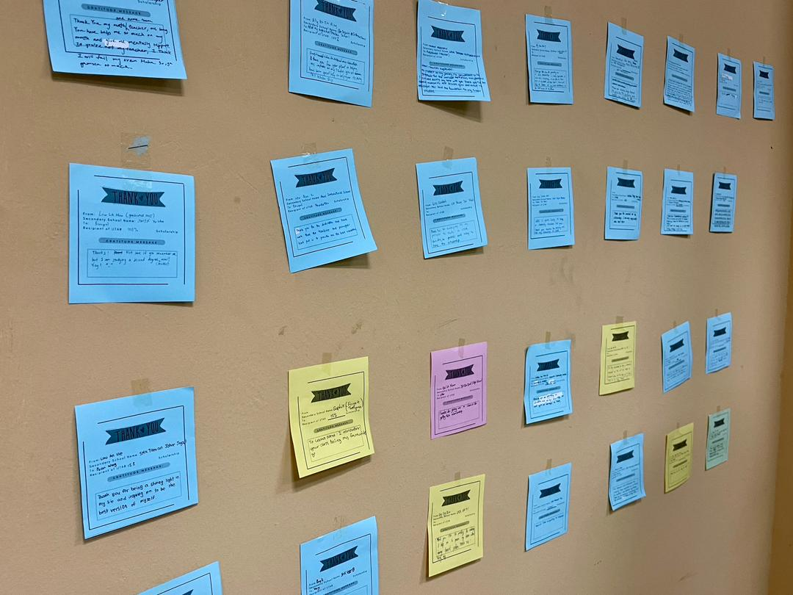 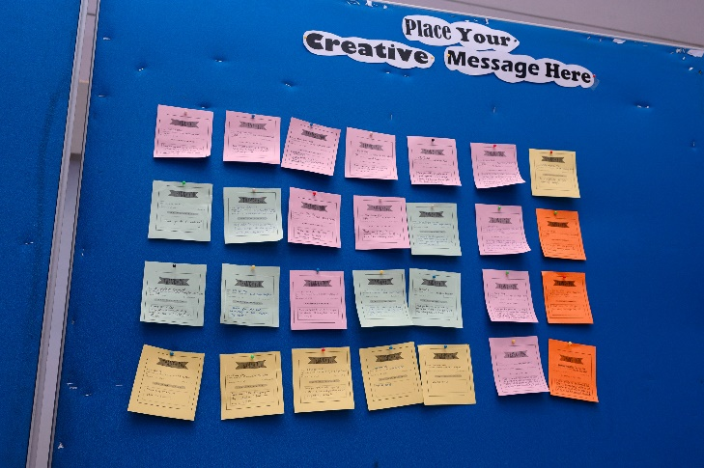

Gratitude messages from students