**UTAR PR students promote breast cancer screening awareness through “THE TALE OF PINK RIBBON” flash mob**

Fifty-three students from UTAR Bachelor of Communication (Honours) in Public Relations programme, came together to organise a flash mob event at the Kampar Ramadhan Bazaar on 20 March 2024.

Starting at 3:00PM and ending at 5:00PM, the flash mob served as the inaugural public engagement initiative of their Corporate Social Responsibility (CSR) project, titled “The Tale of Pink Ribbon.” The project aimed to raise awareness about breast cancer among the residents of Perak and advocate for early detection.

The project was conducted in collaboration with esteemed partners including the National Cancer Society Malaysia (NCSM), the National Cancer Council Malaysia (MAKNA), AEON Mall Kinta City, and Perak Transit.

As part of their engagement, the project’s organising members actively participated in the “Beg2Bekas” campaign organised by the Kampar District Council. During the event, the students showcased a vibrant and creative dance performance while also distributing a total of 1,000 packets of candied dates to the vendors at the bazaar. They were joined by local government officials, including YB Angeline Koo Haai Yen, a member of the legislative assembly for Keranji; Yang Dipertua Ahmad Suqairy, the Office Director of the Kampar District Council; Tuan Nazrul Fazami, the Kampar District Officer; and Mohamad Nazri, from the Kampar District Police Headquarters, in this effort.

Additionally, the students carried out street interviews at the bazaar to assess public awareness about breast cancer and attitudes toward early screening. Numerous interviewees emphasised the significance of early breast cancer screening as a means to prevent and save lives. However, a notable portion of male interviewees revealed a misconception, believing that only females require breast cancer screening, attributing this belief to the lower incidence rate among males.

The organising members took the opportunity during the interviews to educate the public about the importance of breast cancer screening, thus enhancing their awareness and garnering strong support from them. At the end of the interviews, all participants expressed willingness to join the organising members in shouting the project’s slogan "Get Screened Today!” to advocate for early breast cancer detection.

Ms Diong Fong Wei, the project’s advisor and lecturer from the Department of Public Relations at the Faculty of Arts and Social Sciences in UTAR Kampar Campus, emphasised that these collaborative endeavours not only serve the university’s interests but also significantly contribute to raising public awareness about breast cancer. Such initiatives provide invaluable experience for public relations students, enhancing their skill set and understanding of real-world applications.

“The Tale of Pink Ribbon” constitutes Group 1’s initiative within the UTAR Public Relations Corporate Social Responsibility (PR CSR) Project 2024, under the guidance of Ms Diong, the project advisor. Comprising 53 PR students, this project collaborates with the National Cancer Society Malaysia (NCSM), Majlis Kanser Nasional (MAKNA), AEON Mall Kinta City, and Perak Transit Bhd. Its primary objective is to tackle the challenges faced by individuals affected by breast cancer in Perak and advocate for early detection. Additionally, the overall project is aligned with the Sustainable Development Goal – SDG3 focusing on health and well-being.

In addition to the flash mob, the group will also be launching three major events in April, namely “The Tale of Pink Ribbon Exhibition”, “The Battlefield Sports Event”, and “Beat the Drums Music Festival”. The first major event of the project, “The Tale of Pink Ribbon Exhibition”, will be held from 5 to 7 April 2024 at AEON Mall Kinta City, Ipoh. “The Battlefield Sports Event” will take place on 20 April 2024, Saturday, at the Sports Complex of UTAR Kampar Campus. Lastly, the final event under this project is the “Beat the Drums Music Festival”, scheduled for 27 April 2024, Saturday, at the exhibition hall of the Kampar Putra Sentral, Kampar. The organising team invites the public to actively participate in these three events and make a lasting impact on the community.

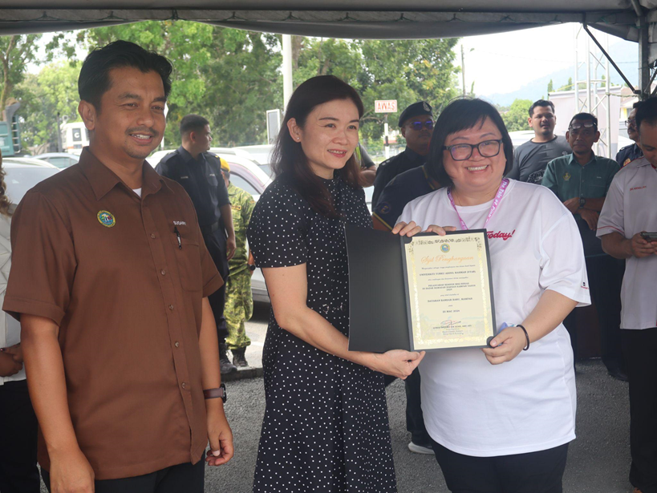

Presenting a commemorative certificate

From left: Office Director of the Kampar District Council, Yang Dipertua Ahmad Suqairy; a member of the legislative assembly for Keranji, YB Angeline Koo; the project’s advisor Ms Diong

Following their performance, the organising members of “The Tale of Pink Ribbon” gathered for a group photo alongside distinguished guests. Positioned as the first from the left in the second row is the project’s mascot.

The organising members of “The Tale of Pink Ribbon” with the Kampar District Council at “Beg2Bekas” event in Ramadhan Bazaar, Kampar

The Programme Department member of “The Tale of Pink Ribbon”, Yap Jiun Wei distributing candied dates to vendors

Committee members who conducted street interviews at the bazaar