**Vice President delivers keynote speech at Third Guilin Development Forum in China**

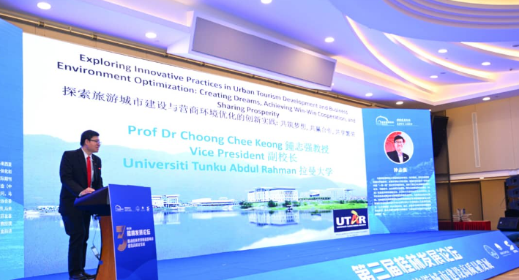

Prof Choong delivering a keynote speech at the Third Guilin Development Forum

UTAR Vice President for Student Development and Alumni Relations Prof Dr Choong Chee Keong was invited to present a keynote speech at the Third Guilin Development Forum (第三届桂林发展论坛) in Guilin, China on 22 March 2023.

The title of his keynote speech was “Exploring Innovative Practices in Urban Tourism Development and Business Environment Optimisation: Creating Dreams, Achieving Win-Win Cooperation, and Sharing Prosperity” (探索旅游城市建设与营商环境优化的创新实践: 共筑梦想, 共赢合作, 共享繁荣).

Themed ‘*Promote the high-quality development of Guilin as a world-class tourism city’*（推动桂林世界级旅游城市建设高质量发展, the forum was organised by Guangxi Normal University, Guilin Municipal Development and Reform Commission, Guilin Tourism Corporation Limited, Guilin Development Research Institute and Guilin Promotion Centre for Building a World-Class Tourism City. It was supervised by the Guilin Municipal People’s Government.

In his keynote speech, Prof. Choong offered a concise overview of his transnational project, titled "Smart, Optimized, High-quality, and On-demand Tourism Innovative Education for Sustainable and Green Development." This initiative engages research partners from Romania, Italy, France, Vietnam, Malaysia, and Bangladesh, with approximately RM4 million in funding. The project is centered on the utilization and advancement of smart technologies, renewable energy sources, and digital innovations, with particular emphasis on smart sustainable tourism. Prof. Choong cited Vietnam and Malaysia as exemplary cases of smart tourism, emphasizing the utilization and advancement of smart technologies, renewable energy sources, and digital innovations, particularly in the context of smart sustainable tourism.

He elaborated, "The current status of smart sustainable tourism in Vietnam and Malaysia is in the developmental phase, with each nation exhibiting varying degrees of adoption and implementation of smart sustainable tourism technologies and methodologies." Despite substantial investment in smart sustainable tourism initiatives and technologies aimed at enhancing visitor experiences and bolstering industry competitiveness, both Malaysia and Vietnam still grapple with limited adoption and exploitation of smart sustainable tourism technologies and practices, primarily due to deficiencies in educational backgrounds and knowledge pertaining to smart technologies.

He elaborated, "A study conducted by the Malaysia Digital Economy Corporation (MDEC) in 2020 revealed that although numerous tourism enterprises in Malaysia have embraced digital technologies for marketing and sales purposes, there remains a notable gap in the adoption of digital technologies for customer service and operational management. Consequently, the National Tourism Policy (NTP) 2020-2030, inaugurated by the Ministry of Tourism, Arts and Culture Malaysia in 2020, seeks to formulate and execute a comprehensive tourism development strategy integrating technology and digital platforms. The overarching goal is to enhance visitor experiences and bolster the competitiveness of the tourism industry."

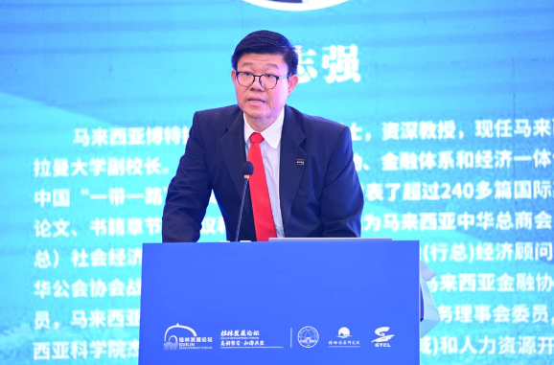

Prof Choong highlighting smart sustainable tourism

He stressed, “Sustainability and smart technologies are increasingly pivotal in reshaping the tourism industry. Through meticulous research and collaboration, we have identified key areas for innovation in urban tourism development and business environment optimisation.”

Next, he shared the focus areas of sustainability and application of smart technologies which included smart technology integration; optimised curriculum design; establishment of the Learning Management System (LMS); cooperation and partnerships; governance, declarations of the knowledge, and centre of excellence to provide a deeper understanding to the audience on sustainability and smart technologies in tourism industry. These initiatives aim to offer the audience a comprehensive understanding of sustainability and smart technologies in the tourism industry.

“Our initiative is profoundly committed to sustainability and green development principles, advocating for responsible tourism practices that minimise environmental impact, safeguard cultural heritage, and promote social equity. By synergising the collective expertise and resources of international partnership, we aspire to cultivate a new generation who are not only adept in their field but also conscious global citizens dedicated to fostering sustainable and inclusive growth for achieving win-win cooperation and sharing prosperity,” he concluded.

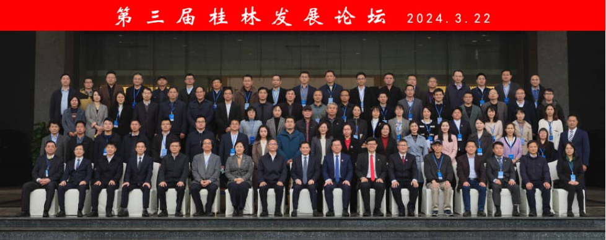

Prof Choong (front row, seventh from right) with the guests of the forum

At the Third Guilin Development Forum, five keynote addresses were delivered alongside a roundtable discussion involving experts and scholars from both China and abroad. The discussions centred on various aspects of tourism development. Additionally, the event featured the official launch of the “Guilin Economic and Social Development Report (2022-2023): Building Guilin into a World-Class Tourism City” blue book.