Cultivating excellence through UTAR Soft Skills Festival 2024
More than 200 UTAR staff and students gathered on 3 April 2024, as the curtains rose to reveal the highly awaited UTAR Soft Skills Festival 2024, hosted at the Multipurpose Hall of the Heritage Building, UTAR Kampar Campus.
A collaborative effort between the Department of Soft Skills Competency (DSSC), the Student Committee of Soft Skills Festival 2024, and the MPU students of Jan 2024 Trimester, the UTAR Soft Skills Festival 2024 aimed to illuminate the significance of soft skills and provide individuals with the opportunity to refine and strengthen these skills through an array of workshops, talks, keynote speeches, and engaging activities.
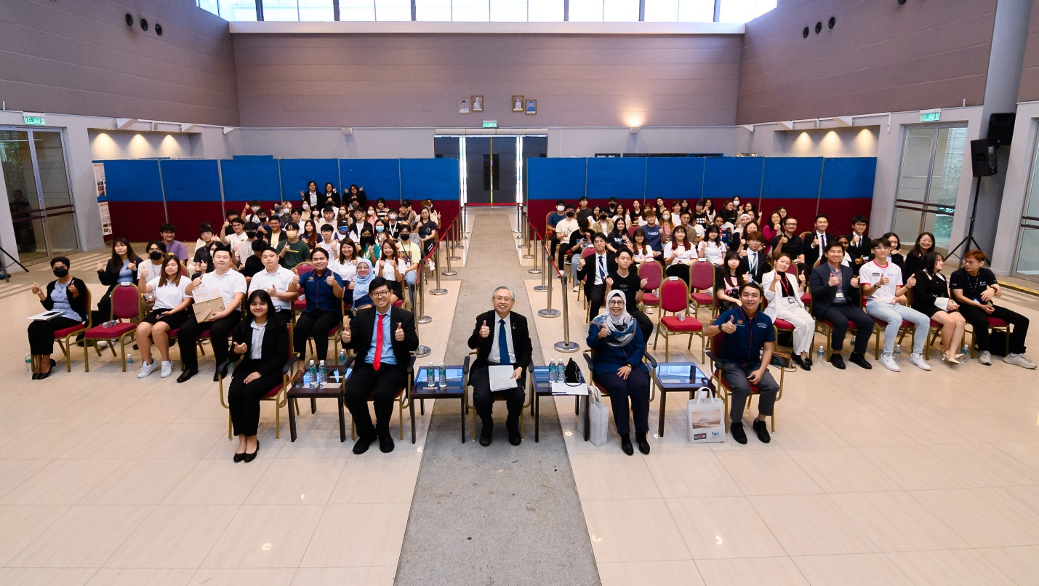
Front row, from left: Ms Yeoh, Prof Choong, Prof Dato’ Ewe, Puan Nor Asmahan and En Hasyimi with student participants at the opening ceremony
Present at the opening ceremony were UTAR President Ir Prof Dato’ Dr Ewe Hong Tat; Esteemed Keynote Speaker and Head of Industry Partnership Department, TalentCorp Malaysia Puan Nor Asmahan Othman, UTAR Vice President for Student Development and Alumni Relations Prof Dr Choong Chee Keong, Senior Executive of Industry Partnership, TalentCorp Malaysia Cik Azura Ahmad, Lead of Campus Engagement and Mobility, TalentCorp Malaysia En Ardi Gunsuh, Senior Executive of Campus Engagement and Mobility, TalentCorp Malaysia En Muhammad Hasyimi Hasyim Mohd Suddin, Student Chairperson of Soft Skills Festival 2024 Charissa Yeoh, student representatives of MPU co-curriculum subject, as well as UTAR students and staff.
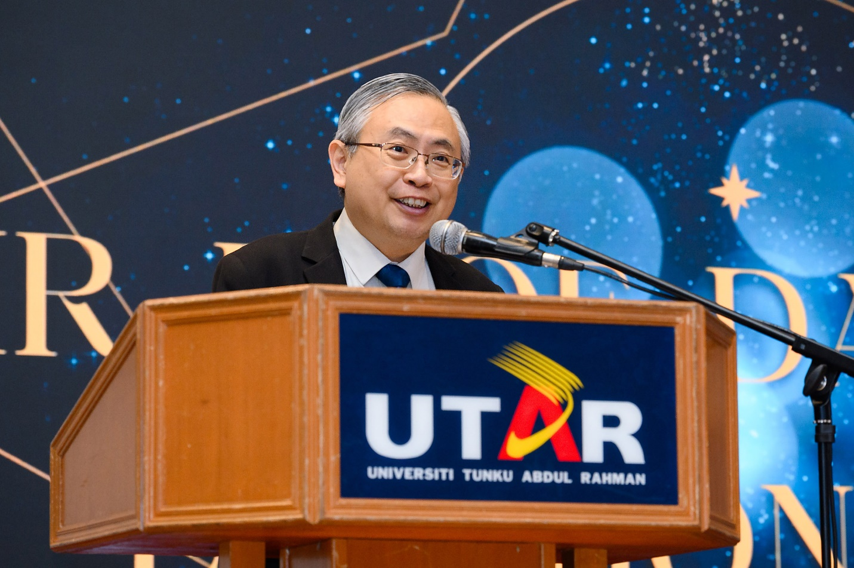
Prof Dato’ Ewe highlighting UTAR’s dedication to fostering students’ soft skills
In his opening speech, Prof Dato’ Ewe said, “At UTAR, we firmly believe in equipping our students with not just academic prowess, but also the essential soft skills vital for success in today’s dynamic workplace. Our soft skills festival stands as a testament to this commitment, offering a platform where students can not only showcase their talents but also engage with industry experts, fostering connections and gaining invaluable insights.”
He continued, “Through initiatives like the UTAR Soft Skills Development Certificate, we empower our students to become adaptable, flexible, and resilient individuals, ready to thrive in any professional environment. We envision a holistic education that nurtures not just intellect but also character, ensuring our graduates are well-prepared to make meaningful contributions to both the workplace and society.”
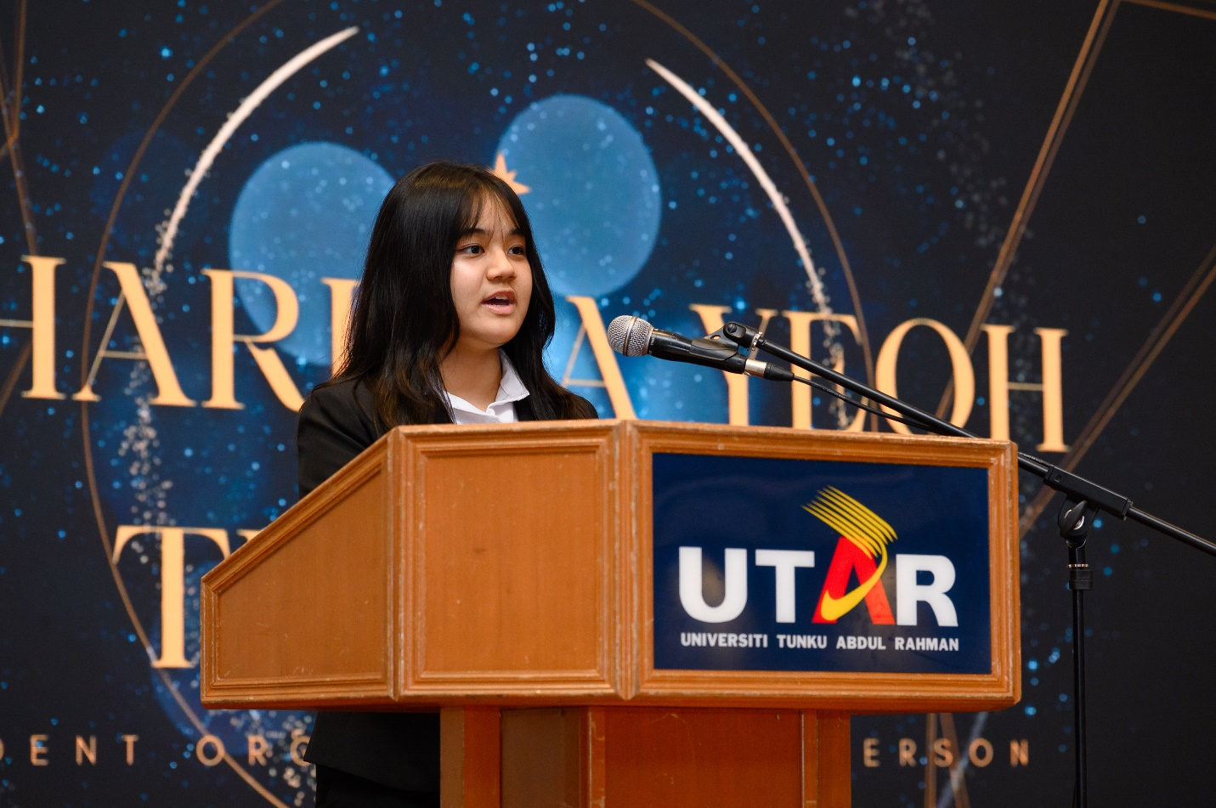
Yeoh expressing her gratitude to UTAR for offering a platform for students to cultivate soft skills
Adding to that, Yeoh, the Chairperson of the Soft Skills Festival 2024, said, “I am deeply grateful to UTAR and DSSC for their unwavering support in providing us with the platform to host this extraordinary event. Prof Dato’ Ewe and Prof Choong, your presence and encouragement mean the world to us. I extend a heartfelt welcome to TalentCorp, whose expertise enriches our event immensely. To our sponsors, your continuous support and belief in our vision are truly appreciated.”
She concluded, “As we embark on this journey of growth and learning together, I urge all participants to actively engage with our speakers and activities, seizing the invaluable opportunities before us. Let us not only absorb the knowledge shared here today but also carry forward the spirit of collaboration and growth into our everyday lives.”
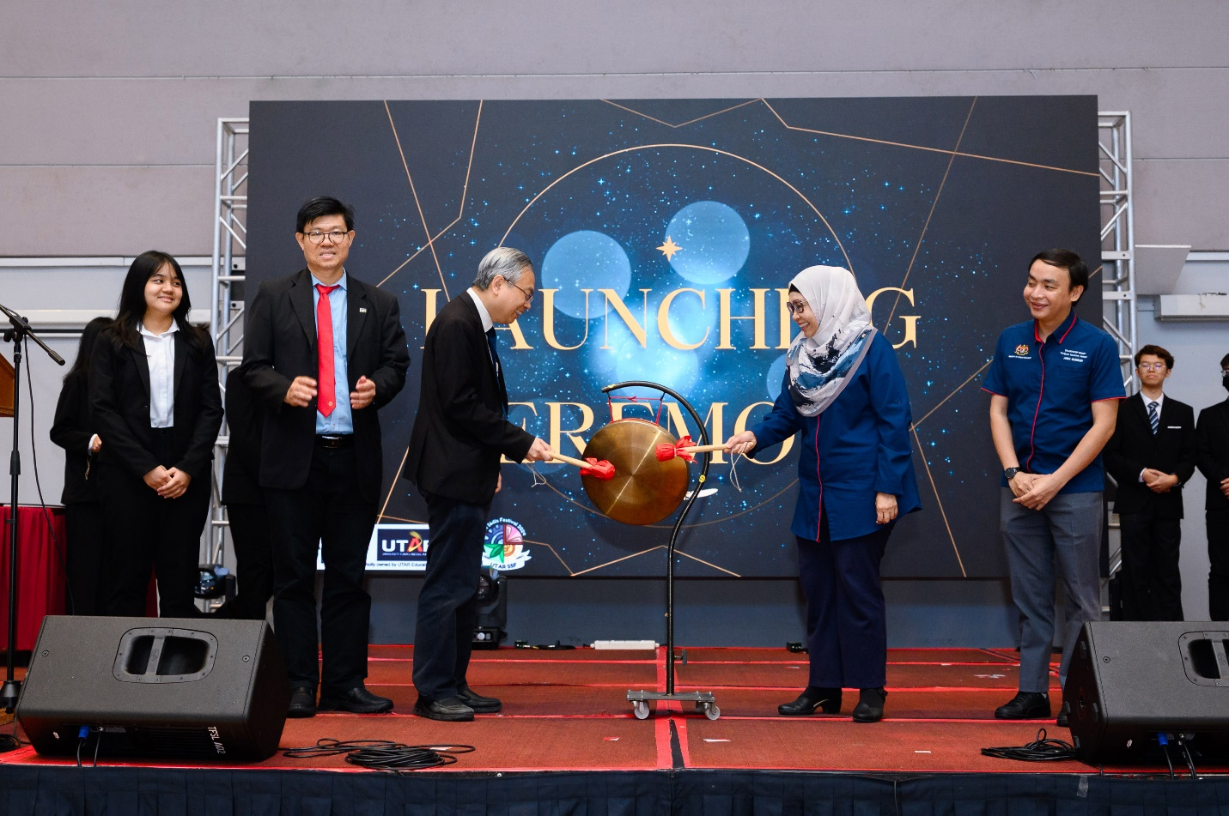
From left: Yeoh, Prof Choong, Prof Dato’ Ewe, Puan Asmahan and En Hasyimi during the gong strike, marking the inauguration of the UTAR Soft Skills Festival 2024
The UTAR Soft Skills Festival 2024 reached its highlight with the unveiling ceremony led by Prof Dato’ Ewe, Prof Choong, Puan Nor Asmahan, Mr Ardi, and Yeoh.
The ceremony also marked the launch of the DSSC Flagship Project, which consisted of annual projects organised by DSSC, during the event. These projects aimed to provide opportunities for UTAR students to enhance their soft skills. Among the projects are the Aquila Cup Badminton Tournament, River of Art concert, and U-Craft.
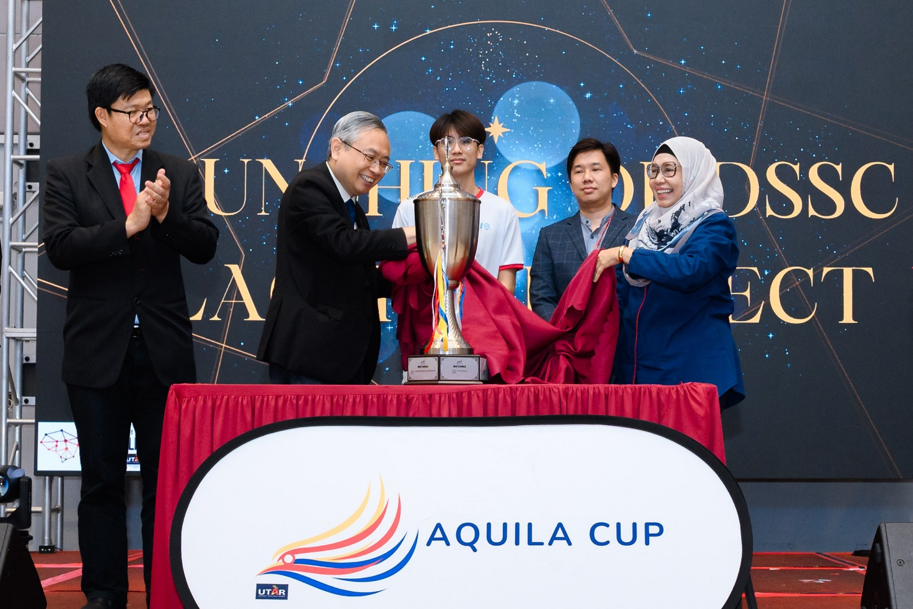
From left: Prof Choong, Prof Dato’ Ewe, Leong, Mr Fong and Puan Asmahan during the unveiling of the Aquila Cup
The event featured the presence of the advisors and chairpersons of each project on stage for the unveiling ceremony:
- Mr Fong Kah Hoong, the advisor for the Aquila Cup and DSSC Lecturer, and Joe Leong Yew Joo, the Chairperson.
- Ms Alison Yoon, the advisor for River of Art and DSSC Lecturer, and Jayden Ho Yong Jie, the Chairperson.
- Ms Mah Siew Huei, the advisor for U-Craft and DSSC Lecturer, and Sim Ji Wei, the Chairperson.

Signaling the start of an exciting journey ahead, the DSSC Flagship Project was officially launched with a resounding hit of the gong.
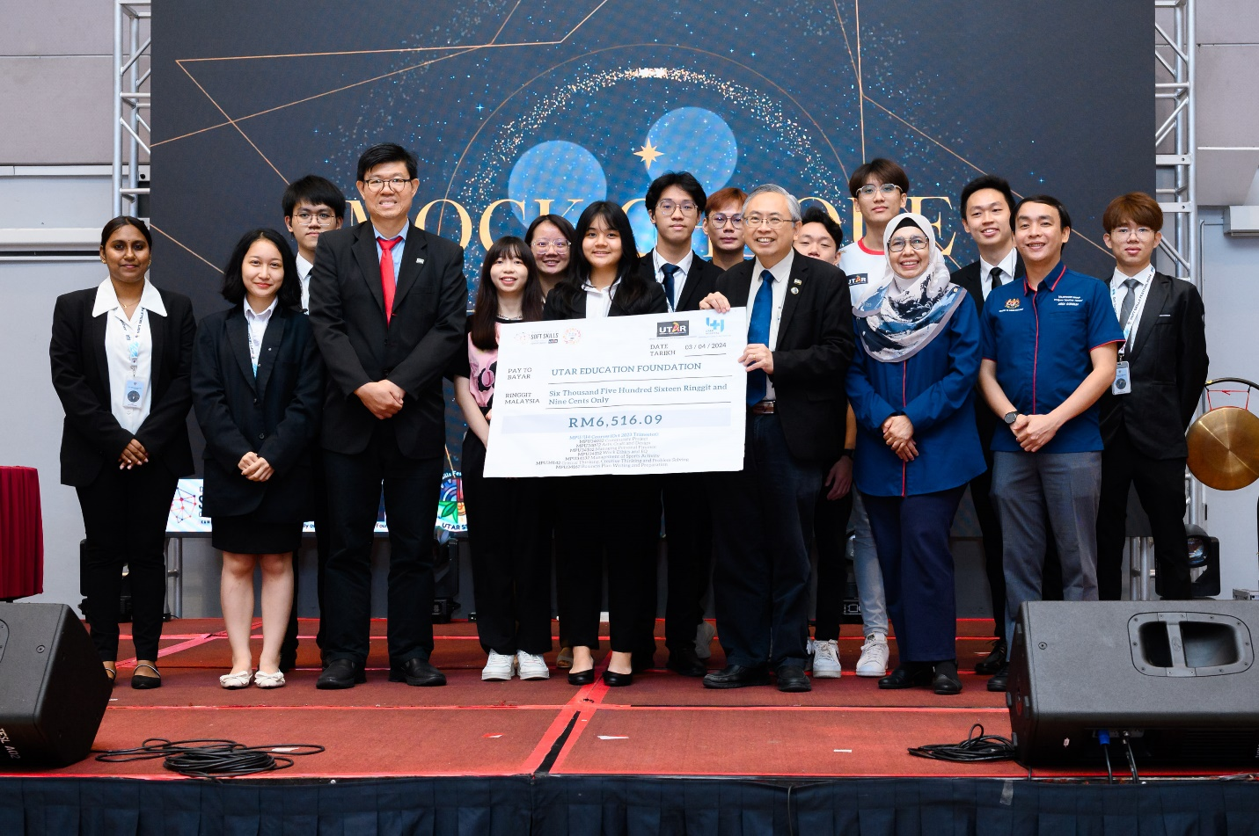

Students generously contributing to the UTAR Education Foundation

The event continued with a notable highlight as student representatives from the MPU programme of January 2024 Trimester took part in a mock cheque presentation. They presented a symbolic cheque to the UTAR Education Foundation, which was graciously accepted by Prof Dato’ Ewe in the presence of Talent Corp representatives. This donation marked the culmination of several student-led initiatives.
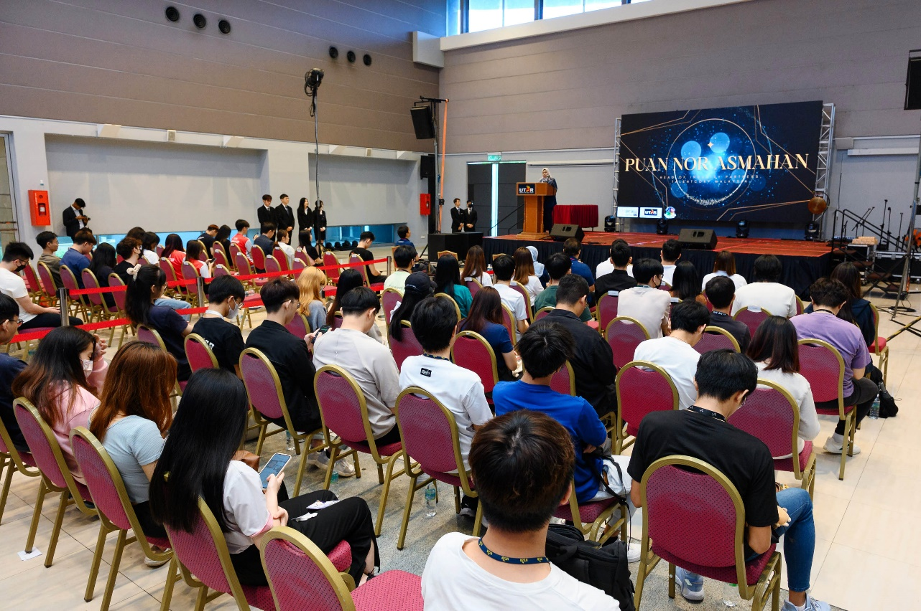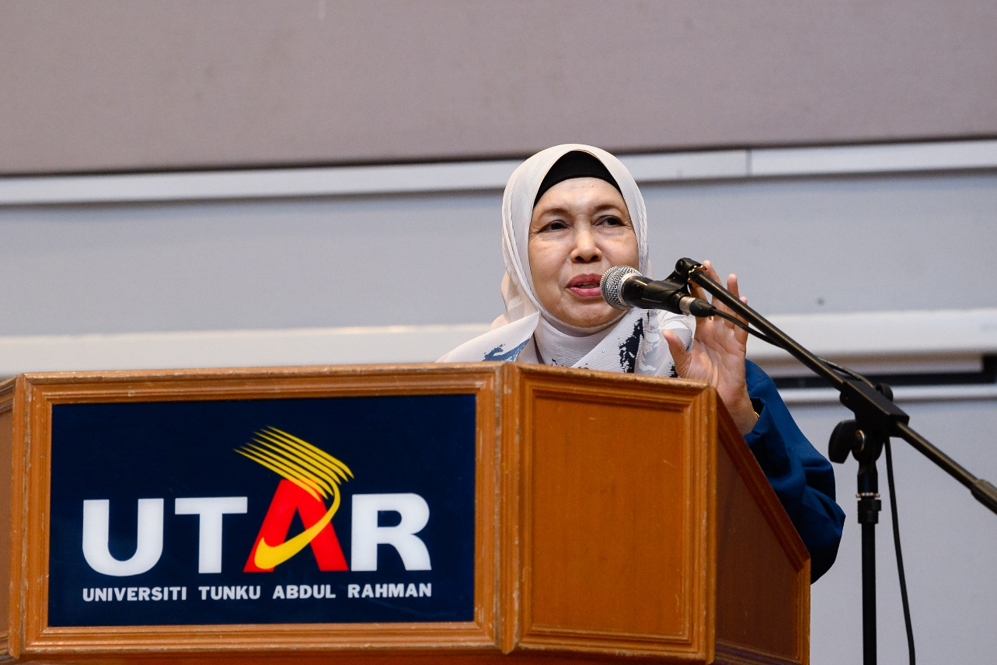

Puan Asmahan explaining the importance of soft skills in the AI era

The opening ceremony of the UTAR Soft Skills Festival 2024 featured a thought-provoking keynote speech by Puan Nor Asmahan Othman. Her address explored the significance of soft skills in the AI era, adding a layer of depth to the festival’s discourse.
The event wrapped up with the presentation of souvenirs, group photo sessions, and exciting lucky draw sessions, adding a festive flair to the event.
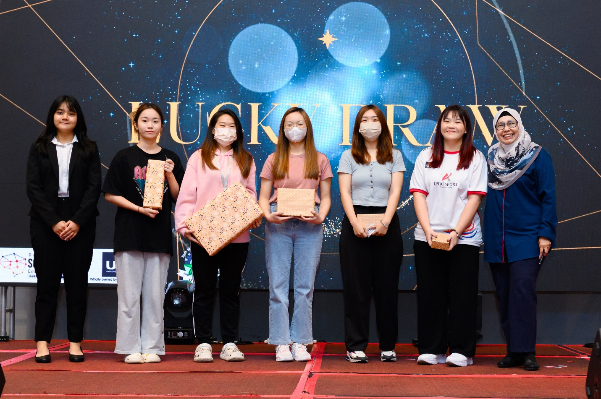
Lucky draw recipients posing with their prizes
Taking place from 1 April to 5 April 2024, the Soft Skills Festival 2024 featured a varied schedule encompassing webinars, workshops, sharing sessions, and hybrid courses, encapsulating the essence of holistic education and lifelong learning.

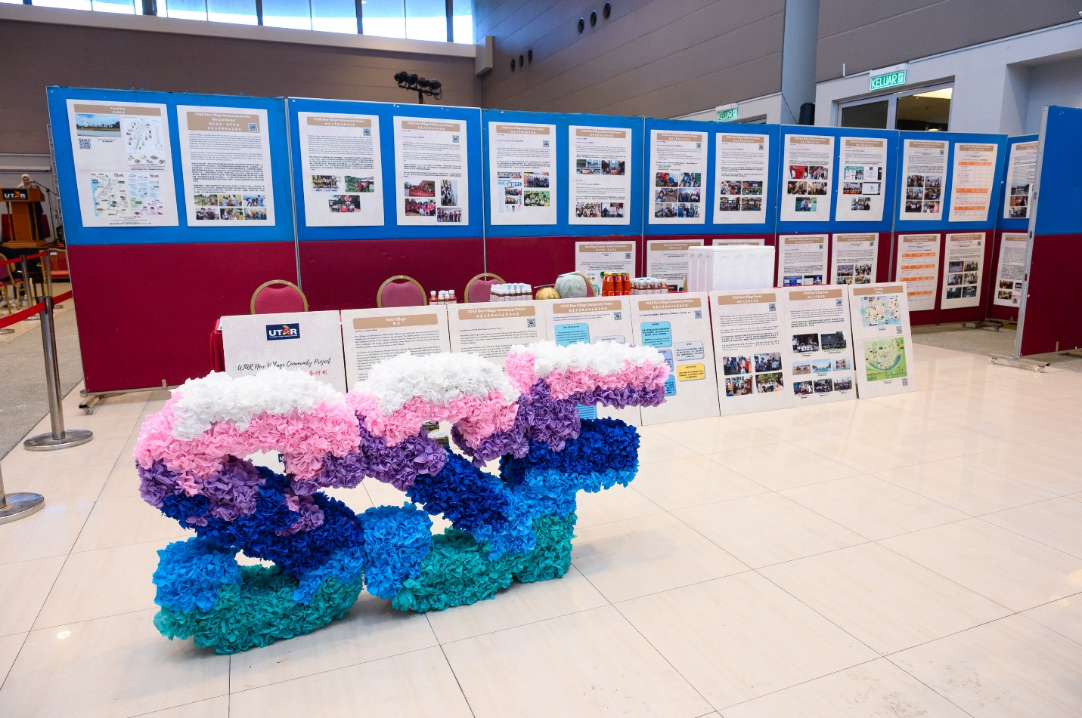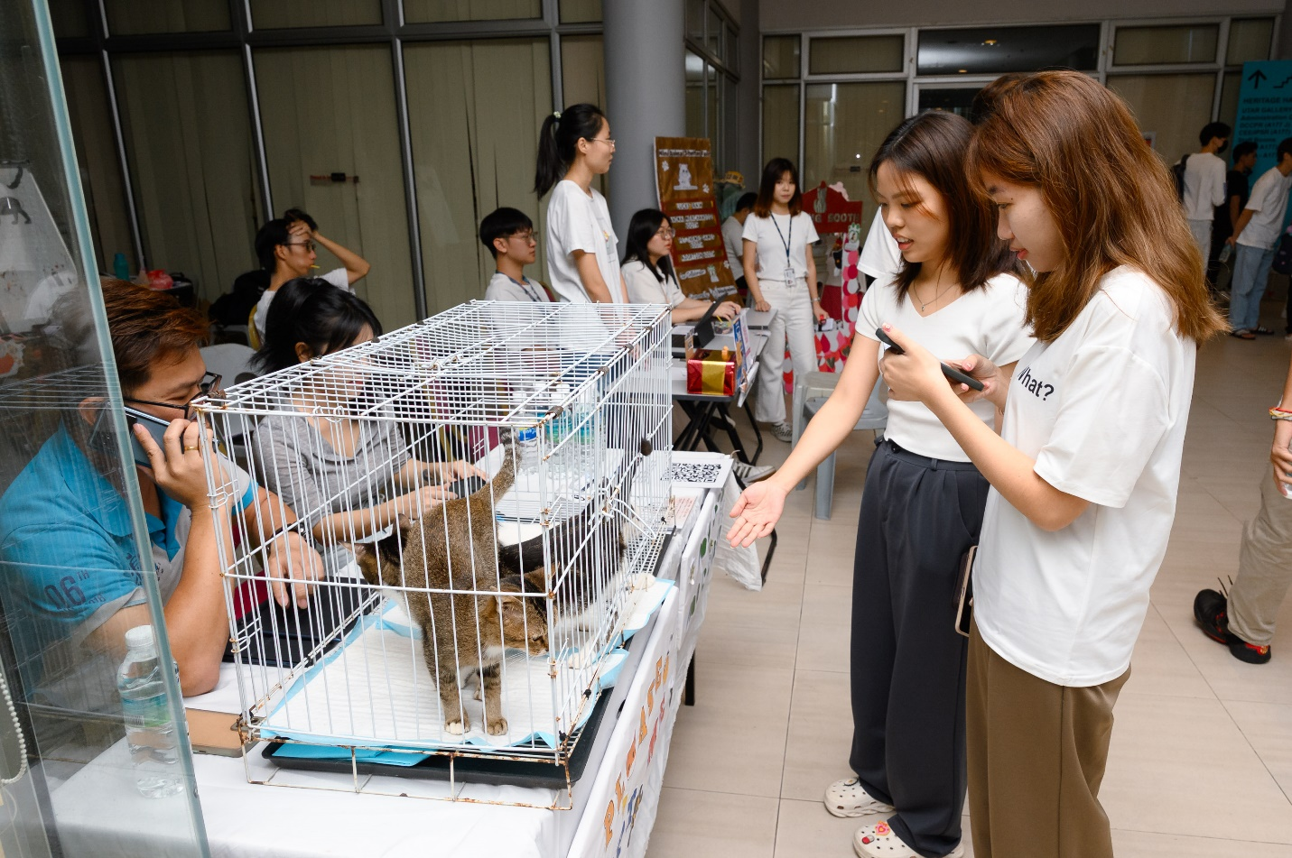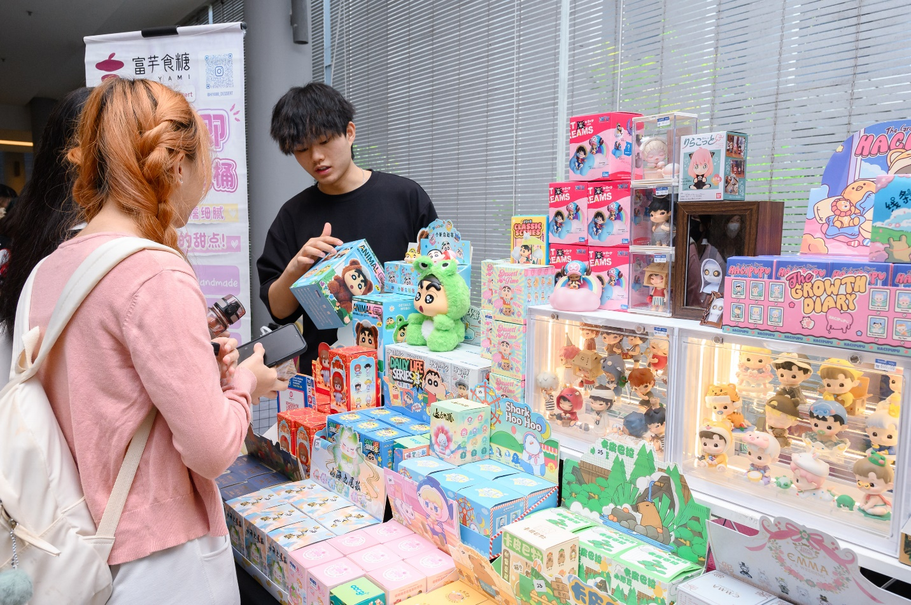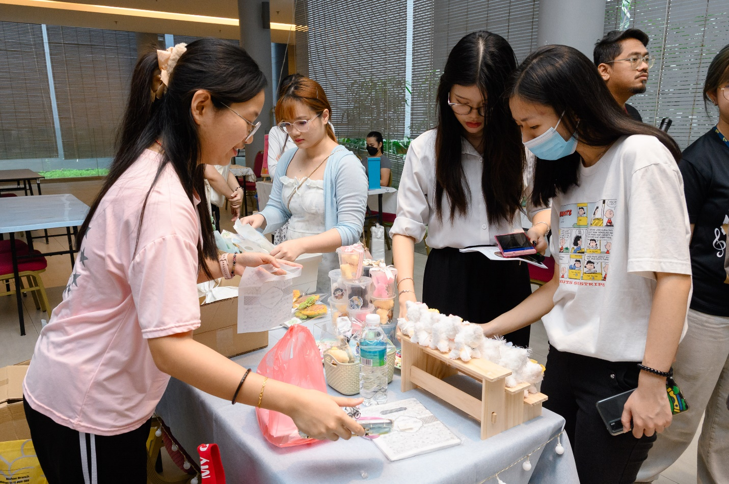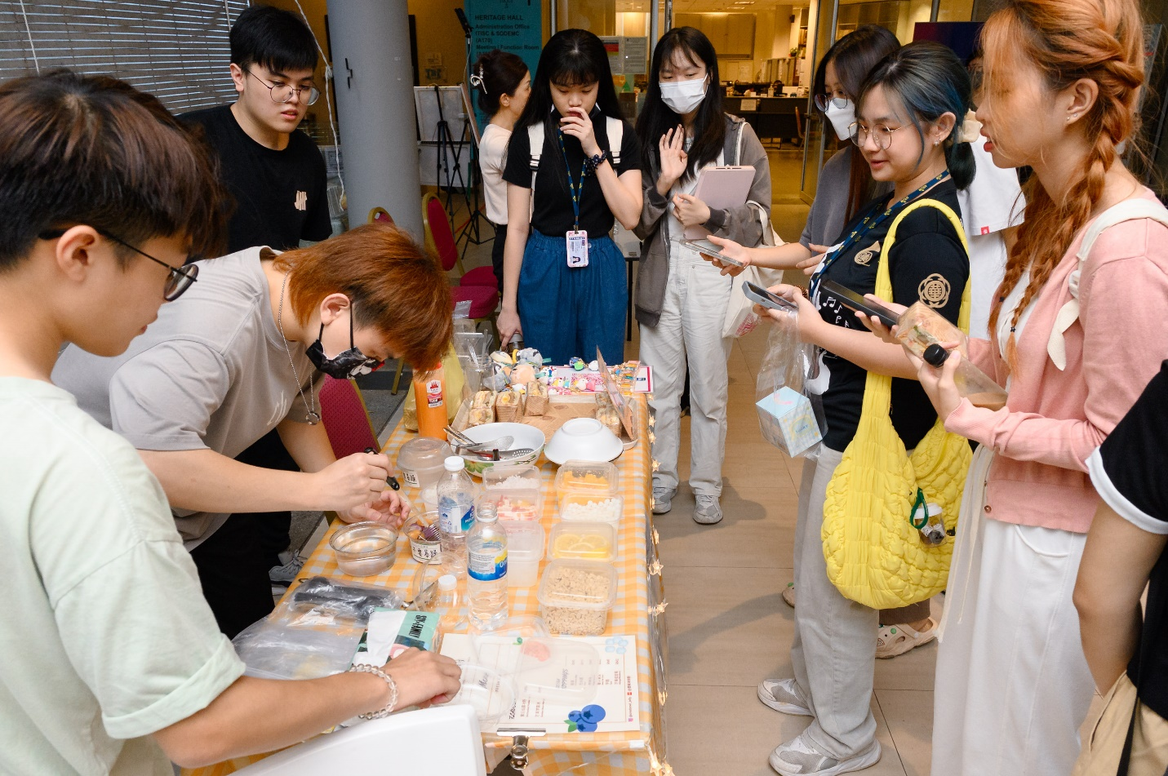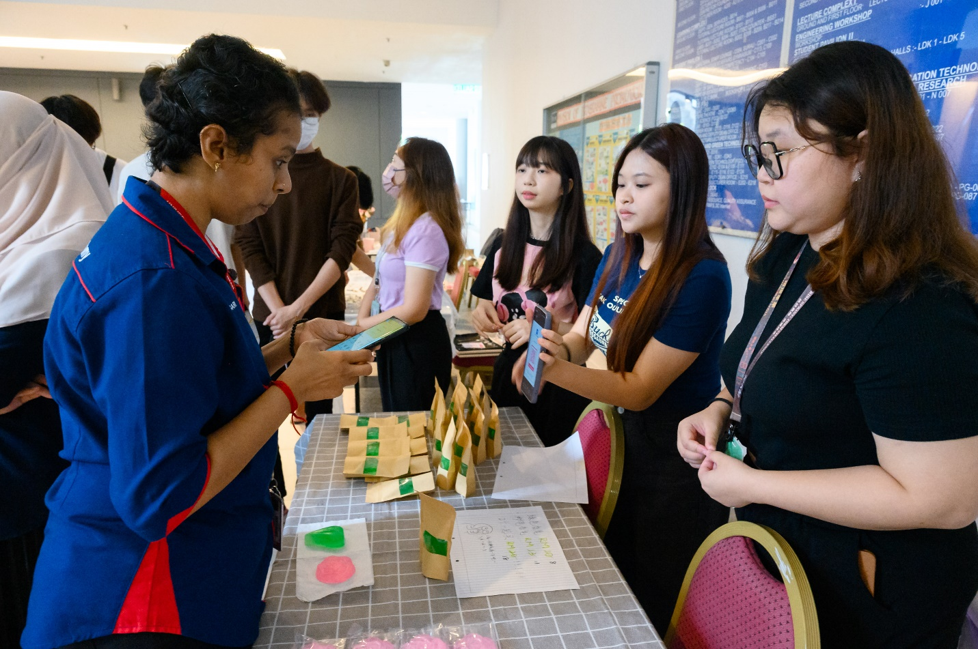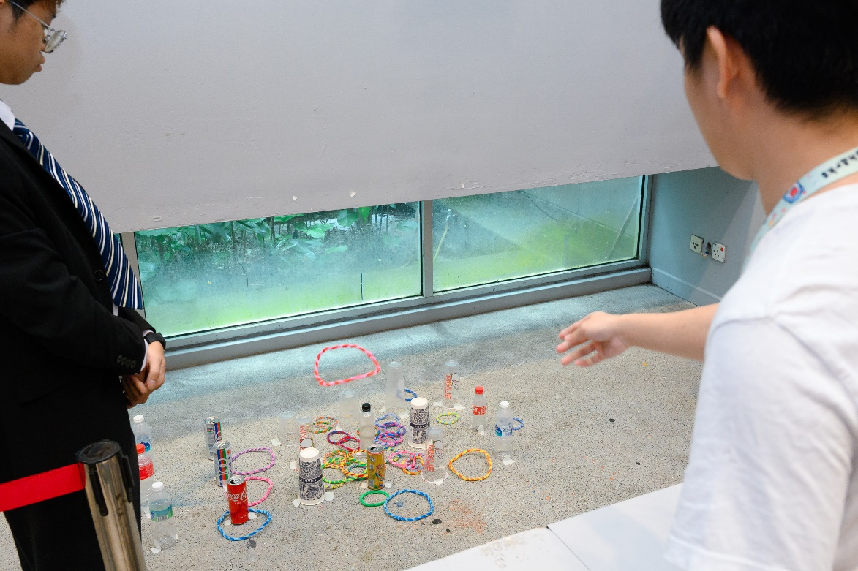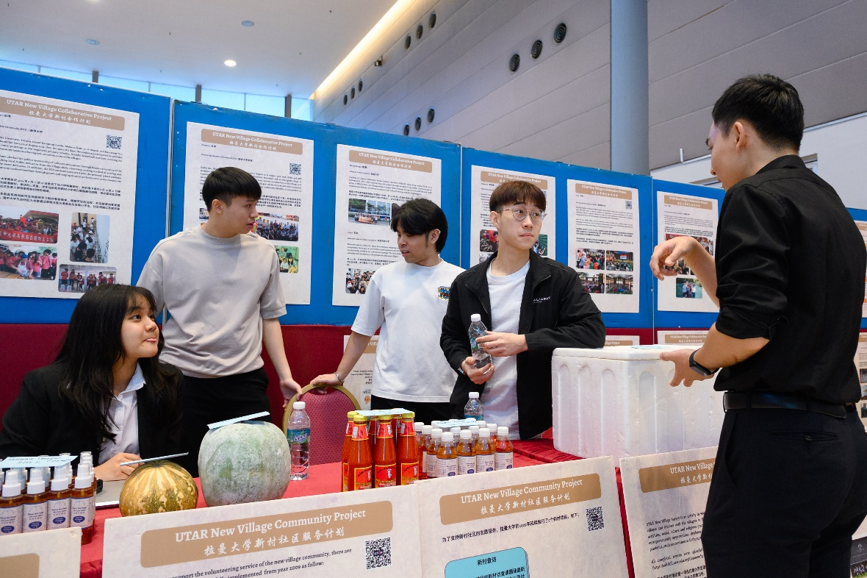
A diverse array of engaging events, activities, and booths showcased at UTAR Soft Skills Festival 2024

