**TCM calligraphy competition celebrates the art of mindful meditation**

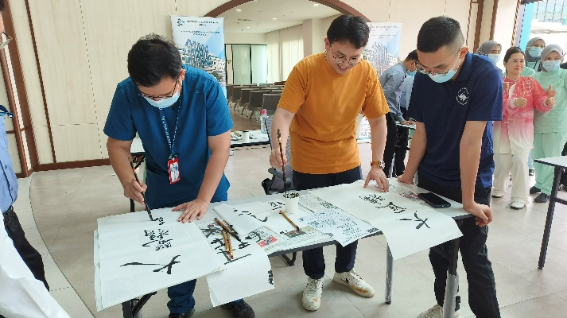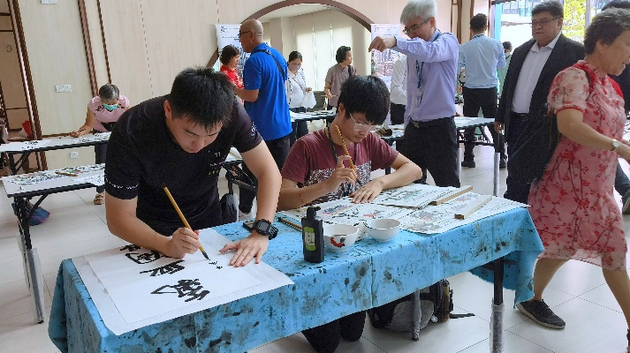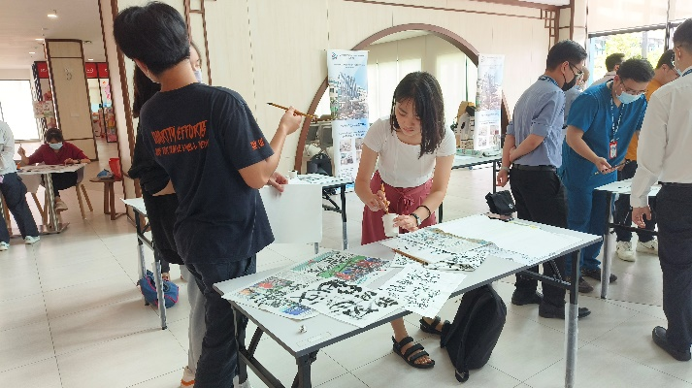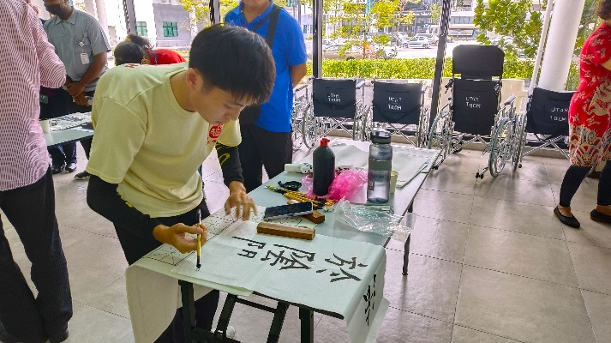

Participants working on their Chinese calligraphy arts in a gleeful and meticulous manner

Arts of brush strokes of black ink aplenty, in synergy with the medical philosophy of traditional Chinese medicine at UTAR Hospital. Commemorating the second anniversary of UTAR T&CM Centre as well as UN Chinese Day, the Traditional Chinese Medicine Calligraphy Competition was held on 16 April 2024 at UTAR Traditional and Complementary Medicine (T&CM) Centre.

The competition was a collaborative effort brought about by the UTAR T&CM Centre, UTAR Confucius Institute, UTAR Institute of Chinese Studies (ICS), and Beijing University of Chinese Medicine (BUCM), China.

Synergising the Chinese calligraphy’s art of meditation with traditional Chinese medicine’s philosophy of healing, the competition was met with works of artistry and enthusiasm from participants. Proficient and fresh calligraphers competed against one another, yet shared light-hearted moments as they learned new knowledge and discussed their passion in either the field of Chinese calligraphy or traditional Chinese medicine. Glides and strokes of brush repeated after one another, while the calligraphers of diverse calibres tried their best to communicate their styles through the works of art. Though myriad styles were presented by the hands of different calligraphers, the art of healing and meditation prevailed across the participants’ works nevertheless.

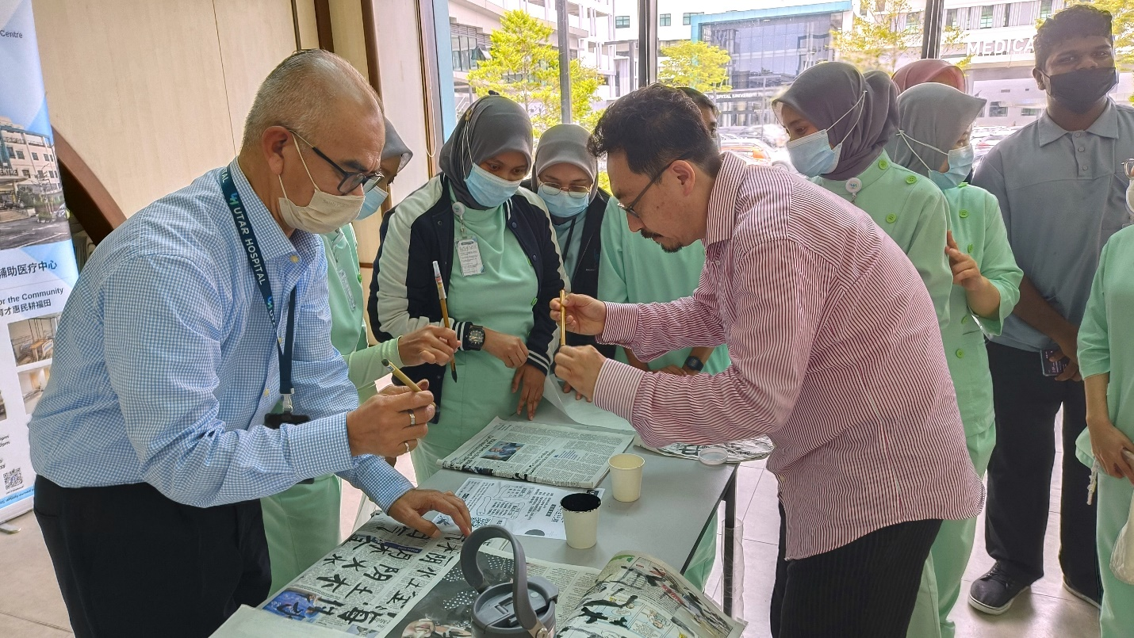

Prof Wang Lepeng (right) explaining the fundamentals of Chinese calligraphy to UTAR Hospital staff

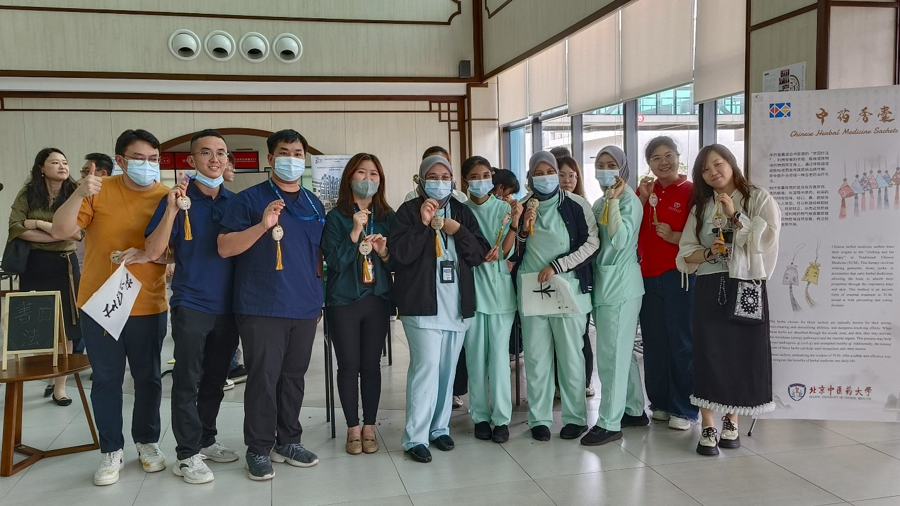

The participants from various cultural backgrounds sharing a group photography session

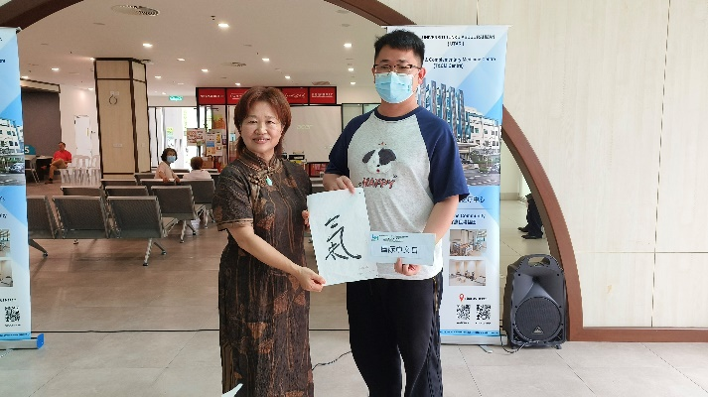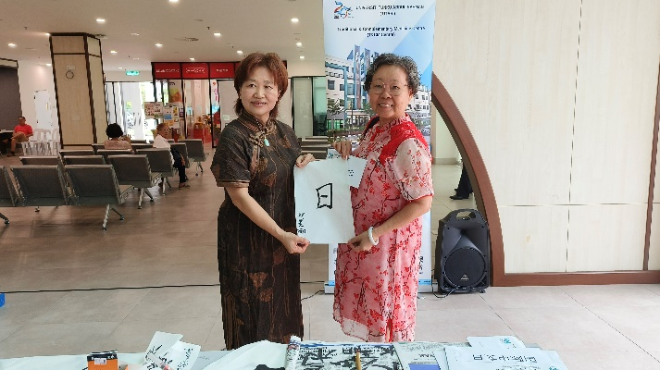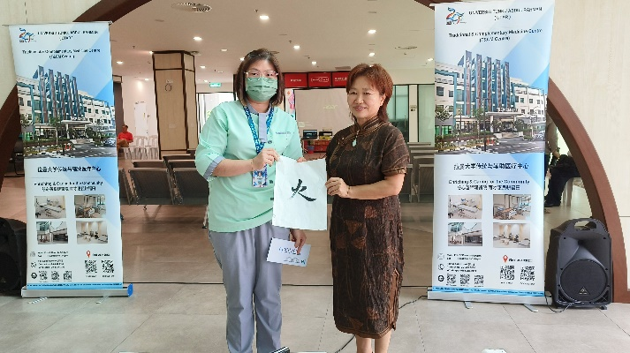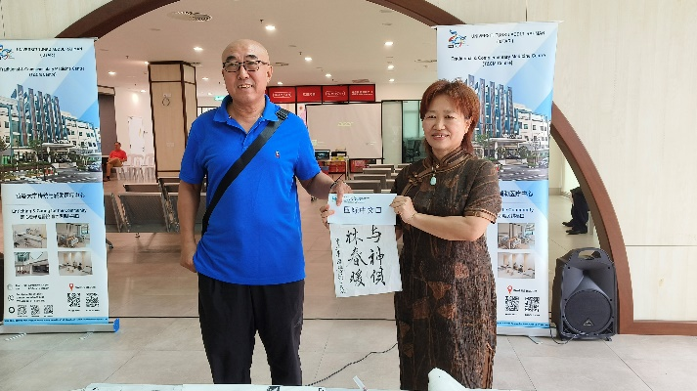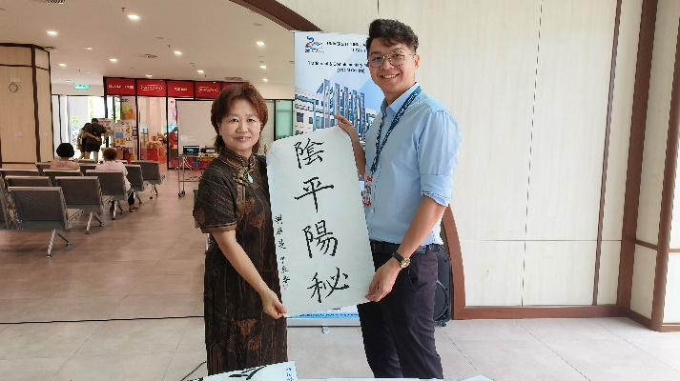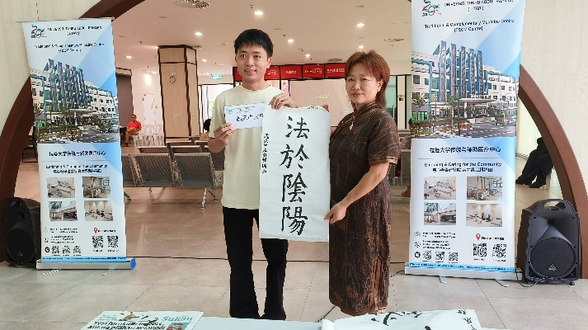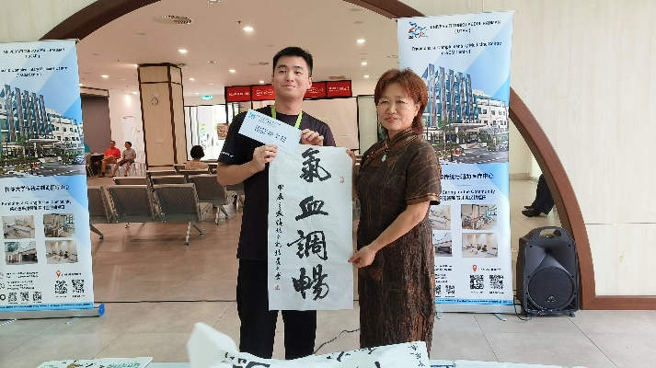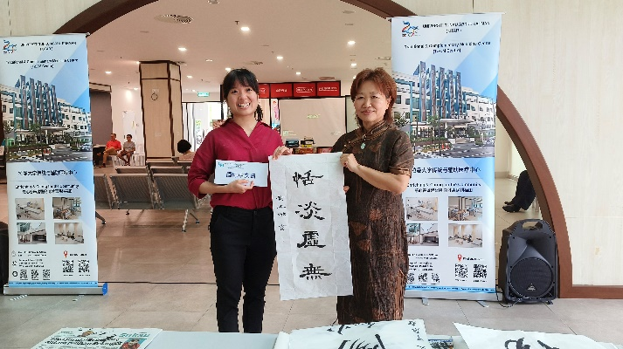

Prof Ma presenting prizes to the winners during the prize-giving ceremony

Besides the competition, the Centre also featured herbal exhibitions, a *Ba Duan Jin* (八段锦) exhibition performance, and talks about traditional Chinese medicine on the same day, showcasing some of the marvels and rich history of the medical field to the visitors. The talks included “Innovative application of moxibustion therapy” by BUCM School of Acupuncture, Moxibustion and Tuina Prof Zhao Baixiao, and “Improving clinical diagnosis and treatment effect of traditional Chinese medicine with the theory of Five Circuits and Six Qi (五运六气)” by BUCM School of Humanities Assoc Prof Wang Lepeng.

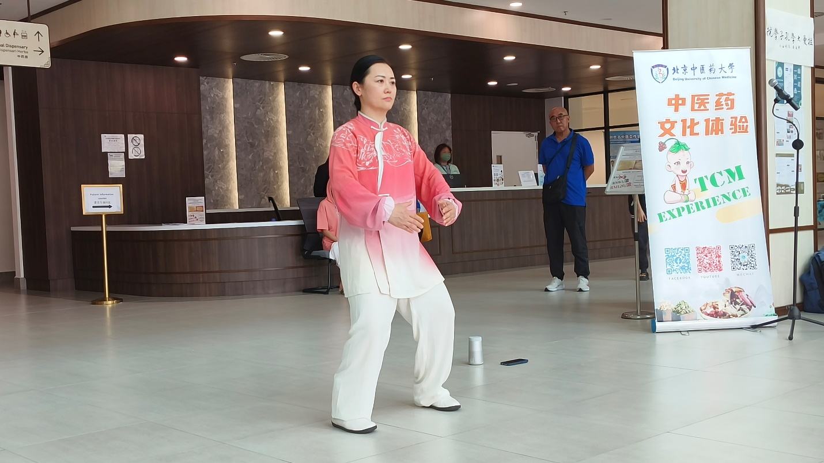

*Ba Duan Jin* performance by Assoc Prof Hu

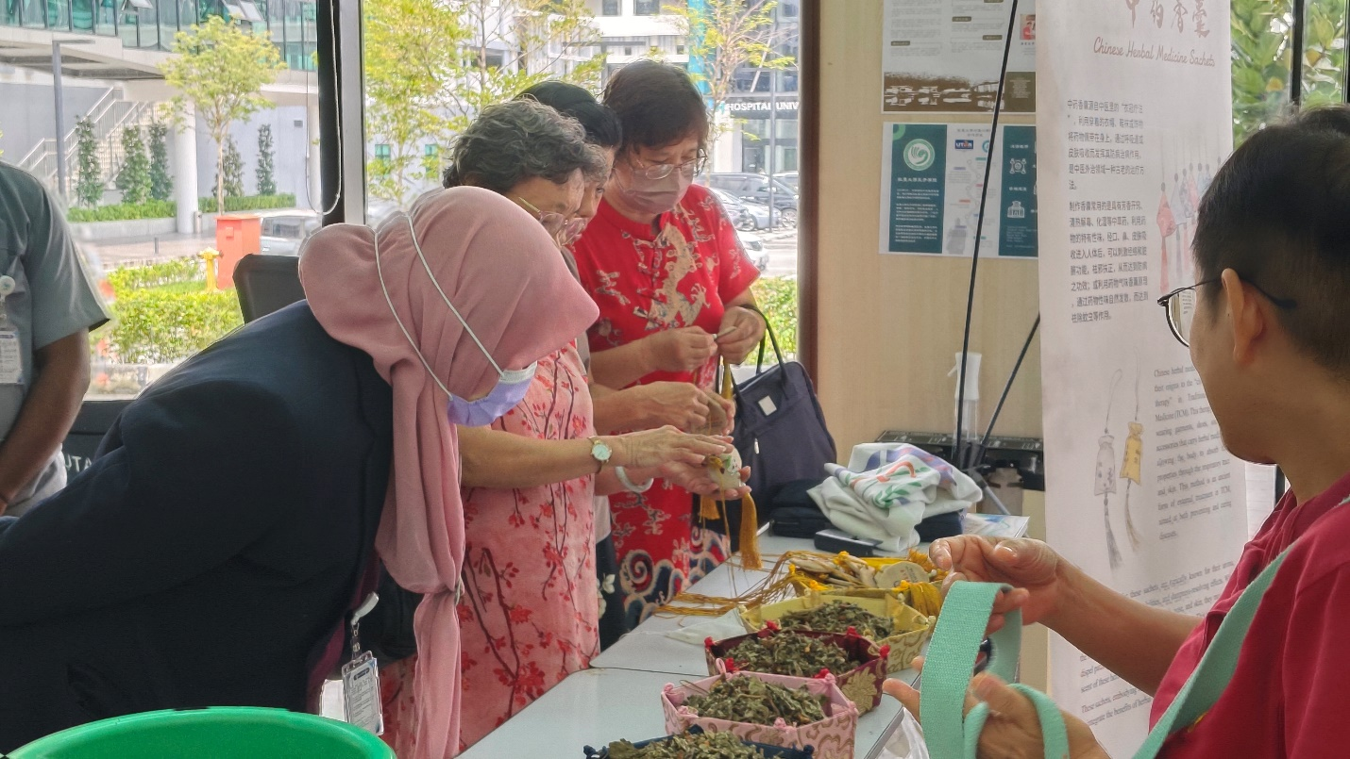

Visitors examining the herbs at the herbal exhibition booth

Also present at the competition were BUCM Chinese Medicine Culture Centre Deputy Director Ms Wang Shan Shan, BUCM Chinese Medicine Culture Centre staff Ms Wang Yinluo, BUCM Physical Teaching Department Assoc Prof Hu Yanbin, BUCM ASEAN Traditional Chinese Medicine Talent Training and Exchange Programme Project Facilitator Prof Zhang Wenkai, UTAR Hospital CEO Prof Dr Lau Hui-Ping, UTAR T&CM Centre Director Assoc Prof Dr Te Kian Keong, UTAR Vice President for Student Development and Alumni Relations Prof Dr Choong Chee Keong, UTAR Confucius Institute Director Prof Dr Ma Yingxin, BUCM staff and students; UTAR Hospital staff, and UTAR students.

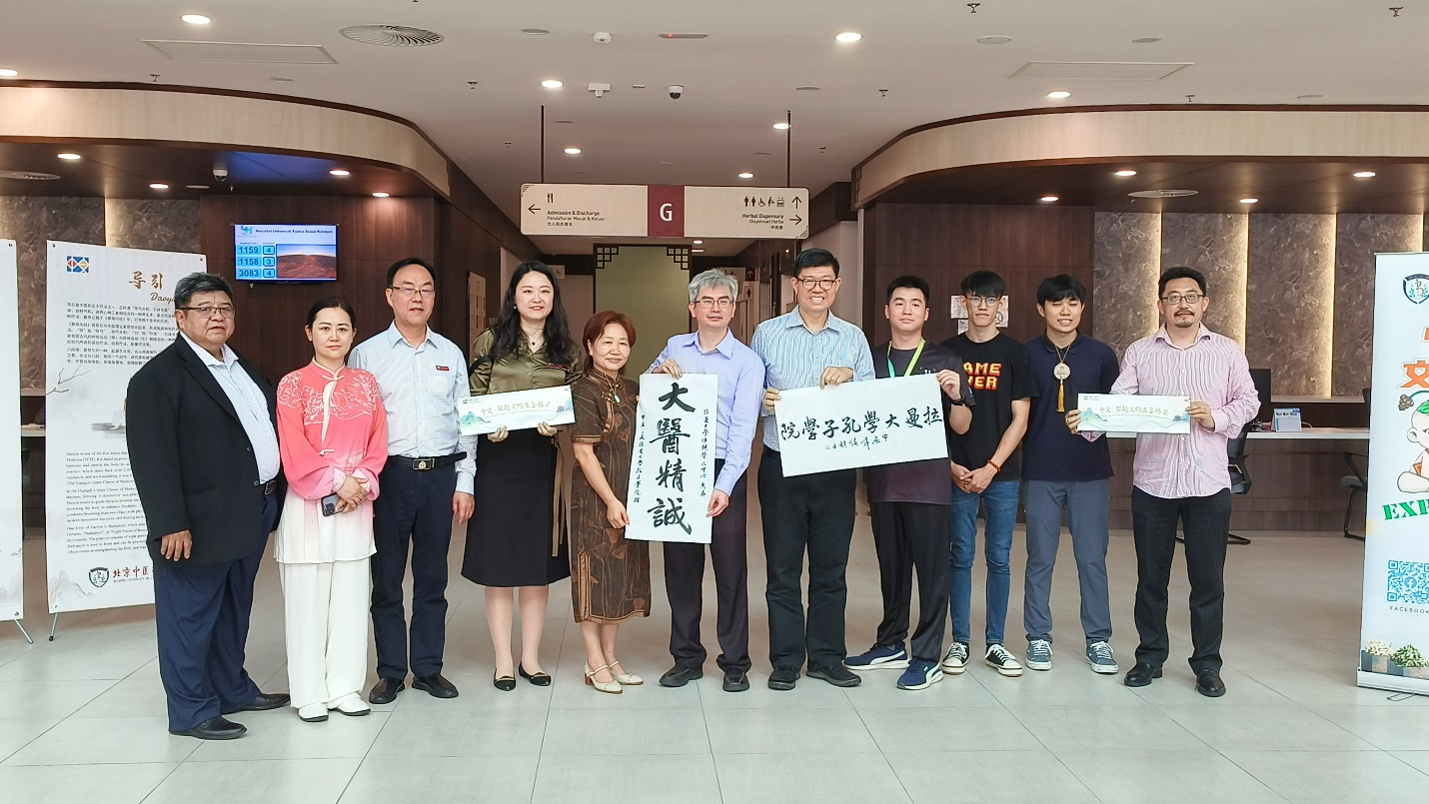

From left: Prof Zhang, Assoc Prof Hu, Prof Zhao, Ms Wang, Prof Ma, Dr Te, Prof Choong, and Prof Wang (far right) with students

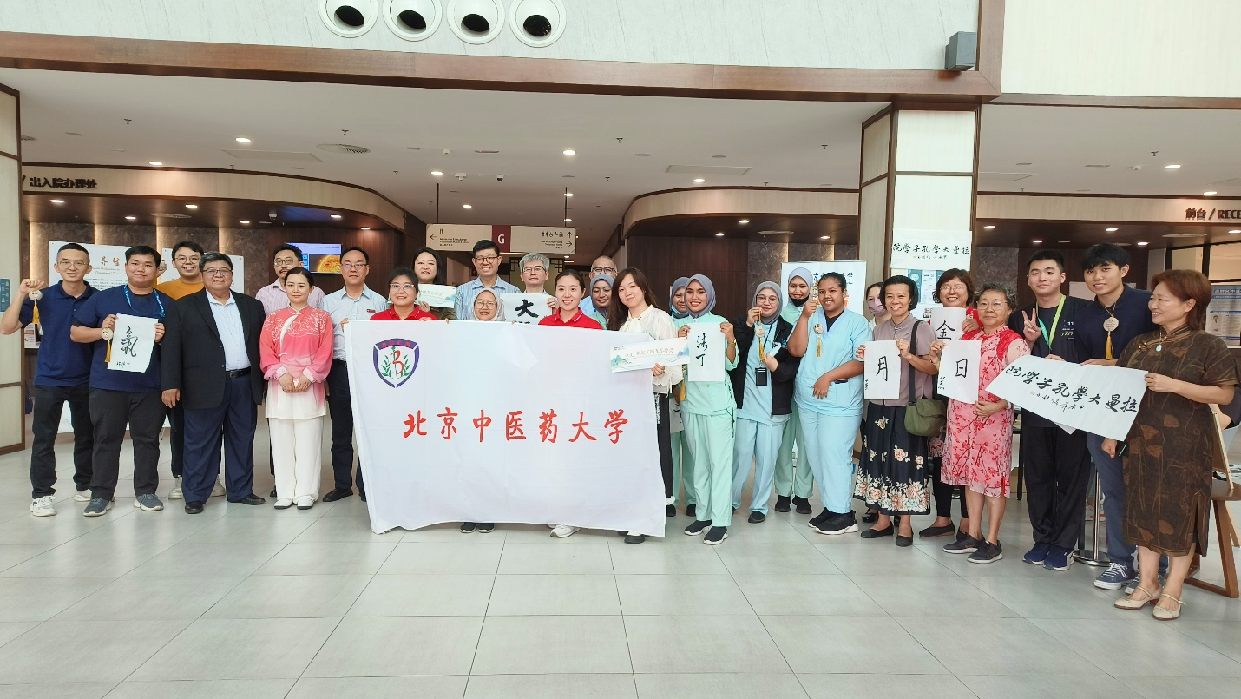

A group photograph at the end of the competition