**Chinese Literature Week 2024 gathers literary writers at Kampar Campus**

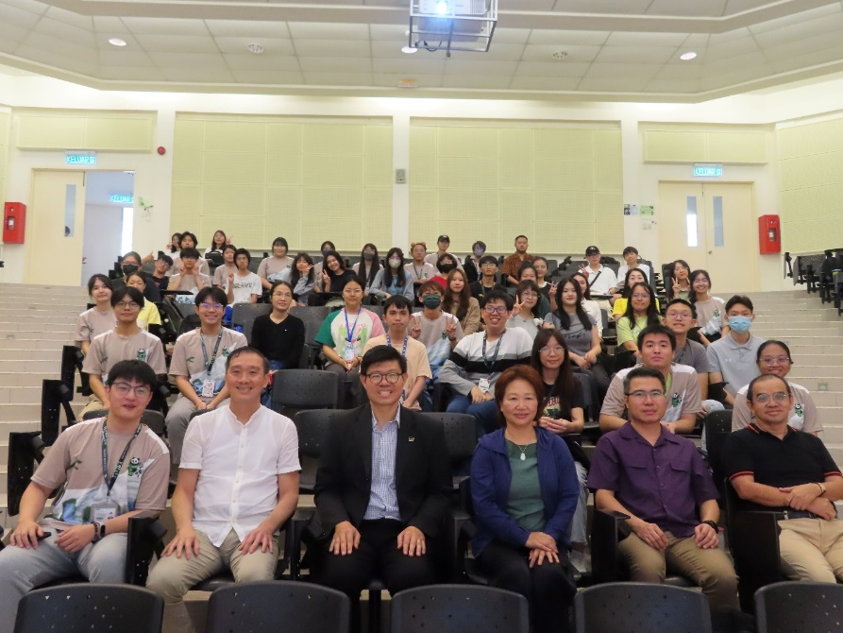

Front row, from left: Zhang, Dr Toh, Prof Choong, Prof Ma, Mr Looi and Dr Lee with the organising committee members and participants at the closing ceremony

The UTAR Chinese Literature Week 2024 – *You Yuan Ya Hui* (第六届文学周 “优缘雅会”) closed its week-long activities with a closing ceremony on 6 April 2024 at UTAR Kampar Campus.

Organised by the Chinese Language Society (CCS) of UTAR, the sixth iteration of Chinese Literature Week began its exuberant take on literary elegance on 27 March 2024, featuring seven days of activities filled with rich cultural and literary elements such as workshops, literary talks, exhibitions, and a book fair.

The event aimed to promote the creation of literary works, improve the UTAR campus’ literary atmosphere, and provide a valued platform for lovers of literature to share and exchange their thoughts.

UTAR Vice President for Student Development and Alumni Relations Prof Dr Choong Chee Keong said, “Every year of Chinese Literature Week has been unique, as they incorporate novel and interesting elements. The Chinese Literature Week 2024 – *You Yuan Ya Hui* is unique too. With a new theme as well as diverse activities, it provides opportunities for participants to meet new friends or deepen existing friendships, allowing them to build social networks while enjoying themselves in the vibrant activities.”

He added, “I would like to thank the members and supervisors of the organising committee for holding this symbolic event that greatly benefits our staff and students. I hope CCS will continue holding this series of events in the coming years.”

The Covid-19 pandemic affected almost all activities in the world. The same went to the Chinese Literature Week, as it was put on hold for two consecutive years during the Malaysian Movement Control Order (MCO) period. With this in mind, the Advisor of the Chinese Literature Week 2024 Assoc Prof Dr Toh Teong Chuan, who is also UTAR Institute of Chinese Studies (ICS) Head of Department of Chinese Studies (Kampar Campus), was glad to witness the continuation of the event. He commented on the challenges of organising this event and the great effort put on by the current student committees to take up the torch left by their predecessors.

The UTAR Chinese Literature Week 2024 Organising Chairperson Zhang Yiming also expressed his gratitude to all the members of the organising committee for giving their best for the event.

The closing ceremony was graced with a performance of the song titled “*Hai Shang Luo Hua*” (海上落花) and a Wushu performance.

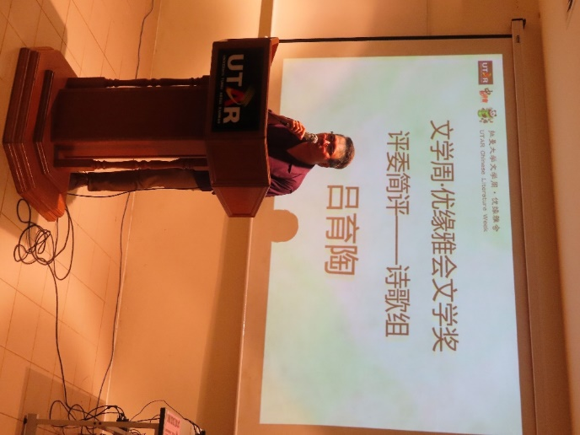

Mr Looi sharing his thoughts on the poetry works submitted by the participants

Amidst the joyous occasion, the results of the UTAR Literature Awards (拉曼大学文学奖) were officially announced to the participants of the event. The competition consisted of three categories, namely the Modern Poetry category, Novel category, and Prose category. The representatives of each panel of judges were Malaysian Chinese poet Mr Looi Yook Tho, Dr Toh Teong Chuan, and ICS academic Dr Lee Soo Chee respectively.

The results of the competition can be viewed here.

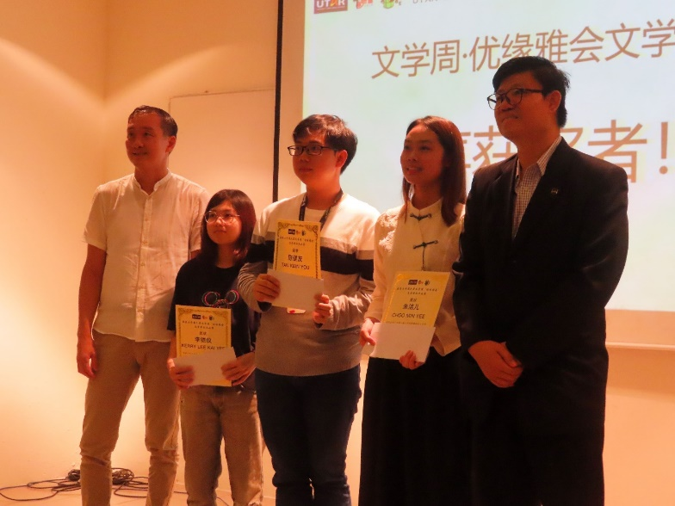

Dr Toh (far left) and Prof Choong (far right) presenting prizes to the winners of the Novel category

Also present at the closing ceremony were UTAR Director of Confucius Institute (China) Prof Dr Ma Yingxin, ICS Head of Modern Chinese Literature Studies Unit Dr Wong Lih Lih, organising committee members, Chinese Literature Week 2024 participants, UTAR staff and students.