**UTAR Vice President discusses career paths and life at Kampar Campus**

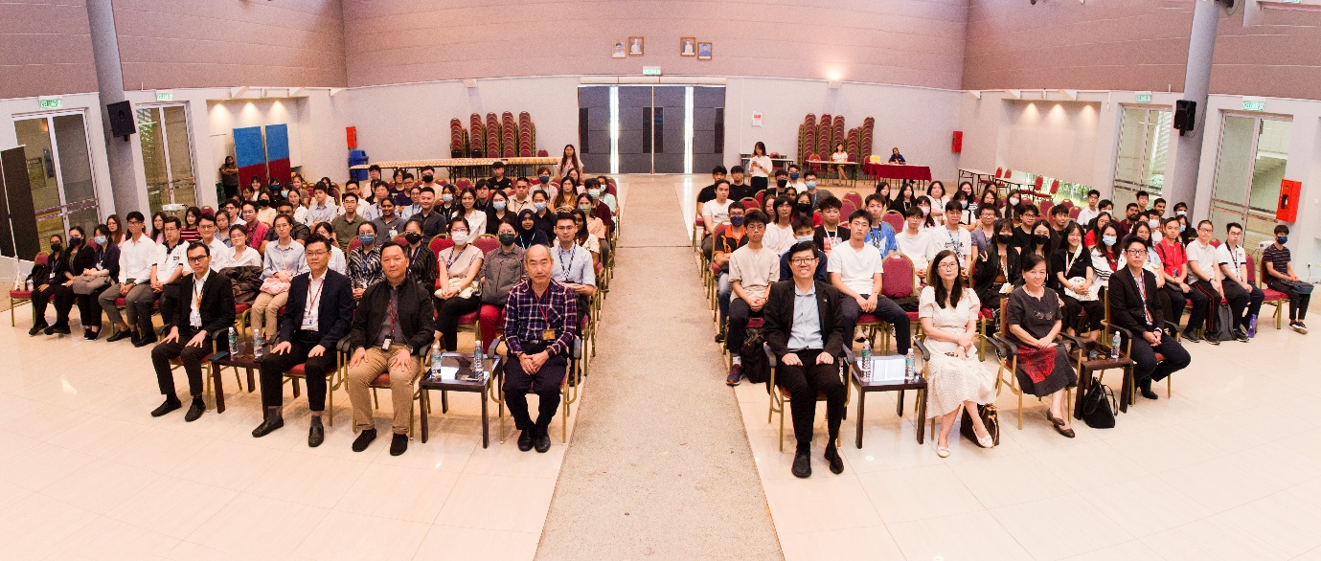

Tea talk with (front row from left) Dr Choong, Dr Cheng, Dr Peter Tan, Dr Lim, Prof Choong, Dr Lee, Dr Ling, and Dr Kwan

UTAR Vice President for Student Development and Alumni Relations Prof Dr Choong Chee Keong, represented UTAR President Ir Prof Dato’ Dr Ewe Hong Tat at a tea talk on 31 July 2024. The event, organised by the Department of Alumni Relations and Placement (DARP) at UTAR Kampar Campus, provided the graduating batch of March 2025 with valuable advice and insights on “Exploring Career Paths and Life”.

The talk session began with Prof Choong giving a brief historical introduction on the evolution of the economy, and the next wave of technologies, which offered students some comparative information on the development of today’s world, impacted by industrial revolutions and technological emergence. On that note, he emphasised the need for knowledge workers to be equipped with a growth mindset and empathy, because learning is continuous, especially in the age of artificial intelligence.

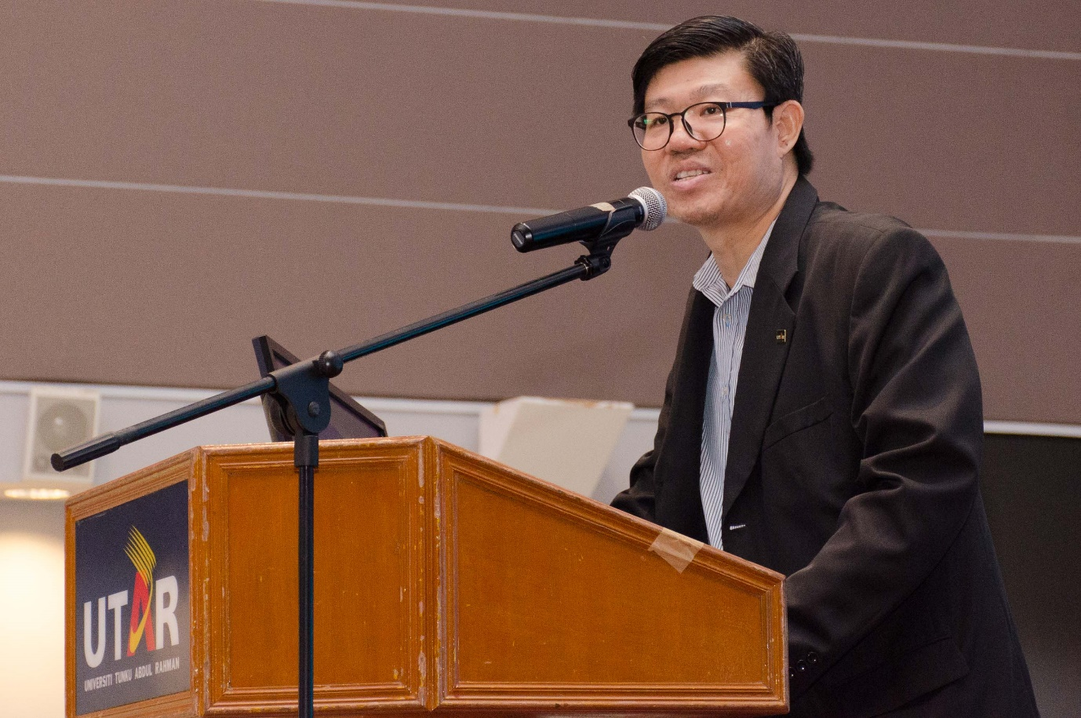

Prof Choong advising students to equip themselves with important skills for employability

He advised, “Two of the most important skills needed for the future are adaptability and continuous learning, and mental balance along with emotional intelligence. In this age, employers are looking to recruit employees, who possess these top five digital skills, namely digital marketing, big data and analytics, database, e-commerce, and software application and development. Additionally, employers are also recruiting employees with these soft skills traits, namely problem-solving, ability to work under pressure, ability to work independently, communication skills, and willingness to learn.”

As he elaborated, the final-year students understood the need to make wise choices when deciding their next step after graduation. They also learnt that these traits, namely personality, scholastic record, communication skills, experience, teamwork, standing of the university, and salary requested, are factors that determine the successful employment of young professionals. He also shared with the students the top reasons for one’s unsuccessful employment and advised students on ways to excel in their interview sessions.

He further advised that the secret to outstanding achievement is a special blend of passion and persistence. He shared a formula, extracted from a book authored by Angela Duckworth, which explained that talent combined with effort produces skill, while skill combined with effort produces achievement. Additionally, he also advised students to be equipped with emotional intelligence, adversity quotient, and cultural intelligence. According to him, these skills will be helpful for individuals to turn obstacles into opportunities.

Prof Choong concluded the talk by encouraging students to cultivate a growth mindset and empathy in alignment with UTAR’s educational pillars of virtue, knowledge, and social responsibility. He also encouraged them to stay in touch with their alma mater after graduation, through DARP and hoped for them to continue carrying UTAR’s flag with pride.

Bachelor of Medicine and Bachelor of Surgery (M.B.B.S.) students Lau Soo Sin and Franky Chee Yung Siang were also present. Lau said, “The information regarding the advancement of technology and the Fourth Industrial Revolution was very relevant to us because these things are immersing into every industry, including medicine and healthcare. The nature of our job requires us to have vast medical knowledge, but with artificial intelligence (AI), this is be made possible. So, the information shared was certainly insightful because this is something we need to be aware of. Times are changing. We need to adapt to the changes and learn ways to apply these technologies.”

Meanwhile, Franky Chee commented, “After our training, we will be doing our housemanship, and for me, I am planning to specialise in paediatrics overseas. I am looking forward to that next phase, and I hope with the skills and knowledge I’ve acquired throughout my studies here in UTAR, I’ll be able to contribute back to society, as well as to the healthcare industry.”

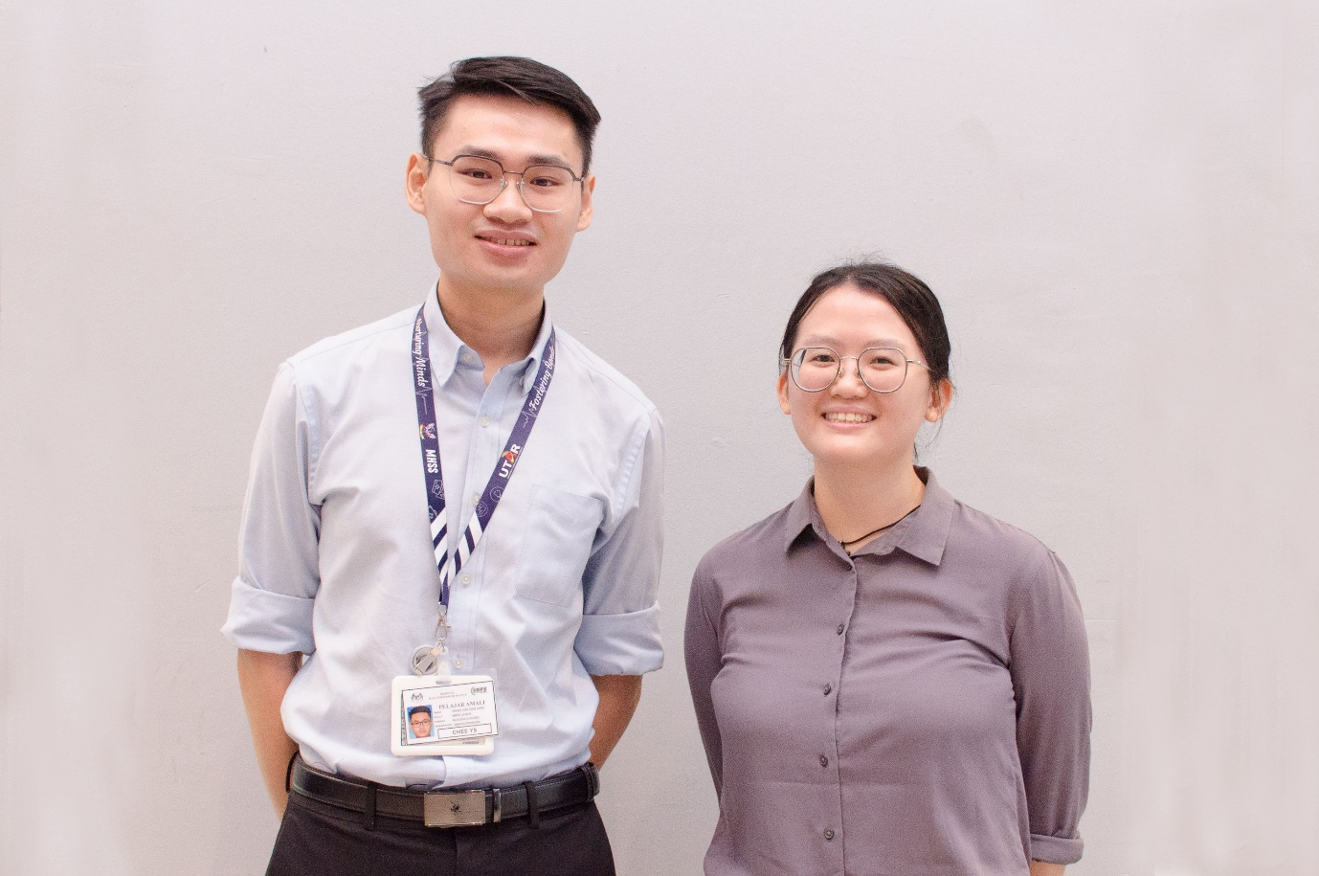

From left: Franky Chee and Lau at the tea talk

More insights and valuable advice were also offered during the Q&A session. Students asked interesting questions, ranging from technical to general questions to Prof Choong, deans, and deputy deans of UTAR.

Also present at the tea talk were Faculty of Science Dean Assoc Prof Dr Lim Tuck Meng, Faculty of Arts and Social Science Dr Lee Lai Meng, Faculty of Business and Finance Deputy Dean for Academic Development and Undergraduate Programmes Dr Peter Tan Sin Howe, Faculty of Information and Communication Technology Deputy Dean for Academic Development and Undergraduate Programmes Assoc Prof Ts Dr Cheng Wai Khuen, Institute of Postgraduate Studies and Research Deputy Director Assoc Prof Dr Choong Yuen Onn, Institute of Chinese Studies Deputy Dean for Student Development and Industrial Training Dr Ling Liong Ngo, and Faculty of Engineering and Green Technology Department of Construction Management Head Dr Kwan Wai Hoe.

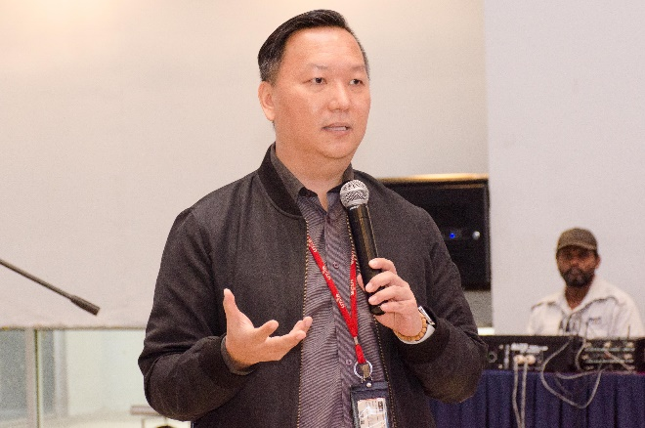 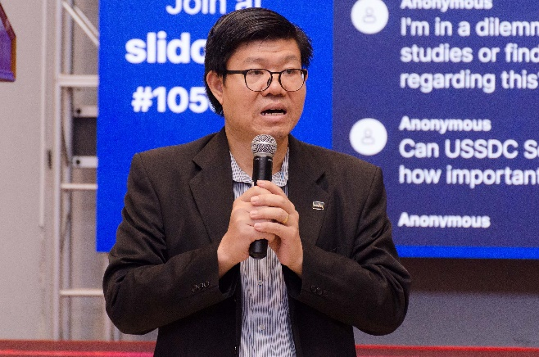 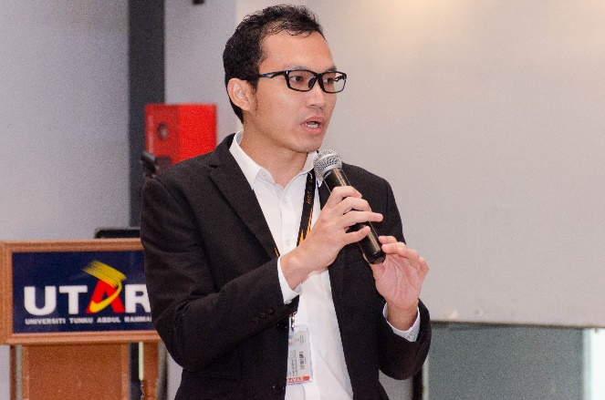 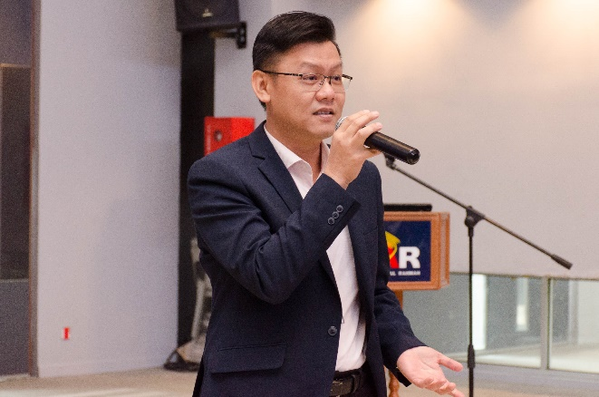

Clockwise from top left: Dr Peter Tan, Prof Chong, Dr Cheng, and Dr Choong answering some questions during the Q&A

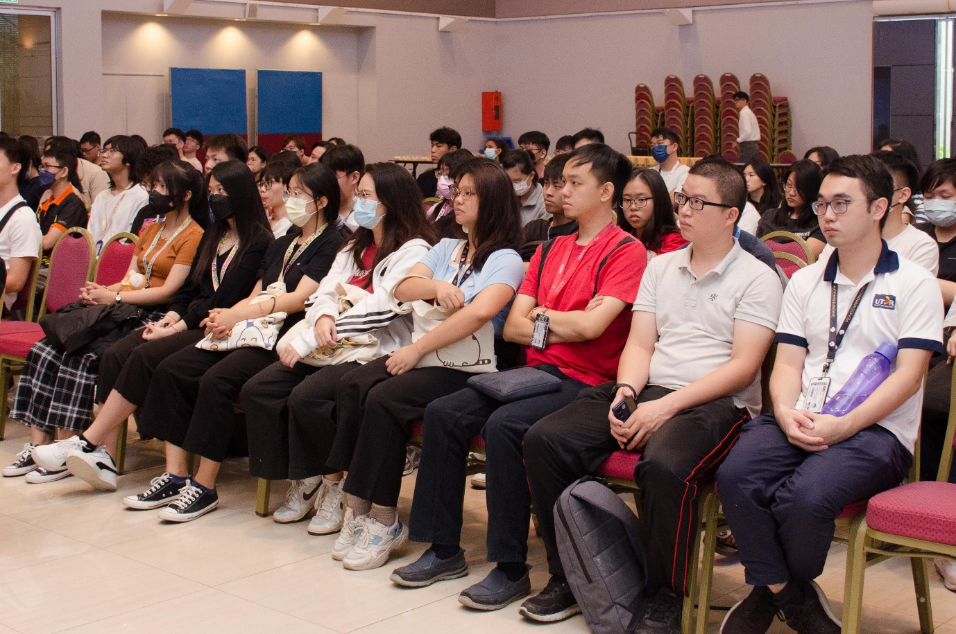

Students listening attentively to Prof Chong’s talk