**HKCO shares merry moments with music lovers at Kampar Campus**

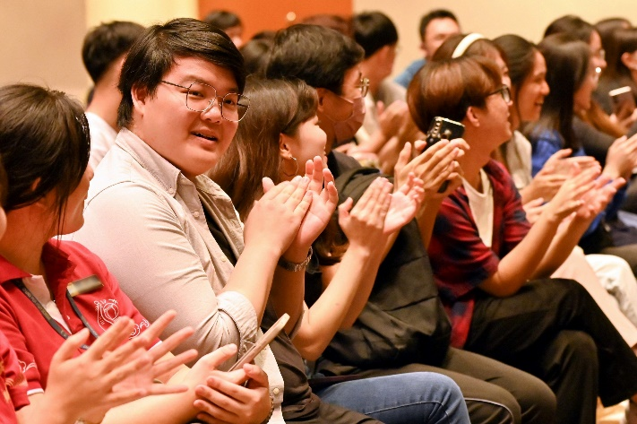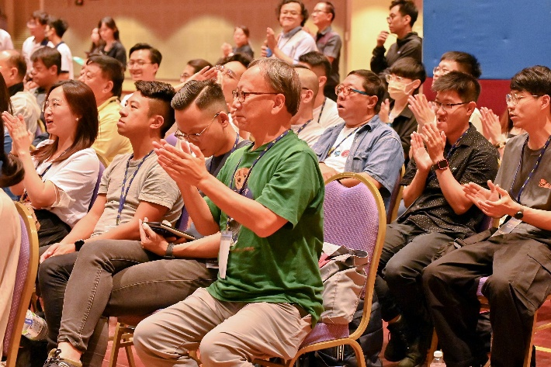

The audience cheering amidst the orchestral performances

A series of dulcet and euphonious notes resounded in the air. Rounds of applause ensued with each passing of musical piece, presented to an audience of music aficionados.

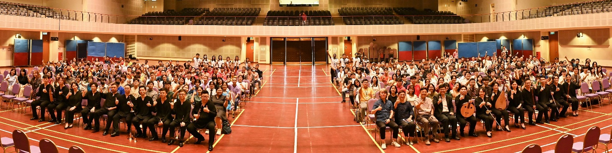

Group photograph at the end of the session

On 5 August 2024, the Hong Kong Chinese Orchestra (HKCO) performed at the Dewan Tun Dr Ling Liong Sik of Kampar Campus, attracting hundreds of music enthusiasts from approximately 14 schools and the Kampar community, along with UTAR staff and students, making it a memorable occasion.

The HKCO Chinese Orchestra Exchange Session was organised in conjunction with the HKCO Debut Malaysia Tour 2024, which saw the global orchestral group’s first official performances in Peninsular Malaysia. Besides enjoying a variety of performances put forth by the orchestral group, the exchange session also provided an opportunity for the participants to interact with the members of HKCO.

UTAR President Ir Prof Dato’ Dr Ewe Hong Tat said, “A heartfelt thank you goes out to all the attendees who supported the HKCO. We are genuinely amazed by the enthusiastic reception from the public.”

He added, “UTAR had the distinct honour of hosting the Hong Kong Chinese Orchestra for their first-ever performances in Malaysia on 3 and 4 August 2024, at Dewan Filharmonik Petronas, Kuala Lumpur. The excitement will continue with the third performance scheduled for 7 August 2024, at Dewan Tan Sri Loh Boon Siew, TAR UMT, Penang. This performance tour represents a significant cultural milestone, fostering a deeper appreciation for Chinese music among Malaysian audiences.”

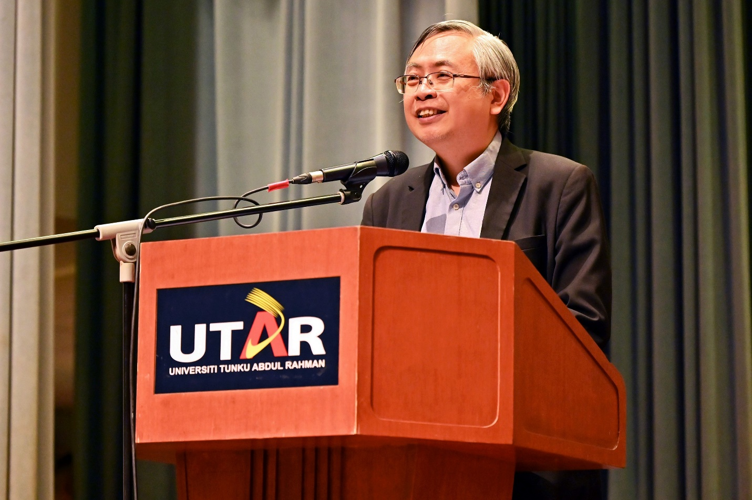

Prof Dato’ Ewe expressing his thanks to the supporting units of the debut tour

The grand hall was filled with a variety of mellifluous notes, produced from a diverse array of Chinese musical instruments, such as *suona*, *dizi*, *sheng*, *luo*, *yunluo*, *ruan*, *pipa,* *zheng*, and *yangqin*. The atmosphere turned solemn yet zestful as the sprightly tunes, originating from folk music and traditional Chinese tunes, hovered around the hall. Some of the tunes played included “Birds Paying Homage to the Phoenix, Shandong Folk Music” (百鸟朝凰，山东民间乐曲), “The Boat on Land, Northern Shaanxi Folk Music” (跑旱船，陜北民歌), “Donkey Grazing, Hebei Folk Music” (放驴，河北民间乐曲), “A Joyful Evening” (欢乐的夜晚), and “Three Variations on Yangguan, Ancient Melody” (阳关三叠，古曲).

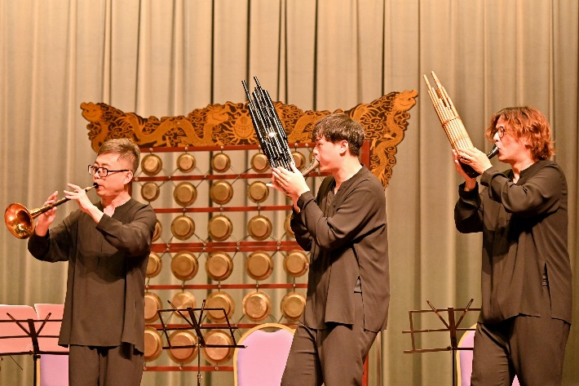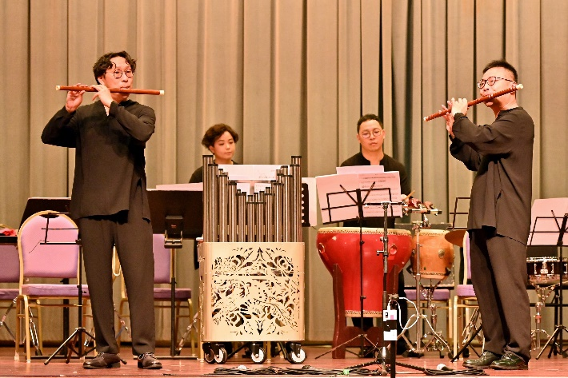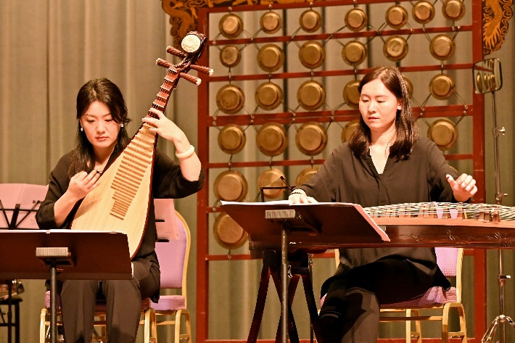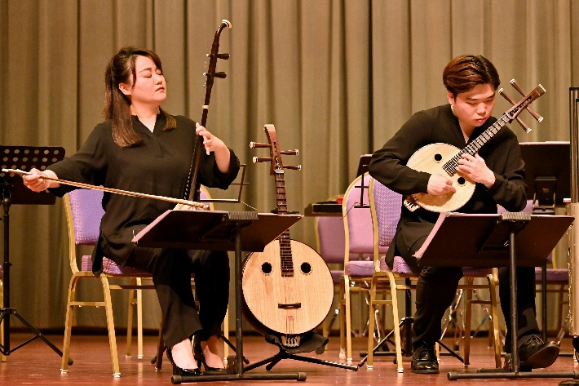

HKCO members assimilating diverse instrumental tunes during their performances

As the performances reached their postlude, active exchanges between the members of HKCO and the audience ensued. The enquiries from the crowd of music aficionados led to multiple sharing sessions on topics such as techniques on using orchestral instruments, ways to improve the proficiency of using orchestral instruments, and introduction to the instruments used by HKCO.

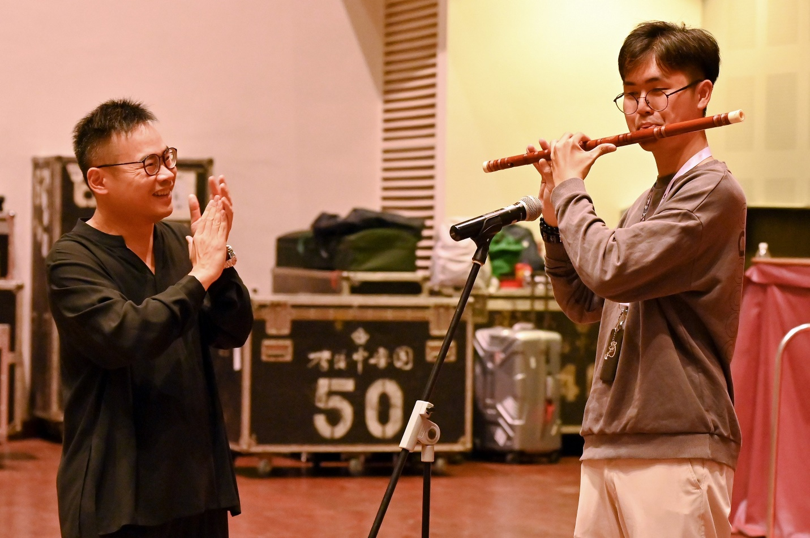

UTAR student (right) receiving advice on improving his *dizi*’s technique from a HKCO member

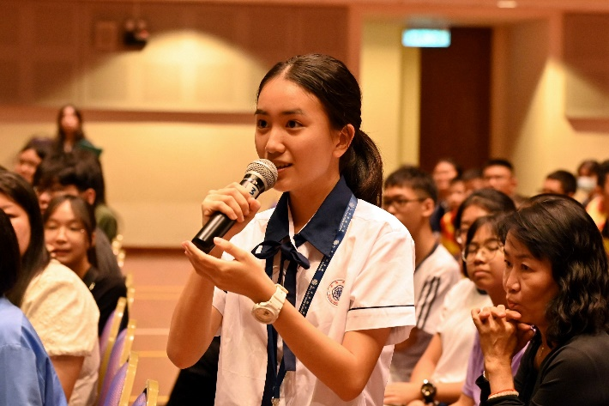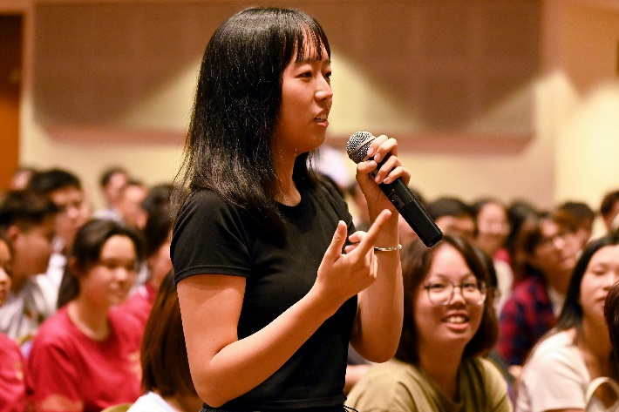

Participants presenting their enquiries to the HKCO members

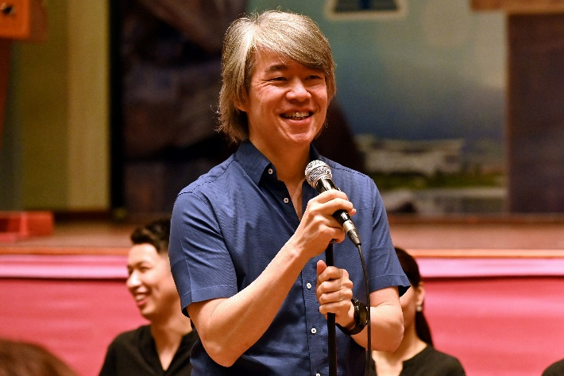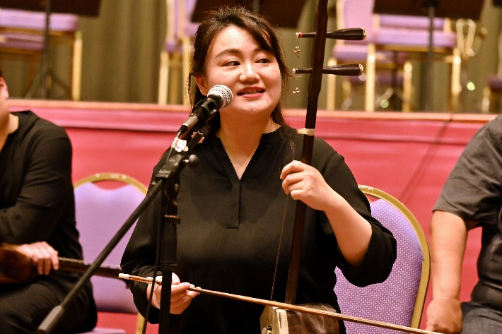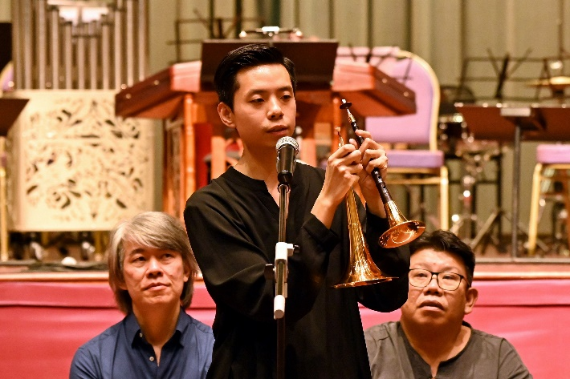

Mr Chew (top left) and some members of HKCO sharing their advice with the audience

The exchange session was also attended by Assistant Artistic Director and Resident Conductor of HKCO Mr Chew Hee Chiat, Executive Director of HKCO Council Member Dr Celina Chin Man Wah, UTAR Council Member Mr Hew Fen Yee, UTAR Vice President for Student Development and Alumni Relations Prof Dr Choong Chee Keong; school principals, teachers and students from various schools, UTAR staff and students.

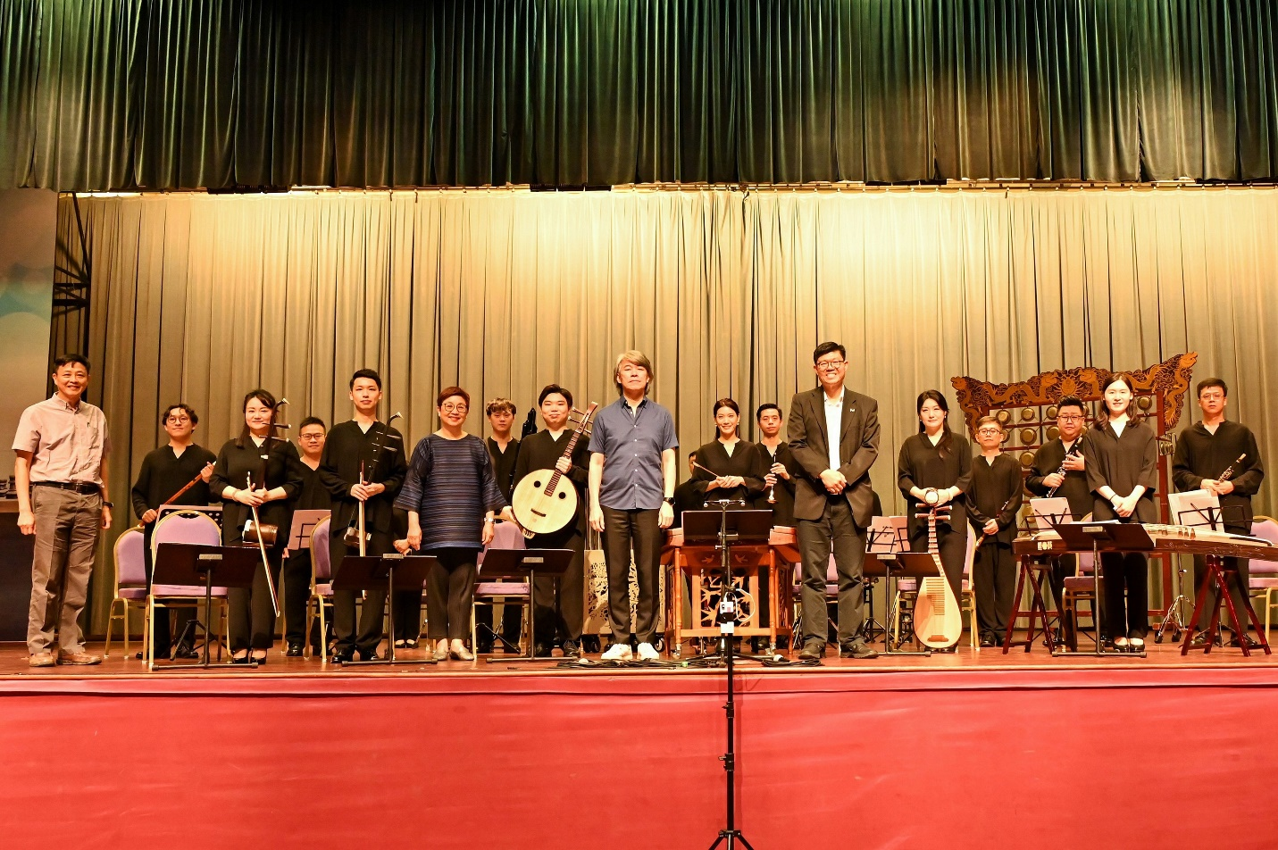

Front row: Mr Hew (most left), Dr Celina Chin (fourth from left), Mr Chew (sixth from left) and Prof Choong with the members of HKCO