**Lessons on nature conservation and ecotourism at Royal Belum State Park**

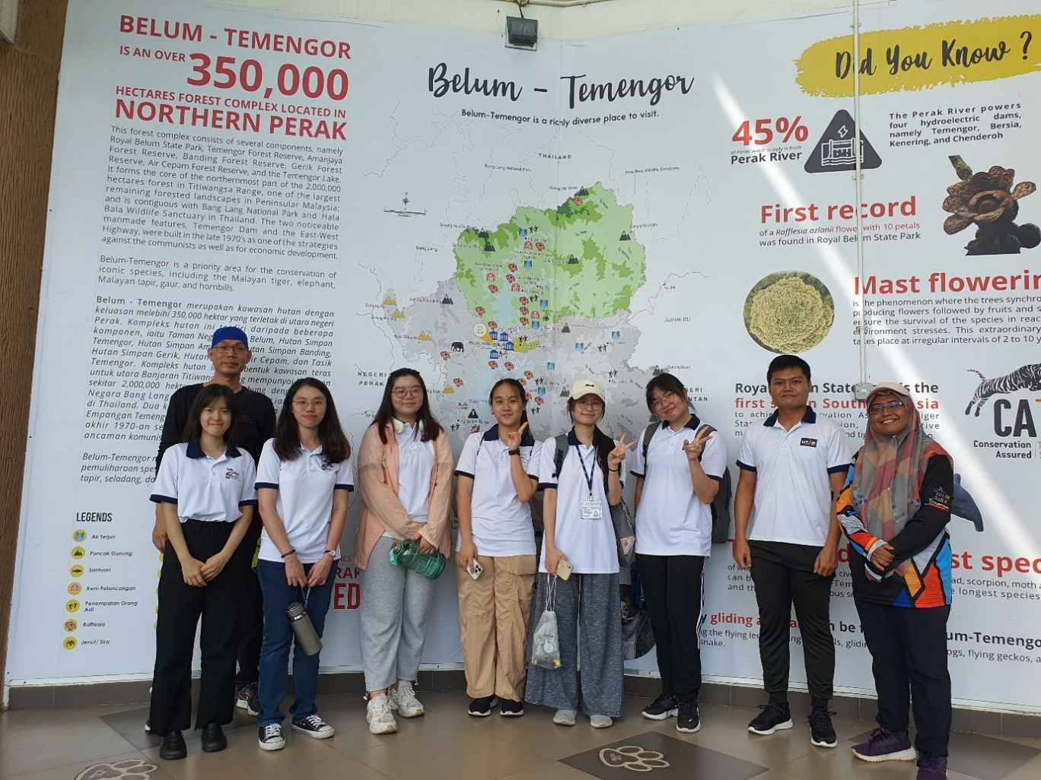

Dr Anthony Tee (behind) and Ms Nur Aliah (far right) with the students at Royal Belum State Park

During a field trip to Royal Belum State Park in Temenggor, Perak, on 30 July 2024, seven Bachelor of Business Administration (Honours) Tourism Destination Marketing students gained invaluable insights into nature conservation and ecotourism. They deepened their understanding of ecological balance and sustainable tourism through community engagement activities, which also offered a closer look at traditional lifestyles and heritage.

Renowned for its biodiversity and conservation significance, the Royal Belum State Park enhanced the students’ awareness of biodiversity and its role in business sustainability and corporate social responsibility. Additionally, it provided students with first-hand experience in ecotourism and conservation practices; a better understanding of the economic benefits of conservation; and the challenges faced in balancing tourism and conservation.

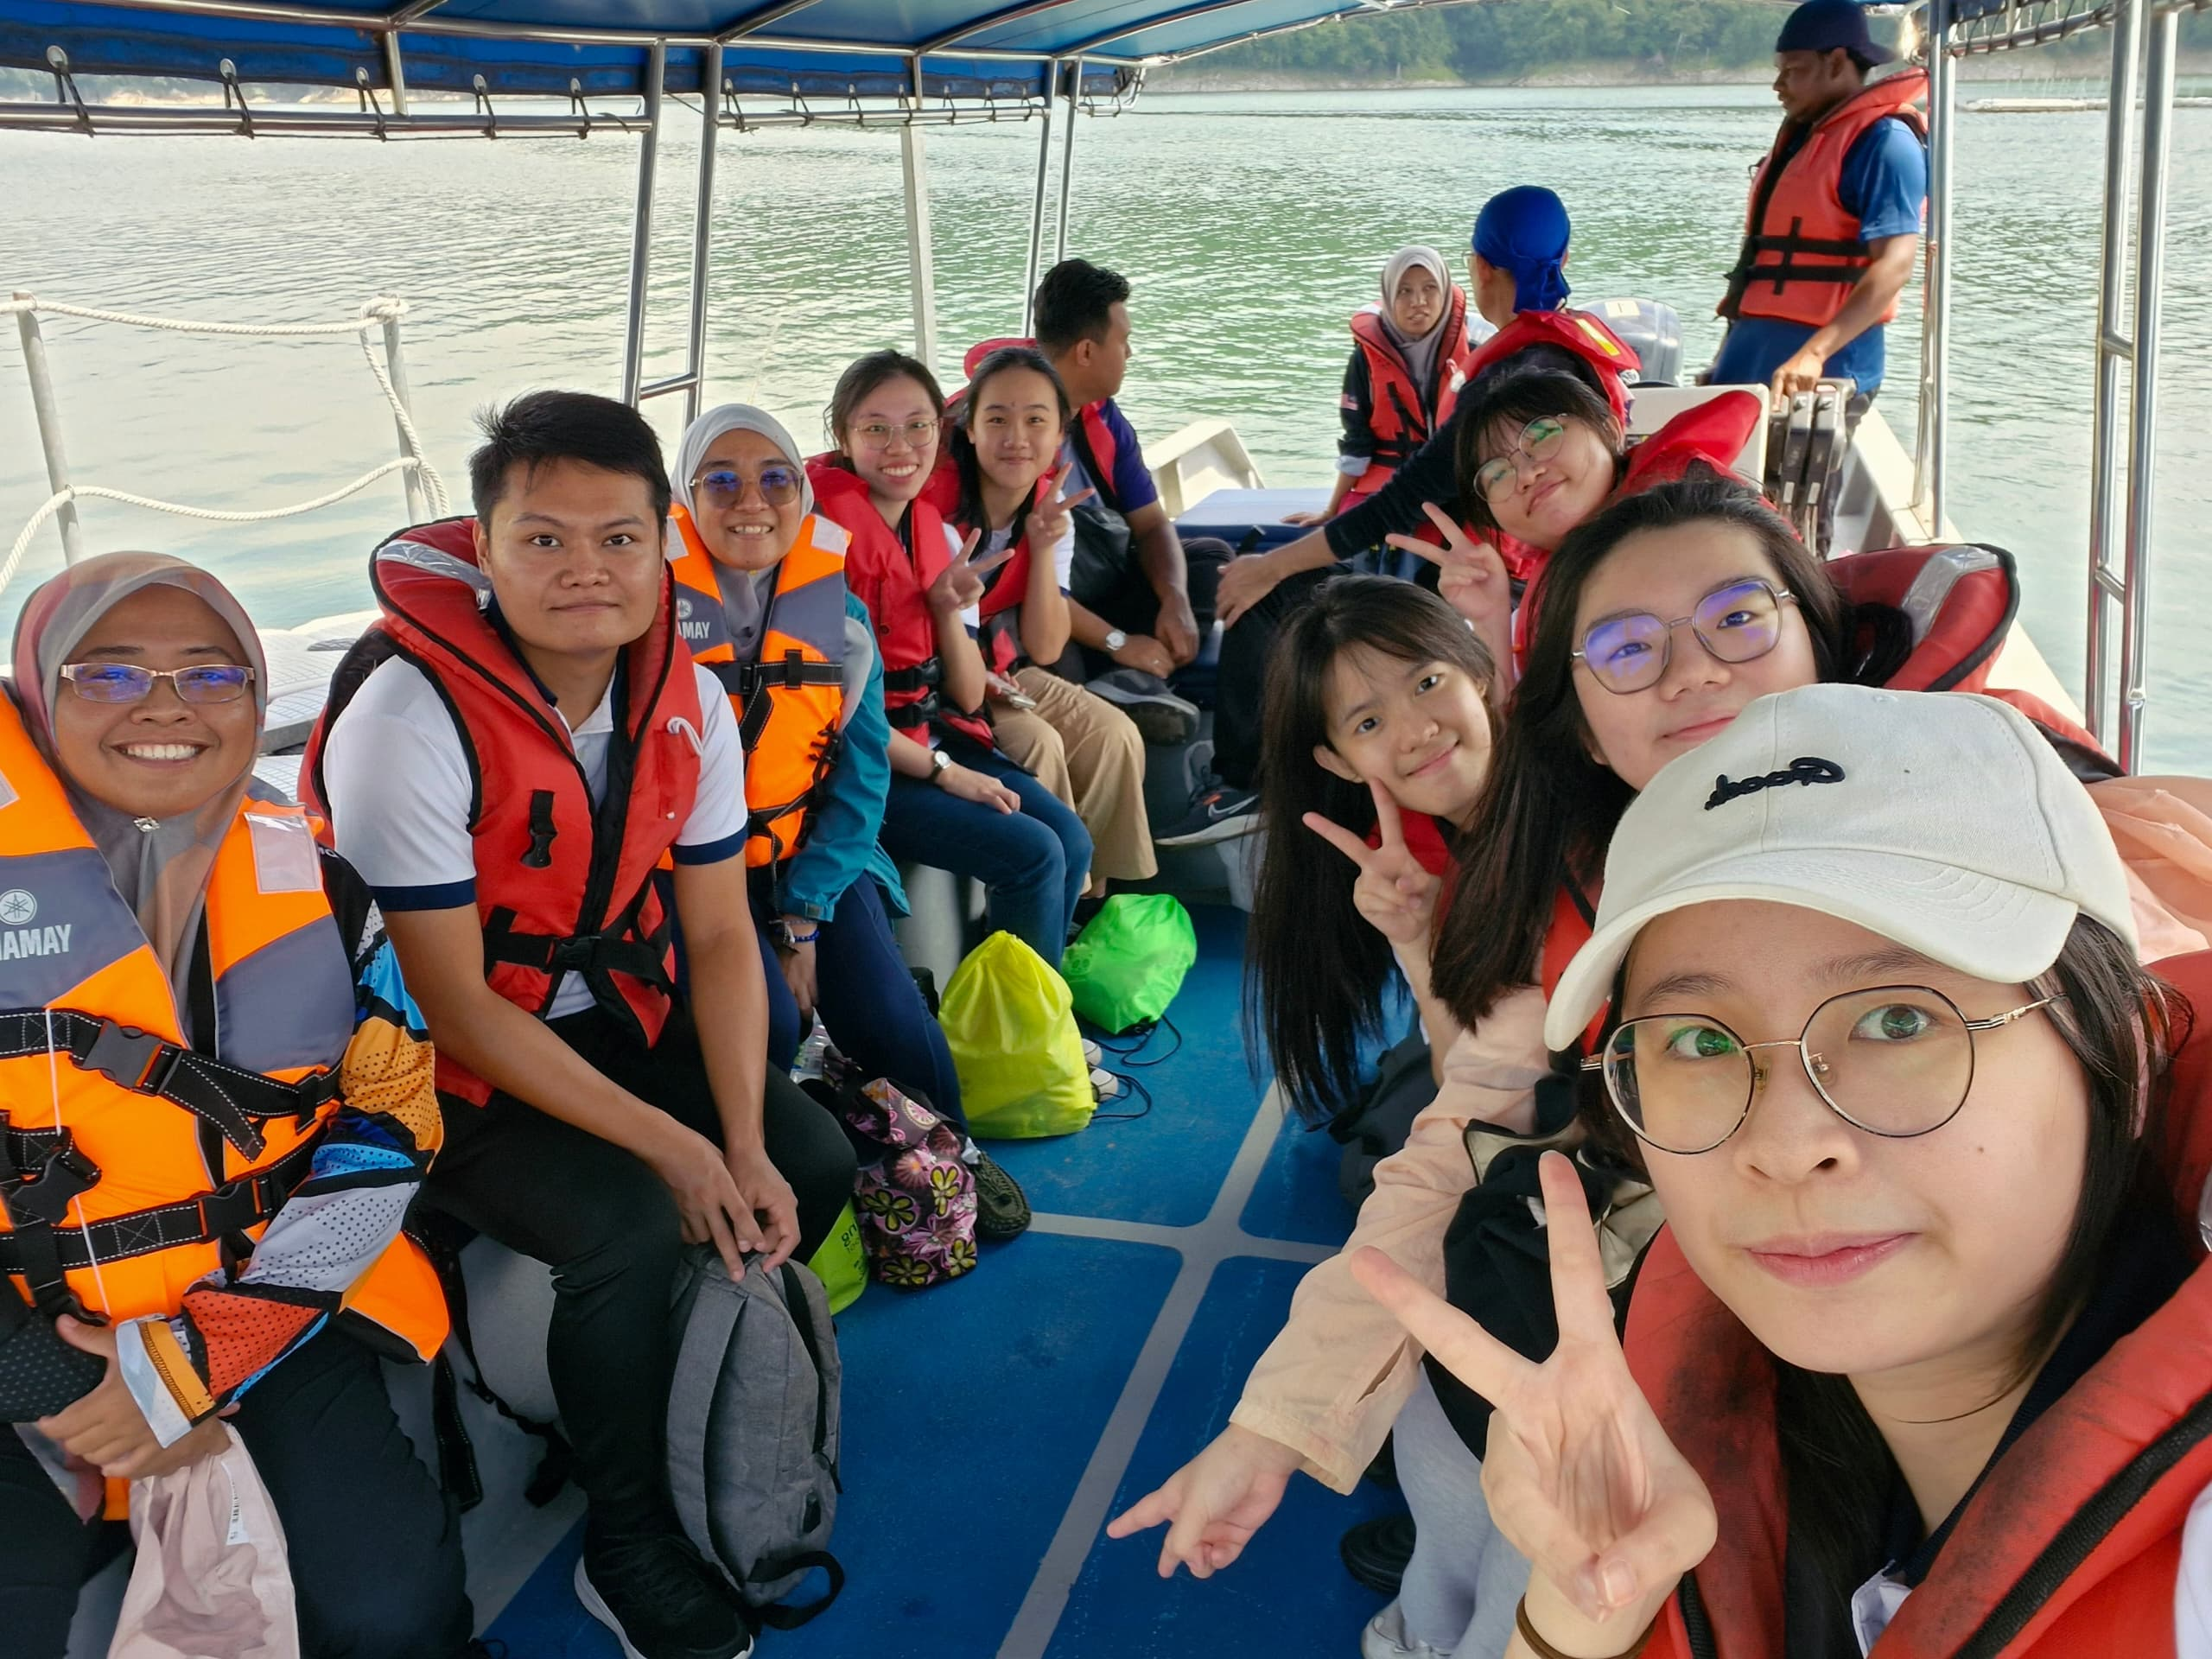

Journeying into the Royal Belum State Park

The field trip was arranged and coordinated by the Faculty of Business and Finance (FBF)’s Head of the MBA (Corporate Management) Programme Dr Anthony Tee Mooi Kwong, and lecturer Ms Nur Aliah binti Mansor, with the involvement of the Perak State Park Corporation, Kampung Klewang, and Koperasi Orang Asli Sungai Tiang (KOAST).

At the conservation and safety briefing by Programme Development Officer Ms Fairuz and Wildlife Helper Mr Zubir, the importance of protecting the park’s diverse ecosystems and ensuring visitor safety was emphasised. Students also learnt further about the conservation practices and safety protocols practised within the park.

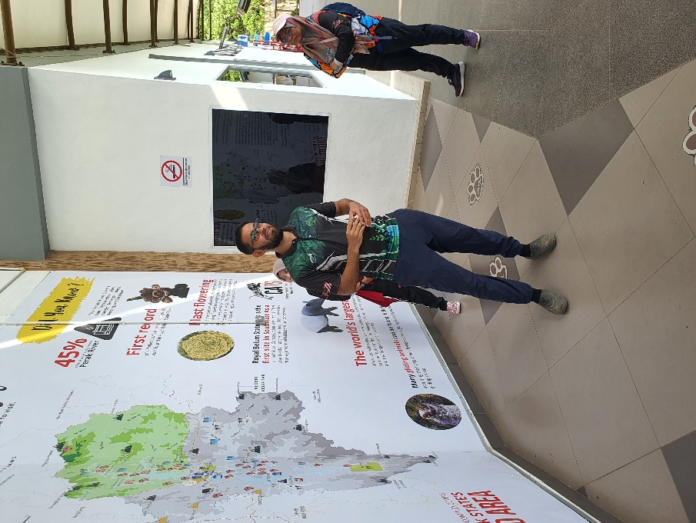 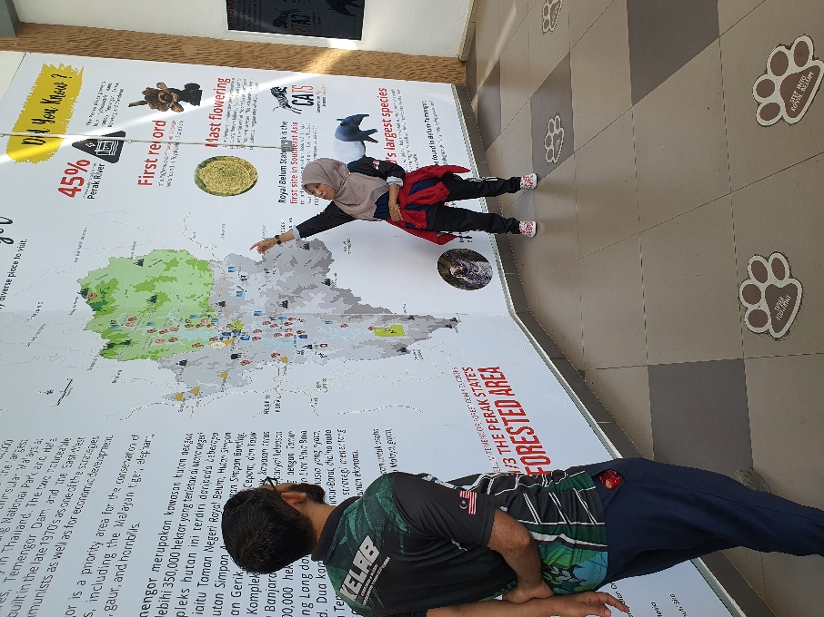

Conservation and safety briefing by Mr Zubir (left photo) and Ms Fairuz (right photo)

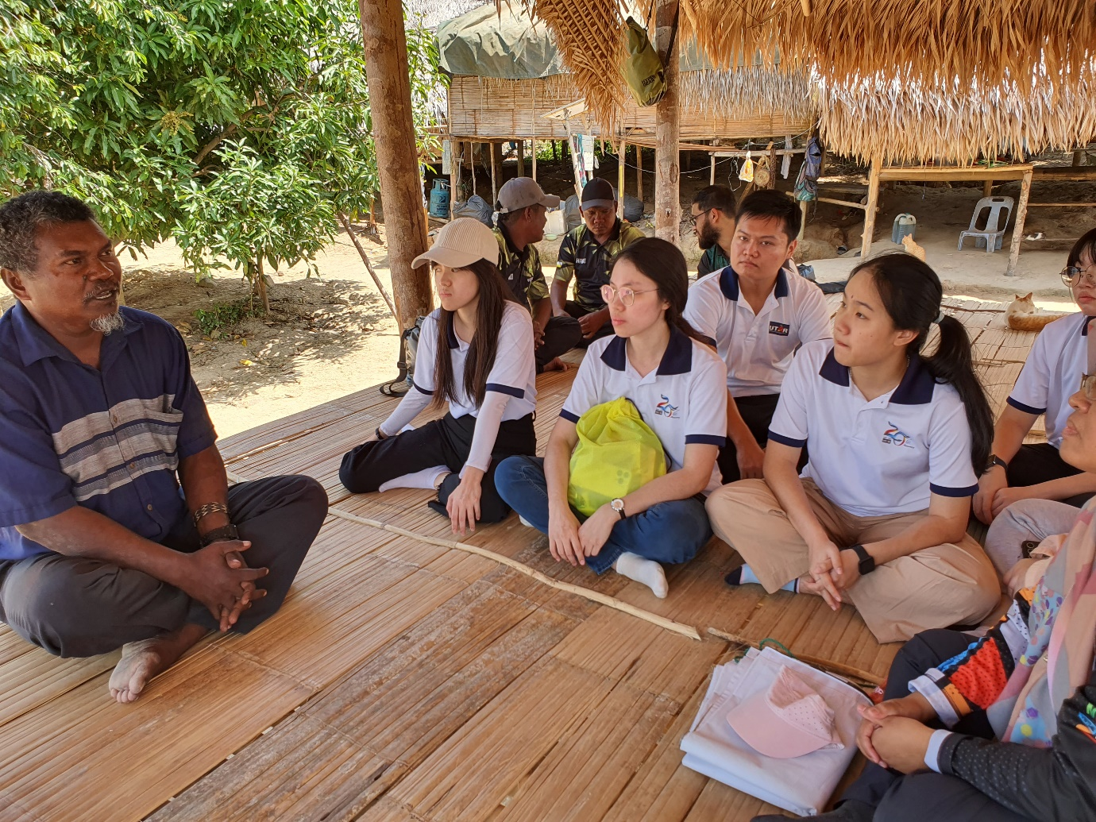

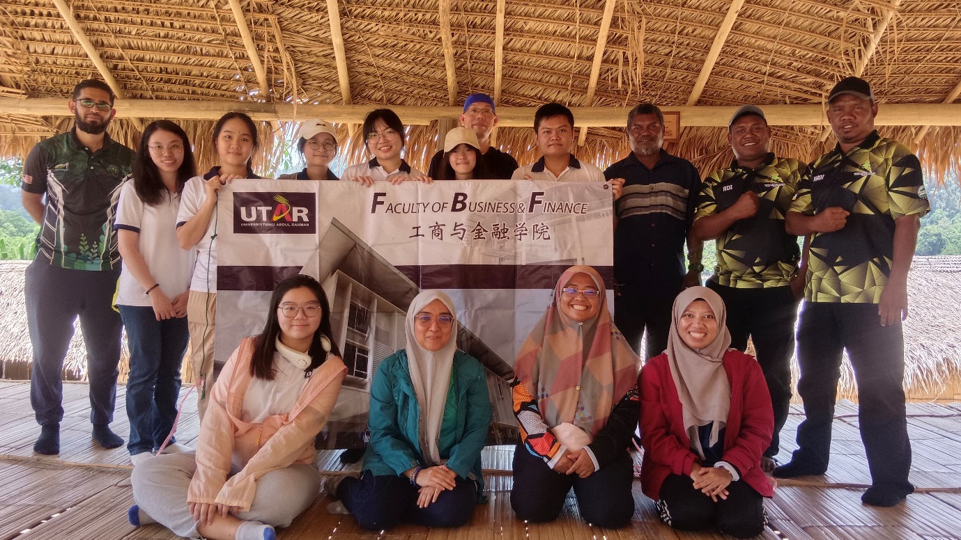

Engagement session with Tok Batin of Kampung Klewang, Sedor bin Gemis

Community engagement activities were included to offer deep insights into traditional lifestyles, fostering a greater appreciation for the area’s heritage and way of life. A significant moment was the meeting with Tok Batin Sedor bin Gemis, the village head of Kampung Klewang, where students learned about the rich cultural heritage and customs of the Jahai people, a subgroup of the Negrito indigenous community. Tok Batin emphasised the importance of education for the younger generation and expressed hopes for an enhanced educational programme with UTAR. It was noted that Kampung Klewang is made up of the Jahai tribe, a subgroup of the Negrito indigenous people. They used to live a nomadic life, but Kampung Klewang has become a permanent settlement for them.

The second engagement was led by Cooperative Chairman Hadi bin Mes, the Tok Batin of Kampung Sungai Tiang, who provided a briefing on the services offered by the Koperasi Orang Asli Sungai Tiang (KOAST) to tourists such as Akekchep. He outlined future collaboration plans, emphasising community engagement programmes aimed at enhancing visitor experiences while supporting sustainable development and preserving cultural heritage. These initiatives aimed to offer students the opportunity to be directly involved, providing them with first-hand experience in addressing real-world challenges related to tourism destination products. It is hoped that the students’ participation in these programmes will earn them practical insights into developing and improving tourism offerings while working closely with the local community to ensure sustainable outcomes.

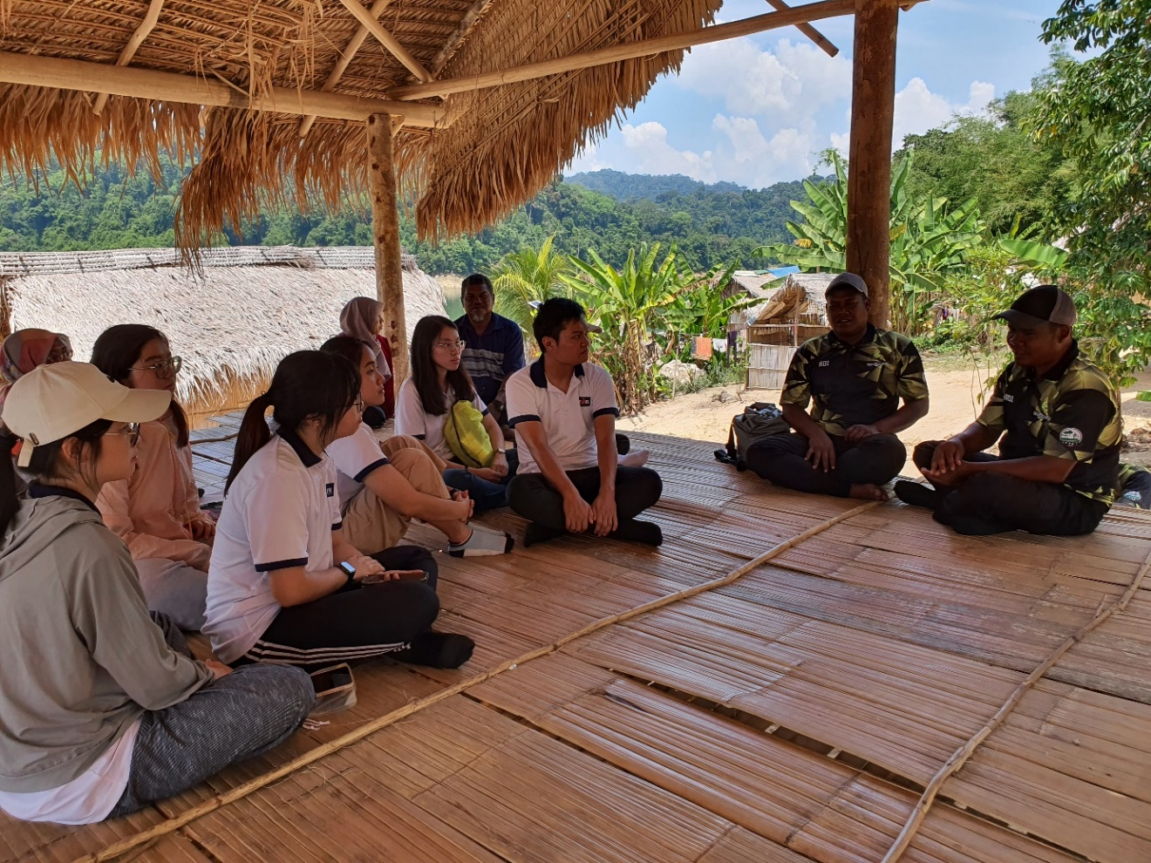

Discussion about Sungai Tiang tourism products with KOAST Chairman, Hadi bin Mes

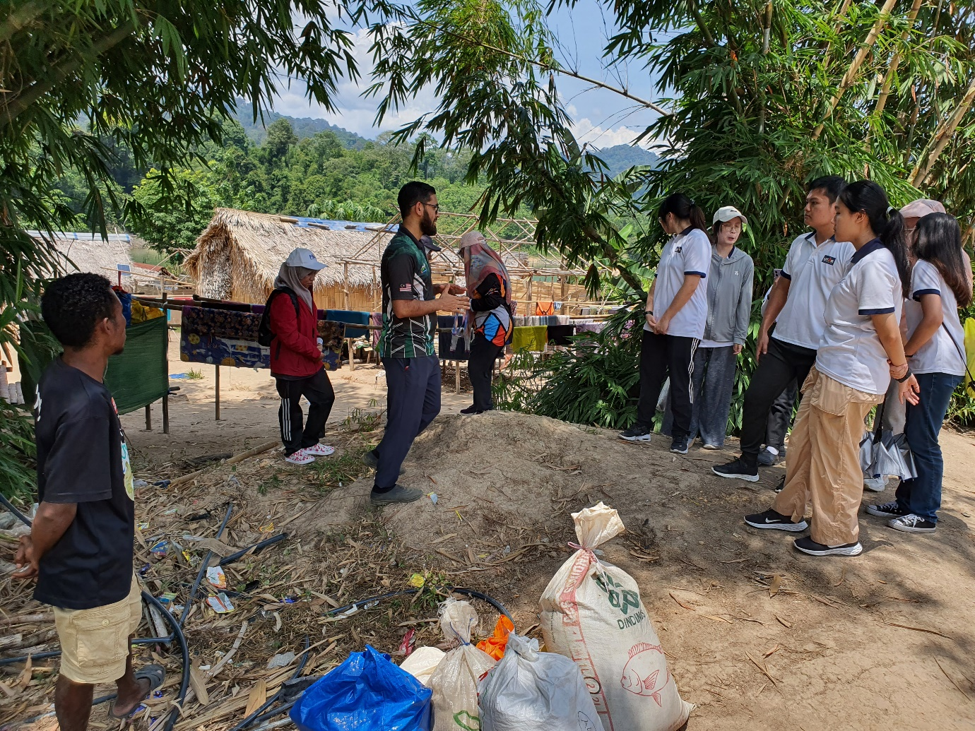

Briefing on Kampung Klewang’s recent conservation activities, with a focus on forest tree (pokok hutan) conservation

The students’ visit to Kooi Waterfall, combined with trekking through ancient forests and bamboo rafting, provided a unique opportunity to connect with nature. As they trekked through the ancient forests, where they encountered trees estimated to be 300-500 years old, it provided them with a profound sense of connection to the region’s rich natural heritage. They also immersed themselves in the breathtaking environment, which helped them gain an appreciation for the importance of preserving such pristine ecosystems. Additionally, the experience inspired them to consider ways to market natural environmental tourism products, and taught them the importance of sustainable tourism practices.

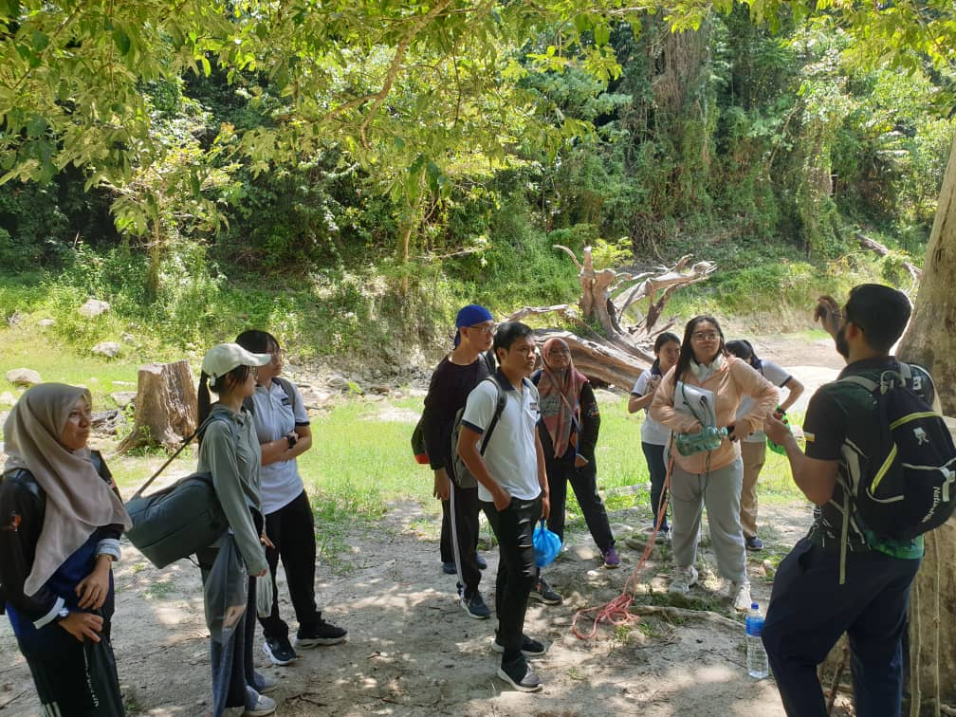

En Zubir explaining about birds and their migratory patterns

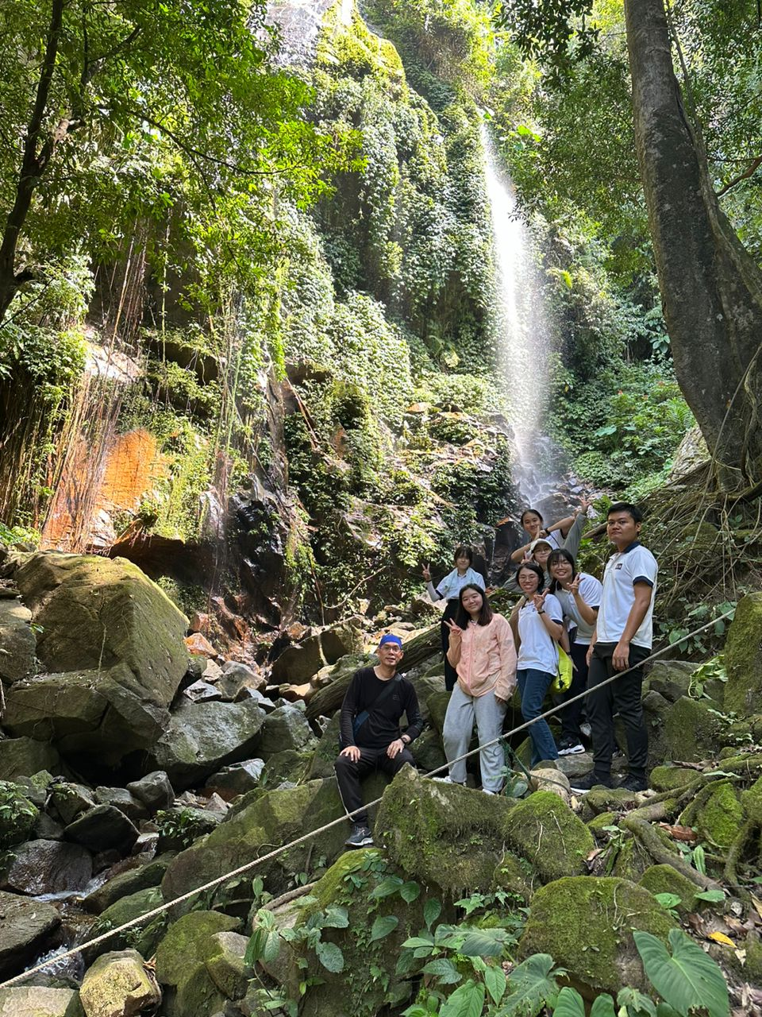

Getting refreshed at the Kooi Waterfall

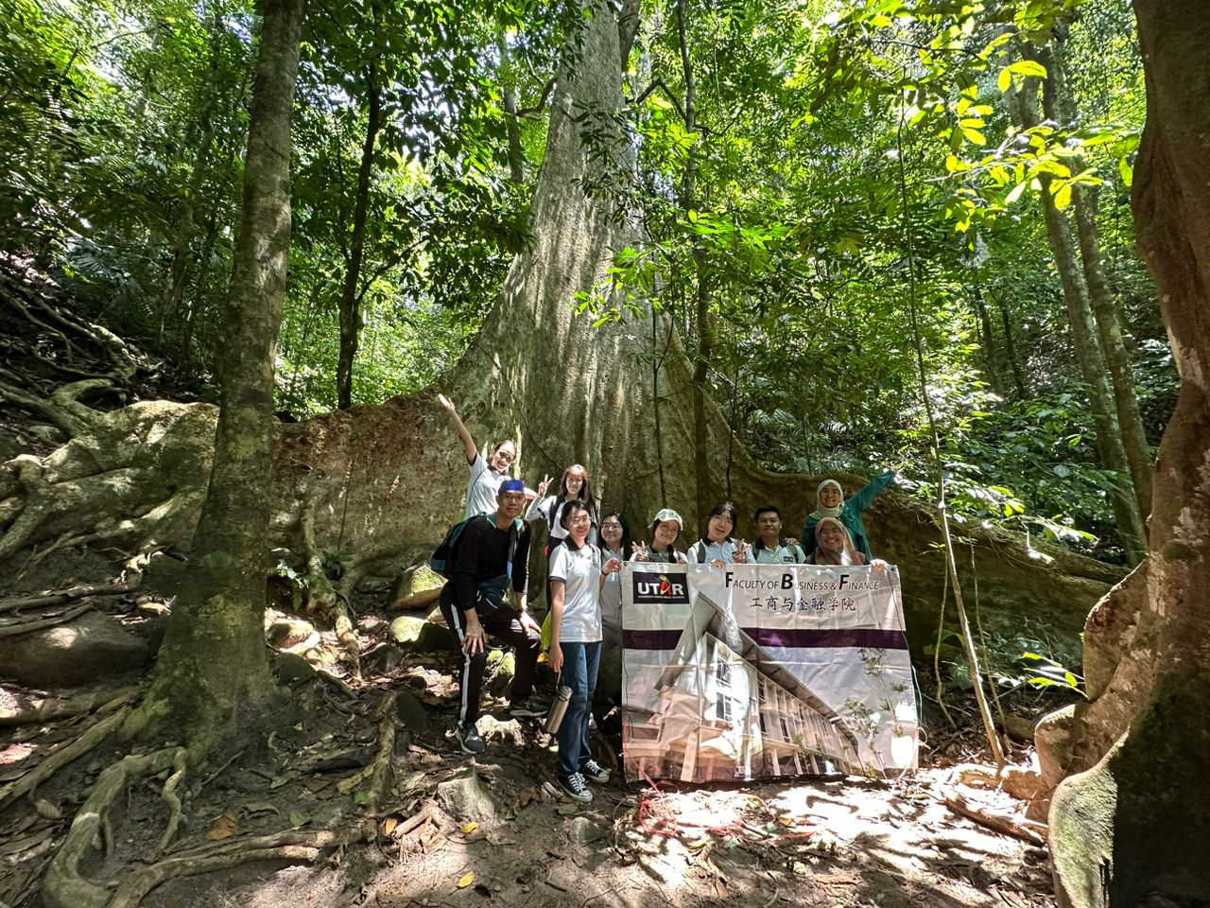

A group photo under the Tetrameles Nudiflora Tree (Pokok Mengkundur)

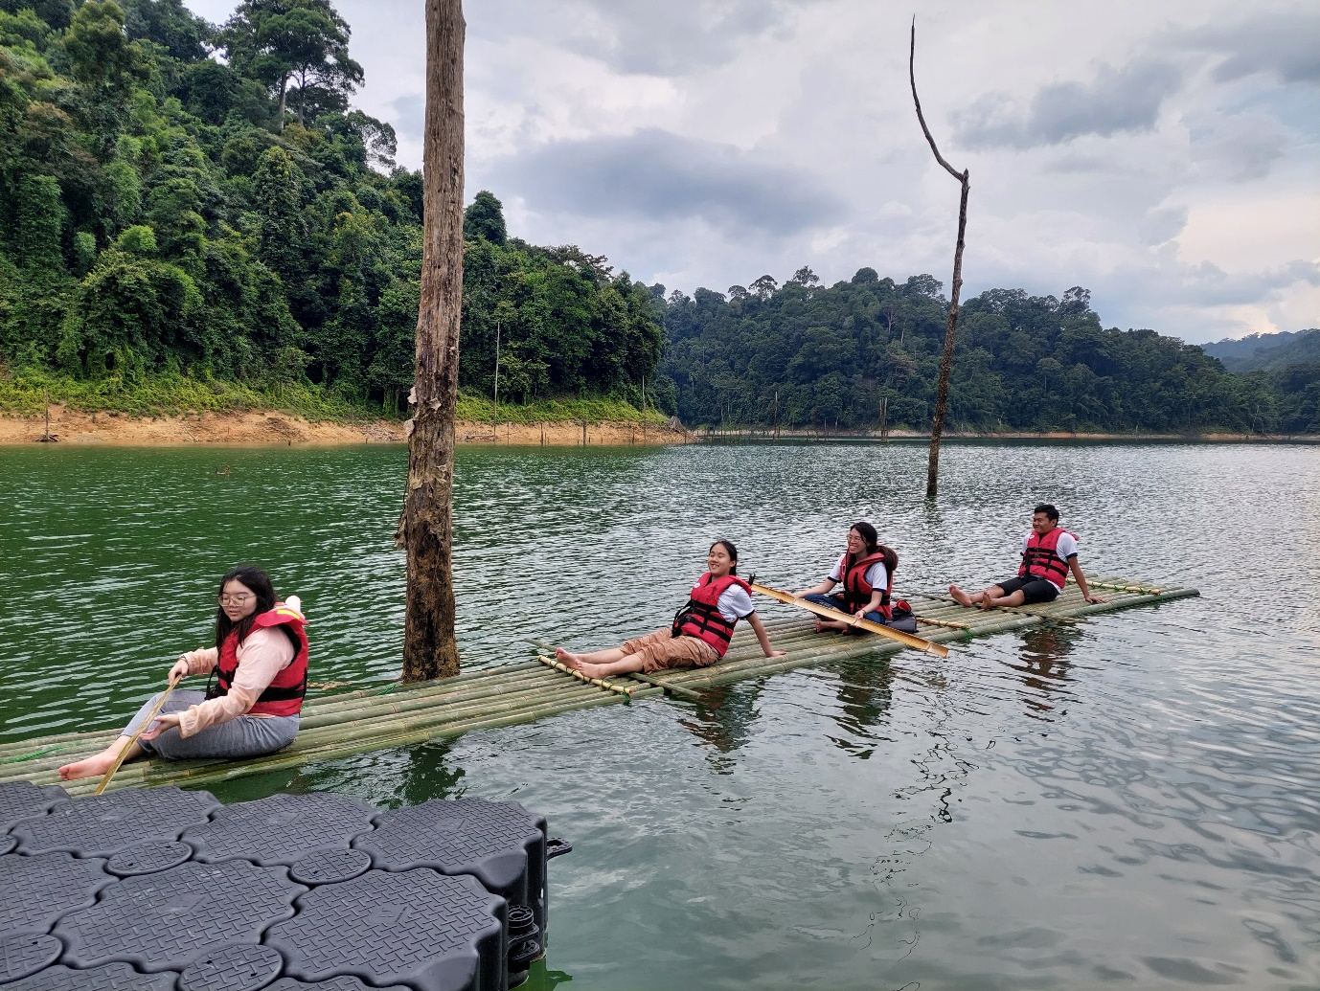

Students enjoying bamboo rafting

Dr Anthony Tee enthused, “The field trip to Royal Belum State Park provided students with invaluable experiential learning opportunities, significantly enriching their understanding of conservation and ecotourism. The park’s rich biodiversity and cultural heritage, alongside its commitment to sustainable tourism practices, offered a holistic view of the intricate balance between ecological preservation and economic development. This immersive experience highlighted the critical need to protect natural habitats while fostering responsible tourism that respects and integrates local cultures. The visit underscored the importance of harmonising environmental conservation with sustainable development, equipping students with the insights and appreciation necessary for future stewardship of our natural and cultural resources.”

Discussion on potential collaborative impactful community engagement programmes between UTAR, Perak State Park Corporation and the Koperasi Orang Asli Sungai Tiang (KOAST) was also held, with emphasis on training in cooperative management, accounting procedures, tourism product development and marketing, and conservation efforts. The initiatives, which also align with multiple Sustainable Development Goals (SDGs), will not only support sustainable community development but also provide valuable practical learning opportunities for students and academia, fostering potential research collaborations and enhancing the overall impact of the initiatives.

The SDGs included:

• SDG 1: No Poverty – By empowering the Jahai Community Cooperative with skills and knowledge, we aim to enhance their economic opportunities and reduce poverty.

• SDG 4: Quality Education – The training programs will provide valuable educational resources and practical learning experiences for community members, fostering lifelong learning.

• SDG 8: Decent Work and Economic Growth – Through improved cooperative operations and tourism product development, the collaboration seeks to create sustainable economic growth and decent job opportunities.

* SDG 11: Sustainable Cities and Communities – Efforts in tourism product development and conservation will contribute to the creation of sustainable communities and the preservation of local heritage.

• SDG 12: Responsible Consumption and Production – Conservation efforts and sustainable tourism practices will promote responsible use of resources and reduce environmental impact.

• SDG 13: Climate Action – By integrating conservation efforts, the collaboration will help address climate change and its impacts on local ecosystems.

• SDG 15: Life on Land – The focus on conservation aligns with the goal of protecting and restoring terrestrial ecosystems, combating desertification, and halting biodiversity loss.