**Working together for a healthier and cleaner life**

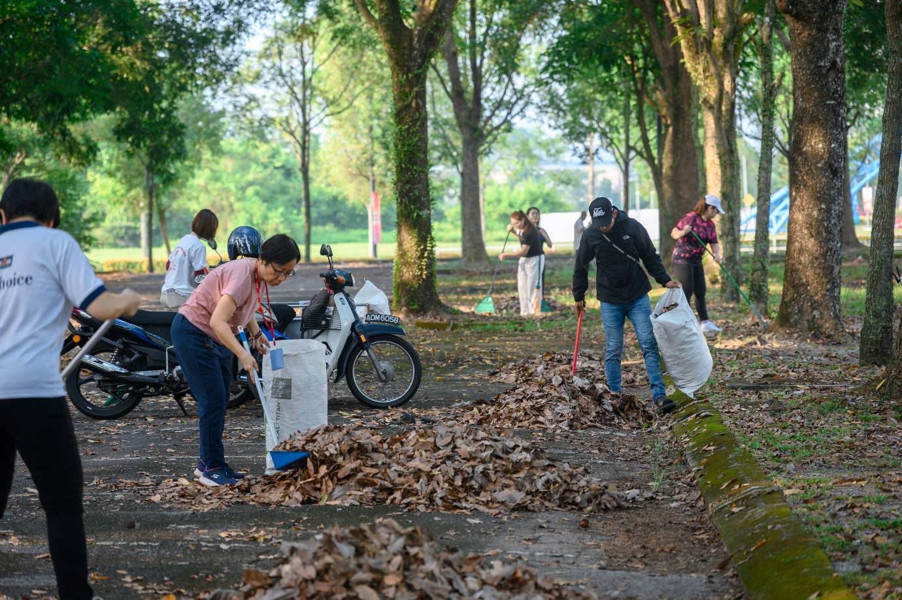

Staff members gathering the fallen dried leaves at the selected parking area

In support of the initiative by the Ministry of Higher Education (MOHE) to foster a culture of healthy living and environmental cleanliness, the Department of General Services (DGS) Kampar and the Division of Human Resource (DHR) Kampar jointly organised the “One Hour Malaysia Clean Up” activity on 12 August 2024 at UTAR Kampar Campus.

The “One Hour Malaysia Clean Up” initiative, part of the Strategic Plan of the Agenda Nasional Malaysia Sihat (ANMS) launched by MOHE, received strong support from 25 staff members who collaborated to clean a parking zone on campus that was covered in fallen leaves. This effort aimed to create a clean and welcoming environment for guests parking in that area during the convocation and to prevent these areas from becoming breeding grounds for Aedes mosquitoes.

Ms H’ng May Eng, the Head of DHR Kampar, expressed that the gotong-royong was an excellent way to bring staff together, fostering teamwork while allowing them to contribute to this initiative. She added that it was an enjoyable experience, as they were able to make a meaningful impact in keeping the campus clean while also getting some light exercise.

The next “One Hour Malaysia Clean Up” is set to take place in November at UTAR Kampar Campus.

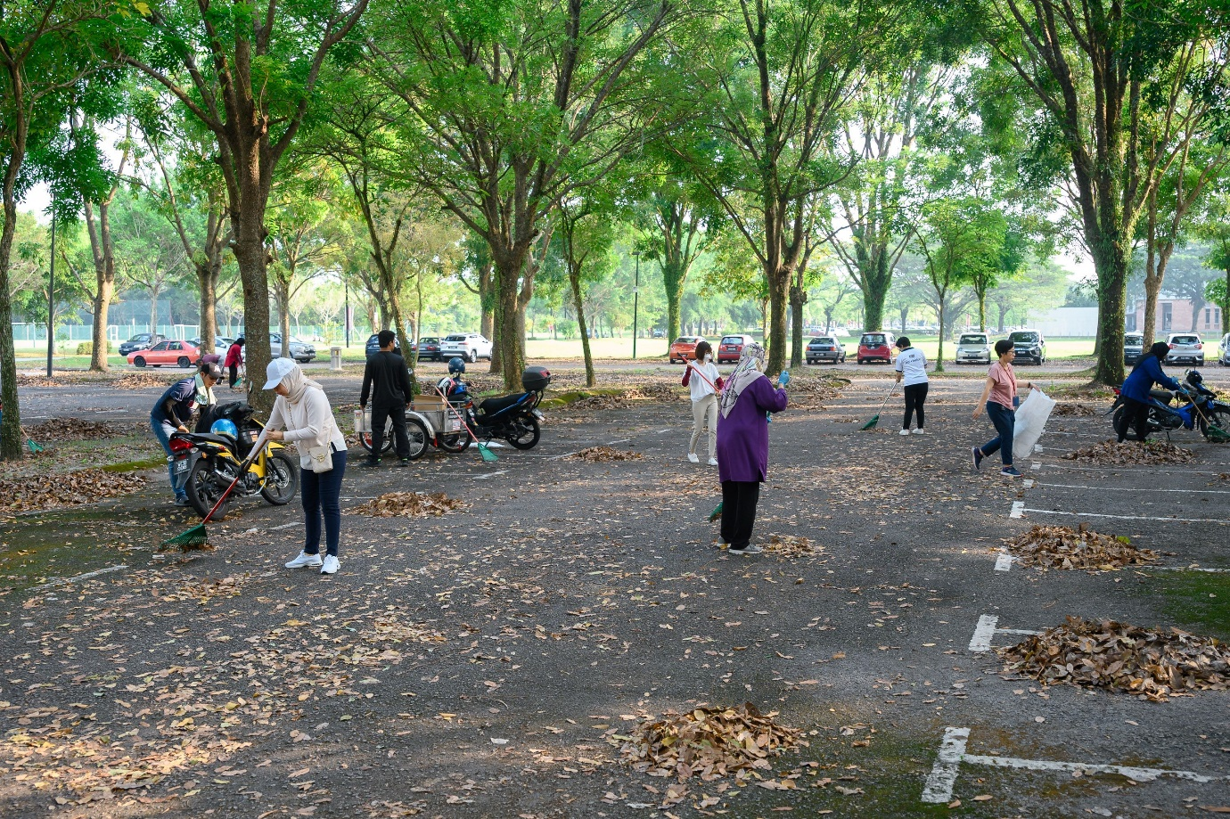

Working together for cleaner and healthier environment in campus

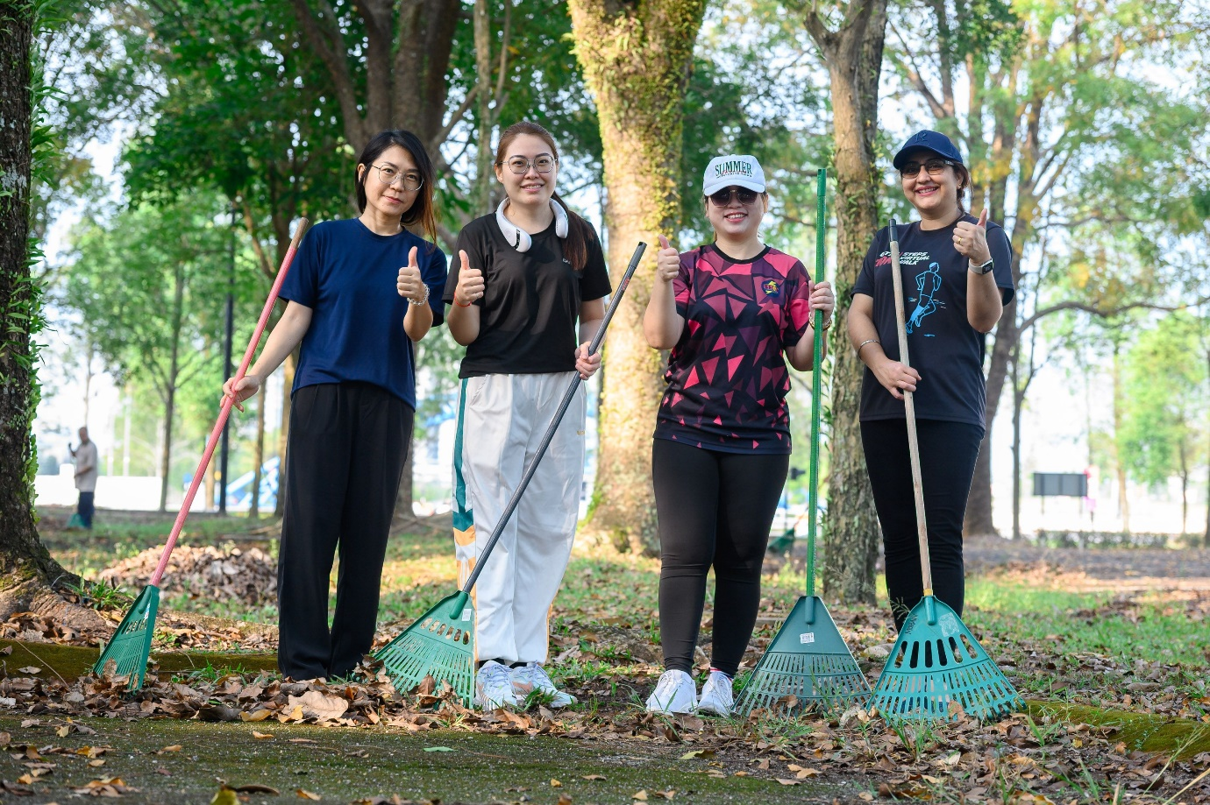

All smiles in support of the initiative