**Second SOHO Transnational Project Meeting marks another milestone**

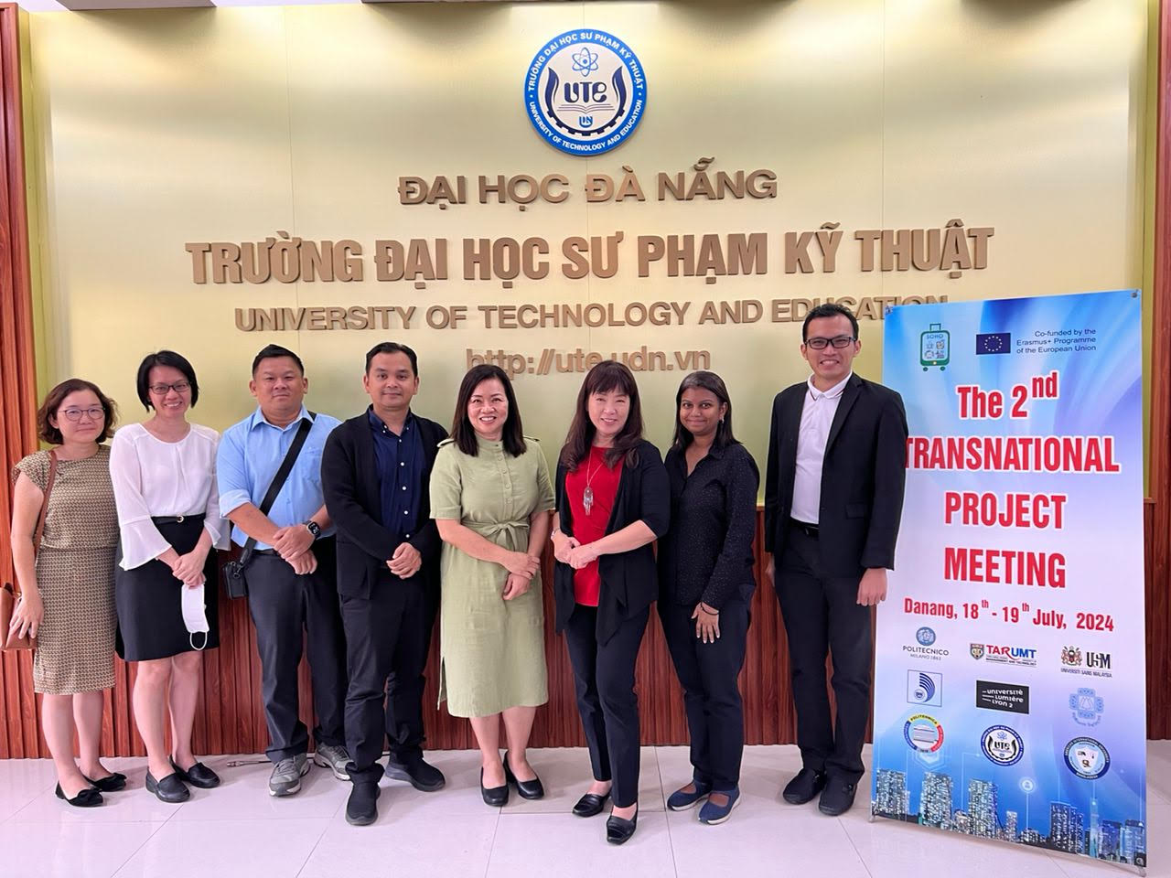

The team from Malaysia (from left): Prof Lau, Dr Lam, Mr Sim, Dr Khairi, Dr Seow, Prof Dato’ Dr Aileen Tan, Dr Annette and Dr Choong

Following a fruitful [first meeting](https://news.utar.edu.my/awards/2024/Mar/19/02/02.html), the members of the SOHO (Smart, Optimized, High-quality, and On-demand Tourism Innovative Education for Sustainable and Green Development) project, gathered once again to hold the second Transnational Project Meeting from 18 to 19 July 2024 at the University of Danang - University of Technology and Education, Vietnam.

The representatives of the project partners were warmly welcomed by the Vice Director of the University of Da Nang MA. Ho Long Ngoc, and the Vice Rector of the University of Technology and Education, University of Danang Assoc Prof Dr Võ Trung Hùng.

From left: Dr Võ Trung Hùng and MA. Ho Long Ngoc delivering their speeches

After that, a project overview sharing was conducted by Project Coordinator Prof Vladimir Tanasiev, who spoke about the project’s current state and progress, focusing on key milestones achieved. Vice-President of the National University of Science and Technology POLITEHNICA Bucharest Prof Dr Tudor Prisecaru was also one of the representatives of the POLITEHNICA Bucharest team. The session continued with a discussion on research and analysis for training needs in connection to the curriculum design phase. Other discussed matters included state-of-the-art activities, responsibilities, and upcoming deadlines. Participants offered valuable feedback and took part in discussions to improve the project deliverables, ensuring thorough coverage of all aspects.

The second day focused on creating training materials for tourism industry learners, which included modules on smart transportation, sustainable accommodation, and renewable energy. The finale of the meeting saw the team summarising the main achievements, positive aspects, and areas for improvement, as well as allocating tasks and responsibilities among partners; setting the stage for the next phases of the project.

At the gala dinner hosted by the University of Danang—University of Technology and Education, Prof Võ Trung Hùng expressed, “It is an honour to hold such a pivotal event, which I believe will contribute to advancing innovative education for sustainable and green development in the tourism industry.”

The SOHO project included participants from nine universities across six different economies, namely Romania, France, Italy, Bangladesh, Vietnam, and Malaysia. Eight representatives of the Malaysian teams, including four members from Universiti Sains Malaysia (USM) and four from UTAR, were invited. UTAR representatives present were Institute of Postgraduate Studies and Research (Kampar Campus) Assoc Prof Dr Choong Yuen Onn, Faculty of Business and Finance (FBF) academics Prof Dr Lau Lin Sea, Dr Lam Siew Yong, and Dr Seow Ai Na, who played key roles in facilitating discussions, collaborative efforts, and mapping out clear roadmaps for future activities. The other two members of UTAR were Vice President for Student Development and Alumni Relations Prof Dr Choong Chee Keong, and FBF Deputy Dean for R&D and Postgraduate Programmes Prof Dr Abdelhak Senadjki.

UTAR team members, from left: Prof Choong, Dr Choong, Dr Seow, Dr Lam, Prof Lau and Prof Abdelhak

Group Photo Session