**CFS Kampar dedicates effort to nurturing future leaders**

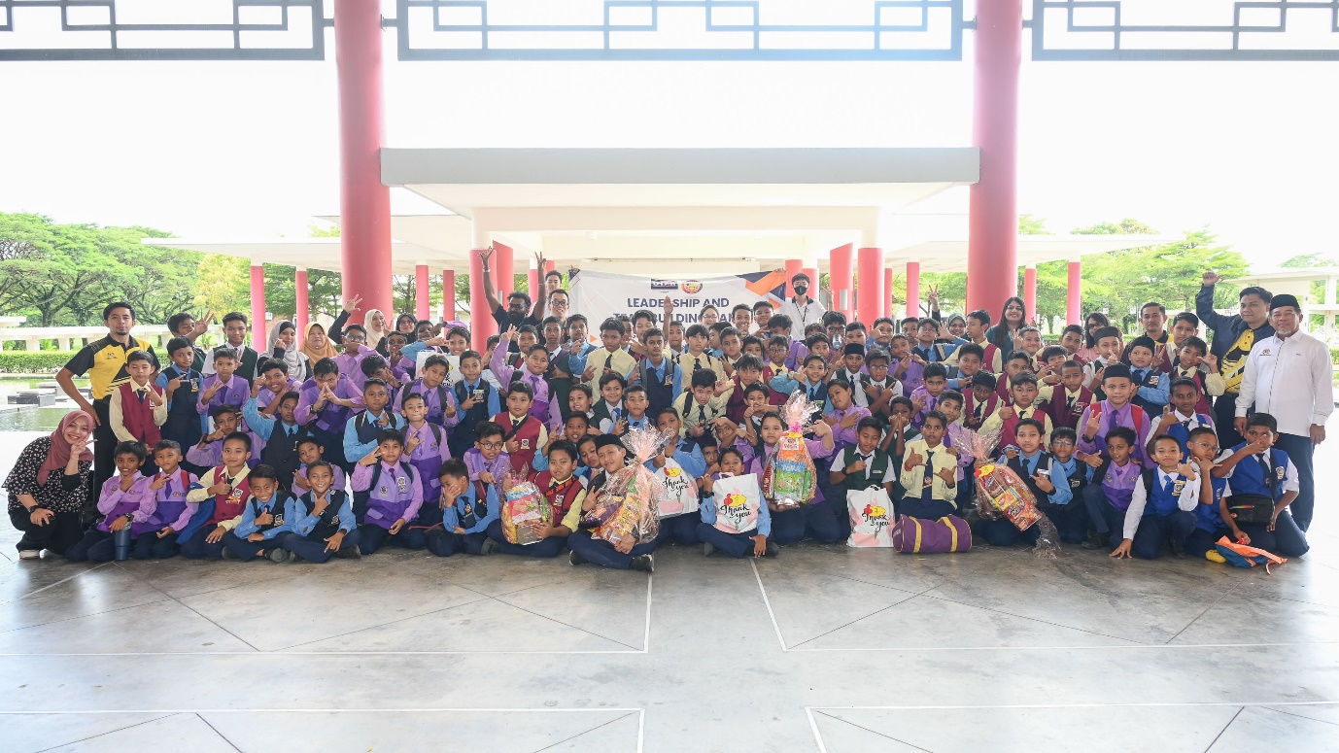

Participants and the organising committee at the end of event

The young generation of today is the future leader of tomorrow— was emphasised by the Centre for Foundation Studies (CFS) in Kampar when they organised the Leadership and Teambuilding Camp on 21 August 2024 at UTAR Kampar Campus.

The aim of the event was to nurture the 115 participants of Sekolah Kebangsaan Sultan Yussuf, Batu Gajah to be capable leaders who will potentially lead change, drive innovation, and progress societal evolution. They were accompanied by their Headmaster Tn Hj Mohd Fadli bin Hj Abu Bakar and school teachers.

The camp kick-started with an opening ceremony. Organising Chairperson and CFS academic Puan Muniroh binti Salleh said, “Leadership plays a crucial role in society, including within schools. Hence, we organised this camp to enhance the participants’ leadership skills. Additionally, we also aim to enhance teamwork, communication and problem-solving skills, and boost their self-confidence.”

Department of Arts and Social Science Head Ms Pakialetchumy Antoni encouraged, “All of you are the future leaders, but leadership is not just about being able to lead. Leadership also includes your ability to work well with others and solve problems effectively. It is a skill that will test your confidence and your ability to cope with others, whether in problem-solving or team dynamics.” She expressed hope that this camp would help participants refine these skills and grasp the significance of cultivating leadership qualities.

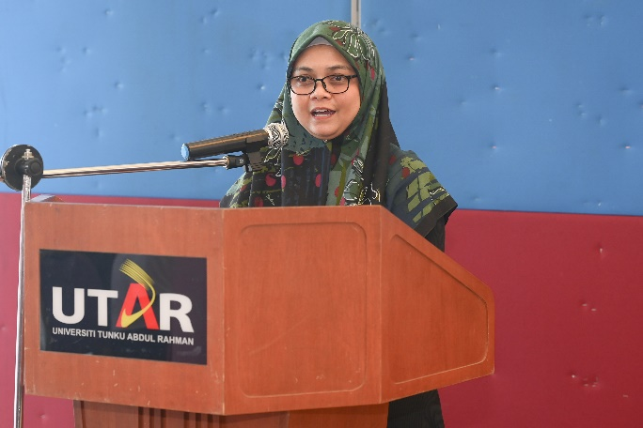 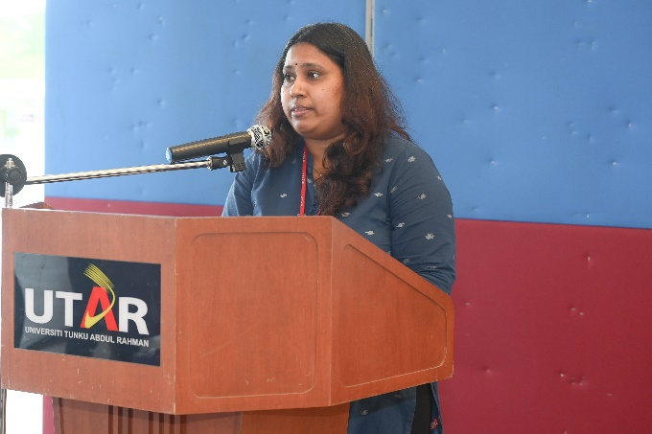

From left: Puan Muniroh and Ms Pakialetchumy highlighting the importance of leadership skill

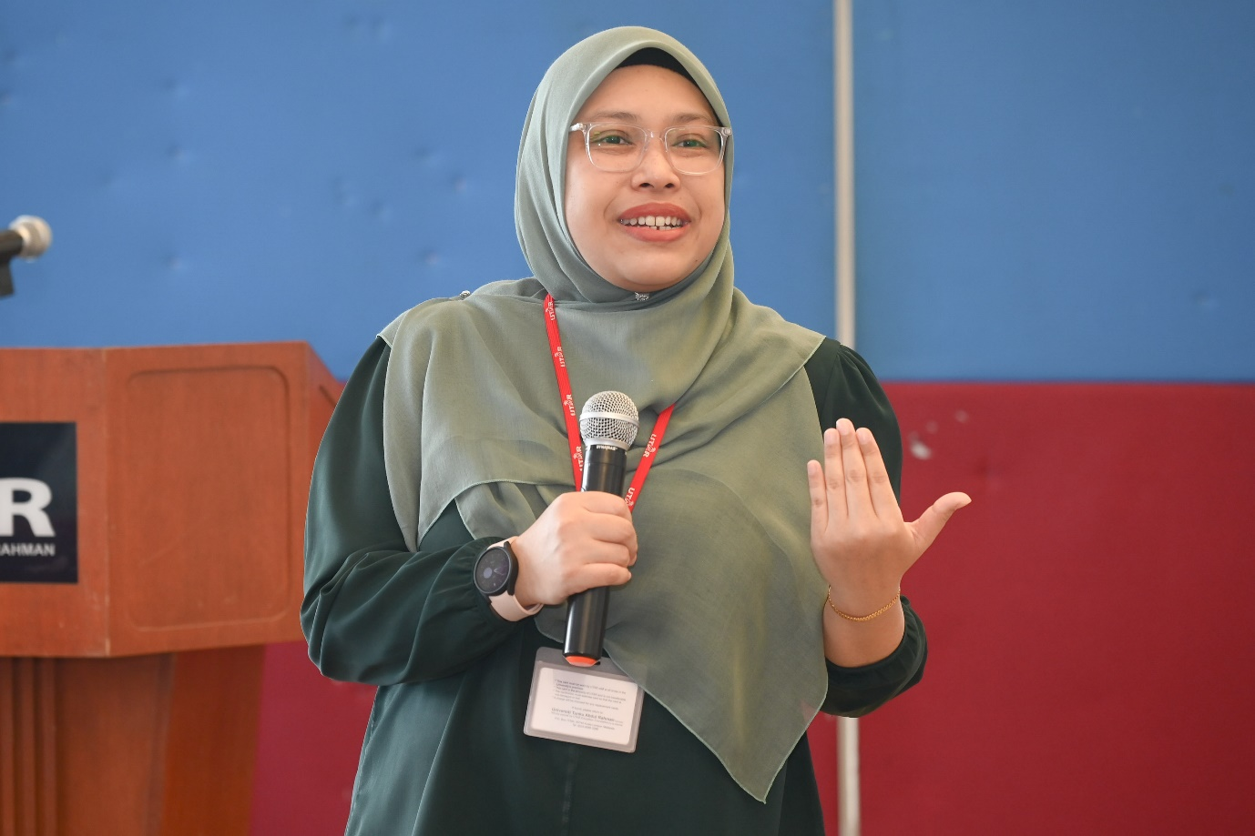

Puan Noor Aina explaining the qualities of leadership

Following was a talk on “Leadership Qualities” by CFS academic Puan Noor Aina Farhana binti Zulkifli. She defined what it means to be a leader and outlined key leadership traits, including integrity, responsibility, courage, effective communication, teamwork, and setting a positive example. Participants also learnt about skill development, which involved increasing one’s self-confidence, managing time effectively, preparing for future challenges, adaptability, and personal growth. To further develop one’s leadership skills, the speaker advised participants to participate in external activities to increase exposure and awareness, practise effective communication, actively participate in curriculum activities, and engage in self-reflection.

The highlight of the event was the group activities that were designed to strengthen teamwork, hone leadership skills, enhance communication, and foster mutual understanding. At the end of the event, Tn Hj Mohd Fadli thanked UTAR for organising this enlightening event, and advised his students to be mindful of the lessons learned about being a good leader.

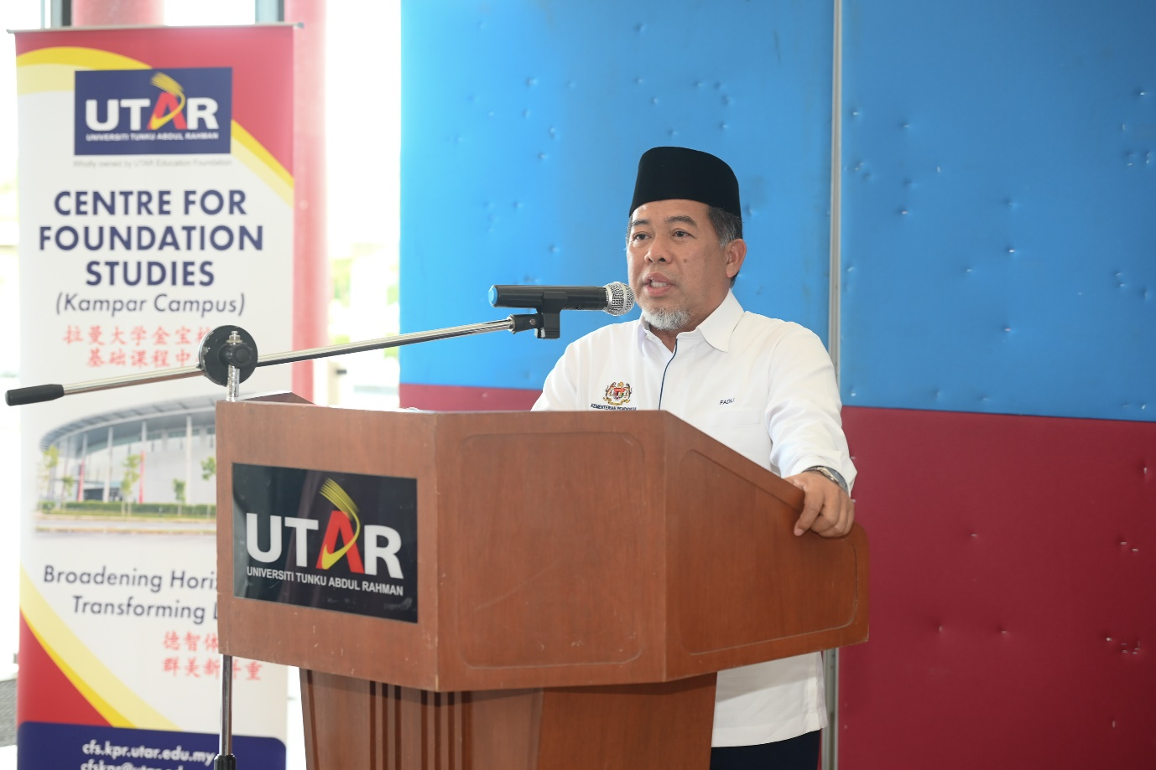

Tn Hj Mohd Fadli thanking UTAR for the enlightening session

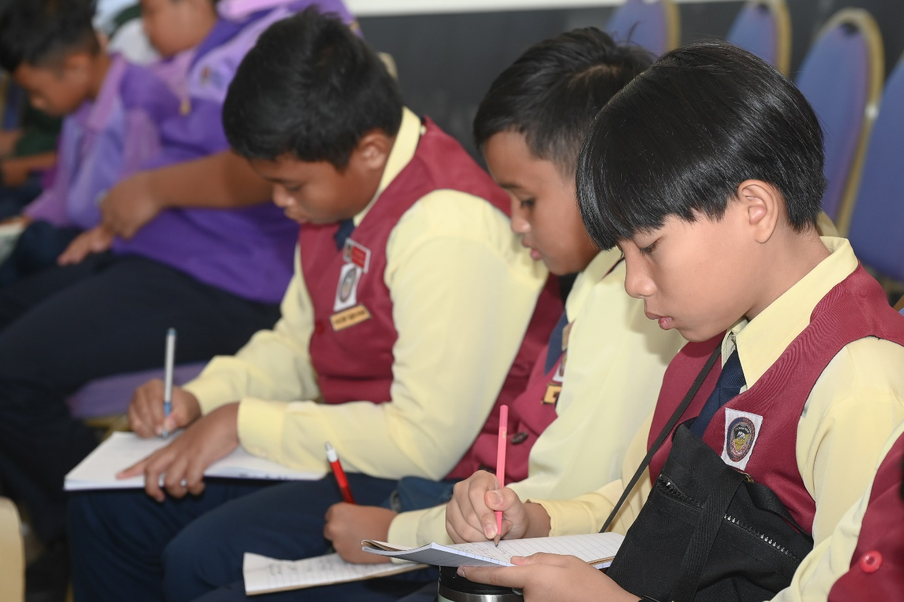 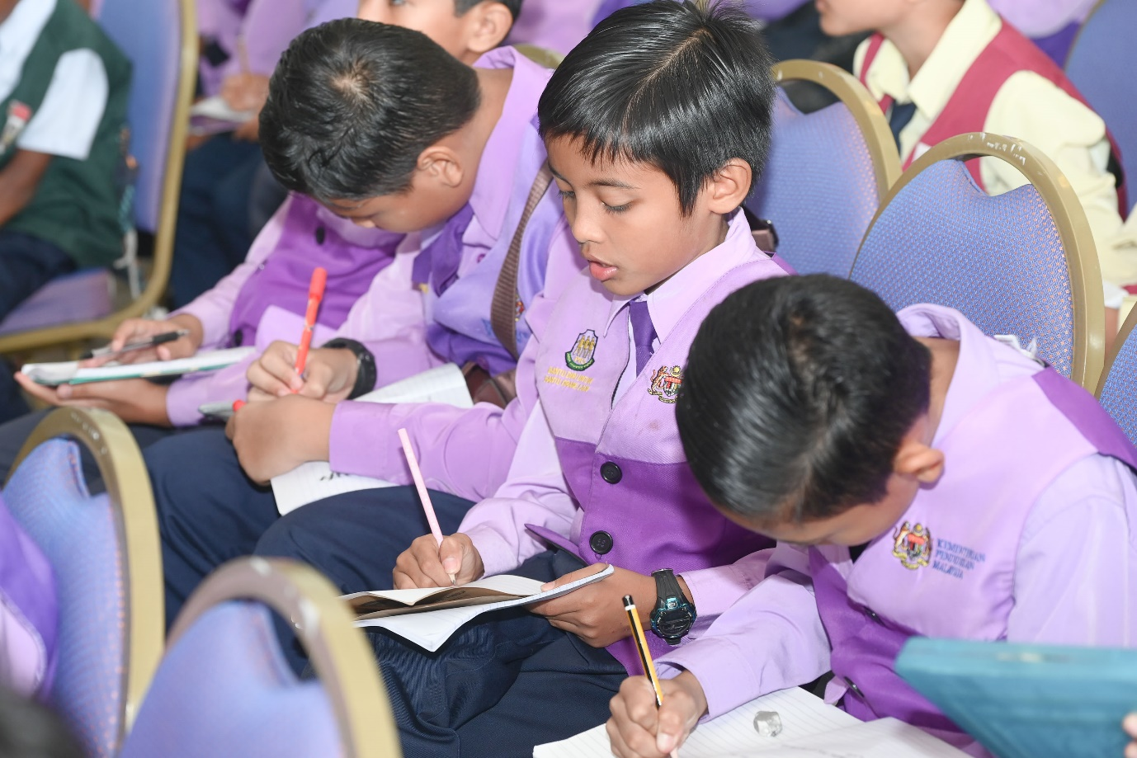

Participants taking down notes during the talk

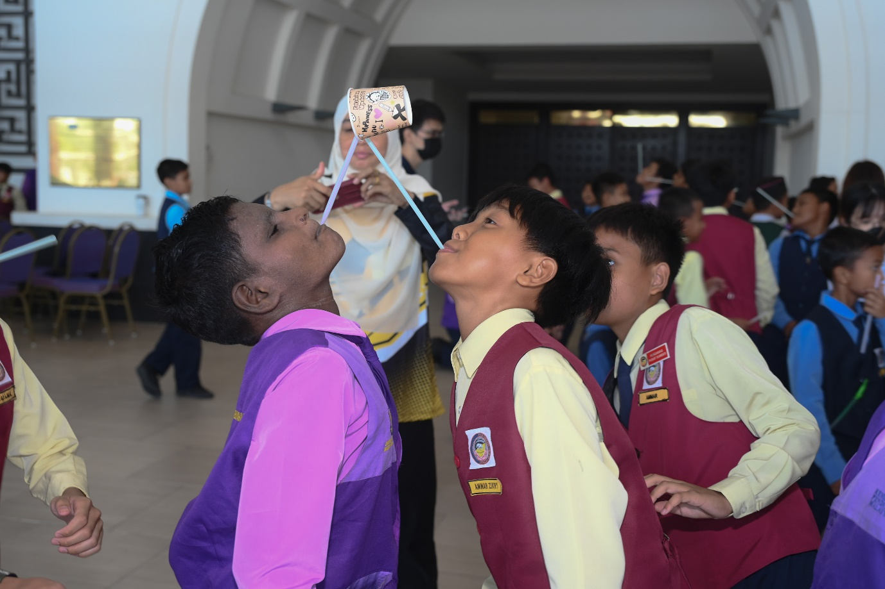 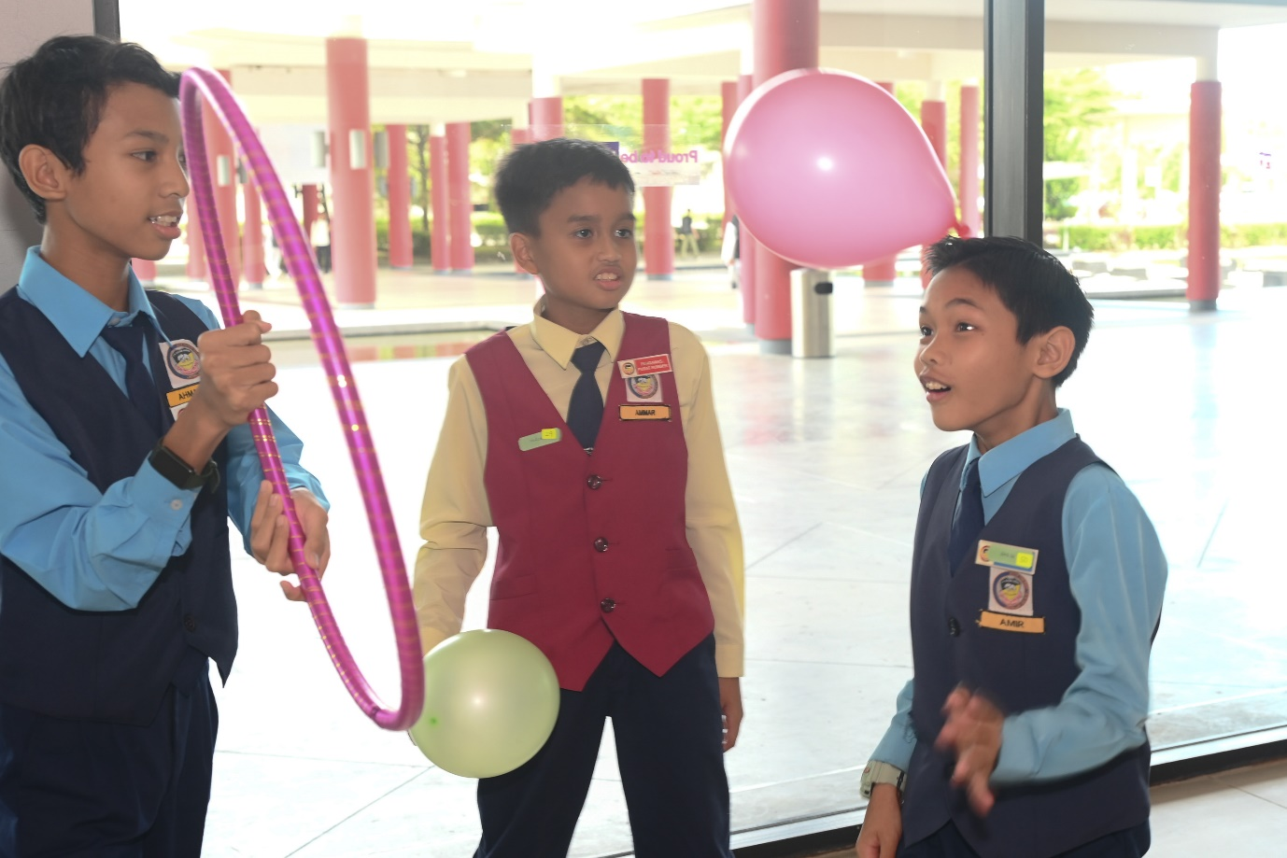 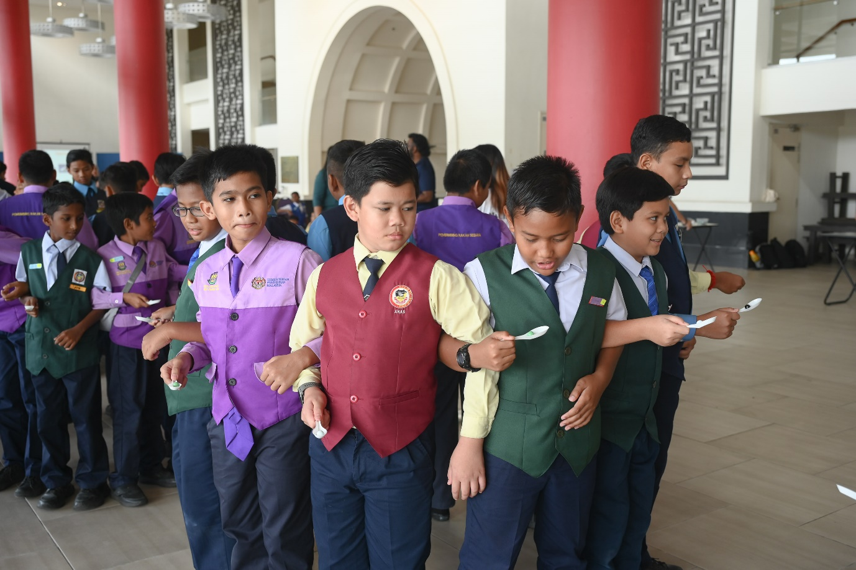 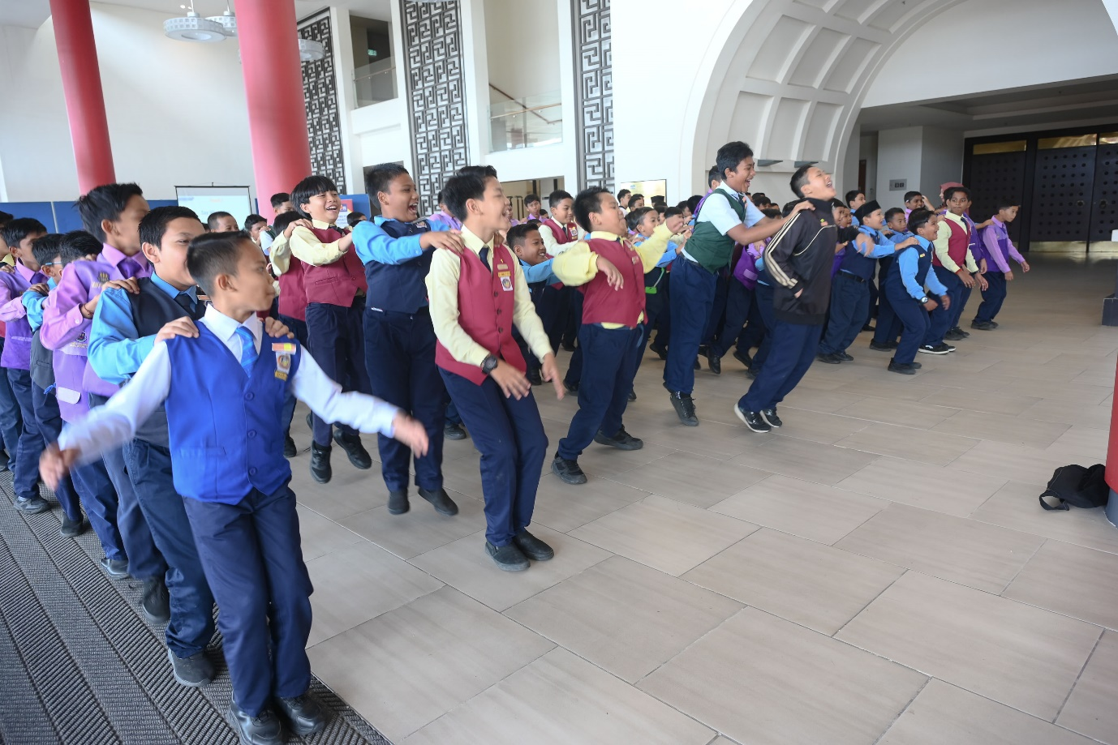

Participants enjoying the group activities