**Mind Competitions 2024 showcases mental prowess**

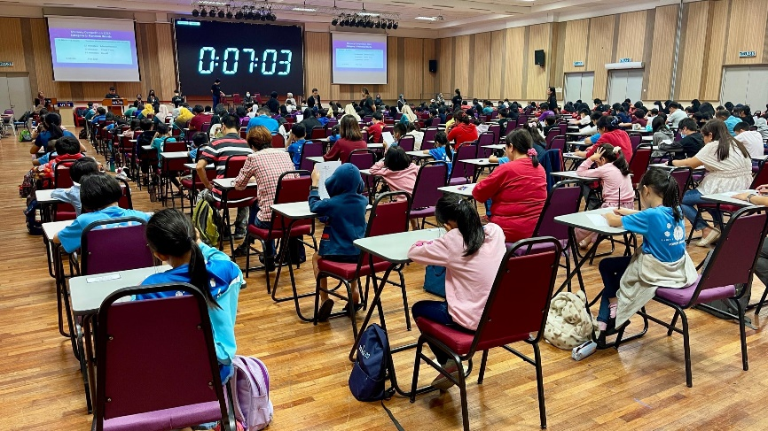

Participants taking part in the memory competition

It was a test of their abilities for participants of the Mind Competitions 2024, held on 29 June 2024, simultaneously at UTAR Kampar Campus, UTAR Sungai Long Campus, and Tunku Abdul Rahman University of Management and Technology (TAR UMT). It was jointly organised by Malaysia Mental Literacy Movement (MMLM), UTAR, and TAR UMT, in collaboration with Kuala Lumpur Engineering Science Fair (KLESF). The competition drew an impressive 880 participants, ranging from age 6 to 79 years old, showcasing a remarkable diversity of talent and enthusiasm this year.

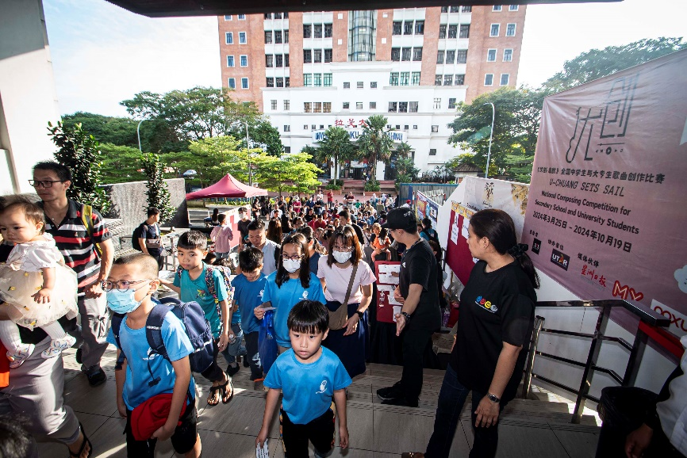

Huge crowd at the event

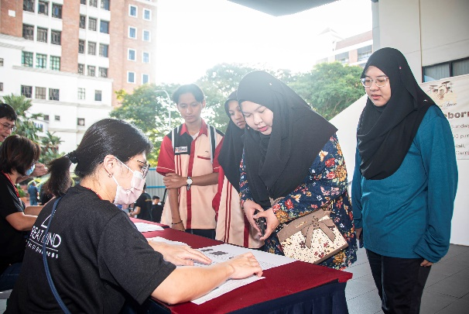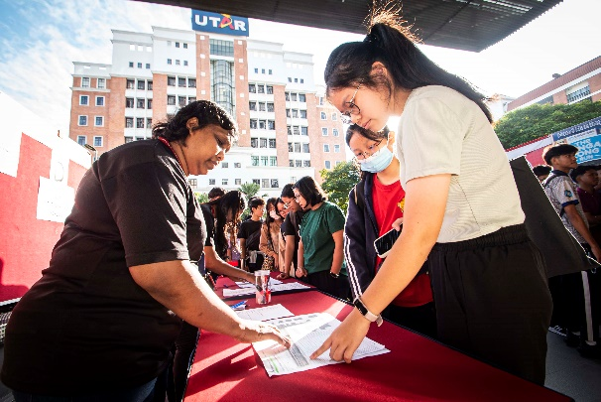

Registration of participants

Driven by intellect and ambition, the individuals embarked on a journey to showcase their skills, as they participated in the Memory Competition, Mind Mapping Competition, and Mental Calculation Competition. The Memory Competition consisted of four categories – Random Words, Random Numbers, Dates & Events, and Random Letters of the Alphabet. Mind Mapping Competition required participants to complete the mind mapping from written text, and free-style creative mind map. In the Mental Calculation Competition, participants were seen completing questions involving mental additions and mental multiplications.

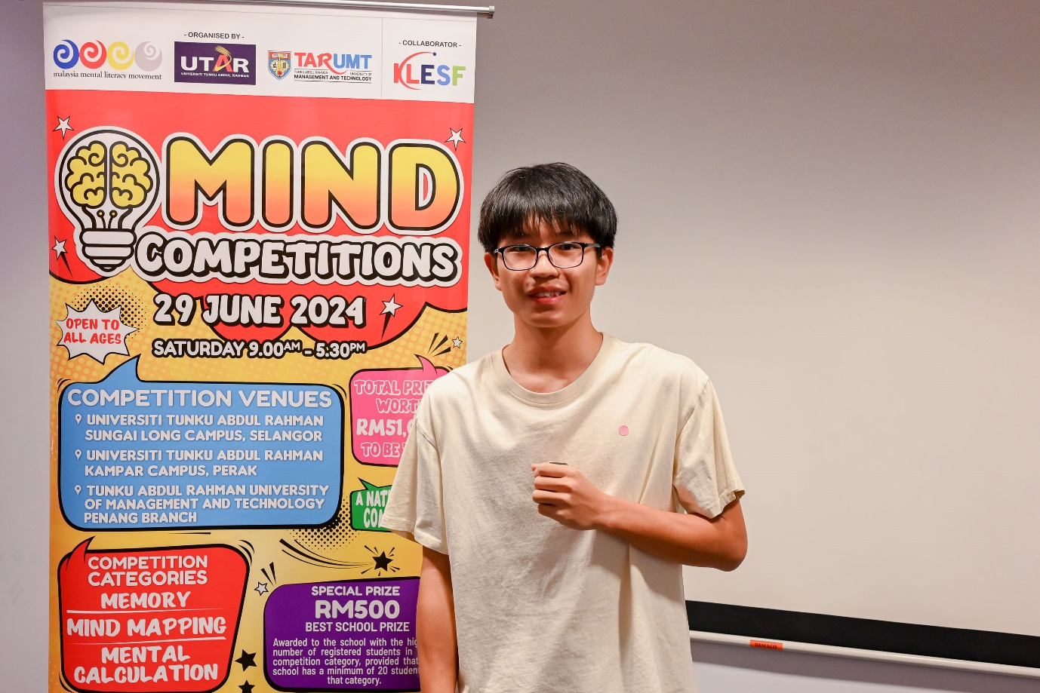

Morton Lai feeling happy to participate again

Morton Lai Jin Hui, a student of SMK Sam Tet responded, “I am glad for this opportunity to showcase my skills and abilities. This is my second time participating in the Mind Competitions. I practised using the mock papers daily during my free time. I am genuinely pleased that my hard work has paid off.”

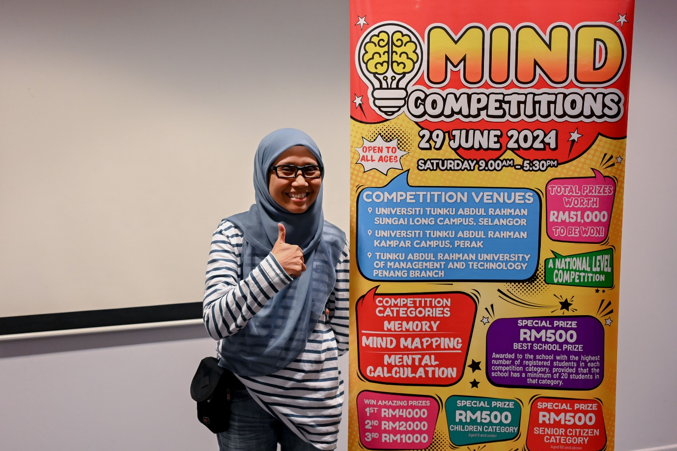

Ms Nur Shahirah feeling confident with her memorisation skill

Ms Nur Shahirah binti Yahya expressed, “I joined this competition because I wanted to know the level of my mind at my current age of 36 years old. The Memory Competition was my favourite because it highlighted my strength in memorisation.”

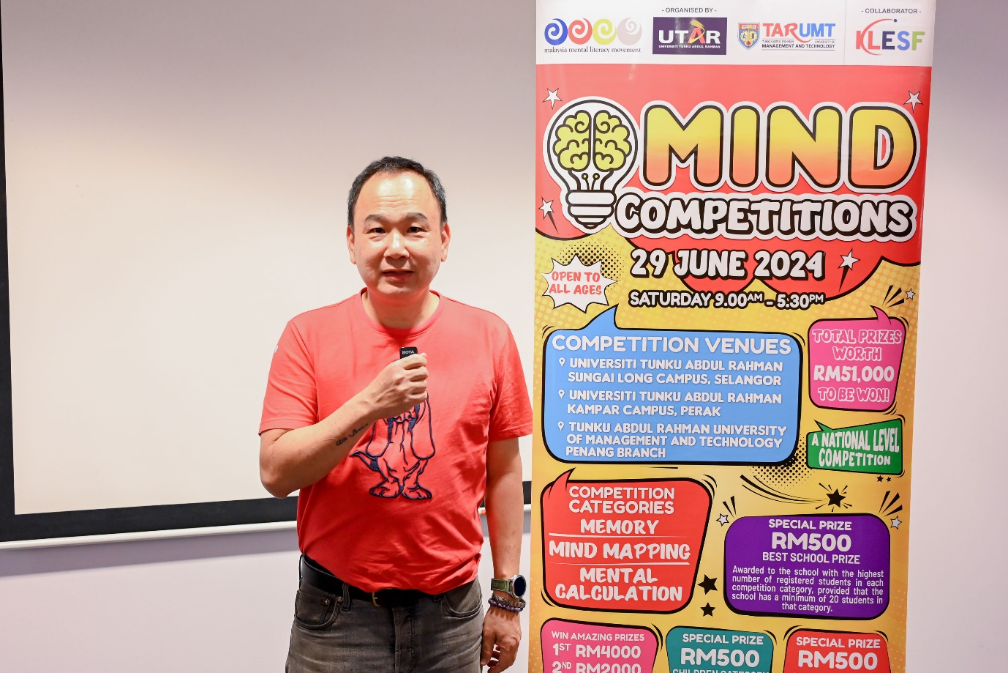

Mr Chin, an advocate of mental literacy

Meanwhile, Mr Chin See Yap commented, “Mental literacy is important. My participation goes beyond testing my mental abilities, it also supports the promotion of mental literacy for all ages. It is also interesting to join this competition in an educational institution, as it feels like a nostalgic return to my school days.”

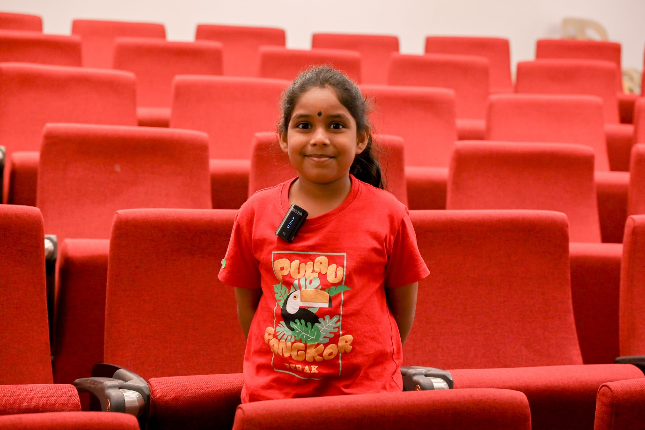

Varanya, who like numbers

A seven-year-old participant Varanya Sree Gunalan said, “This is my first time joining the competition. I participated in the competition because I wanted to test my mind, and so I practised at home with the guidance from my parents. I love numbers, and I am glad to be able to participate in the random number category.”

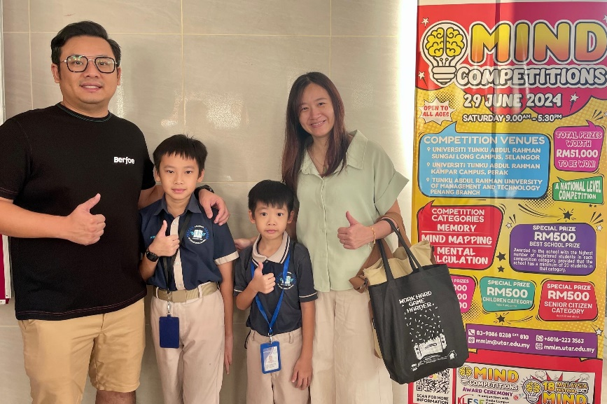

From left: Mr Anthony Leong, Damian Leong, Darren Leong, and Ms Fanny Wong

Eleven-year-old Damian Leong and seven-year-old Darren Leong joined to gain competition experience. Their parents, Mr Anthony Leong and Ms Fanny Wong, shared that they went through the sample provided by the school to prepare for the competition. As this is their first time participating, the focus was on gaining experience. Their mother, expressed excitement for them, emphasising the importance of participating and enjoying the process.

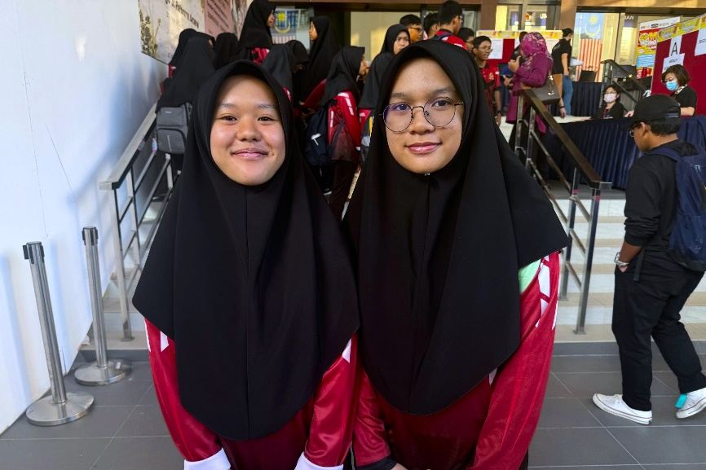

Sarah Arissa bt Mohd Ashraff (left) and Nur Najwa Syafia bt Mohd Usri

Sarah Arissa binti Mohd Ashraff and Nur Najwa Syafia binti Mohd Usri, both 16 years old from MRSM Terendak, joined the Mind Competition to try new things and gain experience. Sarah was particularly interested in the mind mapping competition, while Najwa wanted to gather as much experience as possible from participating.

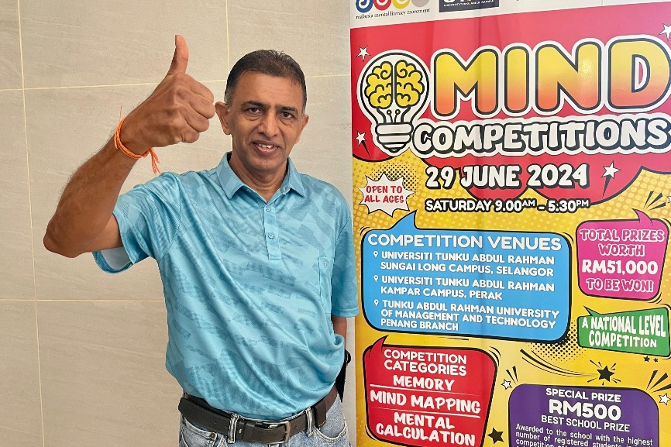

Mr Karunanidhy

Mr Karunanidhy, a 65-year-old retiree who previously worked at Standard Chartered Bank, has long been interested in participating in this competition after seeing it advertised in newspapers. Despite past commitments, he made a point to join this year, even returning from travel specifically for the event. He said, “The only way to keep your mind active is to participate in a lot of activities, particularly those that challenge the mind.” For him, the competition was an opportunity to engage with younger participants, which made him feel invigorated and energised. He enjoyed the university atmosphere, saying, “Being at a university makes you feel youthful,” and he values the experience and interaction with younger individuals, regardless of the competition's outcome.

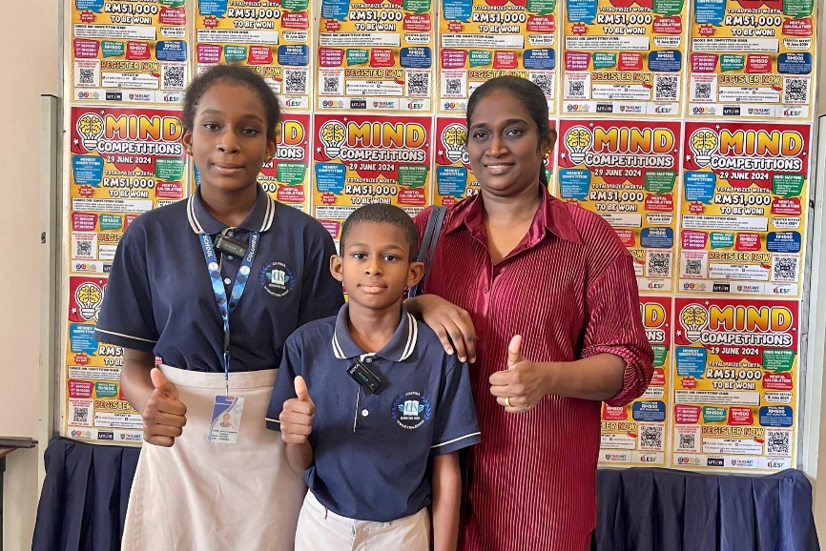

From left: Favour, Prince and Ms Ananthi

Twelve-year-old Favour Chinemerem Nwakaire and nine-year-old Prince Goodluck Chukwuma Nwakaire from Columbia International School decided to join the competition because they wanted to try something new. Their mother, Ms Ananthi, explained that the school selected them and provided materials to help them understand the competition. She prepared them based on this information and encouraged them to participate, viewing it as a new experience for them to try.

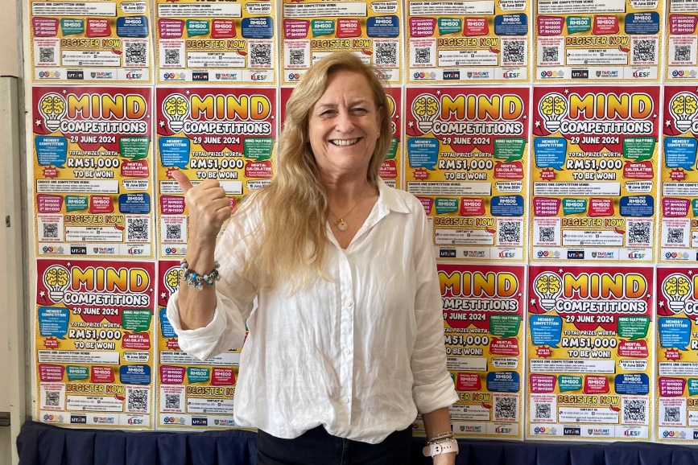

Ms Nicki Coombs

Nicki Coombs, the principal of Beaconhouse Sri Inai International School in Malaysia since 2014, ~~she~~ was also a participant in all categories of the competition. She said, “I've given it a try. It's been a long time since I was in school and an exam room. You never know when you might discover a passion you missed out on, but that could become something you truly excel in.” She encouraged her students to participate in the mind competition to showcase their skills and learn from the experience, emphasising that it’s not always about winning but about the journey and the lessons they can apply to other areas of their studies or careers. She advised her students to “give it a try” and not be afraid.

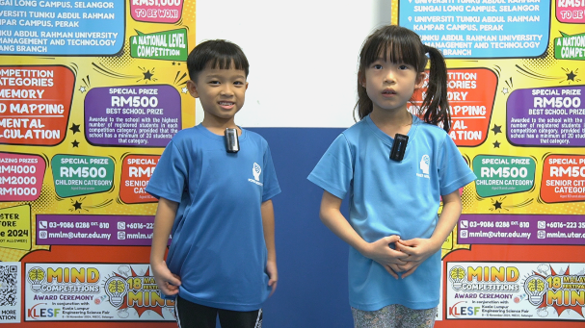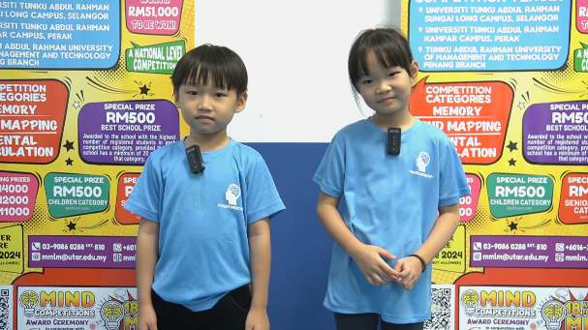

The competitions saw the participation of children as young as six years old

The annual competitions were open to all age groups, from pre-school children to university students, and from working professionals to retirees. The competitions were beacons of opportunity for participants, and aimed to encourage participants to utilise their memory skills, mind mapping, and mental calculation abilities.

A total of RM51,000 worth of prizes were up for grabs. The top three winners will walk away with RM4,000, RM2,000 and RM1,000 respectively. The competition will also award three special prizes worth RM500 each to three special category participants. The three special categories include children category (for participant aged 9 and under); senior citizen category (for participant aged 60 and above) and best school prize category (for the school with the highest number of student registration).

The results of the winners will be posted on mmlm.utar.edu.my on 23 September 2024, and can be viewed online until 15 November 2024. The winners will receive email notifications and invitations to attend the award ceremony at the 18th Malaysia Festival of the Mind, held in conjunction with the KLESF 2024.

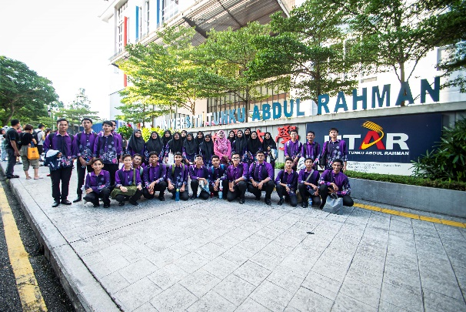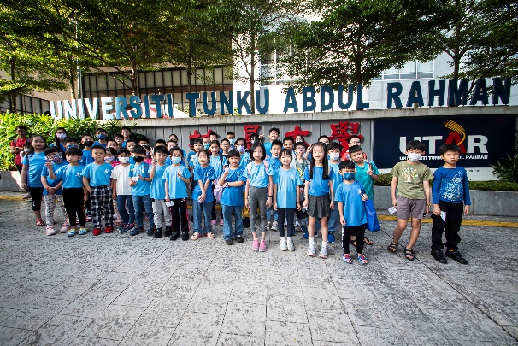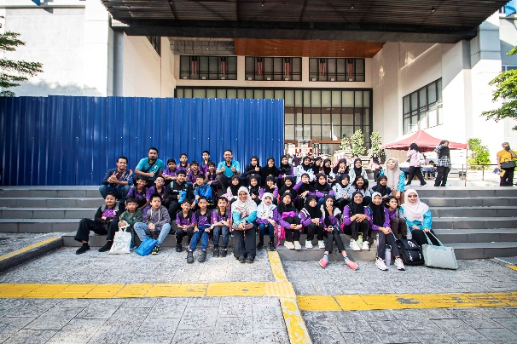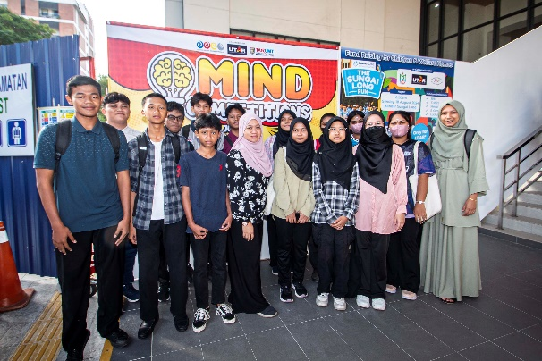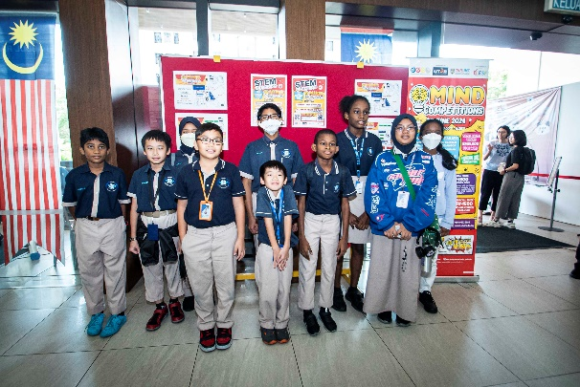

Participants from various institutes at UTAR Sungai Long Campus

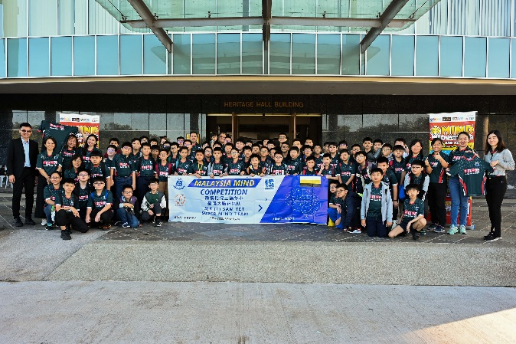 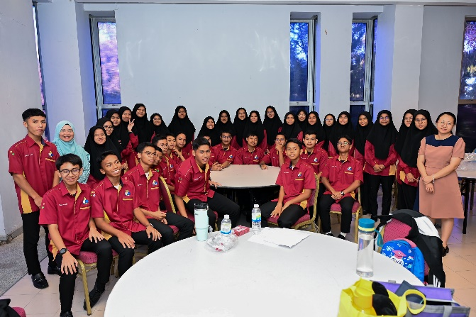 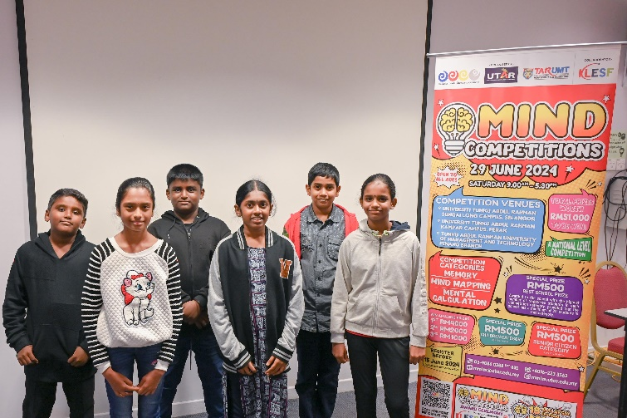

Participants from all over Perak at UTAR Kampar Campus

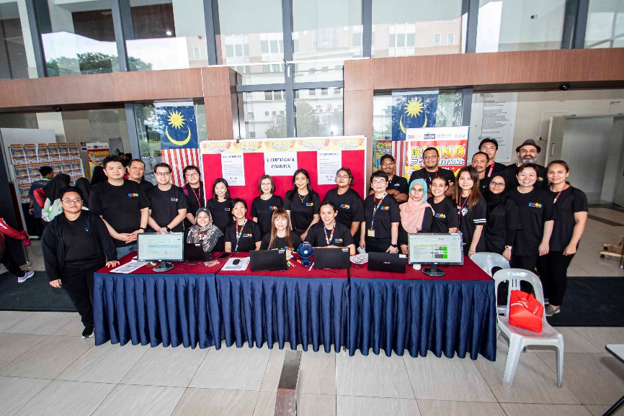

Working staff and organising committee of UTAR Sungai Long Campus

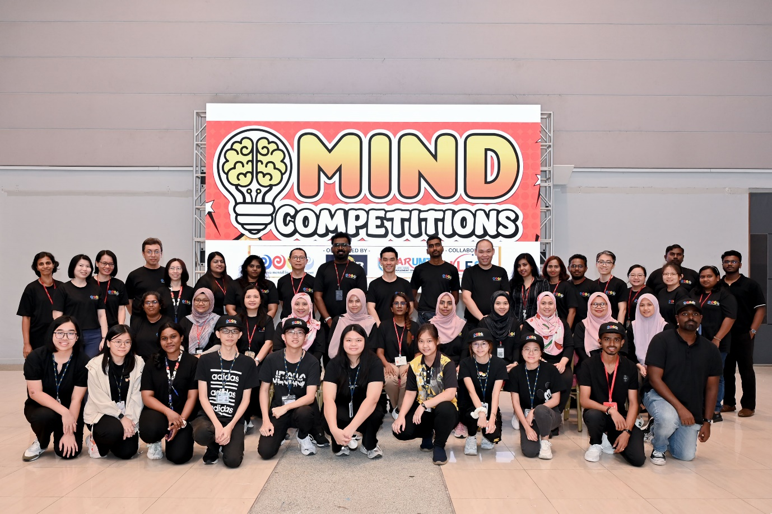

Organising committee of UTAR Kampar Campus