**Insightful exploration of media laws and content regulation**

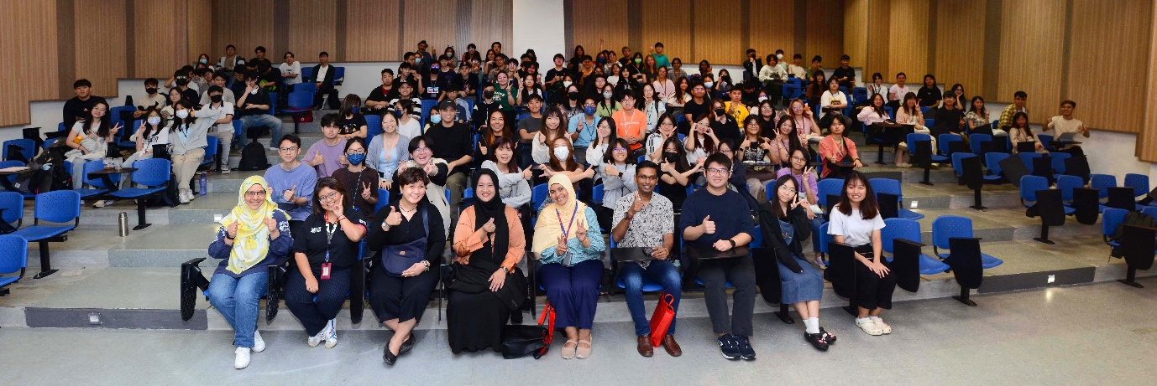

Front row, from left: Puan Iza, Ms Kor, Ms Foo, Puan Mediha, Puan Raja and Dr Rajini with participants

The Department of Media, which is parked under the Faculty of Creative Industries (FCI), collaborated with the Centre for Media and Communication Research (CMCR) to host an insightful event centred around the theme of “Self-Regulation, Censorship & Copyright” on 5 July 2024. The event was attended by 153 participants. The invited speakers were Malaysian Communication and Multimedia Content Forum (CMCF) Chief Executive Officer Puan Mediha Mahmood and FCI academic Dr Rajini Kumar Sreedharam.

Also present were UTAR FCI Head of Department of Media Mr Anthony Gandolfo Miranti Jr, and FCI academics Puan Raja Rodziah binti Raja Zainal Hassan, Puan Iza Sharina binti Sallehuddin, Ms Kor Eng Choon and Ms Foo Mei Lee.

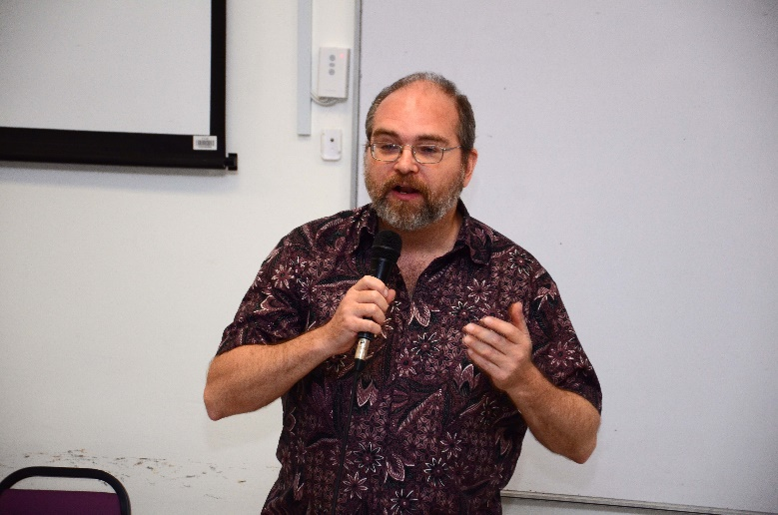

Mr Anthony presenting his speech

“It’s great to see so many people here and to see your interest in continuing to learn how to not only develop your content but also protect your content and yourselves in the future. It’s easy to get lost in the process of creation because it is the part we enjoy the most. This is where we feel the most rewarded and take the greatest ownership of our work,” Mr Antony said and added, “A part of yourself is always embedded in any work you do, and safeguarding that essence is crucial. It is important to be able to pursue the work you desire, taking pride and joy in your creations.”

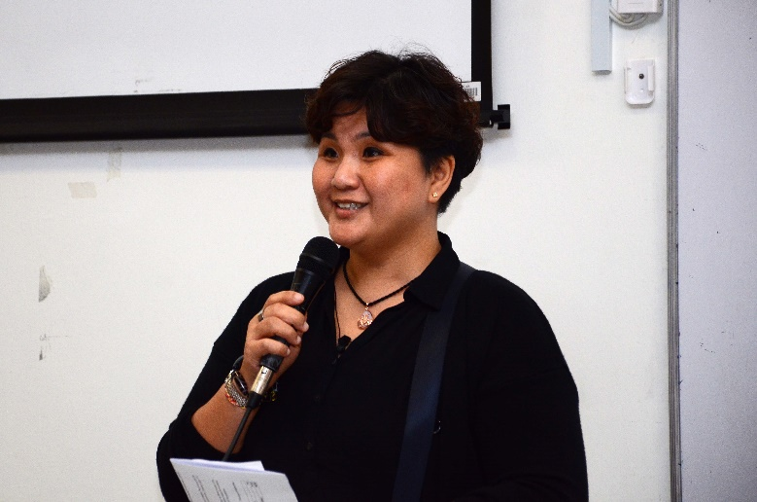

Ms Foo represented Dr Sharon to deliver the welcome speech

Ms Foo, who represented Dr A.W. Sharon Jacqueline, the chairperson of Centre for Media and Communication Research, delivered the welcome speech. She stated, “The theme of this talk, ‘Self-Regulation, Censorship, and Copyright,’ is both timely and critical. In an era where digital media permeates every aspect of our lives, the balance between freedom of expression and the protection of intellectual property has never been more important.”

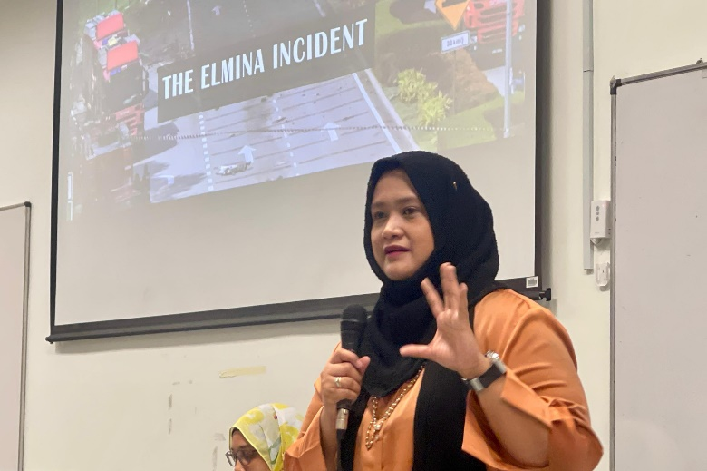

Puan Mediha

The first session, “Content Regulation in the Digital Age”, featured Puan Mediha Mahmood. She explained the importance of self-regulation, distinguishing it from censorship. Puan Mediha emphasised that self-regulation empowers individuals within the media ecosystem to manage the content they create. She said, “Self-regulation strives to encourage civil behaviour. We’re not here to find fault or impose tensions; we want the content to be better.” Puan Mediha highlighted that self-regulation is a shared responsibility for everyone.

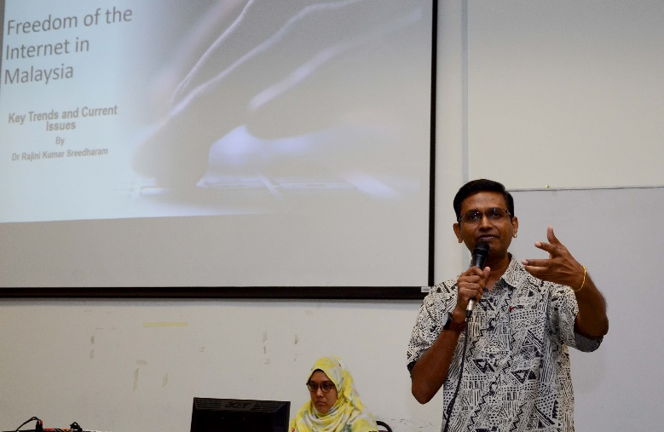

Dr Rajini

Following Puan Mediha’s session, Dr Rajini Kumar Sreedharam delivered a talk titled “Freedom of the Internet”. Dr Rajini provided an insightful overview of Malaysian media laws and their governance over the broadcasting and film industry, as well as media in general. Dr Rajini explained that while Article 10 upholds freedoms, it also includes provisions to prevent their abuse. He stated, “Clause 2 of the same article allows you to speak, present yourself, and express your views freely. However, there is a caveat: if your content falls under any protected elements, you could face consequences. You must avoid saying anything that can cause public disorder.”

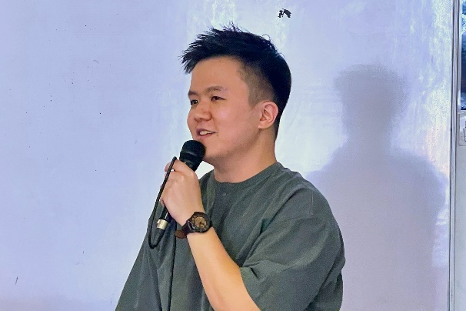

Mr Jacky Chong

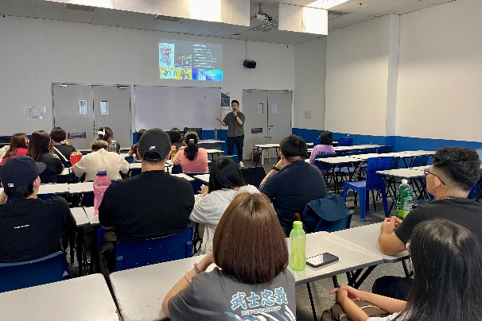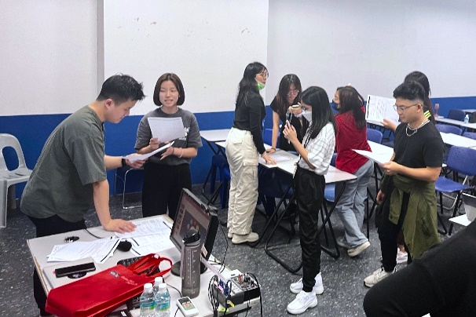

Mr Jacky Chong guiding the participants during voiceover session

Following the informative talks, the afternoon was dedicated to production workshops, which focused on media production tasks. The workshops were conducted simultaneously. One workshop included a voiceover session led by Mr Jacky Chong, a UTAR alumnus who is now a Music Director at the Astro radio station’s GOXUAN. Participants gained an understanding of the various skills required for voice-over work and had the opportunity to hear about Mr Jacky’s personal experiences in the industry.

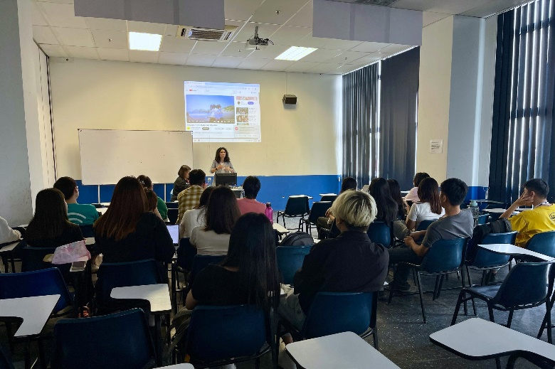

Ms Bethane interacting with participants

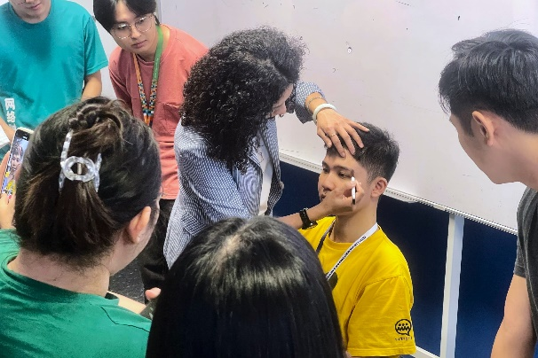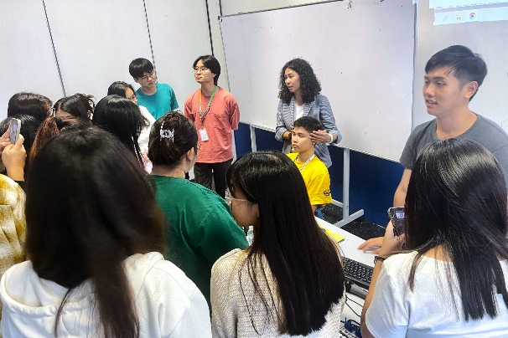

Ms Bethane demonstrating makeup techniques to participants

The other workshop was an image styling workshop conducted by Ms Bethane, a freelance makeup and wardrobe artist active in the film industry. Ms Bethane provided participants with valuable insights into the roles and responsibilities of a makeup and wardrobe artist in the film industry.

The event not only enriched students with a thorough understanding of responsible media practices but also provided practical insights into the dynamic field of media production.