Inspiring new Toastmasters members at Virtual Speech Workshop 2024
The UTAR Sungai Long Toastmasters Club and the Share & Inspire Toastmasters Club held a Virtual Speech Workshop on 8 June 2024. Organised by Dr Saraswathy Thurairaj, the current Area E Director, Chartered President, and Founder of Share & Inspire Toastmasters Club, and Mr Bryan Thong Meng Seng, the President of UTAR Sungai Long Toastmasters Club, the workshop aimed to provide comprehensive exposure to new Toastmasters members.
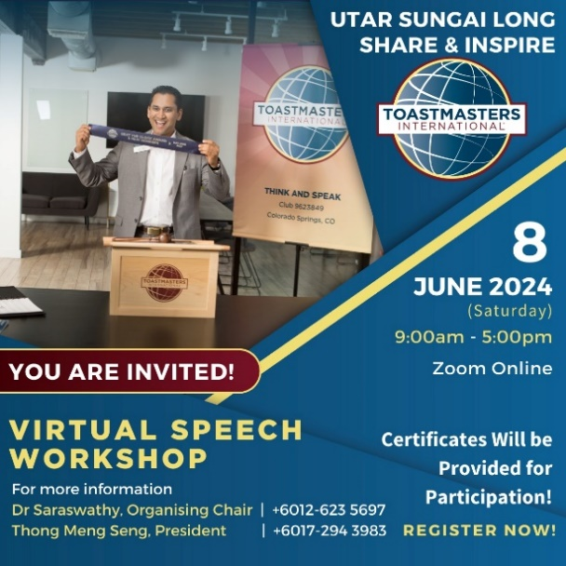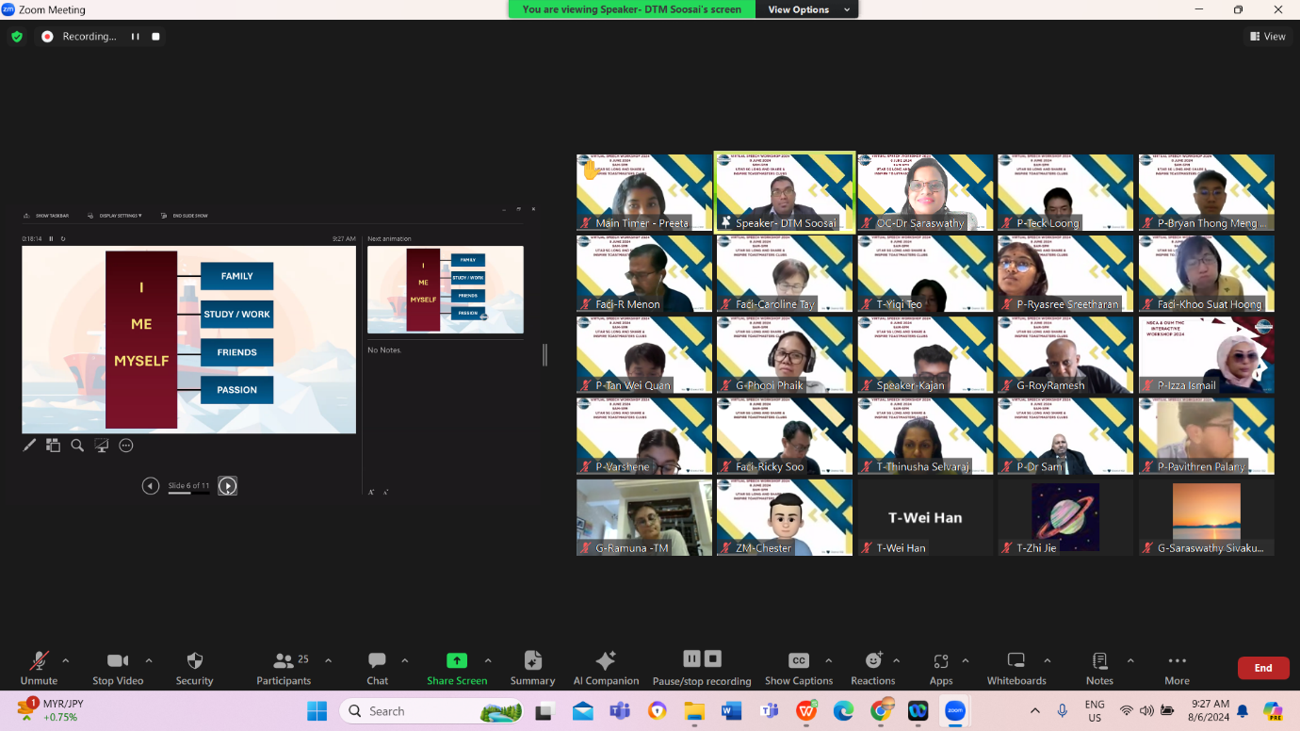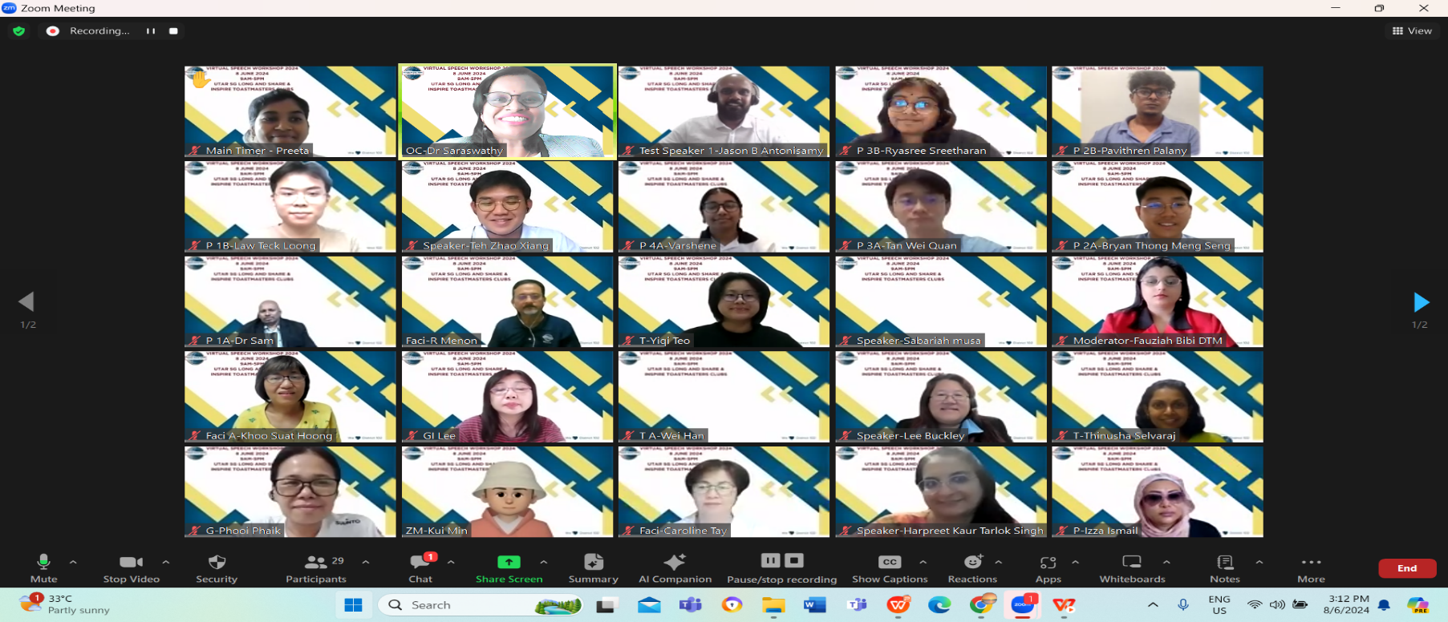
Speakers and participants at Virtual Speech Workshop 2024
The workshop began with Distinguished Toastmaster Mr Soosai Selvanathan, a champion in various contests at the District Level, sharing insights on crafting icebreaker speeches. The session was very interesting and captured many insightful sharing.
Next, Toastmaster Ms Tay Li Ying, the current Area E2 Director and Division E International Speech Contest 2022/2023 Champion, led a session on Writing a Speech with Purpose. She covered various speech purposes, including informing, persuading, entertaining, and inspiring.
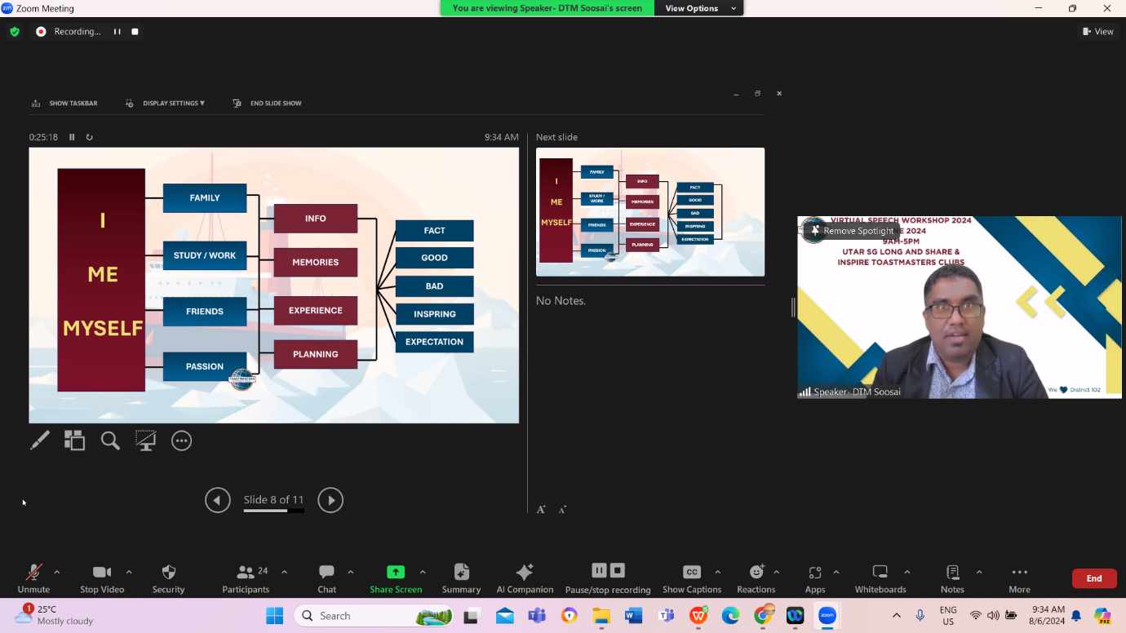
Toastmaster Mr Soosai Selvanathan
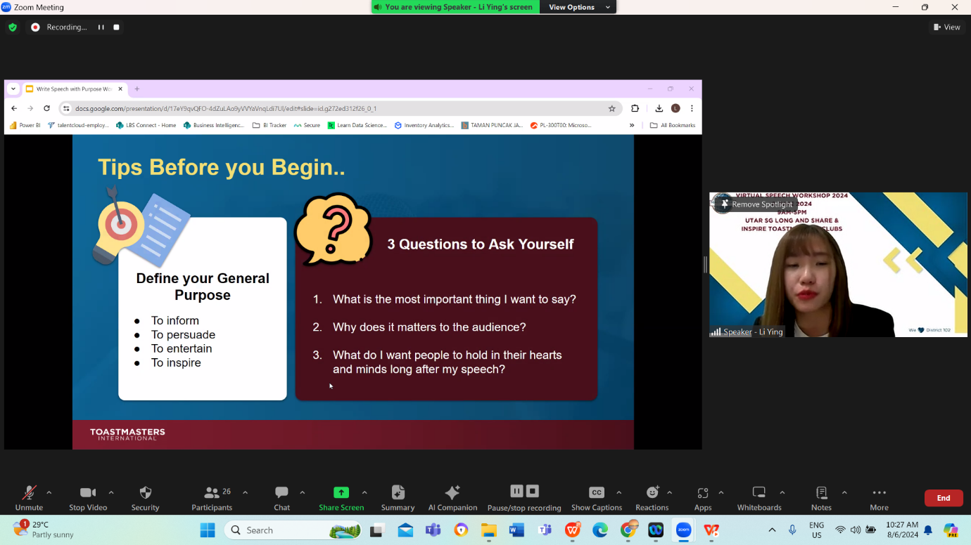
Toastmaster Ms Tay Li Ying
The third session, Introduction to Vocal Variety and Body Language, was conducted by Distinguished Toastmaster Ms Harpreet Kaur. She provided techniques for using body language and vocal variety effectively in speeches. Ms Harpreet was the Champion of the Division W Table Topics 2019/2020 and the first runner-up winner of Division W International Speech 2019/2020.
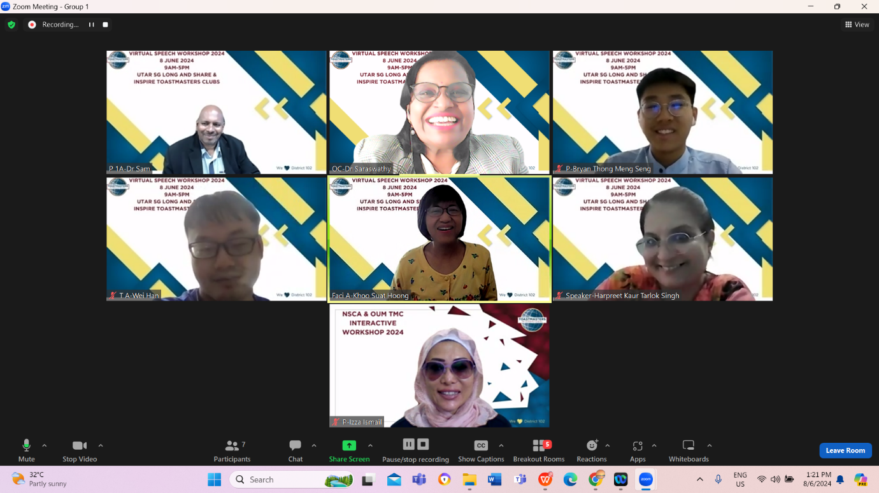
Toastmaster Ms Harpreet Kaur
The fourth session was dedicated to evaluating a speaker’s speech. Toastmaster Mr Teh Zhao Xiang from MyPuchong Toastmasters Club, the 1st runner-up winner of Division E Humorous Speech and International Speech Contest 2023/2024 and Champion of the Division E Evaluations Contest 2023/2024, offered constructive evaluation strategies. Test speakers and evaluators included Toastmaster Jason B. Antonisamy, the Club Champion for the Evaluations Contest from the Personal Development Toastmasters Club, and Toastmaster Mr Teh Zhao Xiang, the Area Champion for the International Speech Contest.
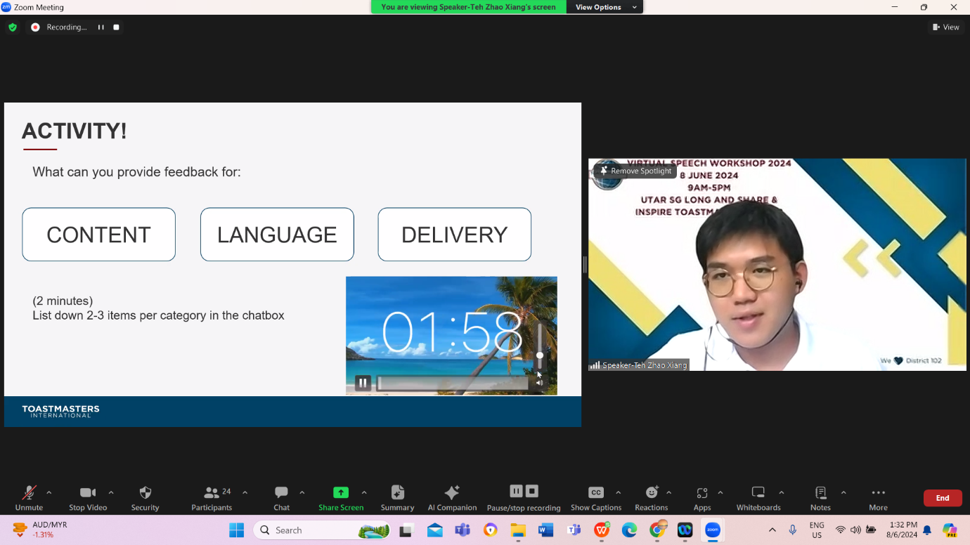
Toastmaster Mr Teh Zhao Xiang
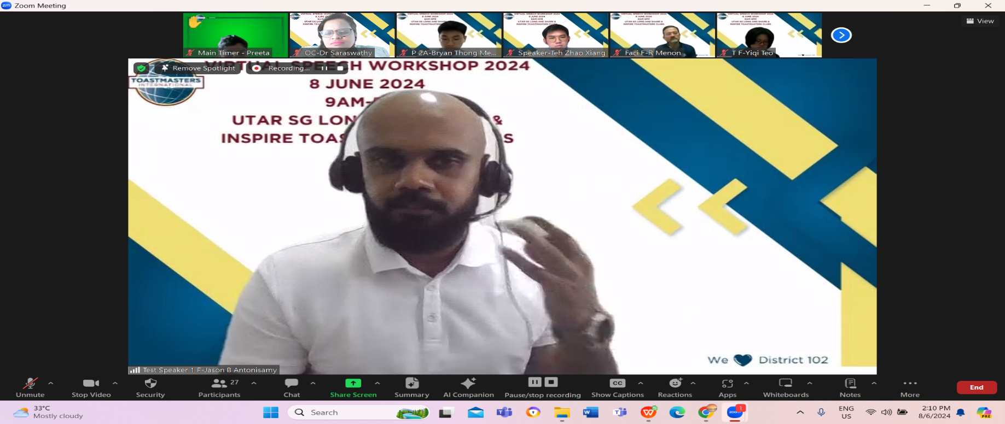
Toastmaster Mr Jason B. Antonisamy
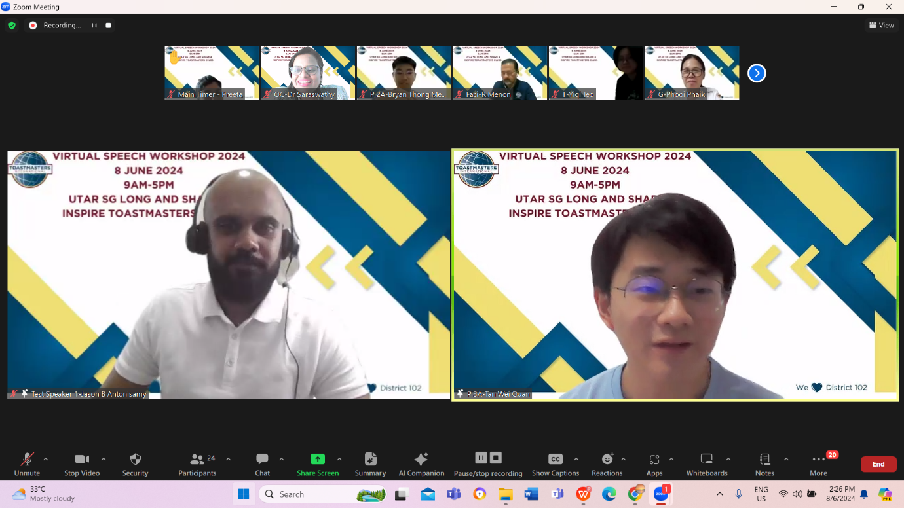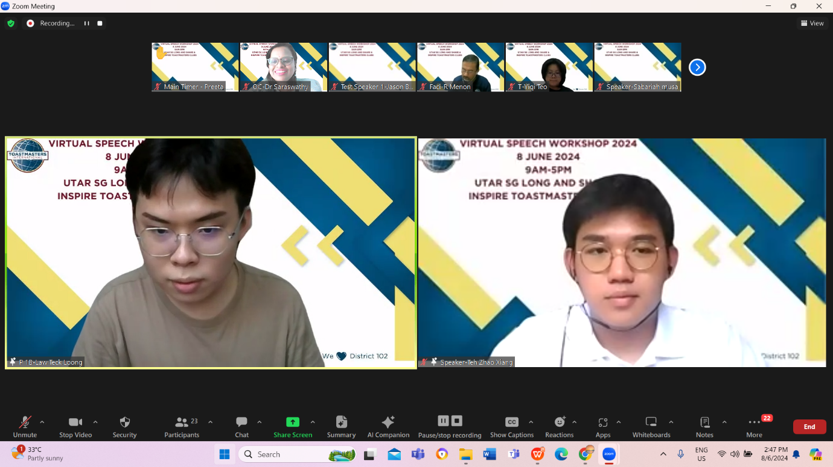
Toastmasters Mr Teh Zhao Xiang and Mr Jason B. Antonisamy Anoto conducting their evaluation and feedback session
Additionally, Distinguished Toastmaster Ms Lee Buckley from Australia, who is also a lecturer at a renowned university in Australia, conducted a session on Powerful Words. She discussed how linguistic features can elevate written scripts.
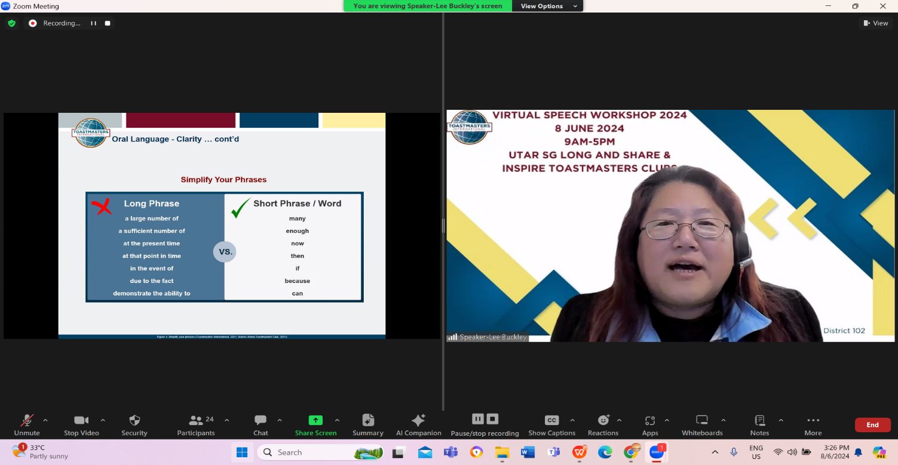
The workshop concluded with a panel session titled Echoes of Excellence, featuring Distinguished Toastmasters Ms Lee Guat Im, Mr Kajamugan, and Ms Sabaria Musa, as well as successful UTAR alumni Mr Teh Wen Yaw and Ms Ng Pey Jiann. The session, moderated by Distinguished Toastmaster Ms Fauziah Bibi, inspired attendees with diverse public speaking techniques and success stories.
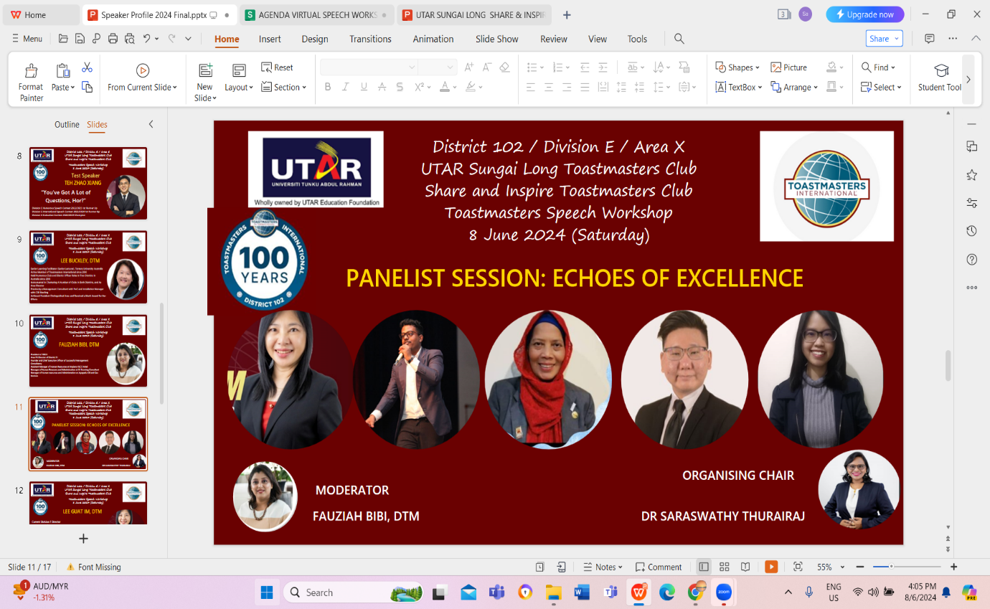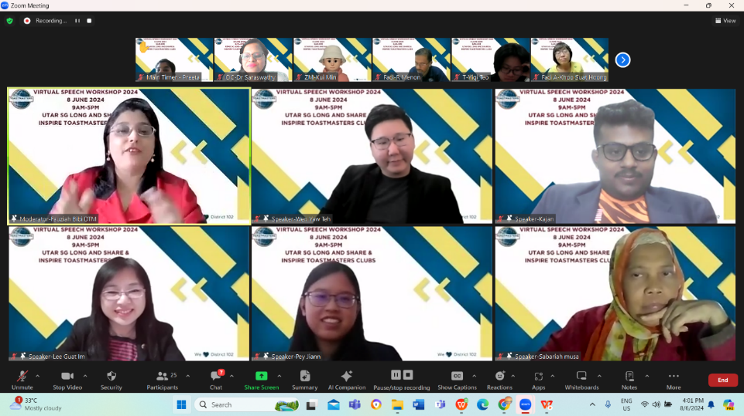
Overall, the workshop was a valuable learning experience. Both the UTAR Sungai Long Toastmasters Club and Share & Inspire Toastmasters Club achieved President's Distinguished Club status for the term 2023-2024. Congratulations to both clubs on their achievements!

