Exploring career pathways and industry insights with Allianz
The Department of Finance, together with the Department of Banking and Risk Management and the Department of Entrepreneurship and Supply Chain Management from the Faculty of Business and Finance (FBF), organised a career workshop titled “Get ready for your first job and picking your industry” on 27 June 2024. The workshop aimed to explore career opportunities in the insurance industry and the necessary skills required. Delivered by UTAR alumnus Mr Eugene Wong Kum Sum, it successfully attracted 103 participants.
The session began with a warm welcome from the host, who introduced Mr Wong, currently is an Underwriter, Reinsurance and Specialty of Allianz, and highlighted his accomplishments since graduating from UTAR.
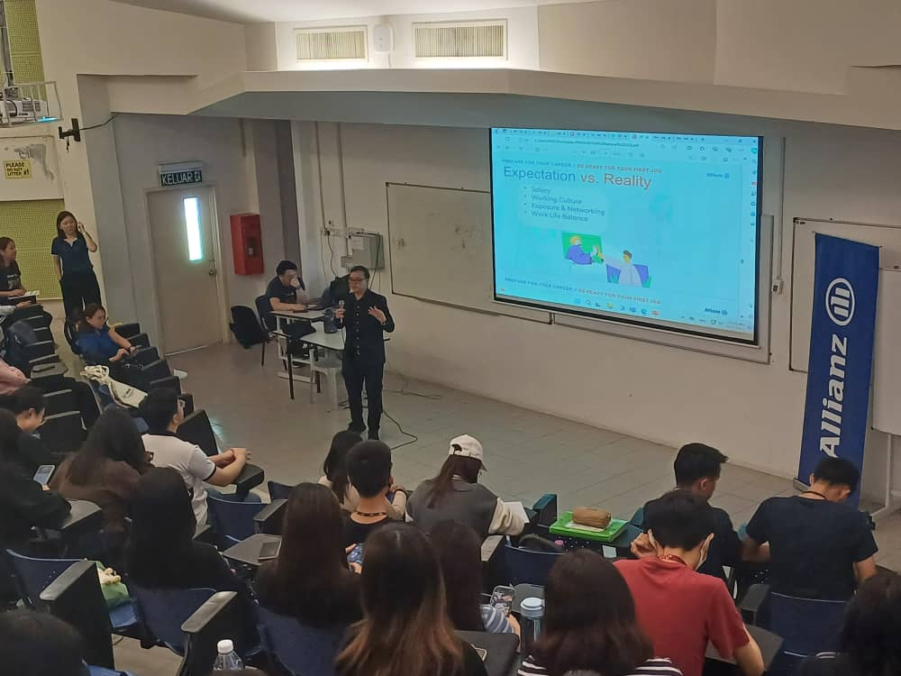
Mr Wong sharing his experience since graduation to his current attachment with Allianz Malaysia
Mr Wong then took the stage and shared his journey from his time as a student at UTAR to his current role at Allianz Malaysia. He discussed his initial steps in the industry and emphasised the importance of continuous learning and adaptability for career growth. Following the presentation, there was an engaging Q&A session where students had the opportunity to ask Mr Wong about specific aspects of careers and the insurance industry.
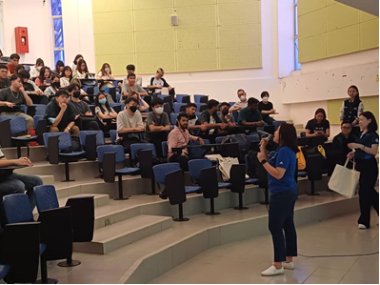
Key speakers, Ms Teresa Teng (in blue) and Ms Nelvy Yong (far right) sharing insights into the industry and Allianz prospects
Additionally, an informative session introduced Allianz, one of the world’s leading financial services providers, with key speakers Ms Teresa Teng Kah Wai, Assistant Manager, HR Centre of Expertise and Ms Nelvy Yong, HR Business Partner, sharing insights into the company’s history, services, global presence, innovation strategies, and commitment to sustainability. The session aimed to familiarise attendees with Allianz’s operations and highlight potential career opportunities within the organisation.
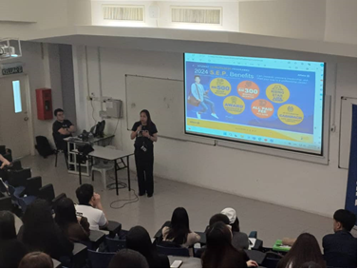
Ms Ang introducing apprenticeship and leadership building programmes offered by Allianz
Subsequently, Ms Ang Chooi Keng, Allianz Business Partner, FINAZ agency (Ipoh branch), Agency Manager, introduced the apprenticeship and leadership building programmes offered by Allianz, namely the L.E.A.P., Student Entrepreneur Programme (S.E.P.), and C.E.O. programmes. These programmes are designed to develop the necessary skills among new entrants to the industry and to train candidates to excel as entrepreneurs.
In a nutshell, these learning and development programmes assist in identifying and matching an individual’s traits to job descriptions, ensuring smooth career advancement within the industry. The session was well-received by the audience and ended on a lively note. Each speaker brought a unique perspective on different aspects of Allianz’s operations and contributions to the industry.
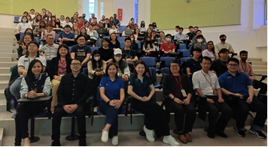
Participants at UTAR Allianz Career Workshop
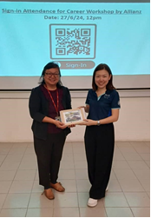
Assoc Prof Dr Au Yong Hui Nee, Dean of UTAR FBF (left) presenting a souvenir to Ms Nelvy Yong (right)

