**UTAR fights plastic pollution with new campaign launch**

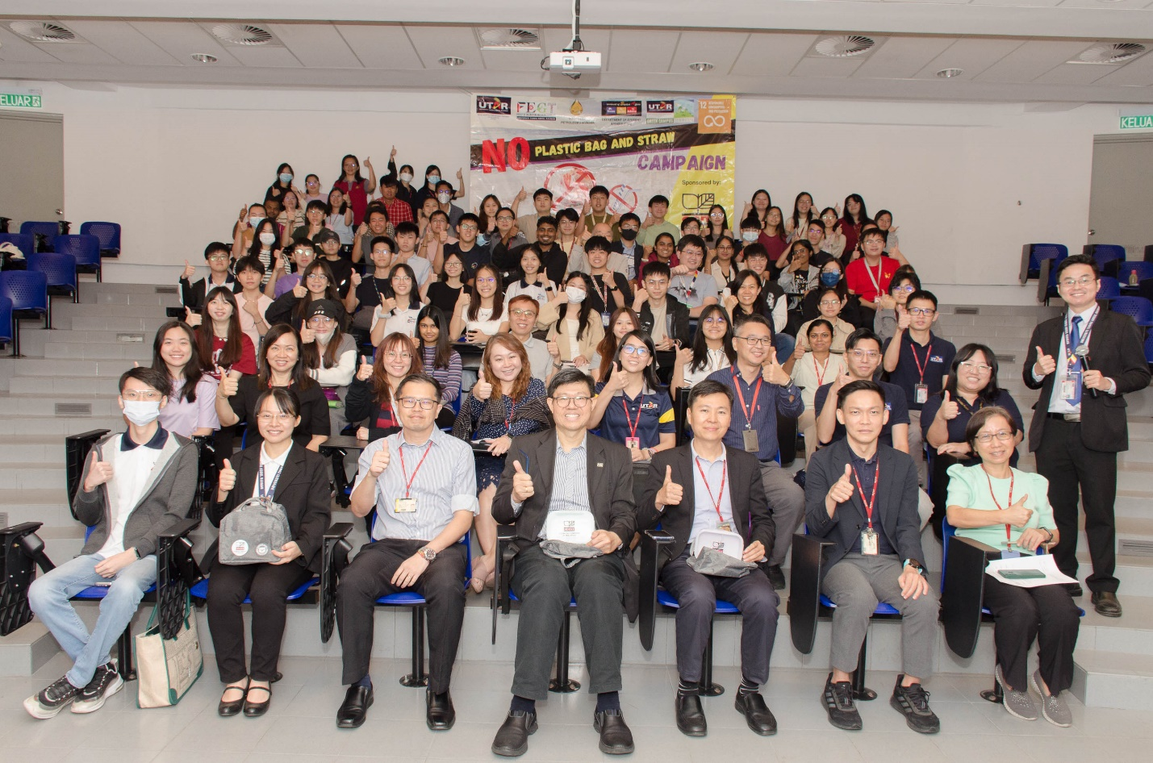

Front row, from left: Kam, Dr Toh, Mr Chiang, Prof Choong, Prof Ng, Dr Tan, and Ms Yee with the UTAR staff and participants

Plastic bags and straws have long provided convenience for transporting goods and consuming beverages, yet they pose a serious threat to our planet and its inhabitants.

To address this issue, UTAR is taking steps to reduce the use of non-degradable plastic bags and straws. As part of this effort, the Faculty of Engineering and Green Technology (FEGT), the Society of Petroleum Engineers (SPE), the Department of Student Affairs (DSA), the UTAR Green Campus Committee of Kampar Campus (UGCC KPR), and the Chemical Company of Malaysia (CCM) launched the *No Plastic Bag and Straw Campaign* on 10 July 2024 at UTAR Kampar Campus.

This campaign is in preparation for the upcoming restriction on non-degradable plastic bags and straws at UTAR events starting on 1 October 2024. The goal is to raise awareness among UTAR staff, students, and the public about the importance of environmental protection and encourage them to stop using non-degradable plastic bags and straws.

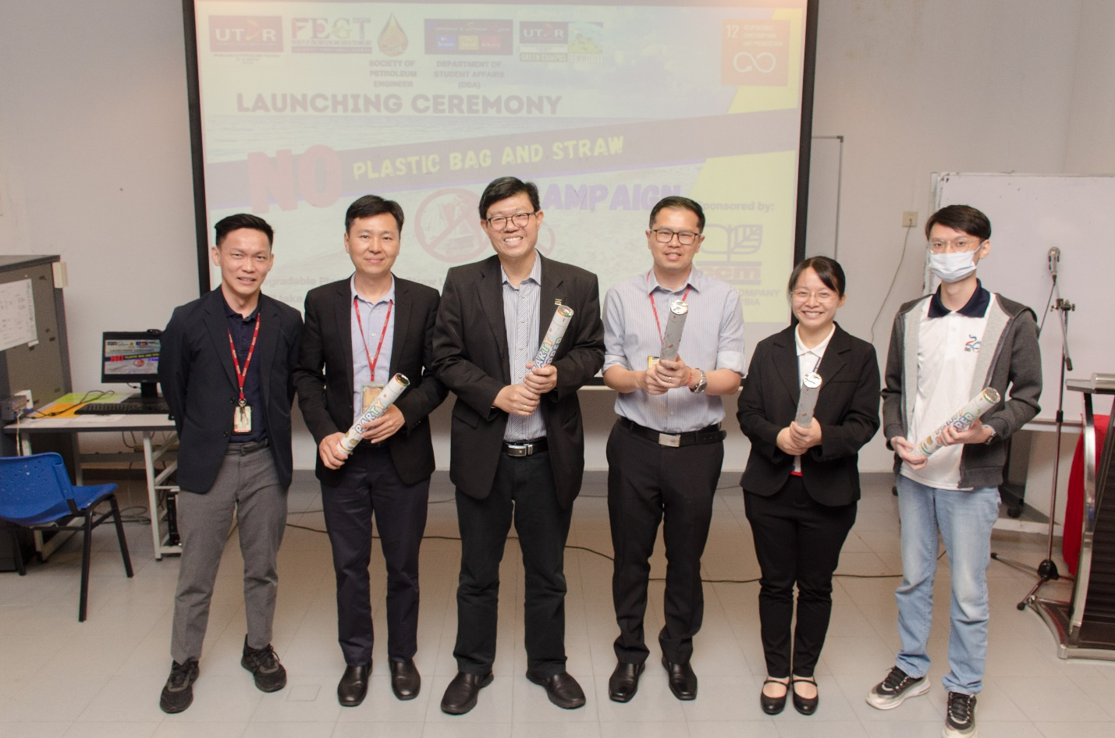

From left: Dr Tan, Prof Ng, Prof Choong, Mr Chiang, Dr Toh, and Kam during the launch

UTAR Vice President for Student Development and Alumni Relations Prof Dr Choong Chee Keong said, “The efforts we made will open a path to a cleaner and greener tomorrow. This campaign is not just about promoting awareness of reducing the usage of plastic bags and straws, but also about fostering a mindset of sustainability and environmental consciousness. This is beyond classroom learning, and it will follow the students even after their graduation.”

Prof Choong also shared the various initiatives by UTAR in promoting sustainability, such as solar panel installation for campus buildings, the UTAR Green Bank Project, and guidelines for saving energy and water on campus.

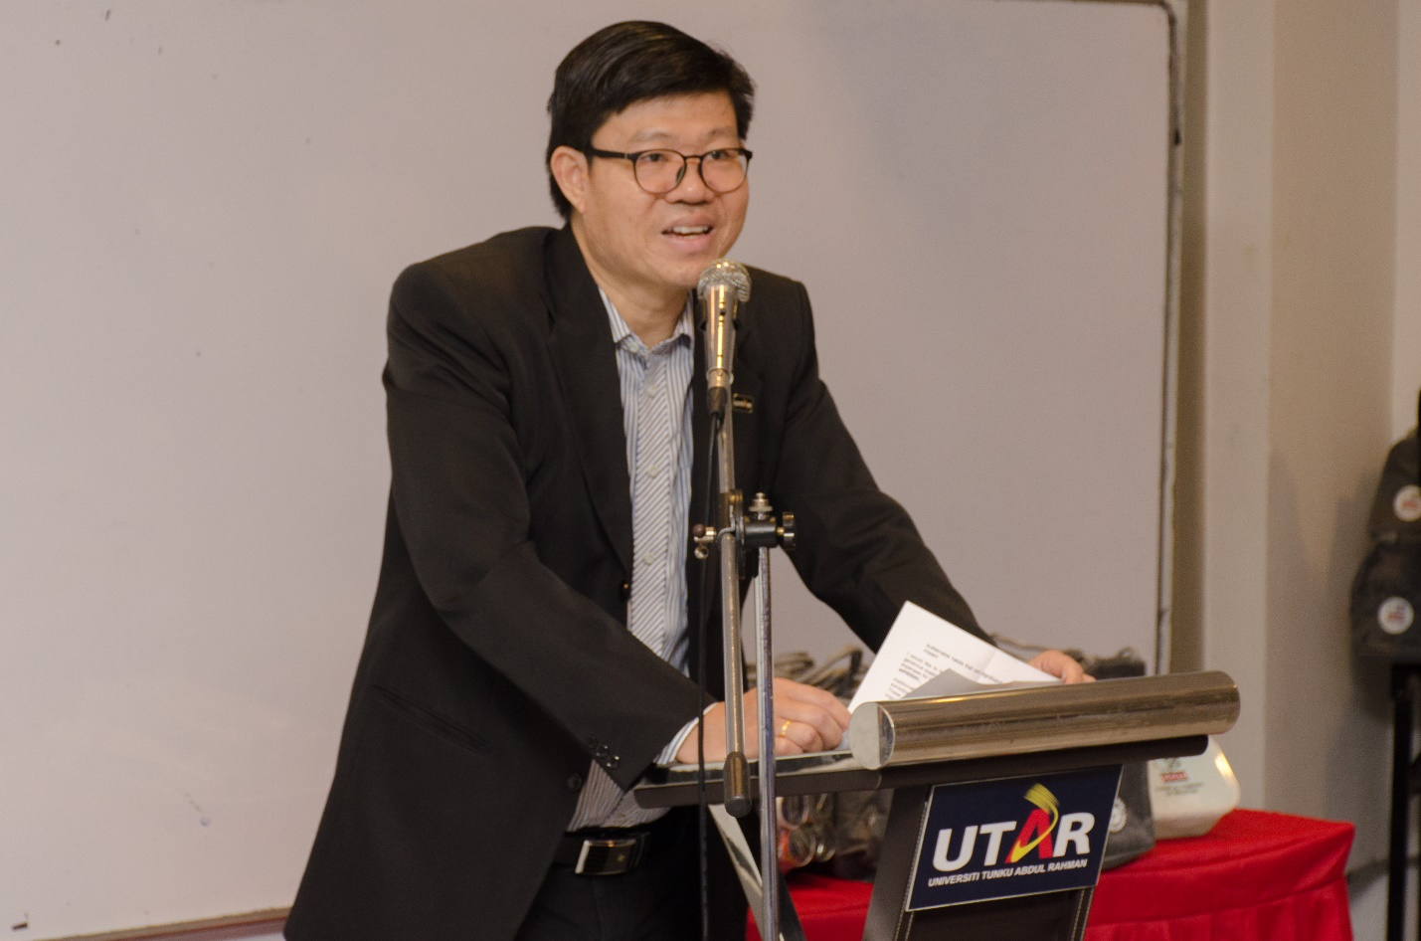

Prof Choong sharing some sustainable developments of UTAR Campuses

UTAR FEGT Dean Ir Prof Dr Ng Choon Aun said, “This campaign is organised to remind us of the gravity of plastic pollution. A recent study shows that Malaysia is ranked one of the highest among 109 countries in microplastic consumption. Malaysians eat an average of 502.3mg microplastic on a daily basis and most of this microplastic consumption comes from eating fish. Hence, we take the initiative to start this campaign for our staff and students, which aligns with UTAR’s goal to foster a green and sustainable campus environment.”

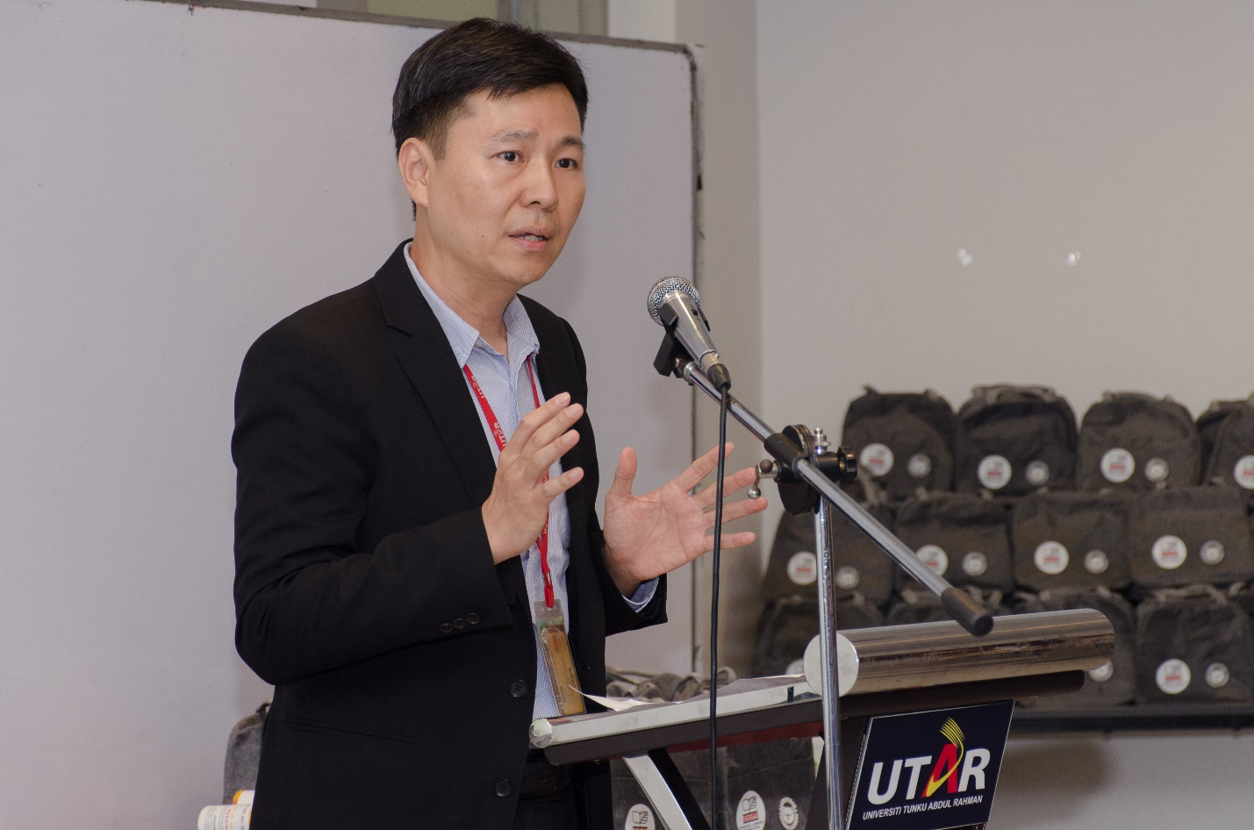

Prof Ng encouraging participants to reduce the use of plastic

During the launch of the campaign, SPE members and UTAR Petrochemical Engineering programme students Pua Sze Yang and Lee Zhen Jie gave an insightful presentation on plastic’s facts, enlightening the participants on the exacerbating situation of plastic pollution around the world, established policies to discourage the usage of plastic, and alternatives of plastics bag and straw to maintain the ease of item transportation and drinking in our daily lives.

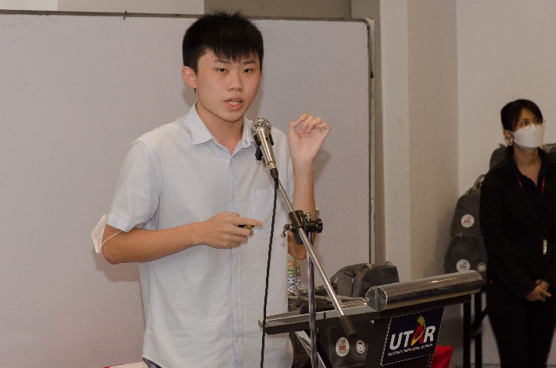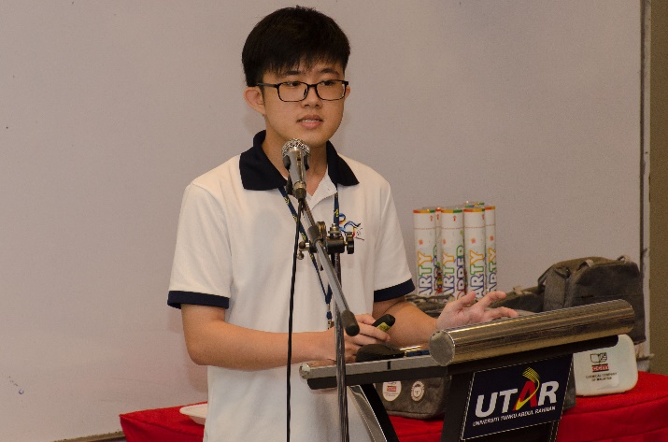

Pua (left) and Lee shedding light on the issues of plastic pollution and ways to reduce plastic usage

The *No Plastic Bag and Straw Campaign,* carried out in the form of exhibition booths, was set up at two locations, namely Student Pavilion I (Block C) and Student Pavilion II (Block K) at UTAR Kampar Campus. The booths entailed a series of facts on the detrimental effects of non-degradable plastic bags and straws as well as ways to effectively reduce their usage. The booths will be open to the UTAR community until 13 September 2024.

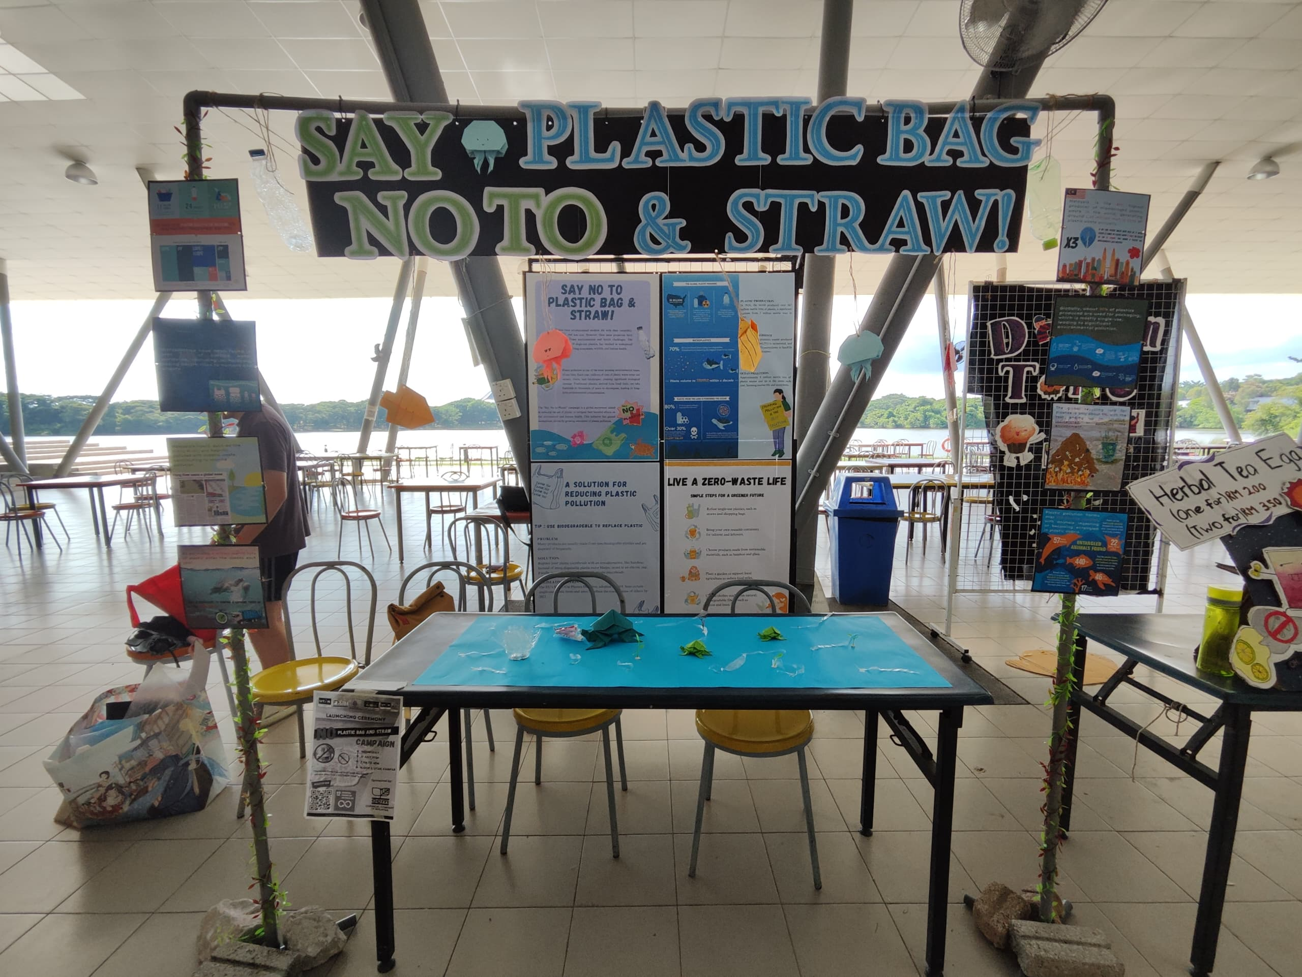

One of the exhibition booths at Student Pavilion I

As an initiative to reduce the usage of plastic, 100 gift bags were also given out to the participants. Each gift bag contained a lunch bag, a reusable Tupperware container and a metal straw, encouraging the participants to practice 6Rs – Rethink, Refuse, Reduce, Reuse, Repurpose, and Recycle in daily life, which will ultimately lead to a reduction in plastic usage.

The gift bags were sponsored by CCM.

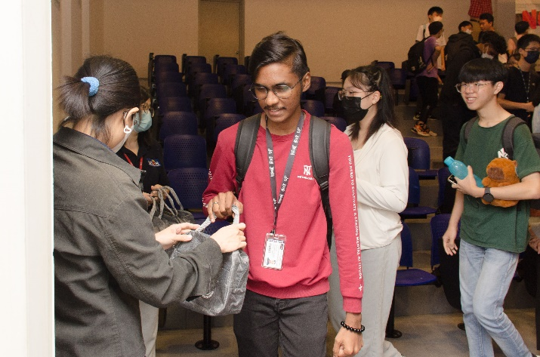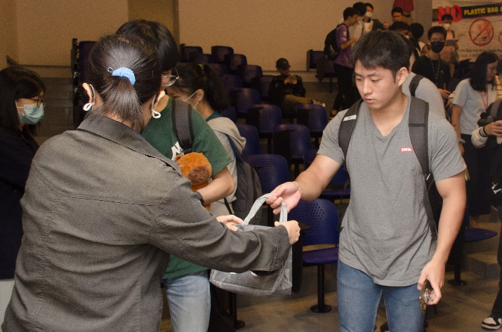

Participants receiving the gift bags at the end of the launching ceremony

Also present at the launching ceremony were FEGT Deputy Dean for Student Development and Industrial Training Dr Tan Kok Tat, DSA (Kampar Campus) Head Mr Chiang Jeng Fong, Department of General Services (Kampar Campus) Head Ms Yee Sook Heng, No Plastic Bag and Straw Campaign Organising Chairperson Assoc Prof Ir Ts Dr Toh Pey Yi, SPE representatives, UTAR Petrochemical Engineering programme student Kam Hao Cheng, and UTAR staff and students.