Cultivating sportsmanship through sports exchange programme
In the spirit of fostering close partnerships and establishing mutual understanding, UTAR is committed to form collaborations with various organisations and institutions. Through these collaborations, lessons are extended beyond indoor classrooms – outdoors, where learning is made fun, interactive, and more engaging. This is also a way for students to maintain a balance between their academic achievements, and health and well-being. Some of these outdoor activities also include sports, whereby friendly matches and competitions are held to promote sportsmanship.
At the recent UTAR-IPT Malaysia Local Sports Exchange Programme Tour 2024, on 22 June 2024, organised by the Sports and Recreation Unit (SRU) of UTAR Kampar Campus, under the Department of Students Affairs (DSA) of Kampar Campus, participants were able to immerse themselves in a positive and enjoyable environment with other sports team.
UTAR teams went up against Multimedia University (MMU) Cyberjaya’s teams in badminton, table tennis, volleyball, and basketball. The friendly matches took place in MMU Cyberjaya Indoor Sports Complex, 149 Sports Arena Seri Kembangan, and SJKC Serdang Baru 2. The matches provided participants an enhanced sporting experience, strengthened bonds, and fostered mutual respect and lifelong values.
UTAR won in the following matches:
- Basketball (Male)
- Volleyball (Female)
- Badminton
- Table Tennis
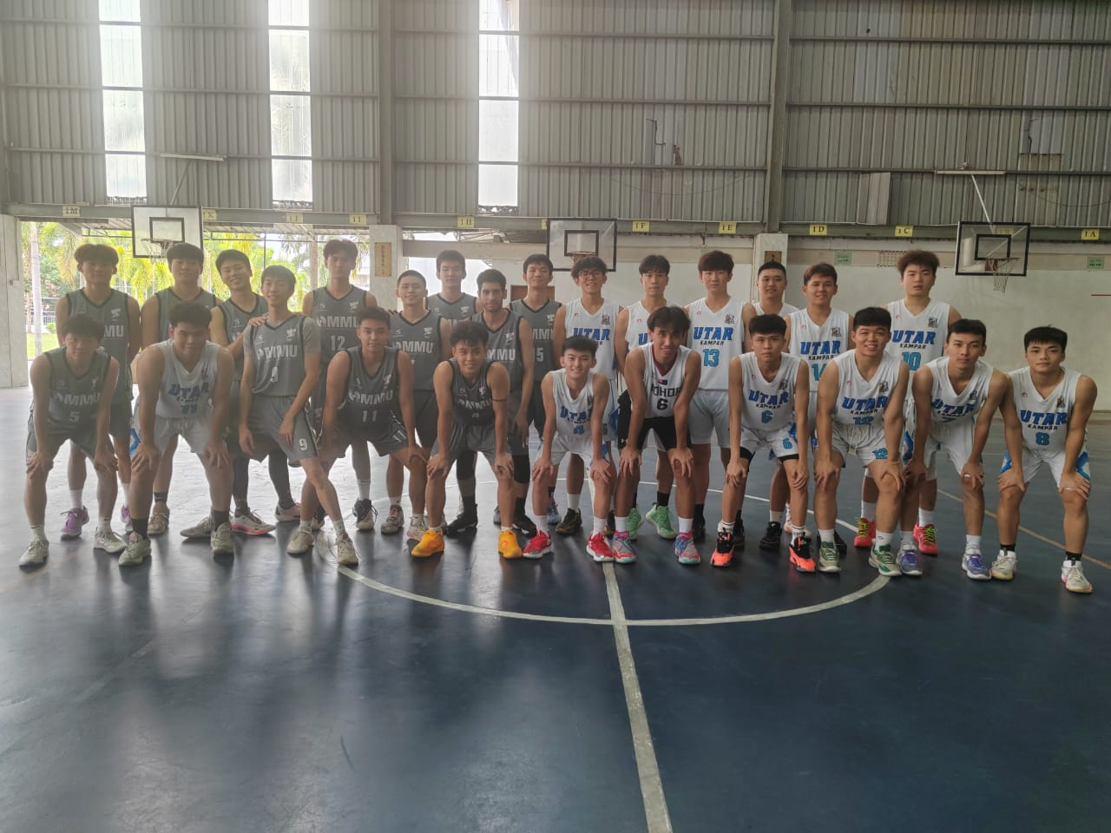
The male basketball teams - MMU Cyberjaya (grey jersey) and UTAR Kampar (white jersey)

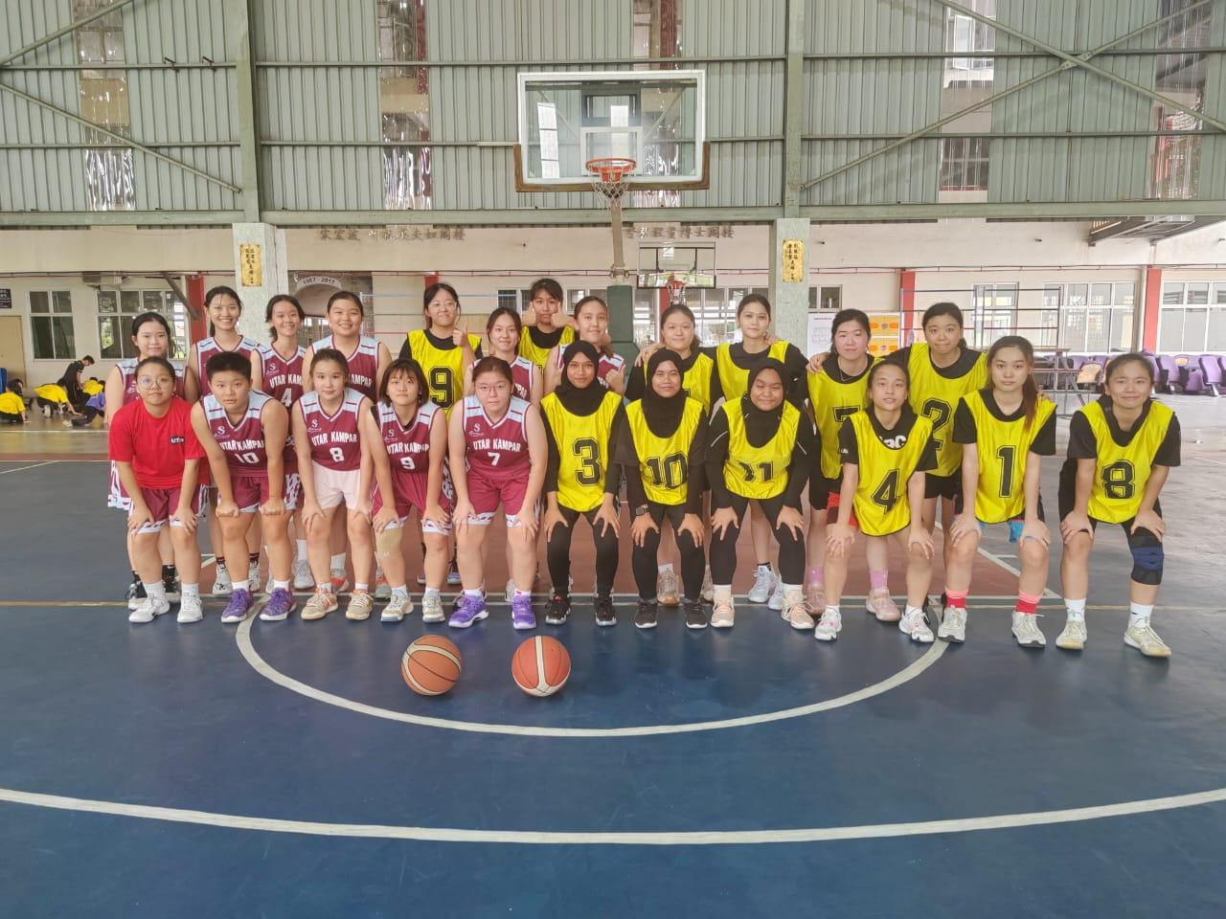
The female basketball teams - UTAR Kampar (red jersey) and MMU Cyberjaya (yellow jersey)

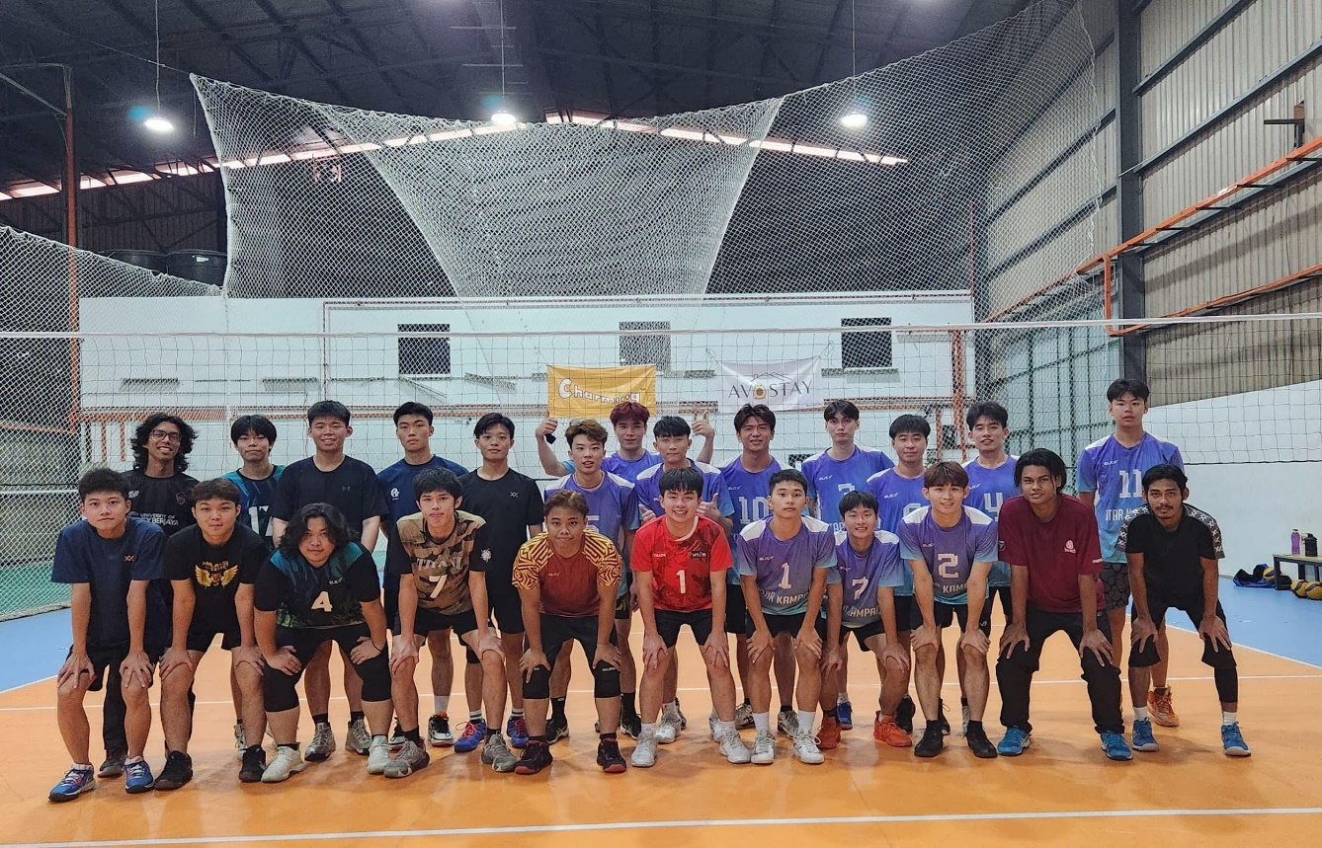
The male volleyball teams - MMU Cyberjaya (black jersey) & UTAR Kampar (purple jersey)
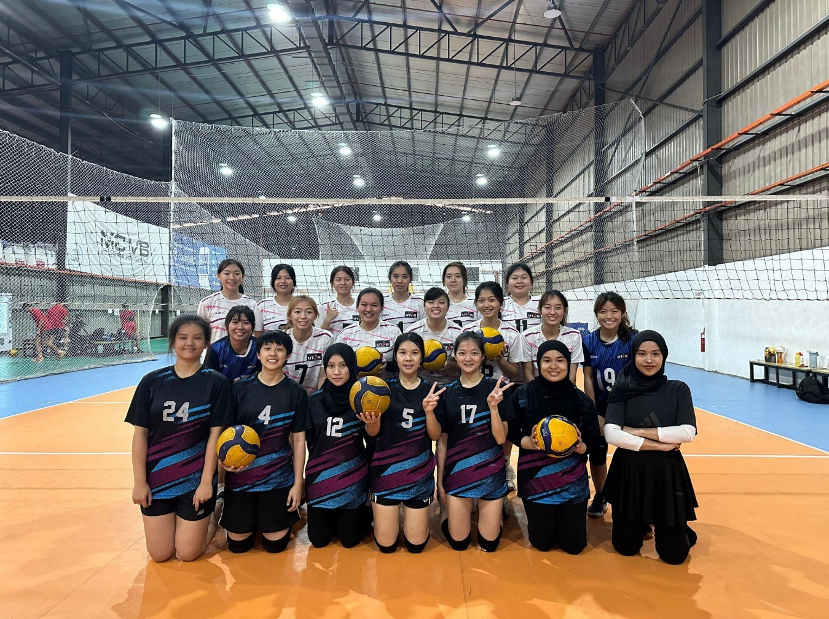
The female volleyball teams - MMU Cyberjaya (black jersey) & UTAR Kampar (white jersey)

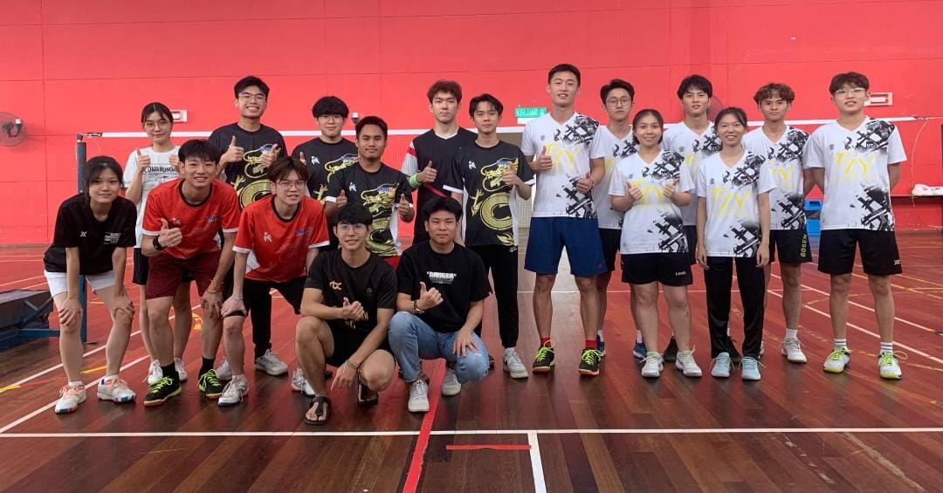MMU Cyberjaya & UTAR Kampar Badminton teams

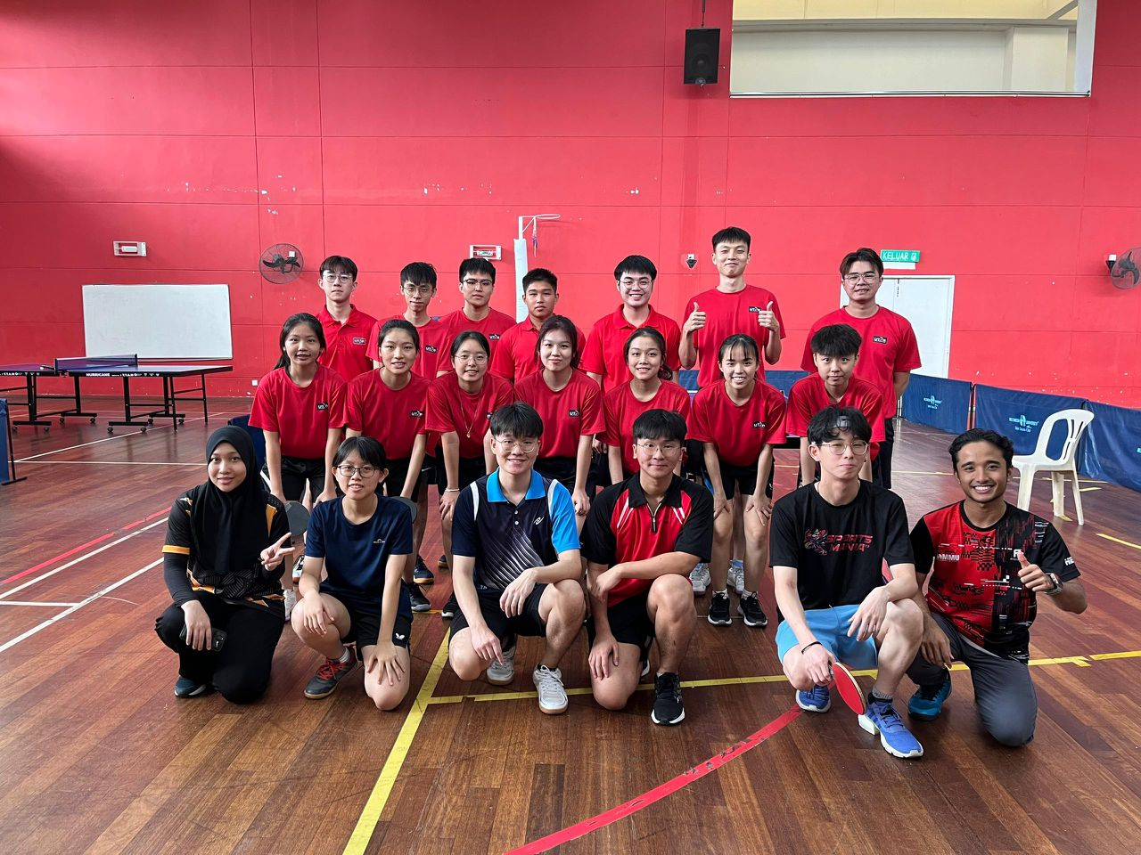
Table Tennis teams from both campuses

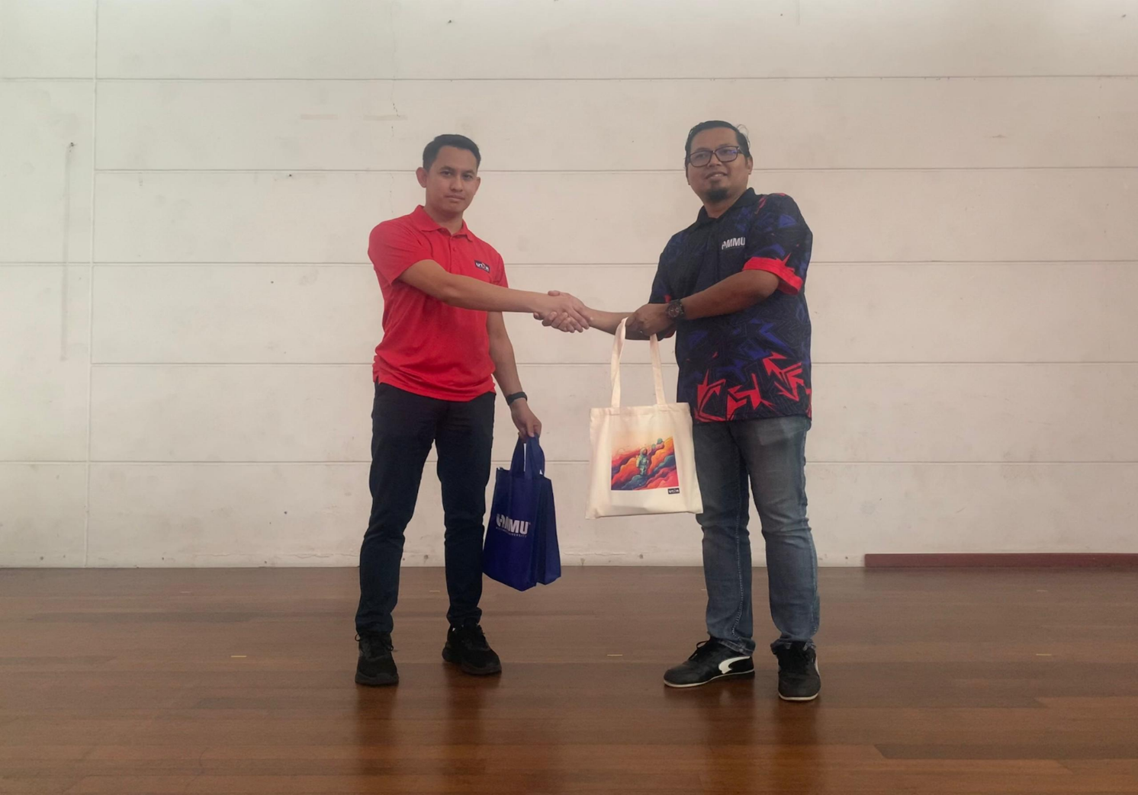

UTAR Kampar DSA staff Encik Zulhanizam bin Zakaria presenting a token of appreciation to Encik Faizol of MMU Cyberjaya

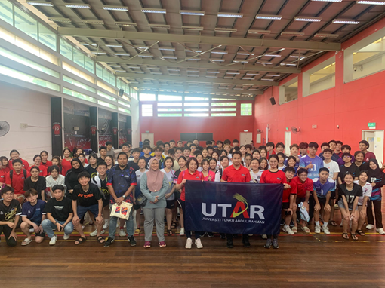

Group photo after the closing ceremony

