**International forum explores the three philosophical systems of Chinese culture**

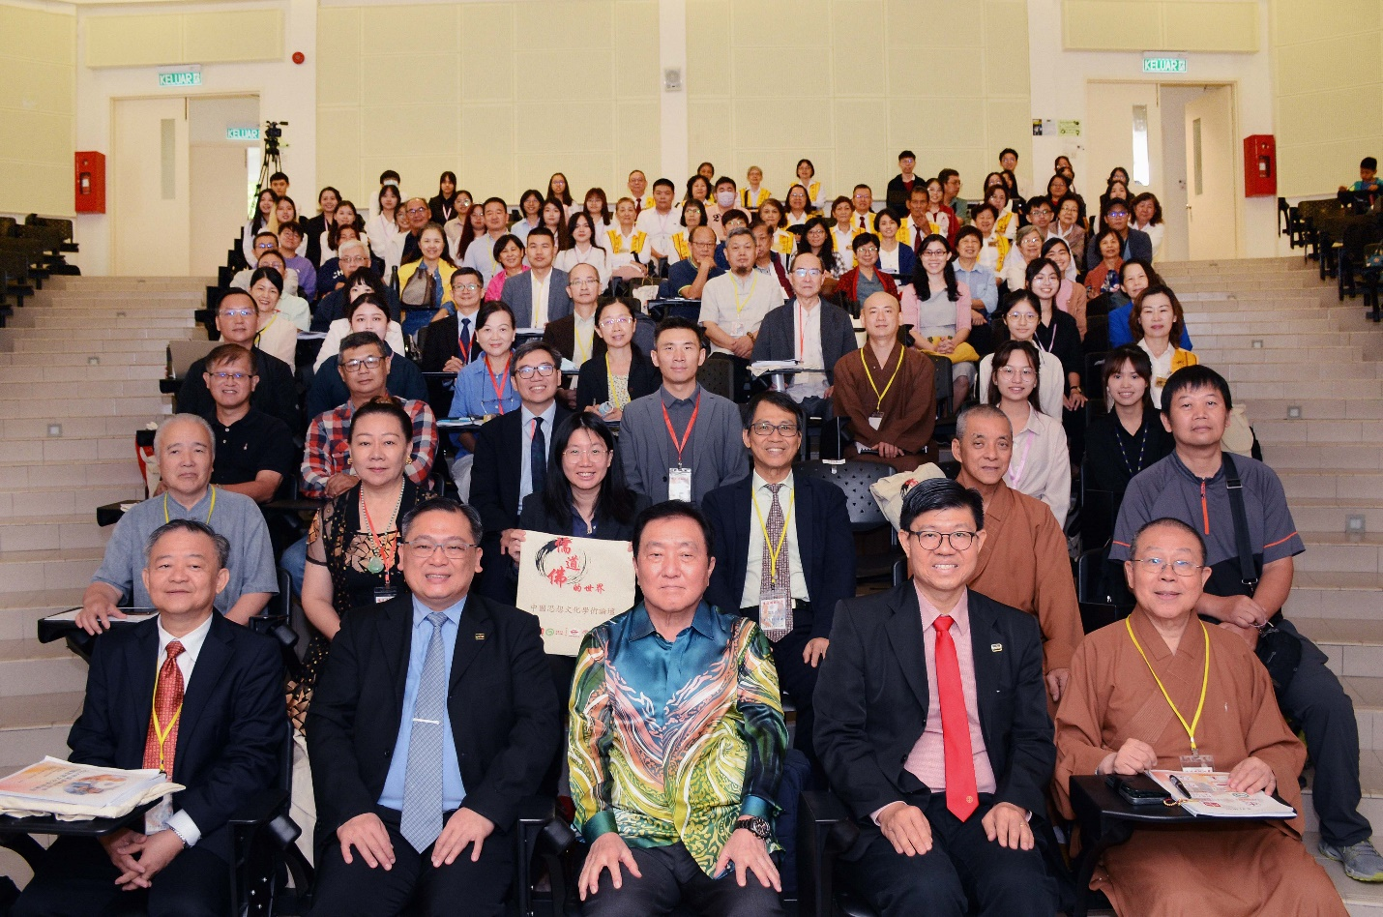

Front row, from left: Dr Wong, Dr Chong, Tan Sri Ong, Prof Choong, and Venerable Prof Huei-Kai with the scholars and participants

Confucianism, Taoism, and Buddhism are fields brimmed with a wealth of philosophies and wisdom from ancient civilisation to the rapidly evolving world of our modern civilisation.

As such, UTAR Institute of Chinese Studies (ICS), Yu Cai Foundation Centre for Chinese Studies (Humanistic Buddhism Studies Unit), Confucius Institute, and Mencius Institute organised an international forum titled “2024 Chinese Thought and Cultural Academic Forum: Exploring the World of Confucianism, Taoism, and Buddhism” at UTAR Kampar Campus on 28 and 29 June 2024, gathering a number of experts and scholars from different economies at one place to promote exchanges and research on the three philosophical systems.

The forum was organised in collaboration with the China Association of Oriental Culture Studies (CAOCS) Chinese Culture and Inheritance Studies Committee, I Culture Berhad, Fo Guang Shan Malaysia, and Kwong Tong Cemetery Kuala Lumpur. Besides progressing research in the relevant fields of study, the forum was also an effort to strengthen academic exchanges between Malaysia and other Asian economies.

UTAR Council Member Tan Sri Dato’ Seri Ong Ka Chuan said, “Confucianism, Taoism, and Buddhism are important pillars of Chinese culture. They not only shape China’s history and culture, but they also have a profound impact on Asia and even the world. Although each of them is unique, they influence and integrate with one another in Chinese culture, moulding the spiritual outlook of Chinese civilisation together. Through this forum, I hope we can find a common ground while reserving differences, appreciate the foundation of different philosophies, explore the inheritance and integration of Chinese thought and culture in Asian economies, promote the integration of multi-ethnic societies and cultures, broaden horizons, and deepen friendly collaboration.”

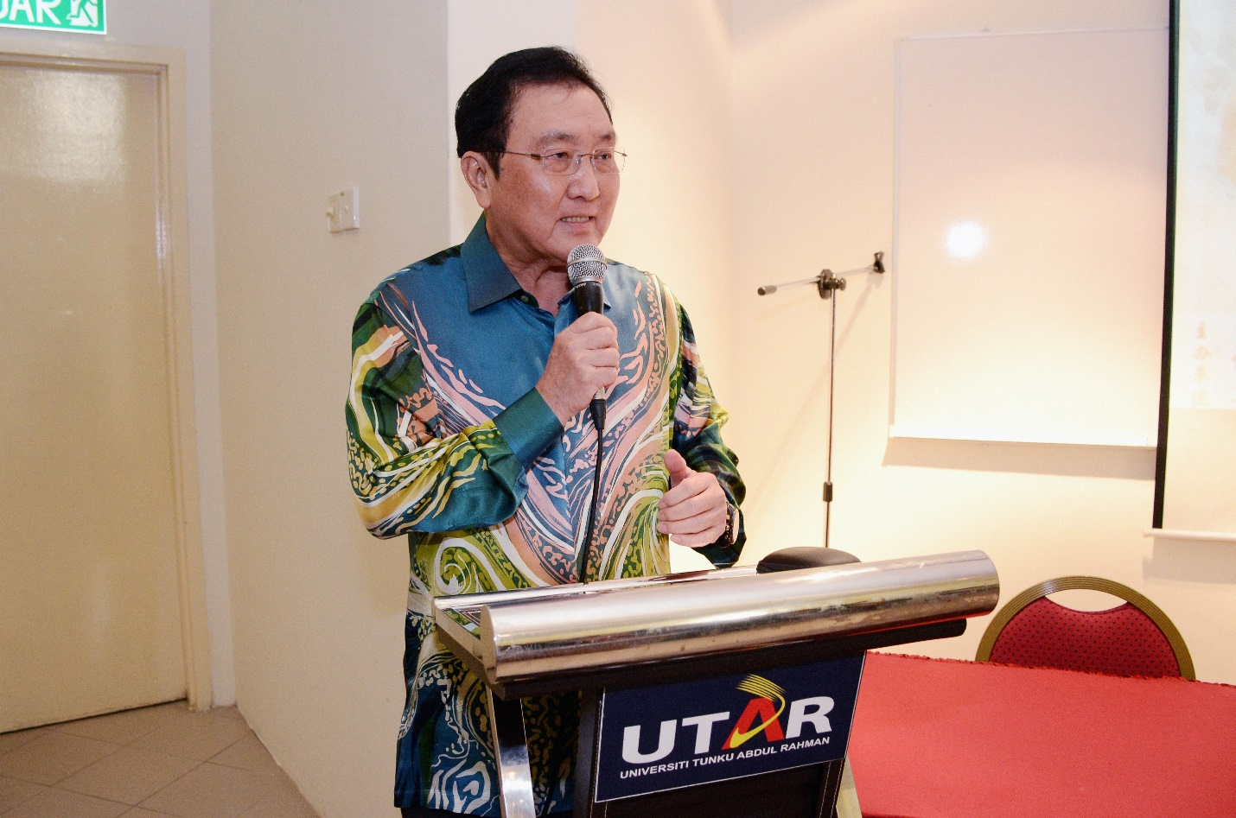

Tan Sri Ong emphasising the importance of Chinese culture

UTAR Vice President for Student Development and Alumni Relations Prof Dr Choong Chee Keong said, “Chinese culture has always been one of the cores of UTAR. Since its establishment, UTAR ICS has been committed to promoting Chinese culture, highlighting its importance as a stronghold of culture. Not to mention, with over 450 undergraduate and postgraduate students currently studying in ICS, UTAR ICS is one of the prominent institutes to offer Chinese studies in Southeast Asia.”

He added, “With the rapid innovation and development of modern scientific and technological research such as biotechnology and artificial intelligence, we should place more importance on humanistic and religious research, as they will be a significant ideological force that promotes the development of our world as well as the pillar that maintains world harmony.”

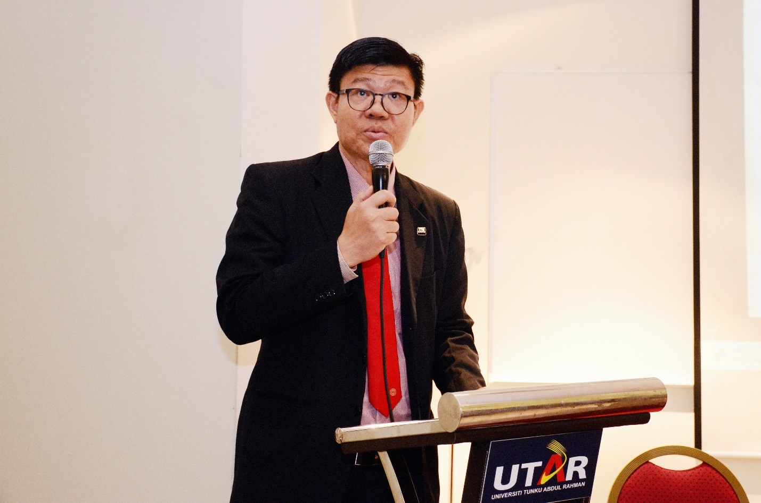

Prof Choong highlighting the many contributions by ICS to the academic world

UTAR Institute of Chinese Studies (ICS) Dean Assoc Prof Dr Chong Siou Wei said, “We are honoured and happy to work together with academic groups from different economies. This forum offers an opportunity to broaden one’s horizons and gain new insights. It shows UTAR’s efforts as an educational institution to preserve the education system and cultural heritage. UTAR places importance on promoting learning and thinking, integrating elements from both East and West. In this era where the eastern and western civilisations converge rapidly, we are committed to imparting excellent moral values, learning from the wisdom of East and West, and thus contributing to the research development of science and technology.”

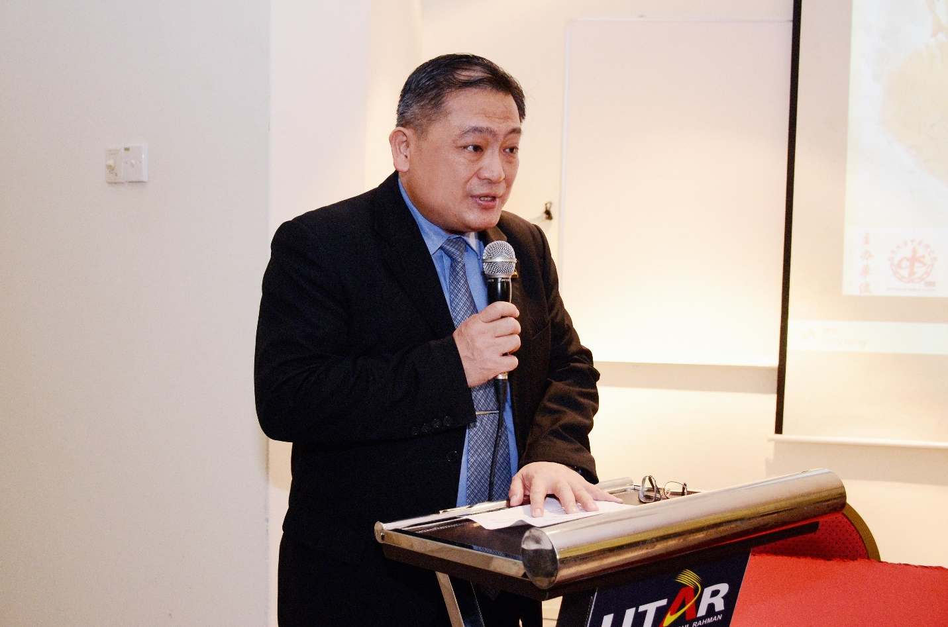

Dr Chong explaining the importance of cultural heritage around the world

The two-day forum invited 25 experts and scholars from various regions, including China, Hong Kong, Singapore, and Malaysia. It saw in-depth discussions and exchanges of Confucianism, Taoism and Buddhism in a diverse array of contexts such as religion, culture, society, literature, and morality.

The invited scholars came from various institutions, including CAOCS Chinese Culture and Inheritance Studies Committee, Nanhua University, Leshan Normal University, Fo Guang University, National Yang Ming Chiao Tung University, the University of Hong Kong, Hong Kong Shue Yan University, National University of Singapore, Nanyang Confucian Association, Xiamen University Malaysia, Universiti Malaya, UTAR, and Tunku Abdul Rahman University of Management and Technology (TAR UMT).

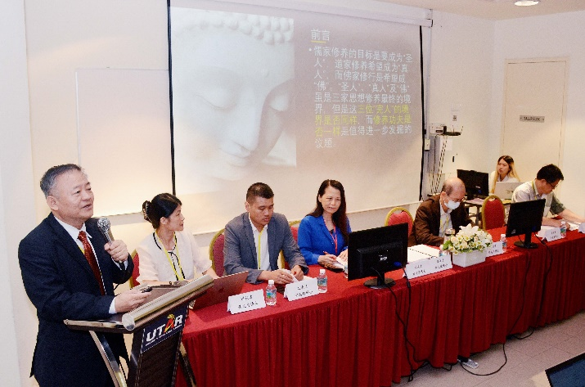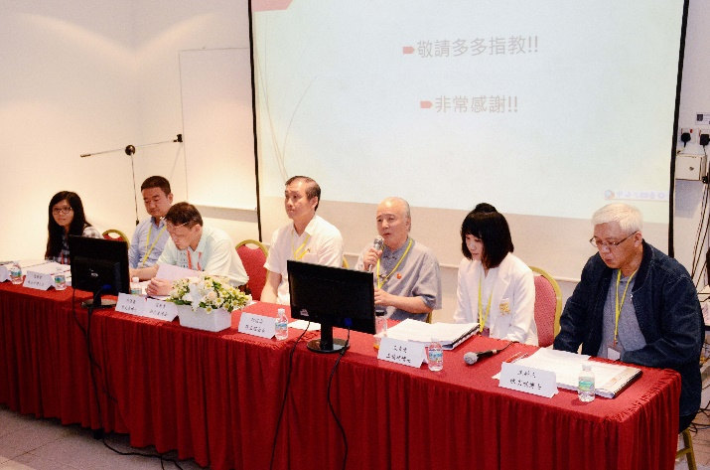

Scholars from different sessions sharing their findings and knowledge with the participants

Also present at the forum were UTAR ICS Deputy Dean for Academic Development and Undergraduate Programmes Assoc Prof Dr Wong Wun Bin, ICS Deputy Dean for Student Development and Industrial Training Dr Ling Liong Ngo, Faculty of Business and Finance (FBF) Deputy Dean for Academic Development and Undergraduate Programmes Dr Peter Tan Sin Howe, Fo Guang Shan Monastery Deputy Abbot and Nanhua University Institute of Religious Studies academic Venerable Prof Dr Huei-Kai, CAOCS Chinese Culture and Inheritance Studies Committee Chairman Mr Zhang Yuncheng, CAOCS Chinese Culture and Inheritance Studies Committee Advisor Ms Zhang Fuping, Fo Guang Shan Ipoh Chairperson Ms Tan Guat Nga, Fo Guang Shan Ipoh Superintendent Venerable Hui Shing, I Culture Berhad Manager Ms Chan Hui Cheng, representatives and scholars from various universities, and UTAR staff and students.

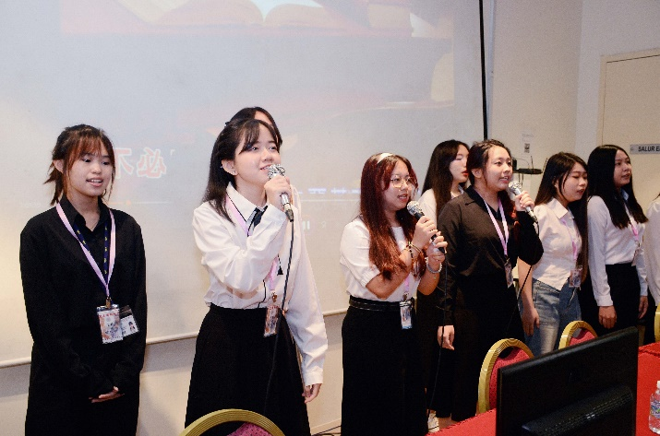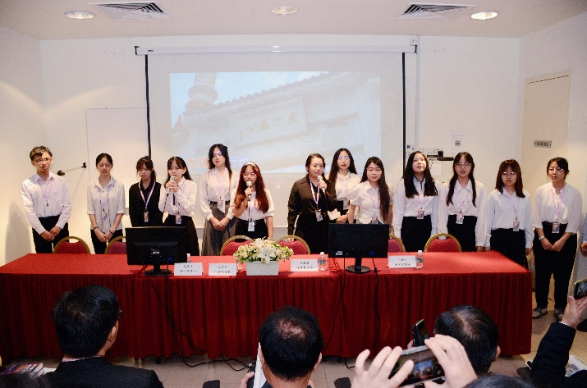

Committee members presenting songs titled “礼运大同篇”, “水” and “无尽灯” at the opening ceremony

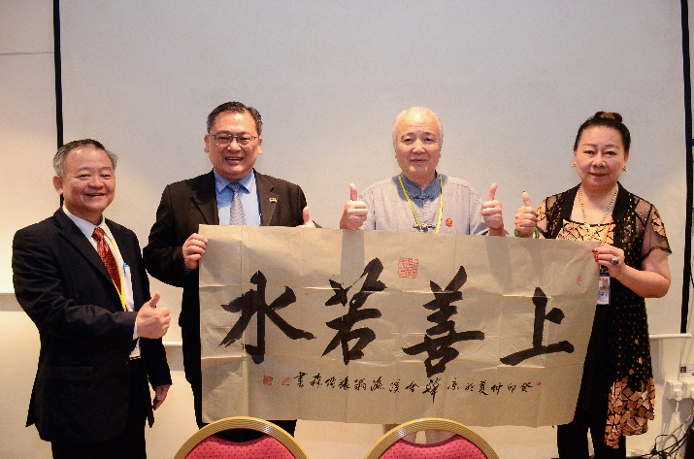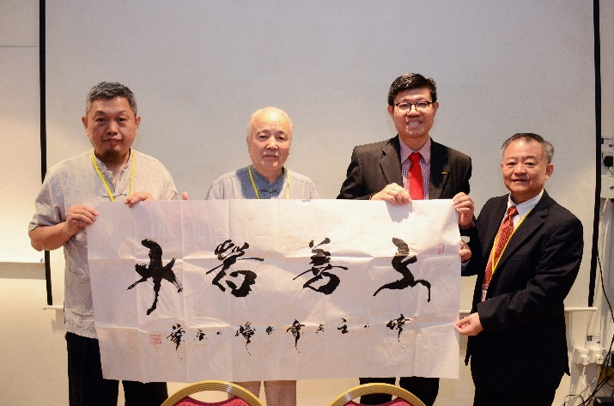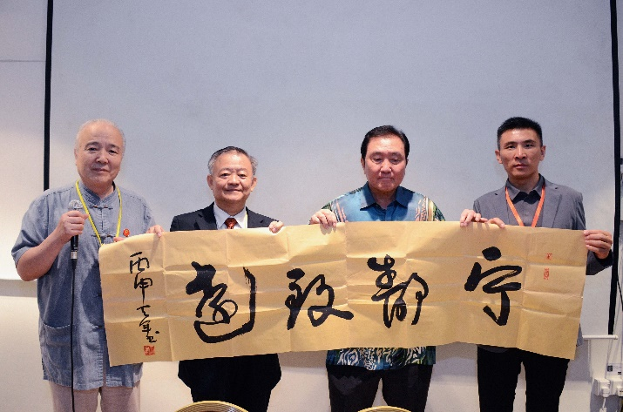

Mr Zhang Yuncheng (bottom row, far left) and representatives from UTAR presenting calligraphy arts to the representatives of participating institutions

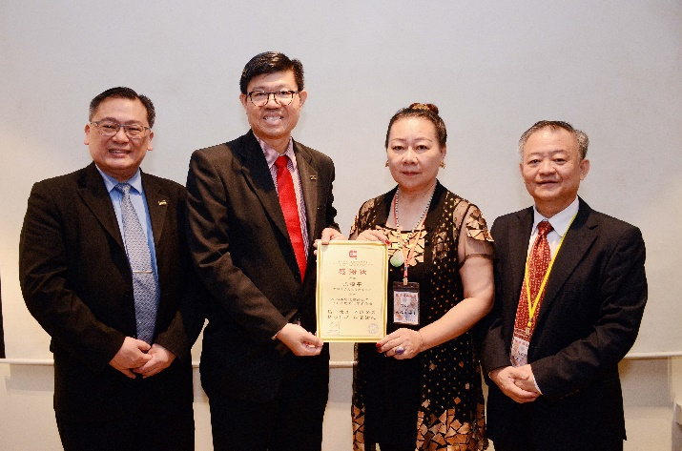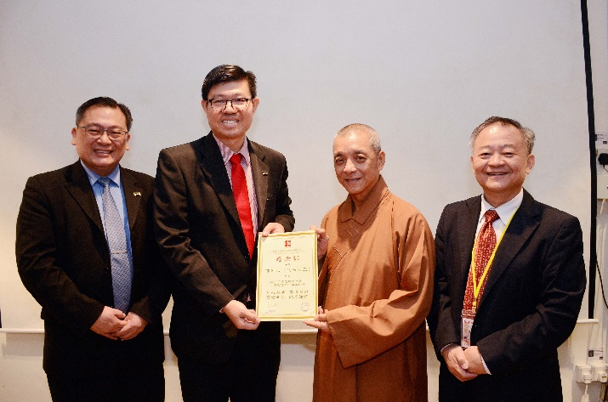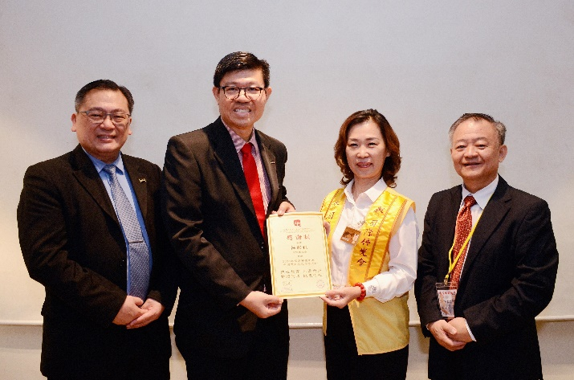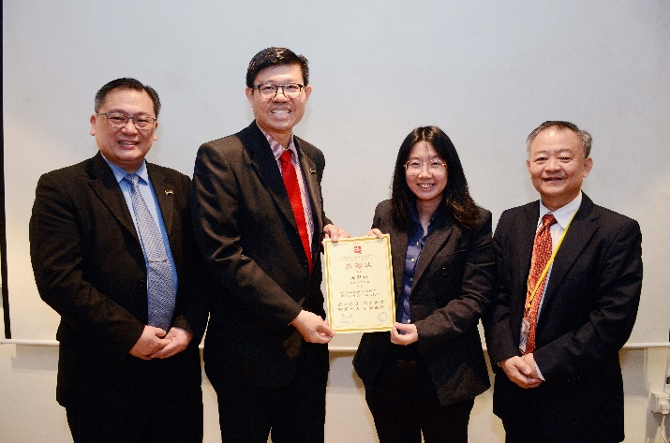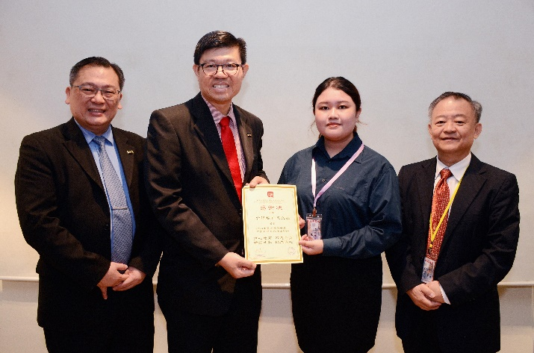

Dr Chong (most left), Prof Choong and Dr Wong (far right) presenting tokens of appreciation to the representatives of co-organisers