**Exploring career opportunities in Kampar’s Career Day event**

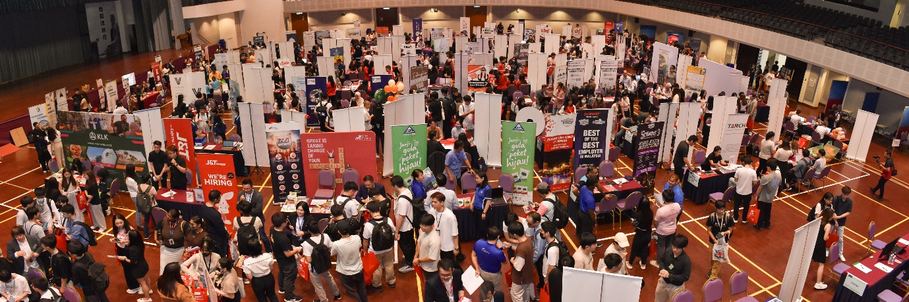

An overview of the Career Day in Dewan Tun Dr Ling Liong Sik

Participants arrived with excitement as they explored Career Day, organised on 17 July 2024, by the Department of Alumni Relations and Placement (DARP) at Dewan Tun Dr Ling Liong Sik, UTAR Kampar Campus.

The Career Day provided a dynamic platform for UTAR students, alumni, and external visitors to learn about the current job market, diverse organisations and their job openings. It enabled students and alumni as well as seasoned professionals to explore, network, and discover for themselves a wide array of opportunities among the participating organisations.

In conjunction with the Career Day, Murata Electronics (Malaysia) Sdn Bhd (“MME”) conducted a roadshow to introduce its Murata Cheerleaders, the world’s first robot cheerleaders. The robot cheerleaders represent the infinite possibilities of electronics to cheer on innovators everywhere. These robots were created for the specific purpose of demonstrating advanced Murata technologies. These robot cheerleaders have visited the United States of America, Finland, Sweden, Germany, Austria, the United Kingdom, Italy, Thailand, Malaysia, Singapore, India, China, Korea, Taiwan, the Philippines, and Vietnam.

The Murata Cheerleaders roadshow also saw the participation of UTAR President Ir Prof Dato’ Dr Ewe Hong Tat and Murata Managing Director Mr Yukio Kishigami, along with staff, students, and participants.

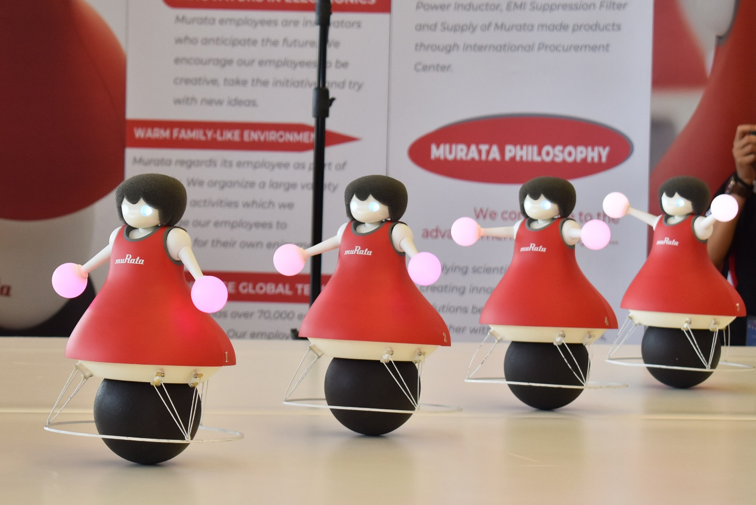

The Murata Cheerleaders

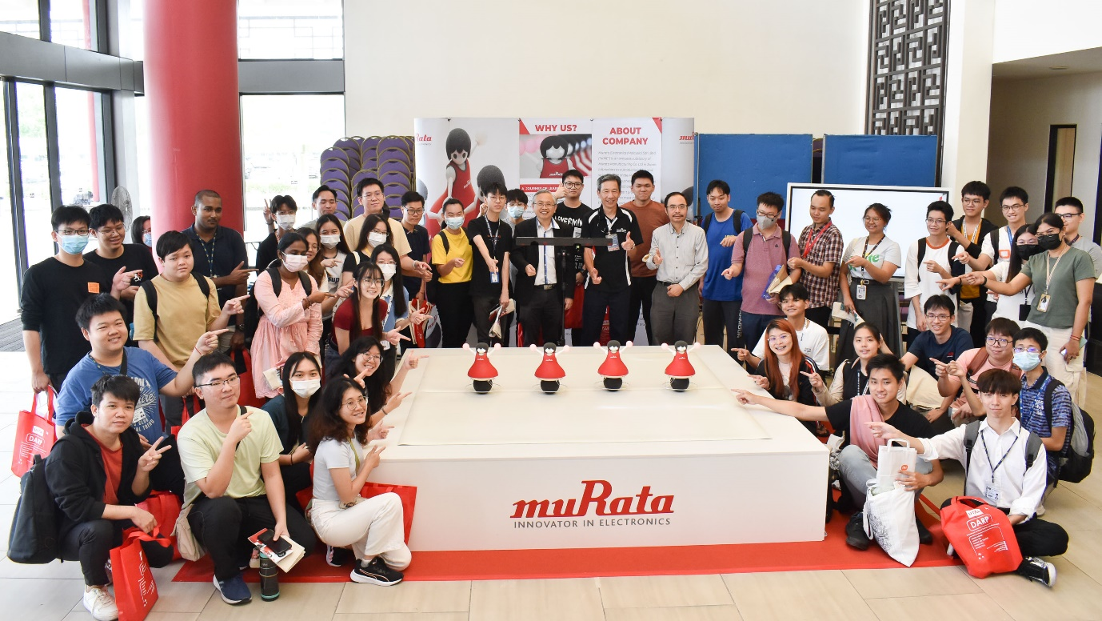

Prof Dato’ Ewe and Mr Kishigami (centre) with participants at the robot roadshow

Besides diving into the exciting hunt for a treasure trove of insights and opportunities in the world of career, the visitors were offered yet another layer of excitement in the vibrant-filled hall with the new lucky draw sessions.

The event was supported by 71 companies, who participated with the hopes of recruiting potential employees. The companies included:

|  |
| --- |
| **Name Of Company** |
|
| 99 Speed Mart Sdn Bhd |
| Ascent Globalop Sdn Bhd |
| Association Of Resource & Education For Autistic Children |
| Ava Wealth Consultancy |
| Averis Sdn Bhd |
| Bandar Utama City Centre Sb |
| Baosteel Can Making (Malaysia) Sdn Bhd |
| BKG Marketing Sdn Bhd |
| Boostorder Sdn Bhd |
| Bravo Team |
| Bridge Data Centres Malaysia Sdn Bhd |
| CBG Risk Management Sdn Bhd |
| Clear Aligners Iii Sdn Bhd |
| D&O Nutraceutical Manufacturing Sdn Bhd |
| Dimerco Express Malaysia Sdn Bhd |
| Eastern Decorator Sdn Bhd |
| Finpreneur Consultancy |
| Hab Construction Sdn Bhd |
| Hankidz Zone Sdn Bhd |
| Homecity Seremban |
| Hong Leong Bank Berhad |
| HSBC Malaysia Berhad |
| Hua Cheng Education Centre Pte Ltd |
| Infinity Logistics & Transport Sdn Bhd |
| Infinity Pg Management |
| Inno Lab Engineering Sdn Bhd |
| Intco Malaysia Sdn Bhd |
| Inventech Solution |
| J&T Express (M) Sdn Bhd |
| Jabil Sdn Bhd |
| JL Group |
| Kamaya Electric (M) Sdn Bhd (217941-T) |
| KTS Trading Sdn Bhd |
| Kuala Lumpur Kepong Berhad |
| Legalsy & Partners |
| M S Nationwide Sdn Bhd |
| Malaysia Aviation Group (Mag) |
| Megalift Sdn Bhd |
| Menicon Malaysia Sdn Bhd |
| MSM Malaysia Holdings Berhad |
| Murata Electronics (M) Sdn Bhd |
| Mythas Legacy Sdn Bhd |
| New Hoong Fatt Auto Supplies Sdn Bhd |
| Ng Leong Sing Sdn Bhd |
| Nirvana Memorial Park Sdn Bhd |
| One Stop Solution Advisory |
| Opensys (M) Berhad |
| Osram Opto Semiconductor (M) Sdn Bhd |
| Pacific Speech Therapy And Learning Centre |
| PCCO PLT |
| Phillip Mutual Berhad |
| PJ Vision Wealth Advisory |
| Polyparts Sdn Bhd |
| PSR Partner Solution Sdn Bhd |
| Ql Maxincome Sdn Bhd |
| Reactive Energy Sdn Bhd |
| Sbh Kibing Solar New Materials (M) Sdn.Bhd |
| Shanghai Quicktron Automation Technology Co Ltd |
| Star Planner Sdn Bhd |
| Sunway Services Sdn Bhd |
| Tarch Systems Sdn Bhd |
| Tasco Berhad |
| Tasek Corporation Berhad |
| Teras Megamaju Sdn Bhd |
| Ts Life Planning |
| Warisan Tc Management Services Sdn Bhd |
| Wistron Technology (Malaysia) Sdn Bhd |
| Y.S.P. Industries (M) Sdn Bhd |
| YG Hub Solution |
| YL Central Services Sdn Bhd |
| Yonyou Malaysia Sdn Bhd |

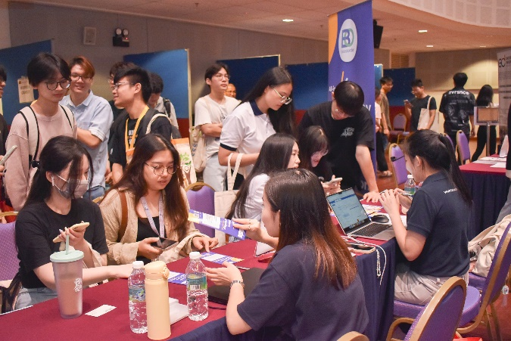 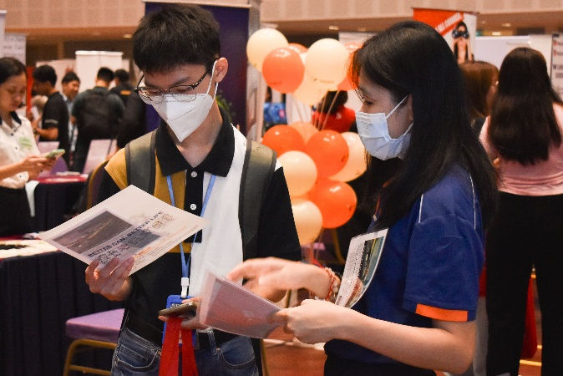 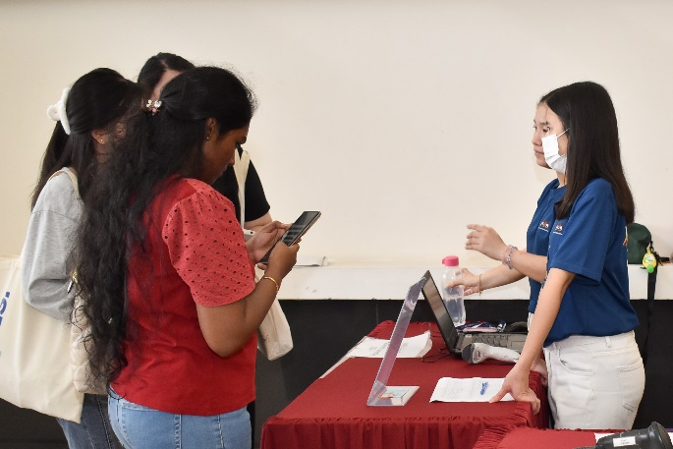 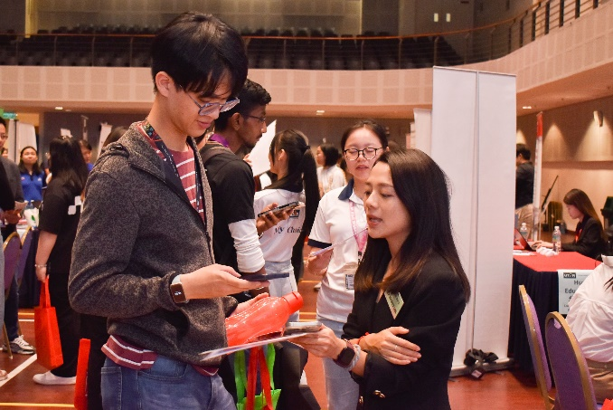 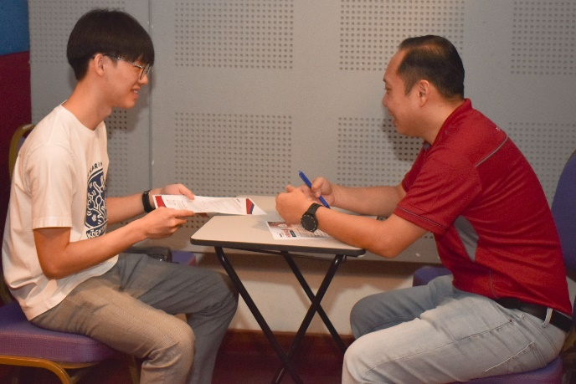 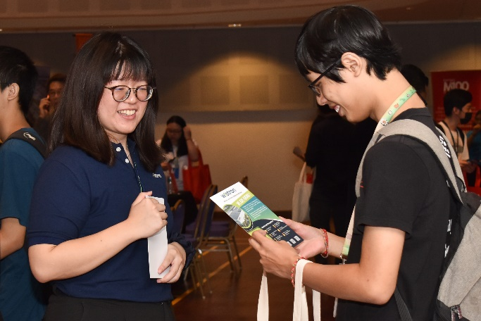

Participants at the Career Day inquiring about potential employment