**Malaysian entrepreneurs share inspiration with UTAR students**

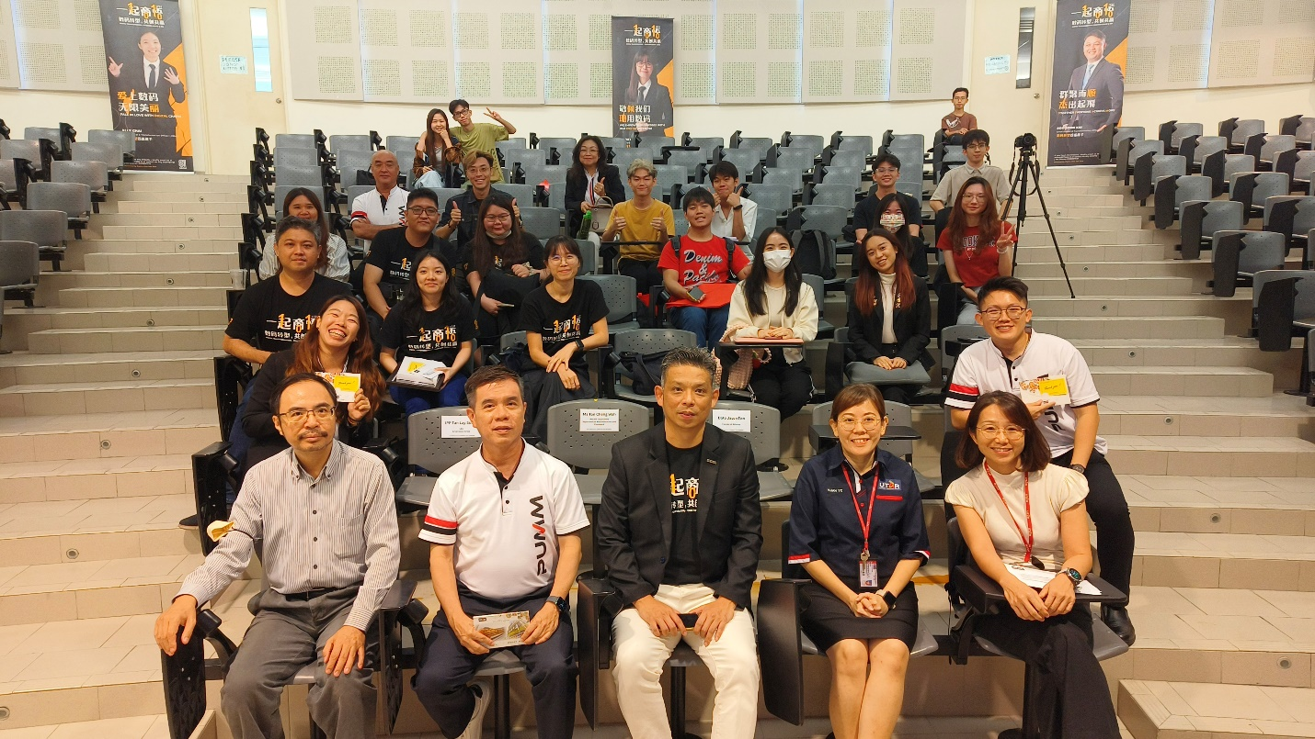

Front row, from left: Dr Choo, Mr Tan Lay Seong, Dato’ Jason Foo, Dr Kuah, and Ms Tan Cheng Wah with PUMM delegates and participants

As human society rapidly advances towards world globalisation and digitalisation, the bridge between age and entrepreneurship draws closer as well. Yet, an eclectic of hurdles remains lurking at various corners of our lives and even in our own abstract world. “Many people, especially the young adults, have an extensive amount of ideas in their minds, but do they have the courage to step out of their comfort zone to make their ideas a reality?” the Secretary General of Malaysia Entrepreneurs’ Development Association (PUMM) and the Founder of Eighty One Sdn Bhd, Dato’ Jason Foo Khee Long, told the students as he shed light on his career journey at UTAR Kampar Campus.

The PUMM Entrepreneur Colosseum (TEC) 2024 Sharing Roadshow was organised on 17 July 2024 to kindle sparks for entrepreneurship among the UTAR community. The sharing roadshow was a part of the roadshow series to promote the upcoming PUMM TEC 2024, which is a competition for aspiring young entrepreneurs to showcase their innovative concepts to successful entrepreneurs in Malaysia. A sharing roadshow was also organised at UTAR Sungai Long Campus on 19 July 2024.

During the sharing session, Dato’ Jason Foo shared his journey in the IT industry while working in Singapore and Malaysia. As an individual who joined the entrepreneurial rank in the late 2000s, he encouraged interested students to create their own businesses in their young adulthood, as they will be exposed to more learning opportunities earlier, which will play a crucial role in their entrepreneurial journey later on.

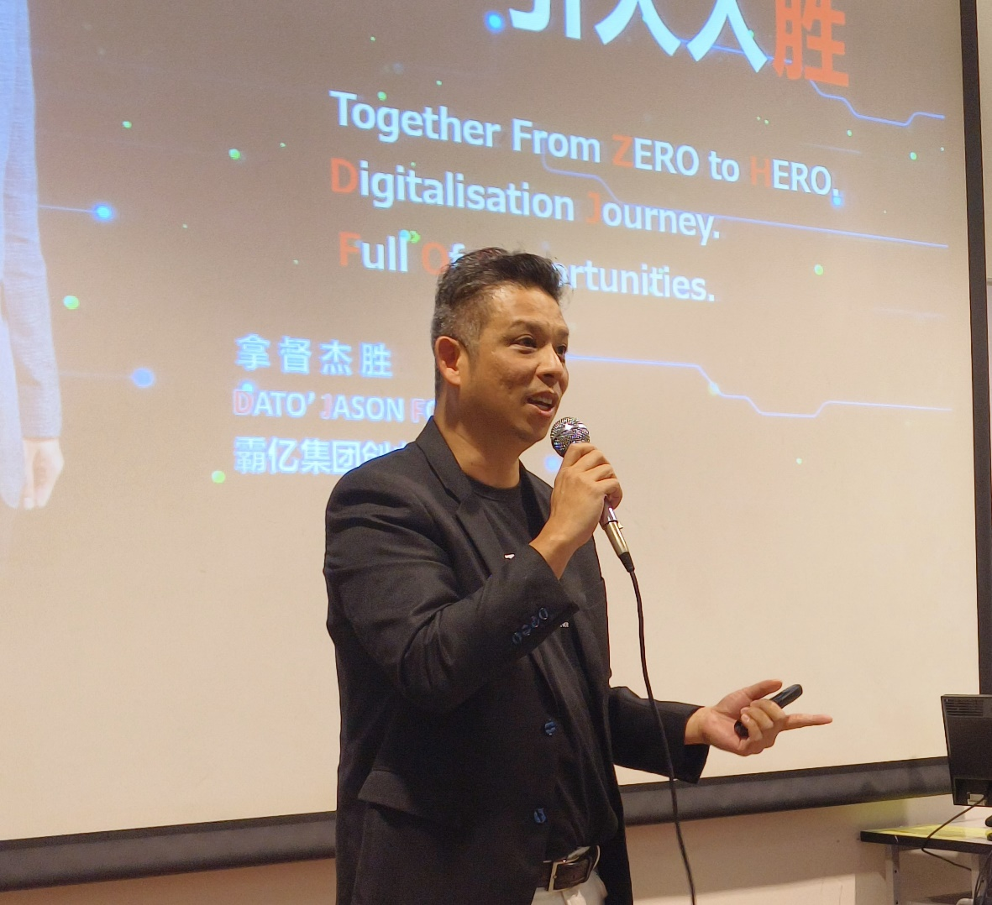

Dato’ Jason Foo explaining the importance of leadership management

Besides giving a brief insight into his career development, he enlightened the students with some advice such as the management styles of a company, the perspectives of being a leader and a worker, the relationship between the evolving trends and a company’s opportunity to success, and the importance of managing workers’ goals and relationships.

Various entrepreneurs were invited by Dato’ Jason Foo to share their advice as well as their inspiring journeys as entrepreneurs.

More information on PUMM and TEC 2024 was briefed by PUMM’s Immediate Past President and the CEO of Great Ideals Group Mr Tan Lay Seong, TEC Project Secretary and TEC Representative Mr Marcus Ong, and TEC Programme Master and the Director of SR IBOSS Global Ms Emily Wong.

A Q&A session was also held, which saw active exchanges between the UTAR students and the PUMM representatives.

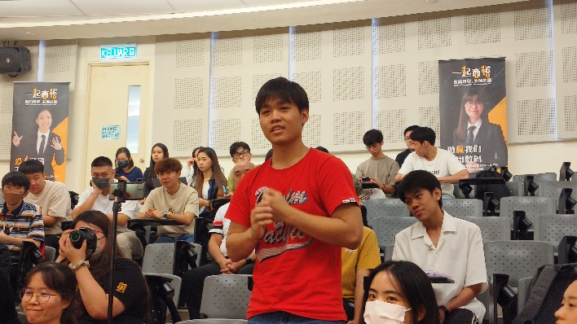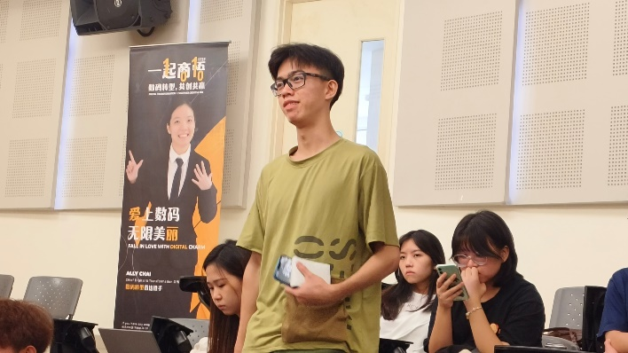

UTAR students presenting their enquiries to the PUMM delegates

Also present at the sharing roadshow were UTAR Faculty of Information and Communication Technology (FICT) Deputy Dean for Student Development and Industrial Training Dr Choo Peng Yin, Faculty of Business and Finance (FBF) Deputy Dean for Student Development and Industrial Training Dr Kuah Yoke Chin, Head of Department of Alumni Relations and Placement (DARP) Ms Tan Cheng Wah, Unovate Centre Assistant Manager Ms Neoh Shi Yii, PUMM delegates, UTAR staff and students.

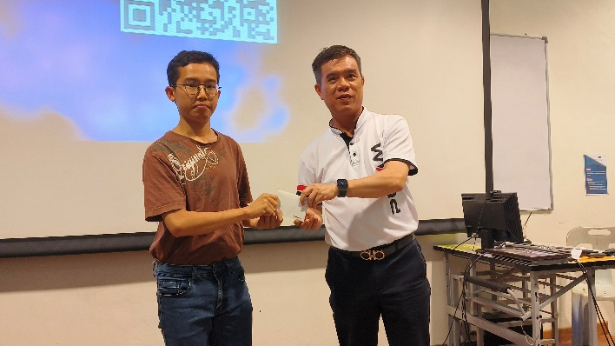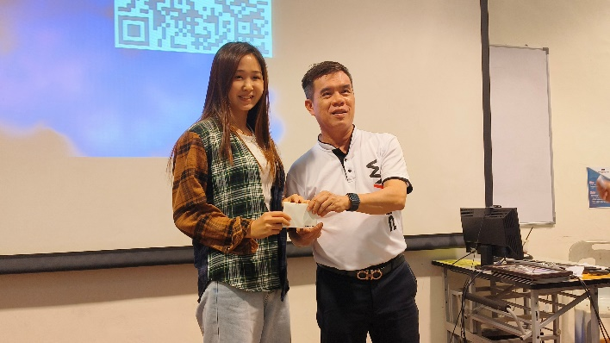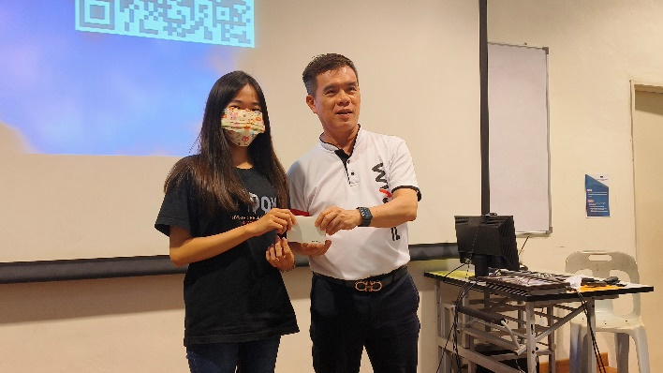

Mr Tan Lay Seong (right) presenting prizes to the lucky draw winners

For more information on the upcoming PUMM TEC 2024, please refer to the TEC 2024 Handbook: <https://drive.google.com/file/d/1DqiKRCiOSMU8_OHZDusj65o78LremTtE/view>