**UTAR-FICT 2nd Intervarsity Capture-the-Flag (CTF) Challenge @ The Amazing CyberHunt**

Building on the success of last year’s inaugural Intervarsity Capture-the-Flag (CTF) Challenge @ The Amazing CyberHunt, the Faculty of Information and Communication Technology (FICT) held the 2nd UTAR-FICT Intervarsity Capture-the-Flag (CTF) Challenge @ The Amazing CyberHunt on 20 July 2024 at UTAR Kampar Campus.

FICT, in collaboration with LGMS Berhad and Dell Technologies, organised this challenge for university students. The event aimed to attract young talents and provide a platform for them to test and enhance their cybersecurity skills, knowledge, and problem-solving abilities in a practical and competitive environment.

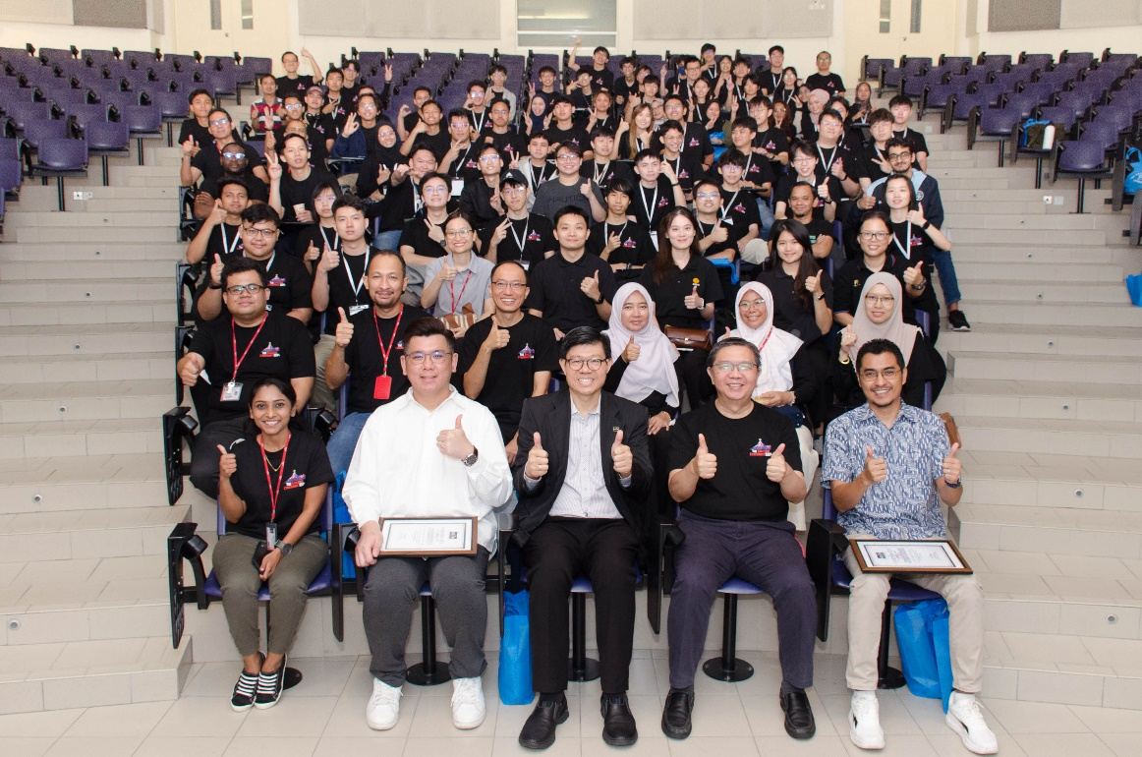

Seated front row, from left: Dr Vikneswary, Mr Gilbert Chu, Prof Choong, Prof Liew and Mr Rizwan with participants at the opening ceremony

The cybersecurity competition featured both physical and online challenges, incorporating real-world threat scenarios and engaging puzzle games. The event commenced with an opening ceremony, attended by UTAR Vice President for Student Development and Alumni Relations Prof Dr Choong Chee Keong, Dean of FICT Prof Ts Dr Liew Soung Yue, Organising Chairperson Ts Dr Vikneswary Jayapal, Chief Operating Officer of LGMS Berhad Mr Gilbert Chu, Senior Manager and Software Engineer IT of Dell Technologies Mr Ahmad Rizwan Romli, representatives from LGMS, FICT academics, and the brilliant participants.

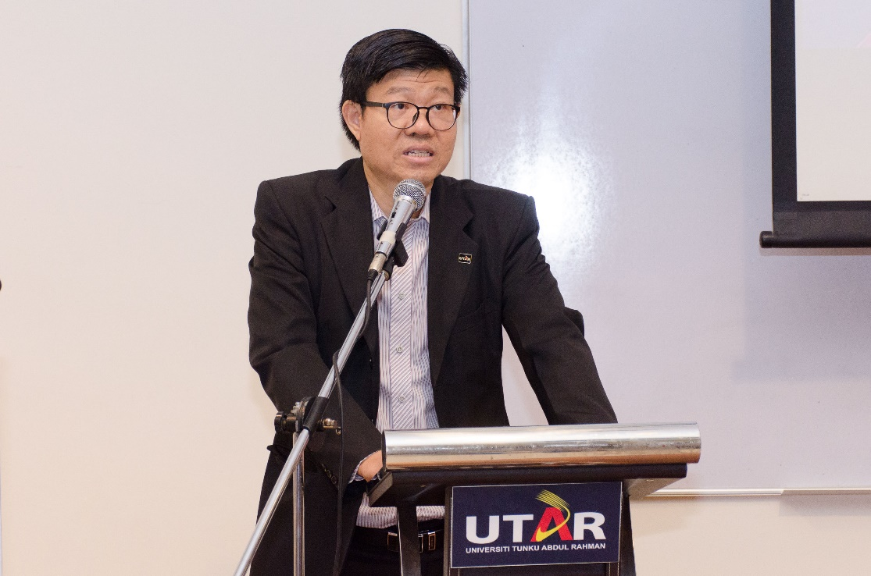

Prof Choong thanking the organising committee, sponsors, and participants, as well as the FICT academics, staff, and students who have made this challenge a success

In his opening speech, Prof Choong expressed UTAR’s pride in hosting the Capture-the-Flag challenge in collaboration with LGMS Berhad for the second time. He remarked, “Participants, working in teams, compete to solve various security-related challenges. This challenge encourages the use of skills and knowledge in areas such as web security, cryptography, and more, enhancing their cybersecurity expertise in a friendly and competitive setting. I would like to thank the organising committee, sponsors, and participants, as well as the FICT academics, staff, and students who have made this challenge a success.”

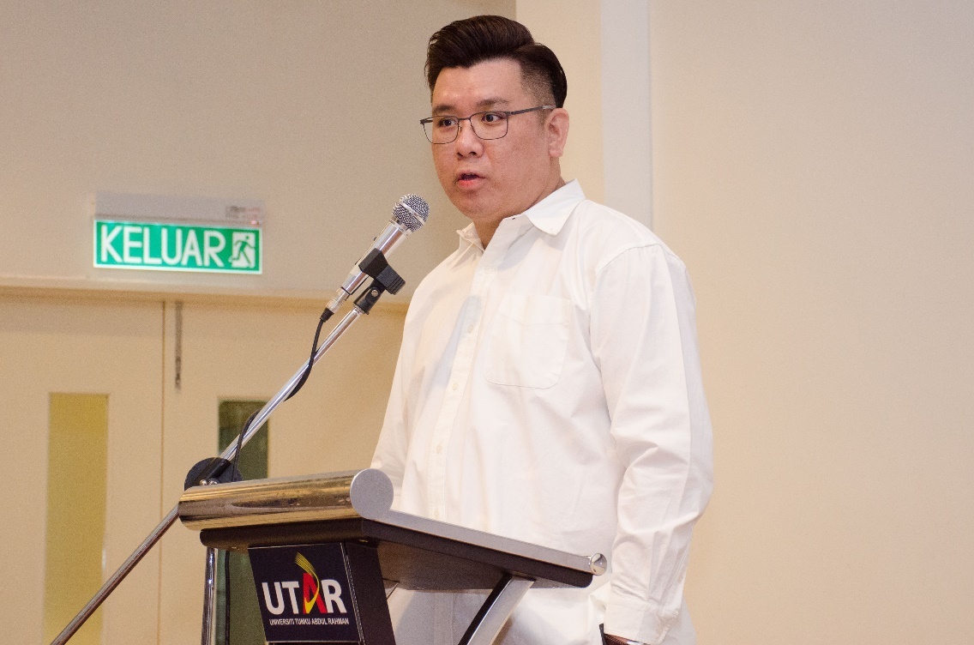

Mr Gilbert Chu encouraging the participants to view the challenge as a learning platform

Mr Gilbert Chu said in his speech, “All the best to all the participants. Taking up the challenge itself is a commendable effort. Regardless of the outcome, it is the effort you put into improving yourself that matters. Your participation is more important than winning because, in preparing for the challenge, you have learned a great deal, an experience you would not have gained without taking part.”

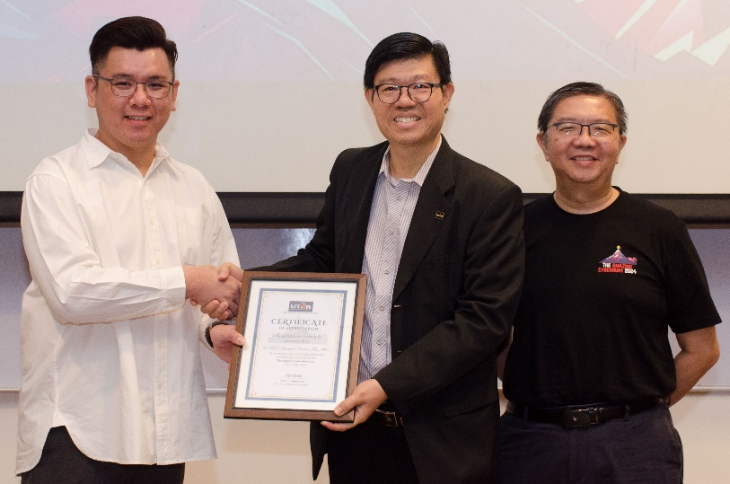 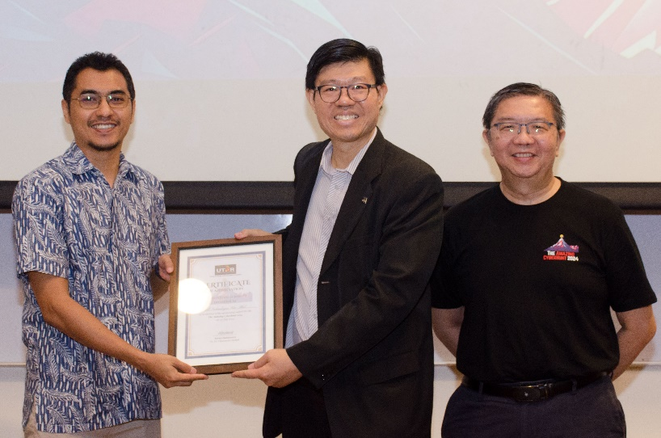

Prof Choong presenting a token of appreciation to Mr Gilbert Chu (top) and Mr Rizwan (below)

The challenge saw the participation of 25 teams, including four teams from UTAR, five from Asia Pacific University (APU), five from Universiti Sains Islam Malaysia (USIM), four from Universiti Teknologi Petronas (UTP), three from Tunku Abdul Rahman University of Management and Technology (TAR UMT), three from Universiti Tenaga Nasional (UNITEN), and one from Politeknik Mersing.

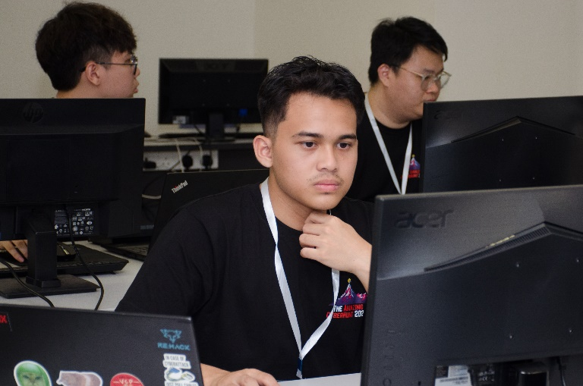 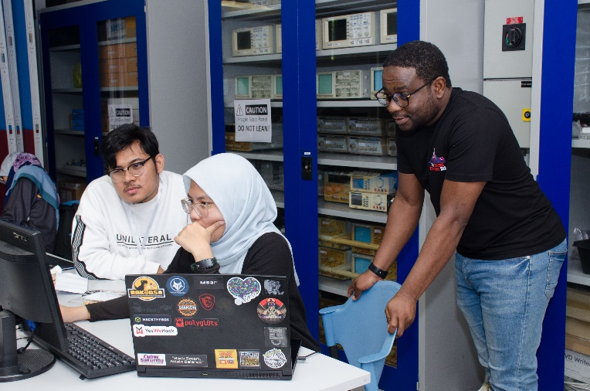 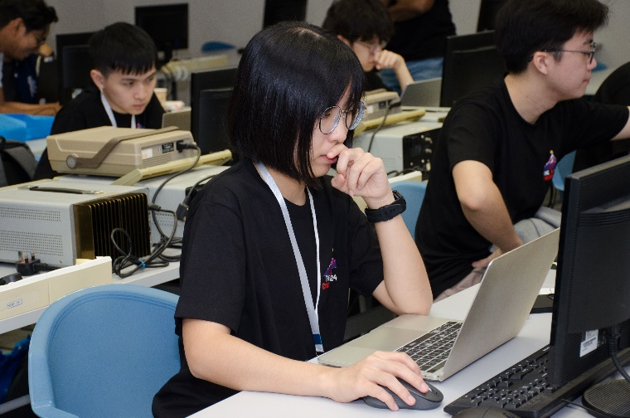 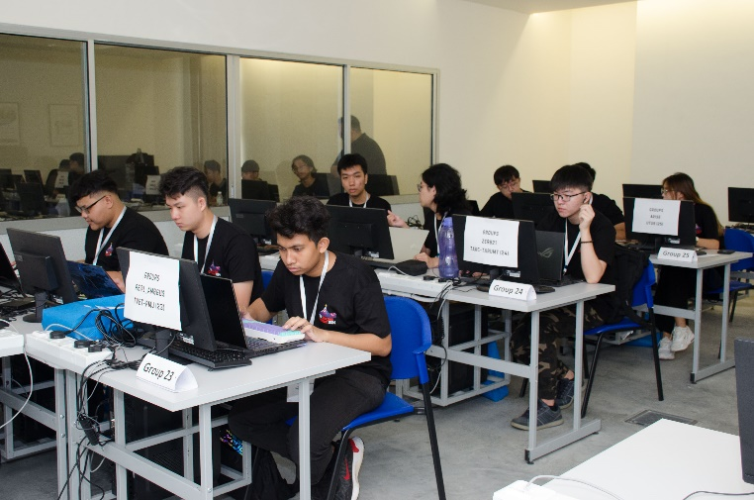 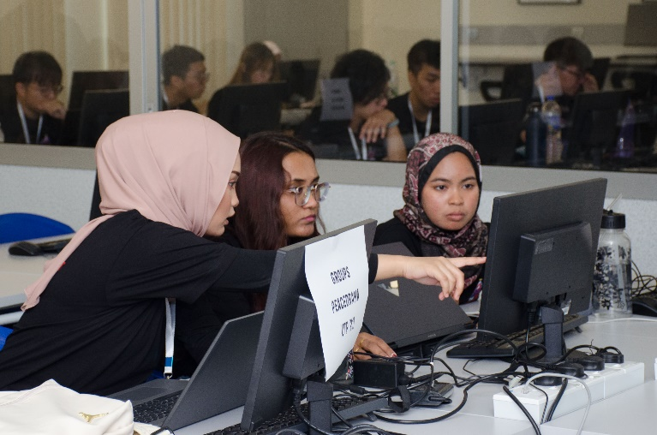 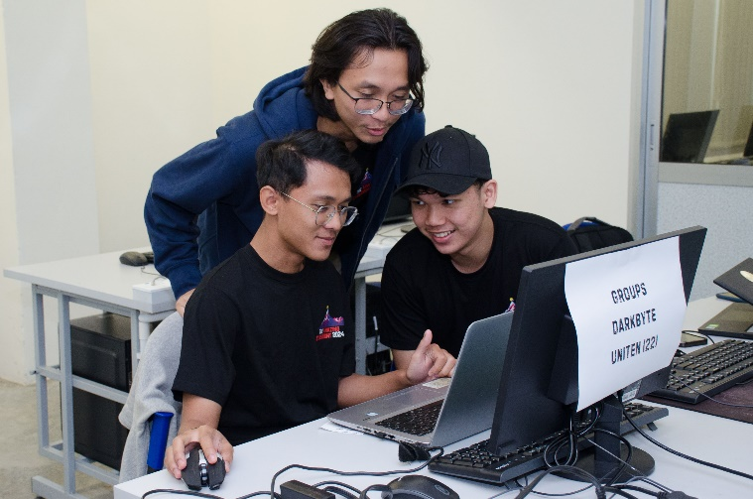

Cybersecurity enthusiasts solving various security challenges to capture the flag and earn points

The event concluded with a closing ceremony and a prize-giving ceremony. In his closing speech, Prof Liew expressed heartfelt gratitude to the main sponsor, LGMS. “First and foremost, I extend my deepest thanks to LGMS for your unwavering support and commitment to fostering cybersecurity talent. Your sponsorship has been instrumental in making this event possible. We are honoured to have representatives from LGMS here with us today, and we deeply appreciate your presence and encouragement,” he said.

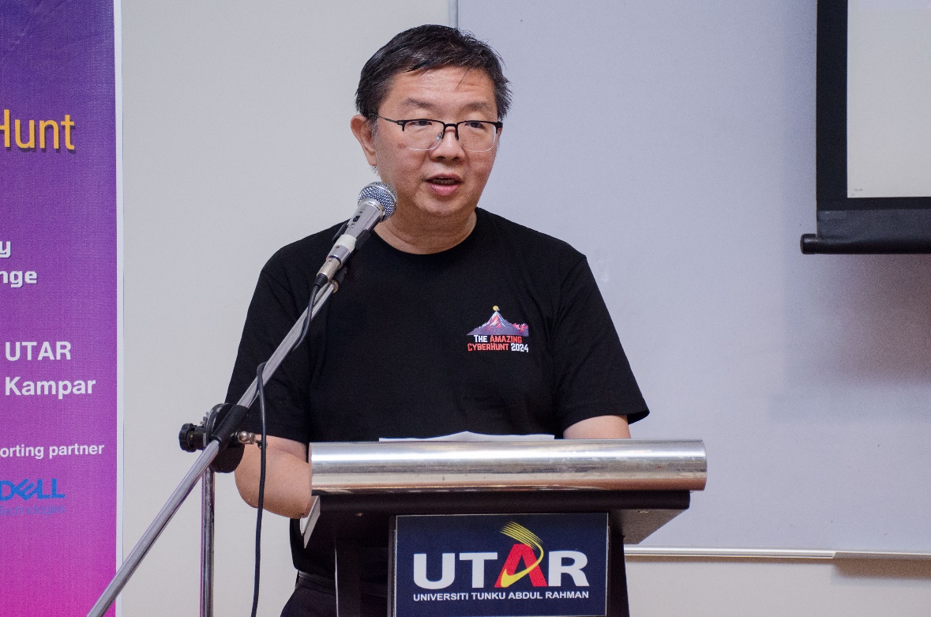

Prof Liew concluding the event by congratulating all the winners and participants

He continued, “I would also like to acknowledge our supporting partner, DELL, for your significant contribution and support in various capacities. Your involvement emphasises the importance of collaboration between academia and industry in advancing the field of cybersecurity.”

Addressing the participants, Prof Liew said, “To the participants, our brilliant young minds from various institutions across Malaysia, you have truly impressed us with your skills, determination, and enthusiasm. The Capture-the-Flag challenge is not an easy competition; it demands a deep understanding of hacking, cryptography, steganography, reverse engineering, and many other complex topics. Your performance today has demonstrated not only your technical skills but also your ability to think critically and creatively under pressure.”

He concluded his speech by saying, “Congratulations to all the winners and participants!”

The list of winners is as follows:

|  |  |  |  |
| --- | --- | --- | --- |
| **Winners Ranking** | **Institute** | **Team Name** | **Prize** |
| Champion | UNITEN | RE:UN1ON Jr | RM1,500 |
| First Runner-Up | TAR UMT | A1ph4_Sh4rk! | RM500 |
| Second Runner-Up | USIM | SkibidiFood | RM250 |
| Second Runner-Up | UTAR | GPT-1001 | RM250 |

The Champion team from UNITEN walked away with a cash prize worth RM1,500, trophies and certificates. TAR UMT team won a cash prize of RM500, trophies and certificates. Last but not least, the second runner-ups from USIM and UTAR walked away with cash prizes worth RM250 for each team, alongside trophies and certificates.

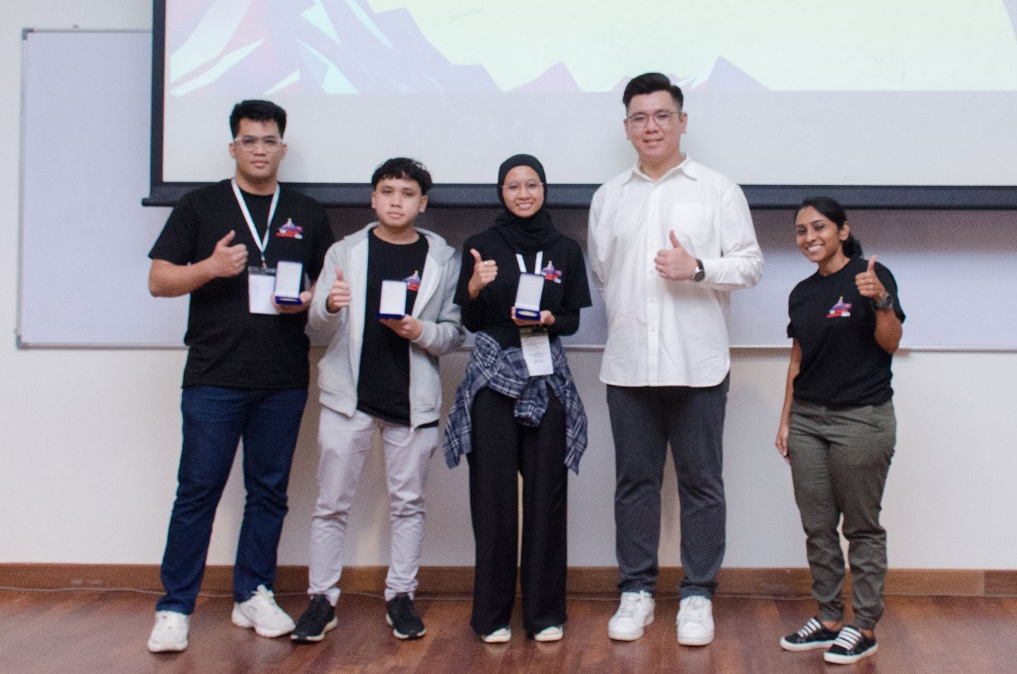

Champion: UNITEN

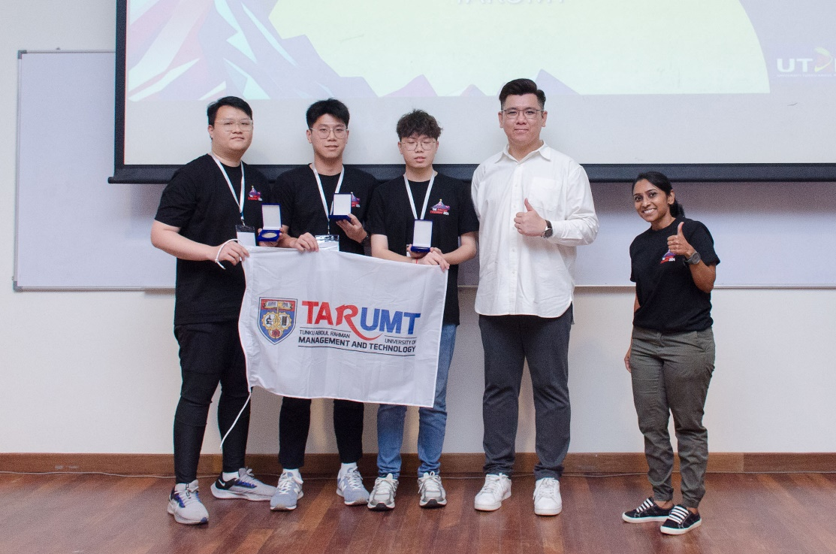

First runner-up: TAR UMT

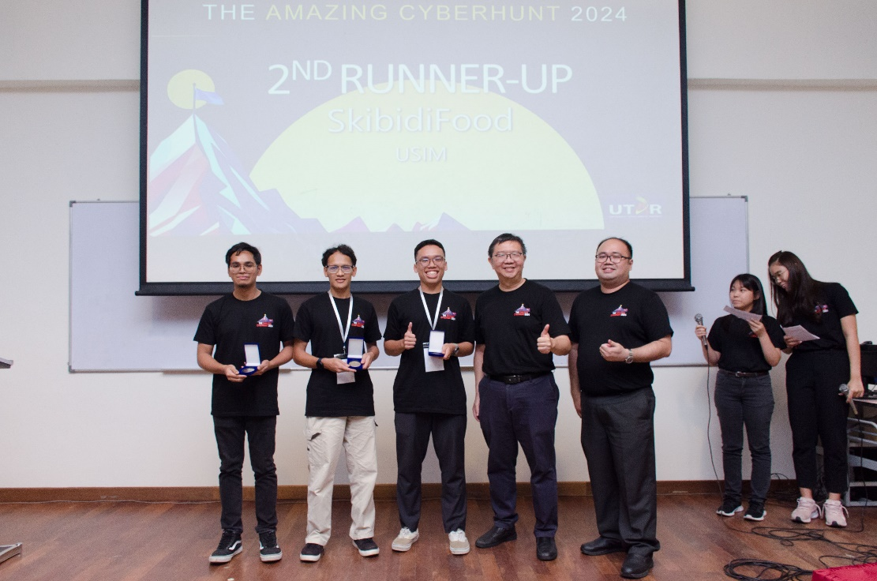

Second runner-up: USIM

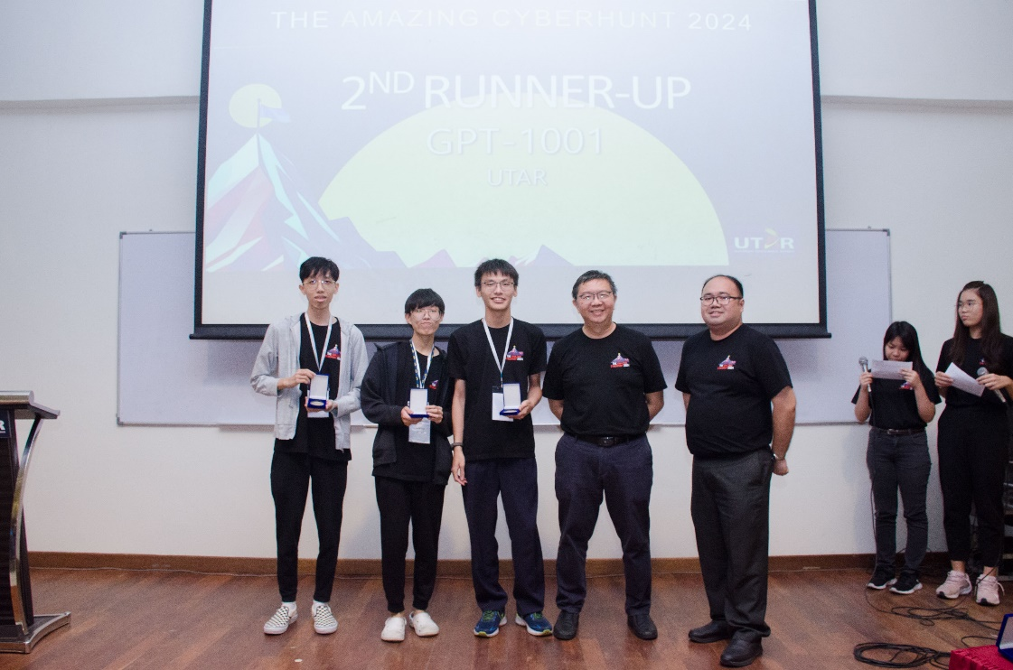

Second runner-up: UTAR