**Successful sustainable muskmelon farming in UTAR’s Green House**

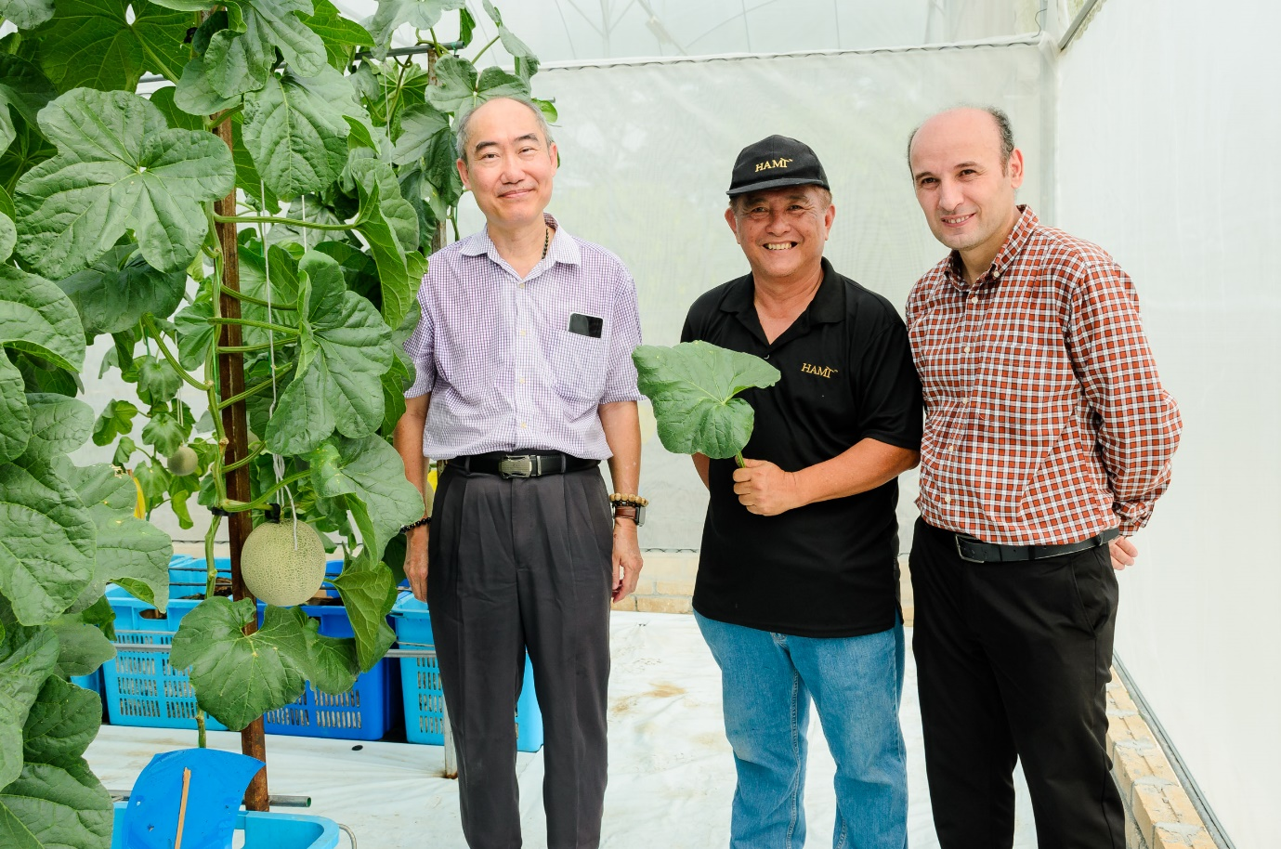

From left: Dr Lim, Mr Aw and Dr Ali

Sustainable agriculture is important for building a resilient food system that enables farmers to produce food, which are more nutritious and accessible to the growing population while preserving the environment. The key to achieving this goal is collaboration with various stakeholders, including educational institutions. In UTAR’s hope to nurture more talents among the younger generation, who are able to contribute to the creation of more sustainable food systems, the University also sees the need to engage stakeholders, including farmers, in the decision-making processes, research, and innovation design for easier adoption of sustainable farming practices. Beyond that, these collaborations facilitate farming leaders in extending resources and technological innovation to ensure a more successful transition and implementation of sustainable farming.

Ultimately, the responsibility in ensuring food and nutrition security is for all to bear. Stemming from this understanding is the fruitful collaboration between UTAR and HAMI Ecofarms Sdn Bhd, on the sustainable muskmelon farming project, conducted at the Green House of Agriculture Park, located in UTAR Kampar Campus.

Faculty of Science Dean Assoc Prof Dr Lim Tuck Meng said, “The Green House has always been a place for our students to explore and research, thus enabling them to gain a better understanding of the importance of environmental sustainability and conservation. The muskmelon farming project is an extension of that educational aspect. Beyond providing theoretical knowledge and fundamentals, the project was an opportune avenue for the students to learn the actual practices of the industry, specifically sustainable agriculture. This includes learning about the challenges faced by farmers who practise organic and sustainable farming, and the practical solutions applied in overcoming these challenges in a more realistic setting and hands-on approach.”

He added, “Additionally, it is also our hope to share with the wider audience the attractiveness of sustainable farming, especially to the younger generations. The exposure and awareness are necessary to produce more human resources in managing sustainable farms, so the sustainable practices can continue on for many generations, thus also ensuring that sustainability continues to be prioritised.”

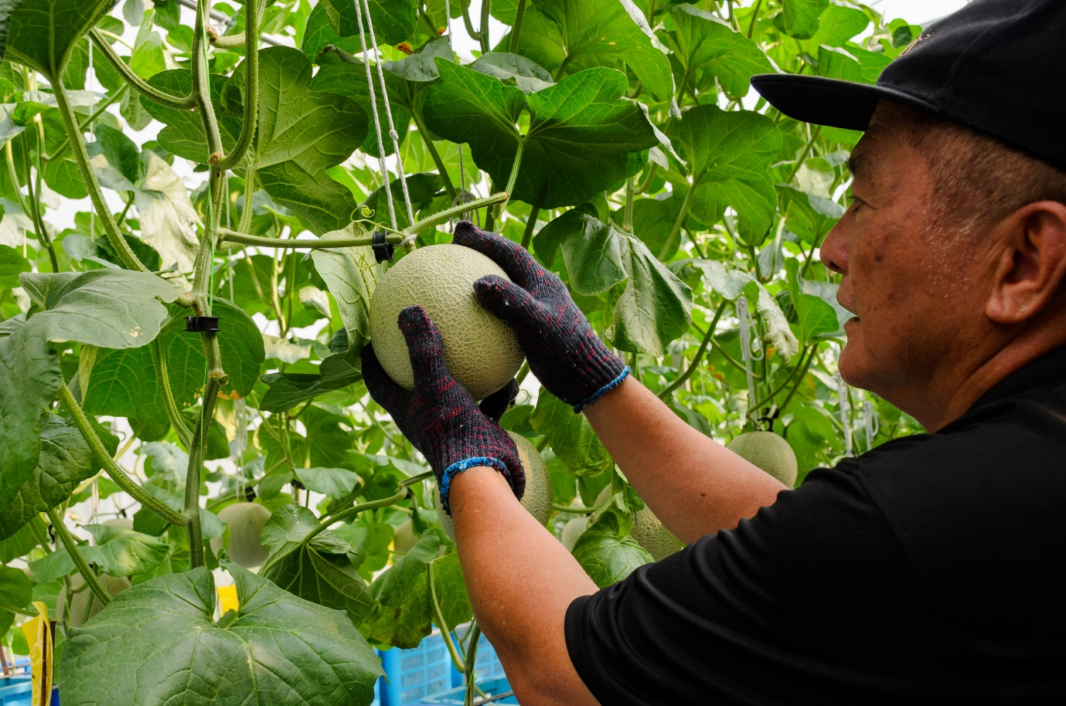

Mr Aw explaining the importance of *massaging* (polishing) the fruit

Likeminded in thoughts, Founder of HAMI Ecofarms Sdn Bhd Mr Aw Chee Choy said, “Sustainability is important for the future. HAMI Ecofarms is built on this understanding, and our business holds three things in utmost importance – organic farming, sustainability, and premium quality produce. We want to be able to share this principle with the wider community, and this collaborative project has given us this opportunity. We are happy to be able to share this knowledge on muskmelon planting. I believe organic farming is the most sustainable farming because we can source materials from our environment to the point of reusing and recycling some items. The reason for this project is also to educate students more about muskmelon planting, and so we hope, with this project, we can teach the students about sustainable muskmelon farming.”

Mr Aw further explained the many techniques and care required to ensure the optimal growth of the muskmelons, including the special technique of *massaging* the fruit, which helps the netting become more prominent. It was noted that the optimum weight of the fruit for commercialisation ranges between 1.8 to 2kg, with the sweetness scale up to 14 Brix degrees. One full cycle of planting will take not more than 90 days under Malaysian weather and planting conditions. The muskmelons are available for purchase and pre-order in advance of the harvest.

The project is led by the Head of Department of Agricultural and Food Science, Dr Ali Yassoralipour, with the guidance of HAMI Ecofarms, who jointly look into assessing and maintaining the conducive conditions for the plant and fruit to grow optimally. In adherence to sustainability, organic fertilisers and compost are used in their soil nutrient management for optimum soil health. The team also applied Integrated Pest Management (IPM), whereby the greenhouse is double-netted to prevent insects and other pests. Sprinklers are used for efficient irrigation systems, and for better water management to minimise waste. The team also repurposed heavy-duty plastic baskets for the planting. The significance of this collaboration is that it has enabled the academic staff and students to have a first-hand experience of sustainable muskmelon planting from preparation of planting materials to harvesting. Every detail of the process can be monitored and recorded for future development and improvement.

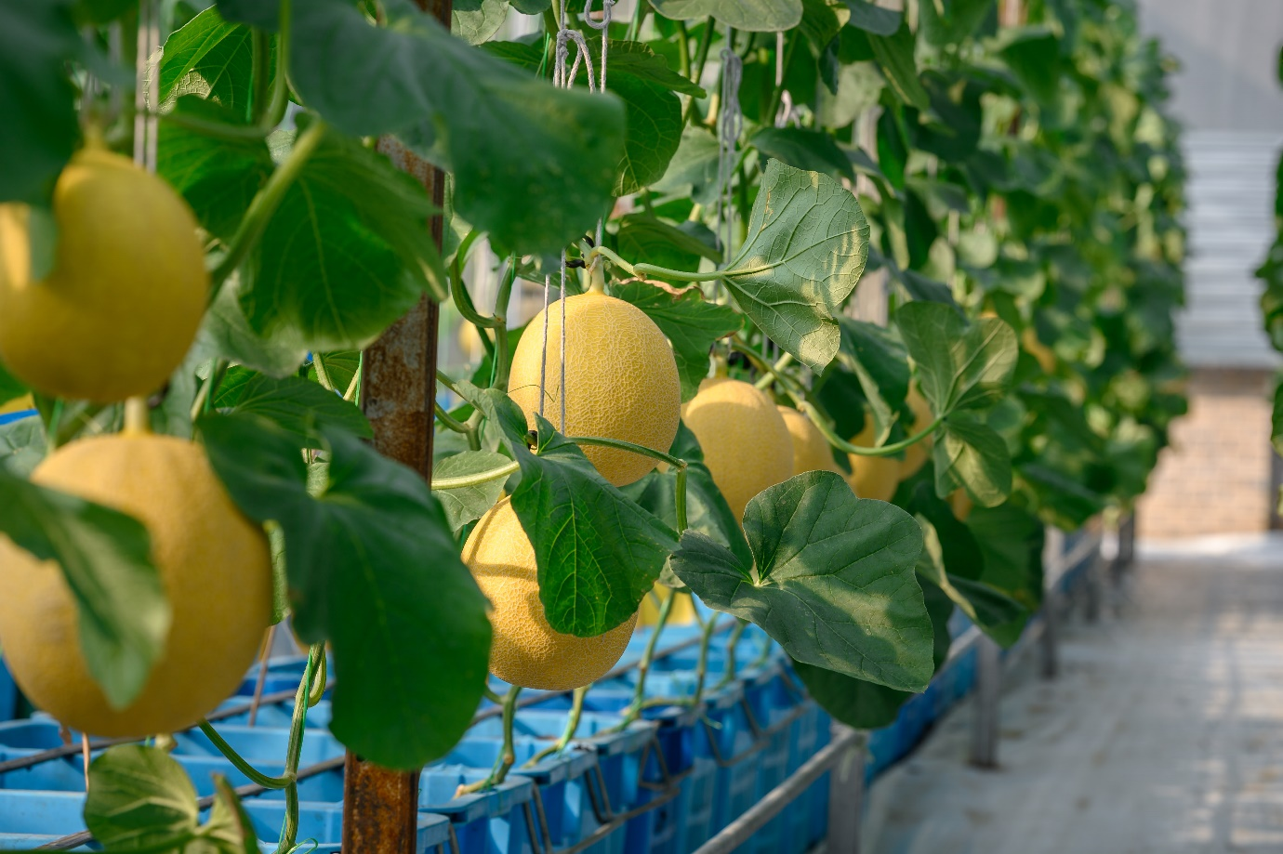 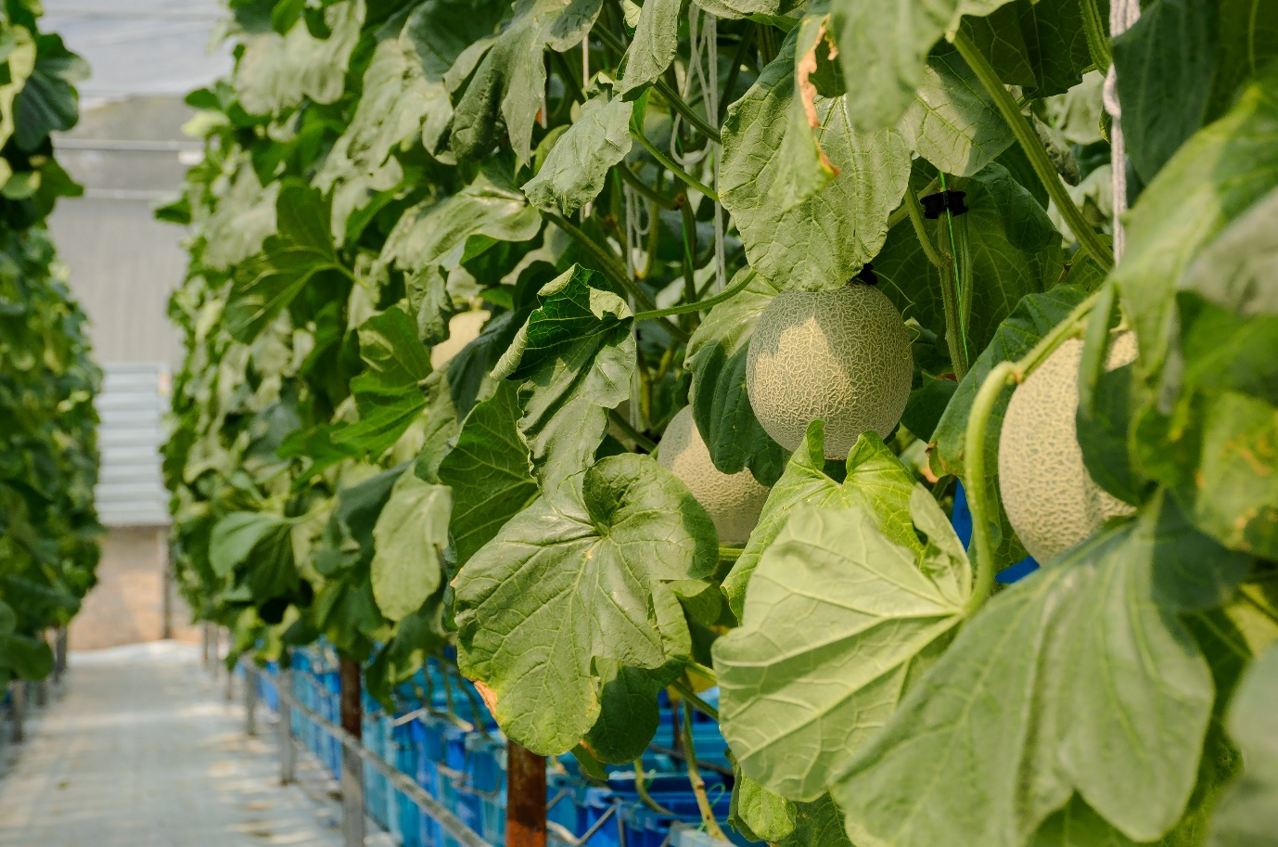

The Mizuki (top photo) and Asahi (bottom photo) muskmelons, two of the variations grown in the Green House

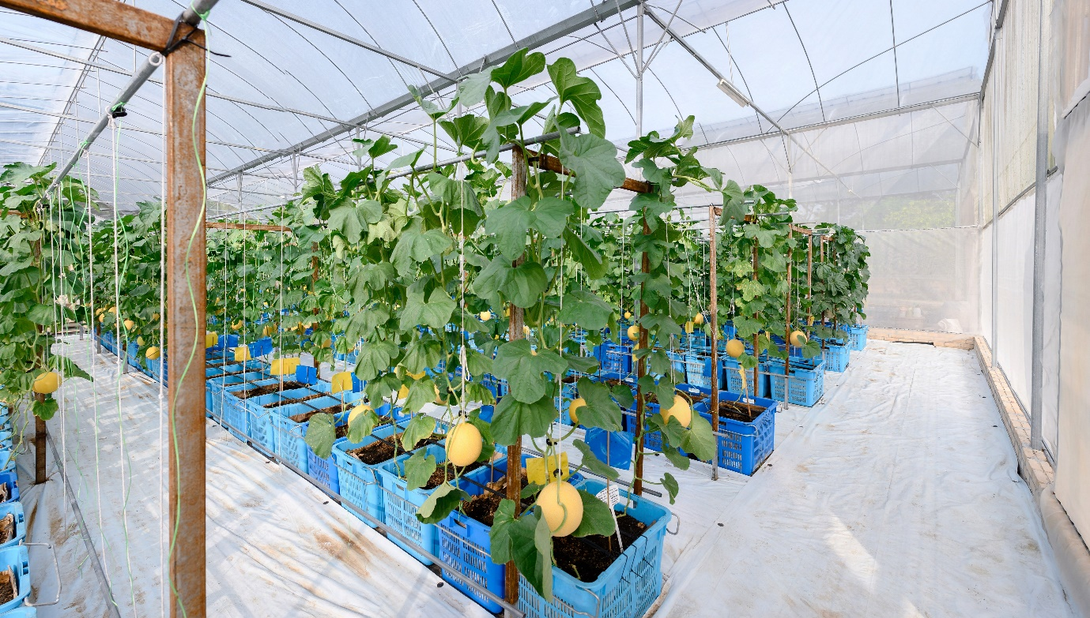

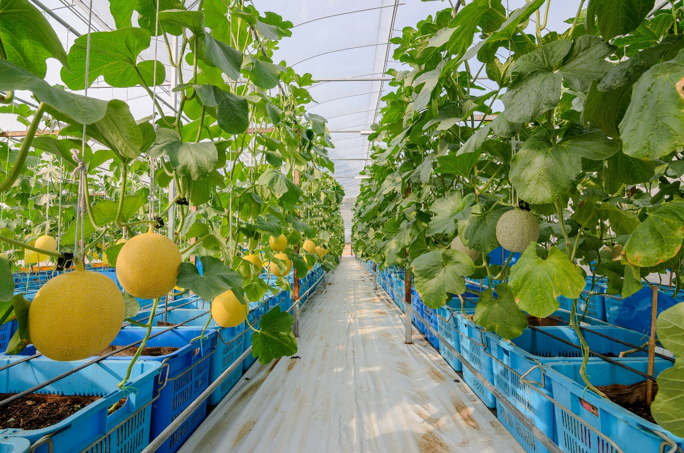

The internal views of the muskmelon farm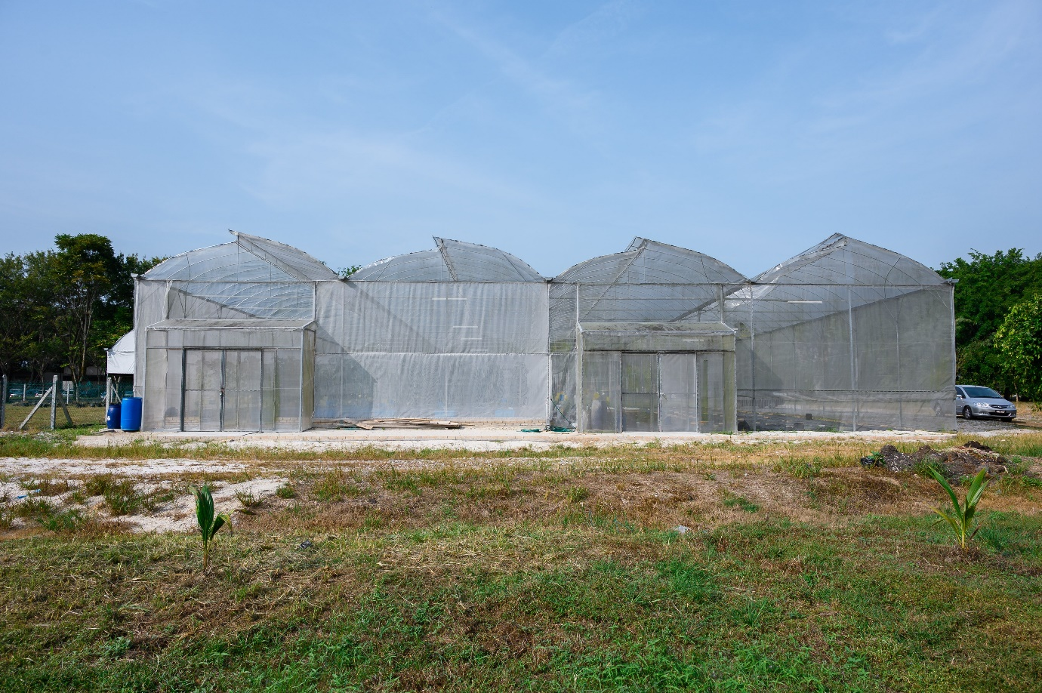

The Green House

At present, the muskmelon farm occupies the space of 120 sqm in the green house, and four variations of the muskmelons are grown, namely Asahi, Sagami, Mizuki, and Akane. Upon harvest, which is expected to take place in mid-August, the muskmelons will be stored in an air-conditioned storage for two to three days before consumption to enhance their sweetness. The teams are also considering exploring farming cherry tomatoes, white pumpkins, and butternut squash as their upcoming projects.

Three Bachelor of Science (Honours) Agricultural Science students, namely Ellina Saad, Vernon Chu Yen Han, and Vanesa Vrinnda Lawrence are involved in this project, under the UTAR’s Undergraduate Research Scheme (URS). They work with HAMI Ecofarms’ staff for pruning, inspecting the muskmelons’ leaves for signs of diseases or insects, checking soil moisture, weeding and manual pollination. Additionally, they also take EC and pH readings to ensure the appropriate amounts of fertiliser are given to the individual plant. The students expressed that the project has provided them insights on managing a farm, and the benefits of sustainable farming. They also understood better about the real working environment as they acquired industrial insights on the commercialisation of fruits and entrepreneurship.

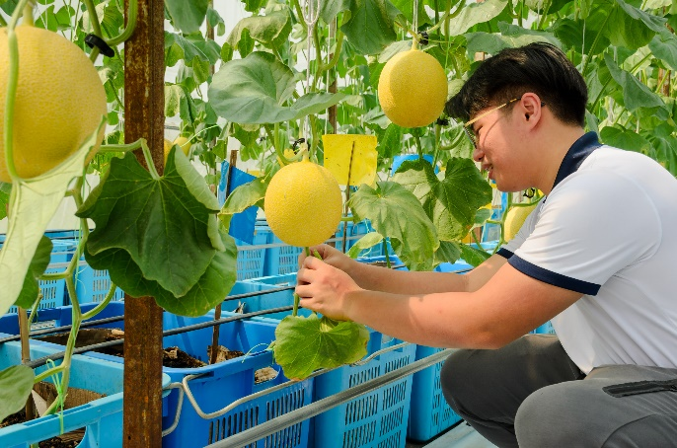 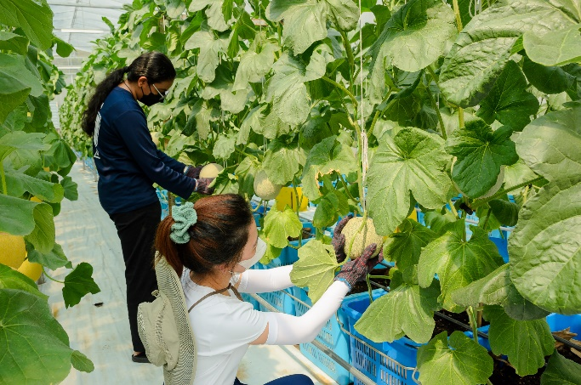

Left photo: Vernon Chu pruning the plant  
Right photo: Ellina and Vanesa (in blue) *massaging* the fruit

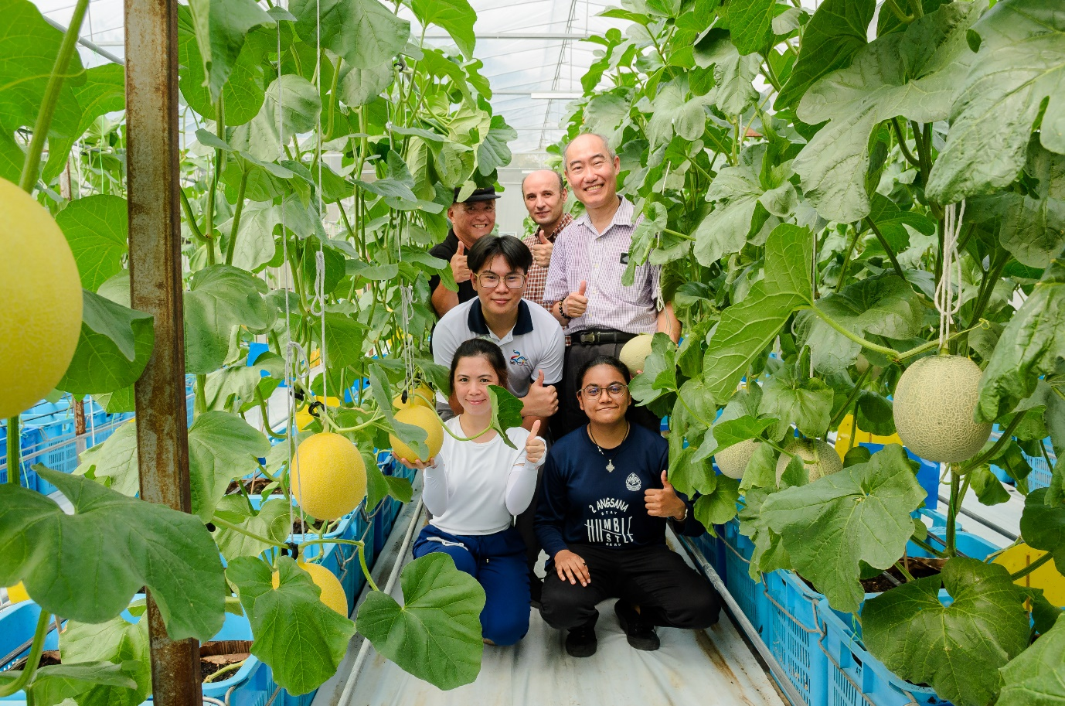

All smiles for a successful collaborative project between FSc and HAMI Ecofarms