**An insightful day with FBF Industry Advisors**

On Industry Advisory Panel Day, held by the Faculty of Business and Finance (FBF) at UTAR Kampar Campus on 7 March 2024, participants gained valuable insights into their prospective careers, offering them a glimpse into what lies ahead in the industry.

The industry advisory panel consisted of Founder, Principal Trainer and Consultant of First Penguin Sdn Bhd Dr Wong Lai Yong; Obstetric Industry Advisor and Gynaecologist UD56, O&G Department, Hospital Raja Permaisuri Bainun Ipoh Dr Loo Chee Voon; Country Manager of Nuffnang Sdn Bhd Mr Hieu Kau Sern; Country Chief Risk Officer of OCBC Bank (M) Berhad Mr Thor Boon Lee; and Principal of Y W Soo & Co Mr William Soo Yuit Weng.

Present to welcome the panellists were FBF’s management committee, namely Dean Assoc Prof Dr Au Yong Hui Nee, Deputy Dean for R&D and Postgraduate Programmes Prof Dr Abdelhak Senadjki, Deputy Dean for Academic Development and Undergraduate Programmes Dr Peter Tan Sin Howe, Deputy Dean for Student Development and Industrial Training Dr Kuah Yoke Chin, Doctor of Philosophy (Economics) Programme Head Dr Vikniswari Vija Kumaran, Postgraduate Programmes Head Assoc Prof Dr Leong Lai Ying, MBA (Corporate Management) Programme Head Dr Tan Chi Hau, Department of Finance Head Dr Lee Chee Loong, Department of Business and Public Administration Head Dr Siti Fazilah binti Abdul Shukor, Department of Banking and Risk Management Head Mr Chong Tun Pin, Department of Marketing Head Dr Choy Johnn Yee, Department of Entrepreneurship and Supply Chain Management Head Dr Ng Yin Kuan, Department of Commerce and Accountancy Head Sonia Johanthan, and Department of Economics Head Dr Thavamalar Ganapathy.

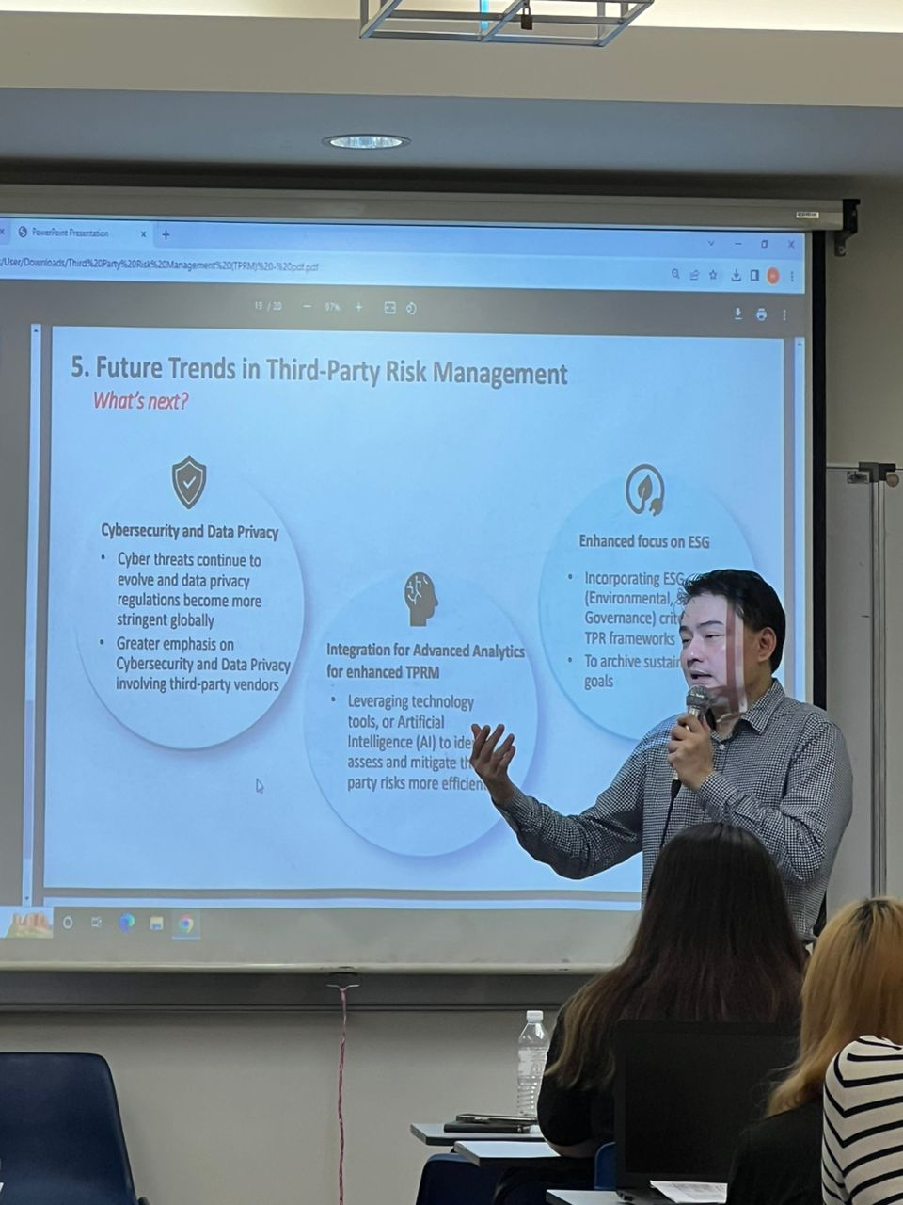

Mr Thor highlighting the trends of third-party risk management

The highlights of the day were the talks delivered by the industry advisors, offering participants the latest information into the industry and tips to perform better at one’s job. The first speaker, Mr Thor, emphasised the significance of managing risks associated with third-party services in financial institutions, and the impacts of such risks on financial institutions through the safeguarding of confidential information, managing adverse effects on financial institution’s reputation, and maintaining public confidence in the financial system. Strengthening his point, he presented examples of third-party services encompassing three main aspects, namely document processing, information system hosting and sales and marketing services.

Participants also gained an understanding of the important role played by the regulator (Malaysia and Singapore) in setting the policies outlining regulatory guidelines for financial institutions on managing risk associated with outsourcing arrangements; covering due diligence, data protection, compliance with legal and regulatory requirements; and ensuring the resilience of outsourced operations. He also shared ~~on~~ the roles of respective key persons from various departments, such as information security, human resources, business continuity risk, technology, legal, regulatory compliance, and operational risk.

Mr Thor’s generous sharing imparted invaluable insights and best practices on effective management of third-party risks. This included information on understanding the importance of conducting thorough due diligence and risk assessments when engaging third-party service providers, including evaluating their financial stability, security measures, and regulatory compliance. Additional information shared were the implementation of robust contract management processes to clearly define roles, responsibilities, and performance expectations, while also incorporating adequate provisions for risk mitigation, indemnification, and dispute resolution, as well as, establishing proactive monitoring and oversight mechanisms to continuously assess third-party performance and compliance, including regular audits, performance reviews, and incident response protocols.

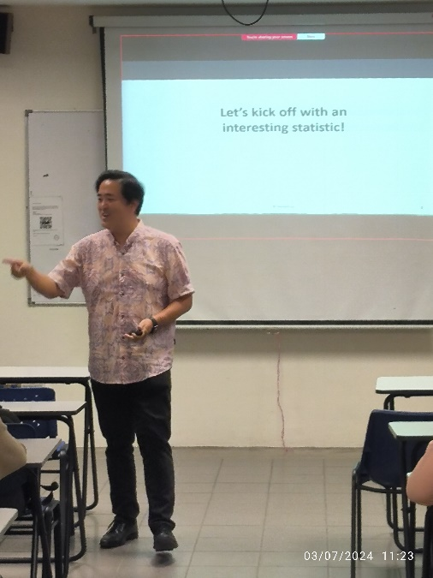

Mr Hieu asking participants some questions

Mr Hieu, who spoke on “What do Influencer Marketing Agencies Do?”, through interactive and role-playing, provided participants with the basic understanding of influencer marketing. He further shared the role of an influencer marketing agency, and the functions of different departments in the influencer marketing agency, as well as the skills required in each department. He spent a great time focusing on the interaction with participants and encouraged them to provide their feedback. Followed after was an interactive Q&A session, that became an avenue for all to learn more about influencer marketing.

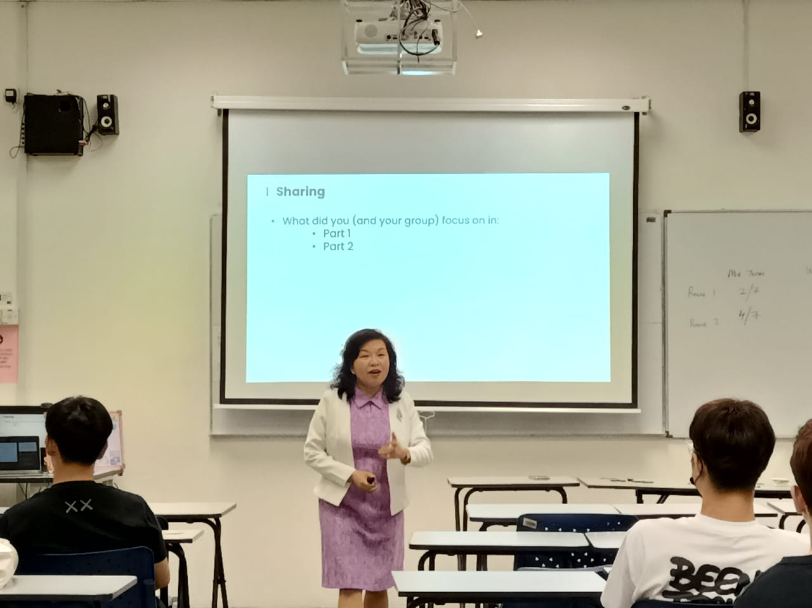

Dr Wong asking participants for their feedback

Through the 2030 SDGs Game, Dr Wong provided the participants with a better understanding of the interconnectivity between economic activities, environment and social implications, highlighting how the escalation of economic activities often leads to environmental depletion, consequently impacting social welfare. The participants were each given a card, which indicated the goal they needed to achieve by 2030. The game consisted of two parts; the participants were requested to present the mid-term report and final report (2030).

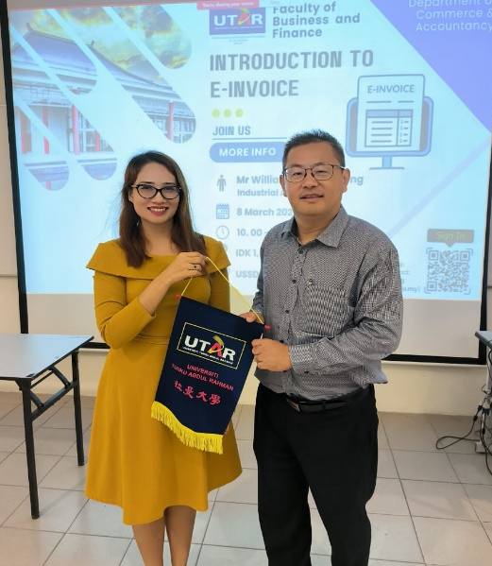

Ms Sonia presenting a token of appreciation to Mr William Soo

The following day, Mr William Soo presented the “Introduction to E-invoice”, which explained that the advancement of technology has transformed traditional practices in the dynamic realm of business. According to the speaker, Electronic invoicing (E-invoice) was implemented as one of the strategic thrusts for digital transformation in taxation, as well as an effort by the Malaysian government to foster the development of the digital economy and improve the efficiency of Malaysia’s tax administration management.

He further elucidated that the implementation of E-invoice aimed to unify the invoicing process by streamlining the document creation and submission electronically to the Inland Revenue Board Malaysia (IRBM). It also aided in enhancing the transparency of the invoicing process and the accuracy of information transmission. He further explained that such practice also aids in reducing the shadow economy, preventing tax fraud (detecting fake invoices), and enhancing tax compliance.

Mr William Soo also enlightened the participants on different cases with the E-invoice mechanisms and requirements, such as self-billed invoices used in cross border transactions where it involved foreign suppliers; items that required E-invoice for each transaction, for instance, motor vehicles, flight tickets, luxury goods, construction, licensed betting and gaming, and payment to dealers, agents, or distributors; and lastly, exemption from implementing e-invoice, especially for Ruler and Ruling Chief, Government, state authority, Statutory body, and individual who does not conduct business.

Course leader and FBF academic Dr Annie Ng Cheng San, commented, “To propel Malaysia’s tax system, the government is now gearing up for a tax reform to gradually implement the E-invoice and it will become mandatory for all businesses regardless of the turnover effective from July 2025. E-invoice is a new era of tax administration. To guarantee its success, it is important to ensure the stakeholders are aware and ready for E-invoice adoption. It was against this backdrop that the talk was organised.”