Promoting preventive health practices at U-Health Matters Health Fair
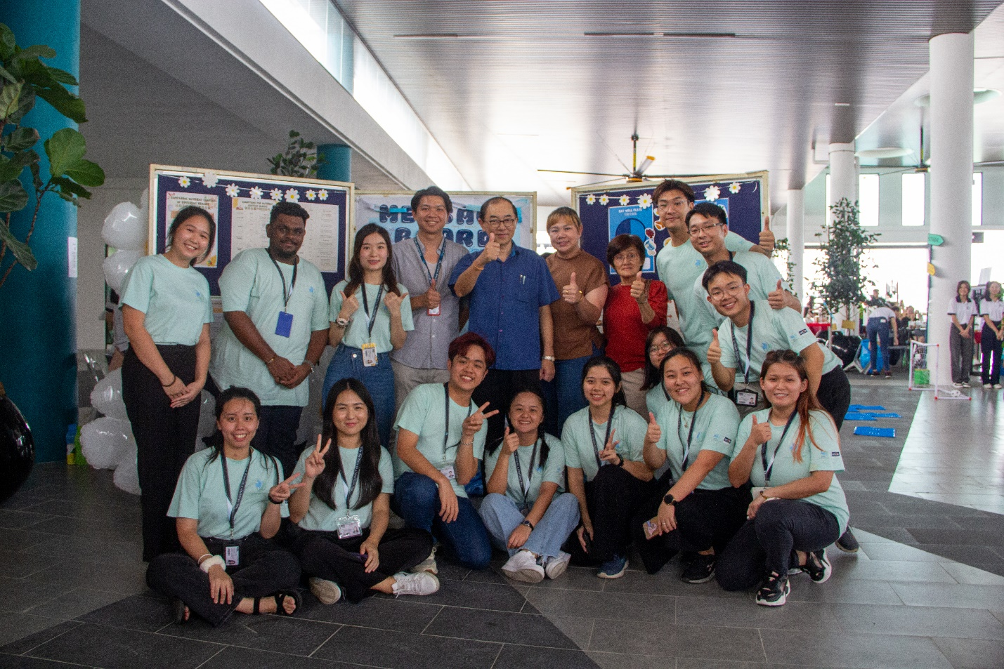
U-Health Matters project committee members and UTAR Hospital staff taking a group photograph with Malaysia’s Former Deputy Minister of Education Dato’ Dr Mah Hang Soon (centre)
A group of 15 UTAR Faculty of Arts and Social Science (FAS) Bachelor of Communication (Honours) Public Relations (PR) final-year students fostered healthy lifestyles and community spirit in their concerted effort to raise health awareness among the Kampar community. As part of their health awareness campaign, the members of the “U-Health Matters” project joined hands with the health practitioners at UTAR Hospital to organise the “U-Health Matters Health Fair” at UTAR Hospital on 24 March 2024.
With the tagline “Ride the Wave to a Healthier You”, the U-Health Matters project aimed to optimise public health, emphasising the importance of a healthier lifestyle. Besides providing healthy tips on various subjects of life to the Kampar community, the zestful bunch brought together an assortment of health-revolving activities with a veil of fun at the U-Health Matters Health Fair. The activities included free medical check-up, free medical consultation, Zumba session, nutrition exhibition, song and dance performances, and food and drink sales by vendors.
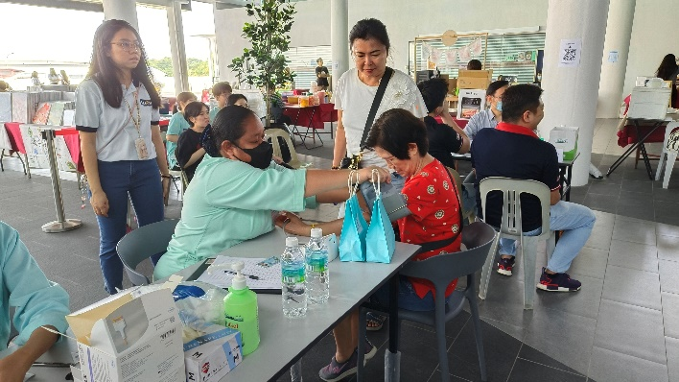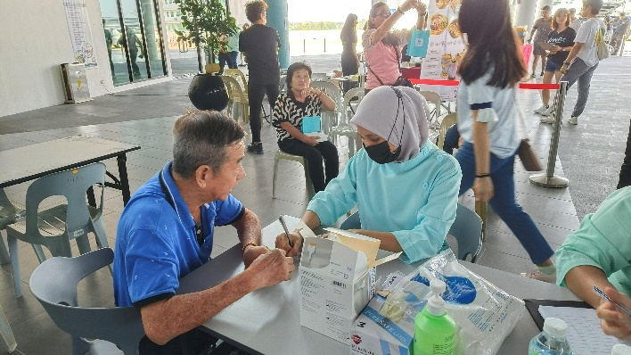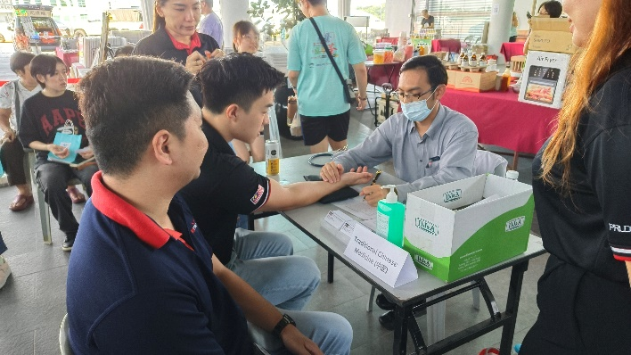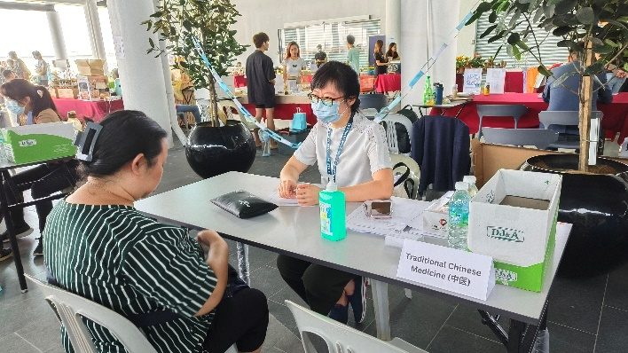
Visitors having free health check-ups and consultations with the personnel from UTAR Hospital
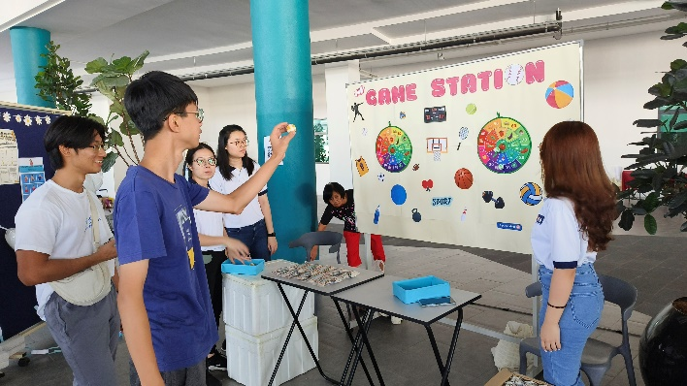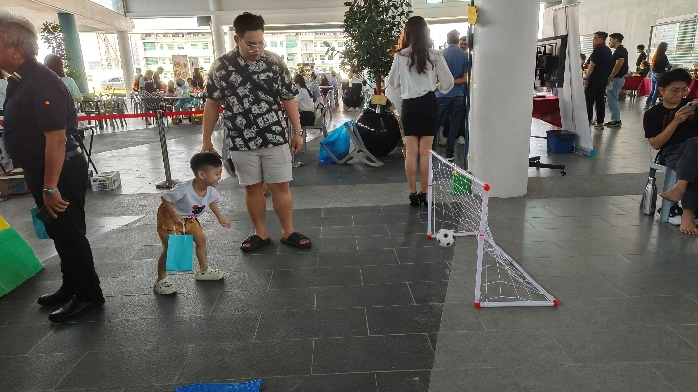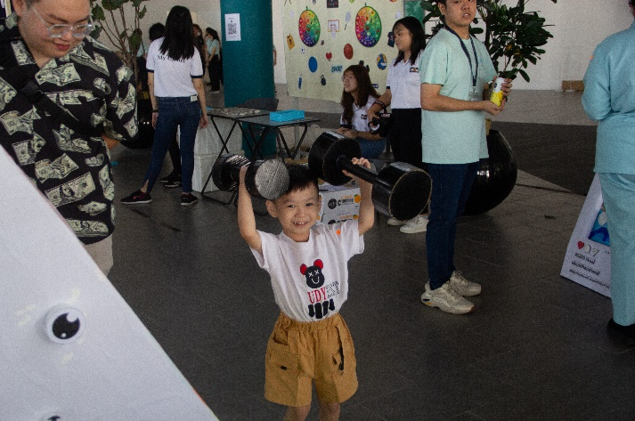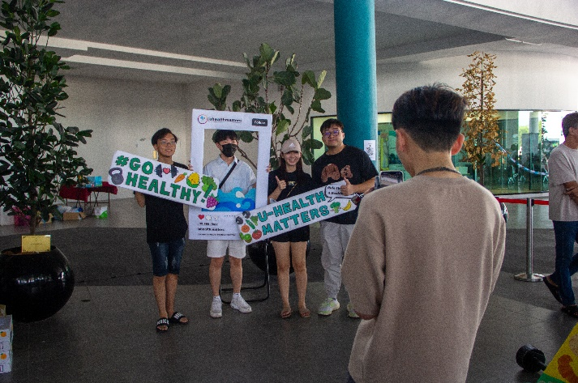
Visitors enjoying lighthearted games at the games corner
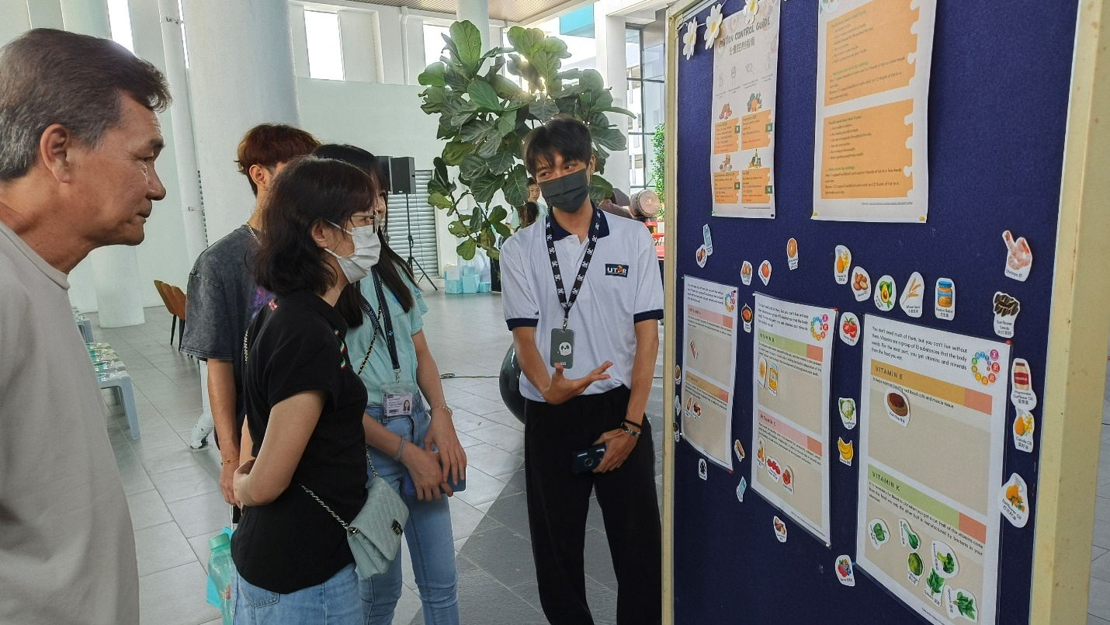
Student helpers providing nutritional facts to the inquisitive visitors
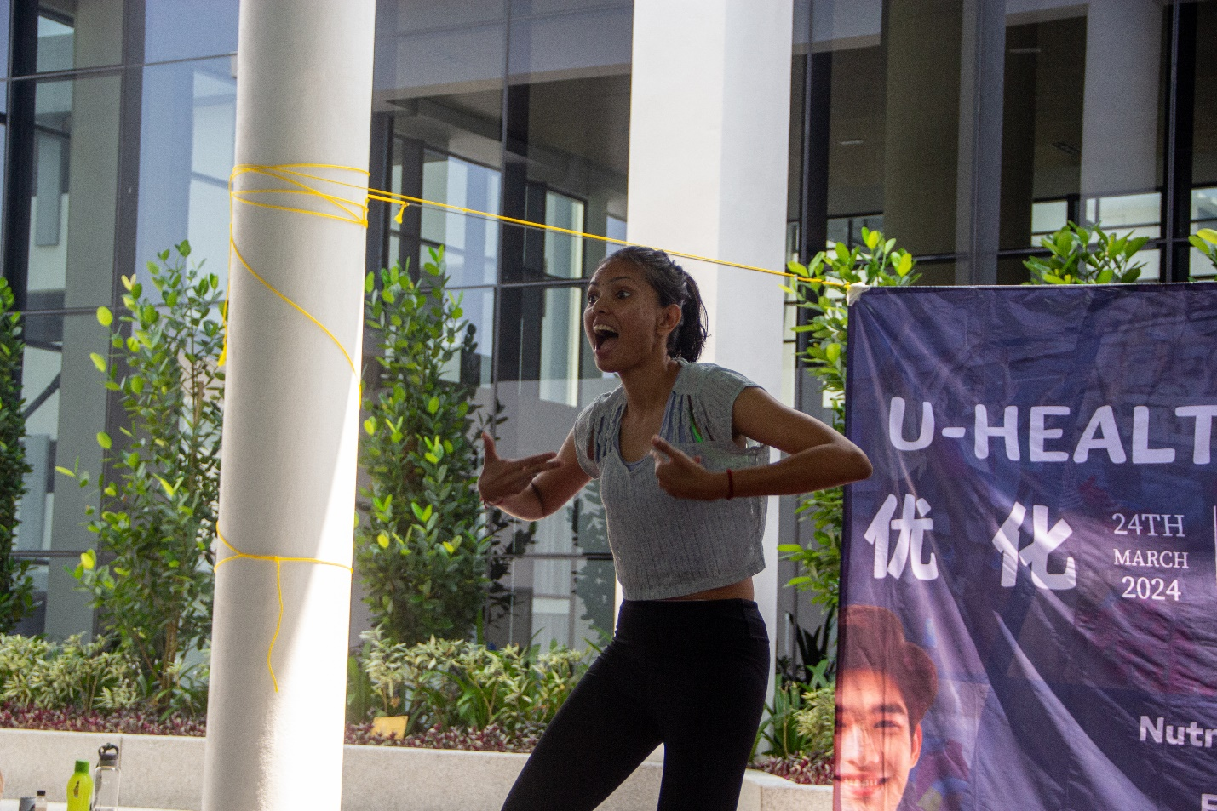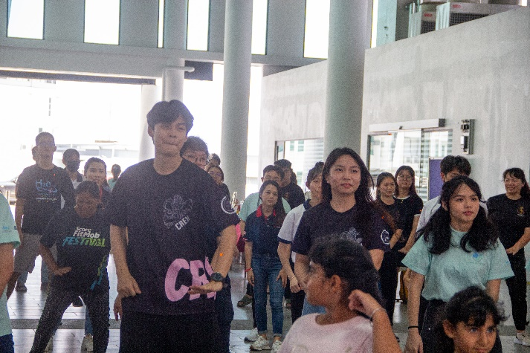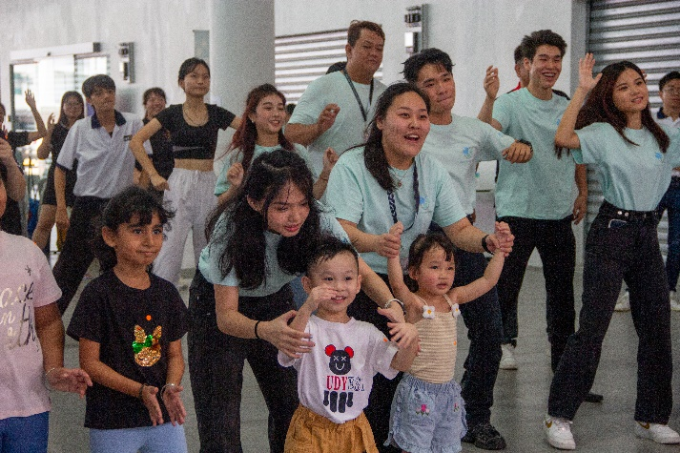
The Zumba session led by Ms Hariprisa Mohanasunthar roused a series of rhythmic dances among the participants
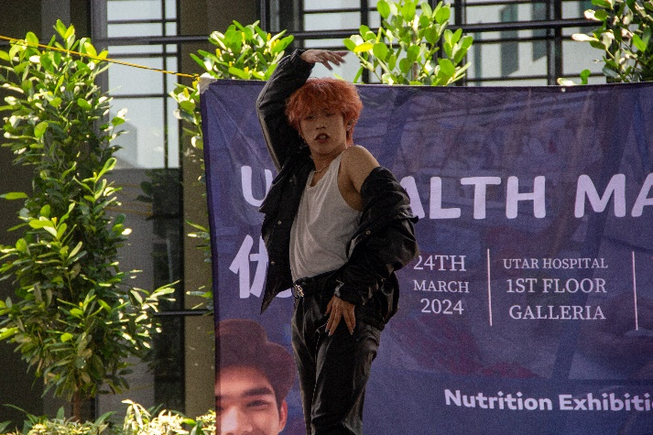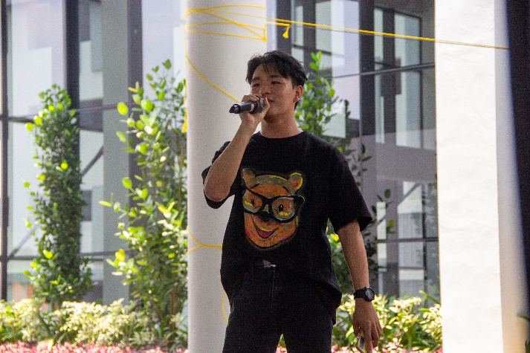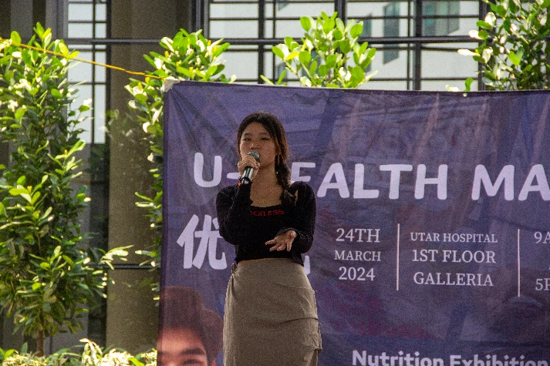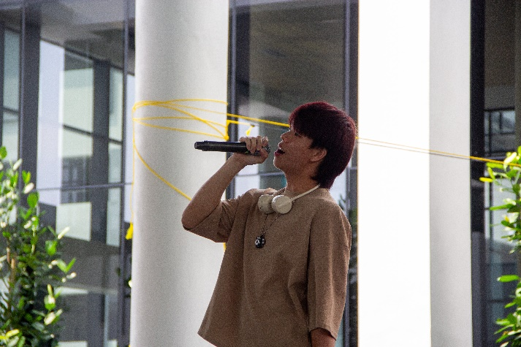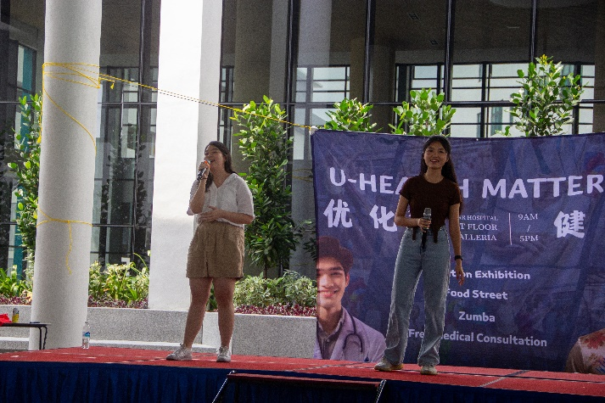
The lively atmosphere was there to stay with the effervescent performances put on by the student performers
Accompanied by the spirited drum beats from the 24 Festive Drums performance, the health fair was officiated by UTAR Vice President for Student Development and Alumni Relations Prof Dr Choong Chee Keong, UTAR Hospital Deputy CEO Ms Maria Khong, and U-Health Matters Project Chairperson Ms Cheong Sweat Wei.
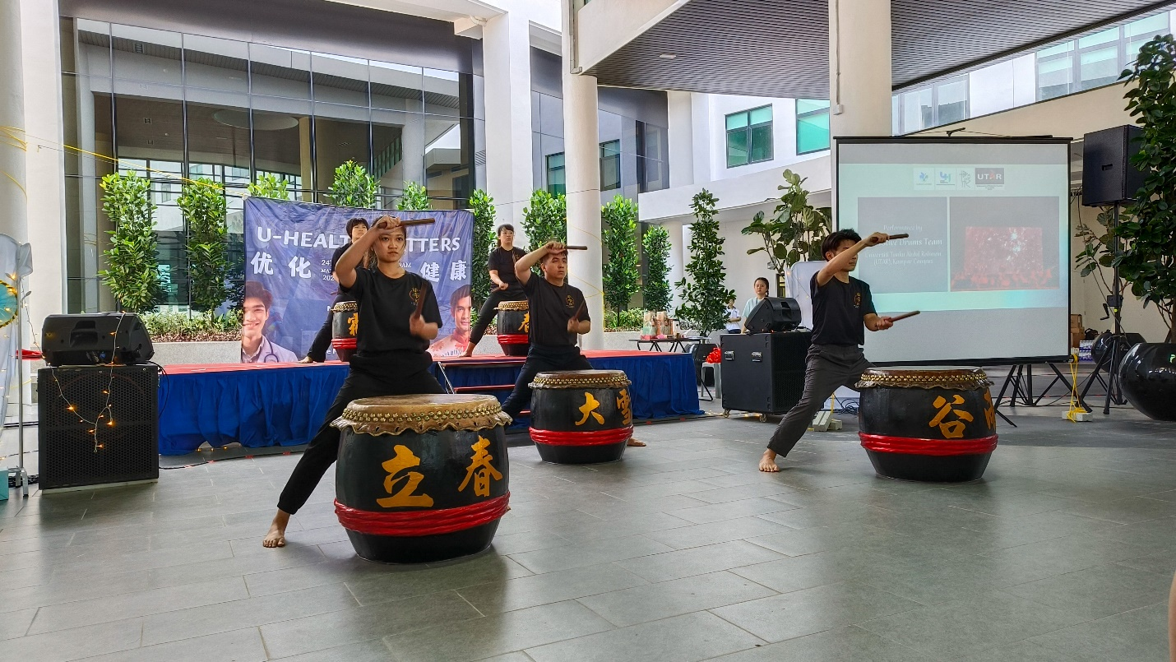
A thriving ambience revolved around the booming drumbeats of the 24 Festive Drums
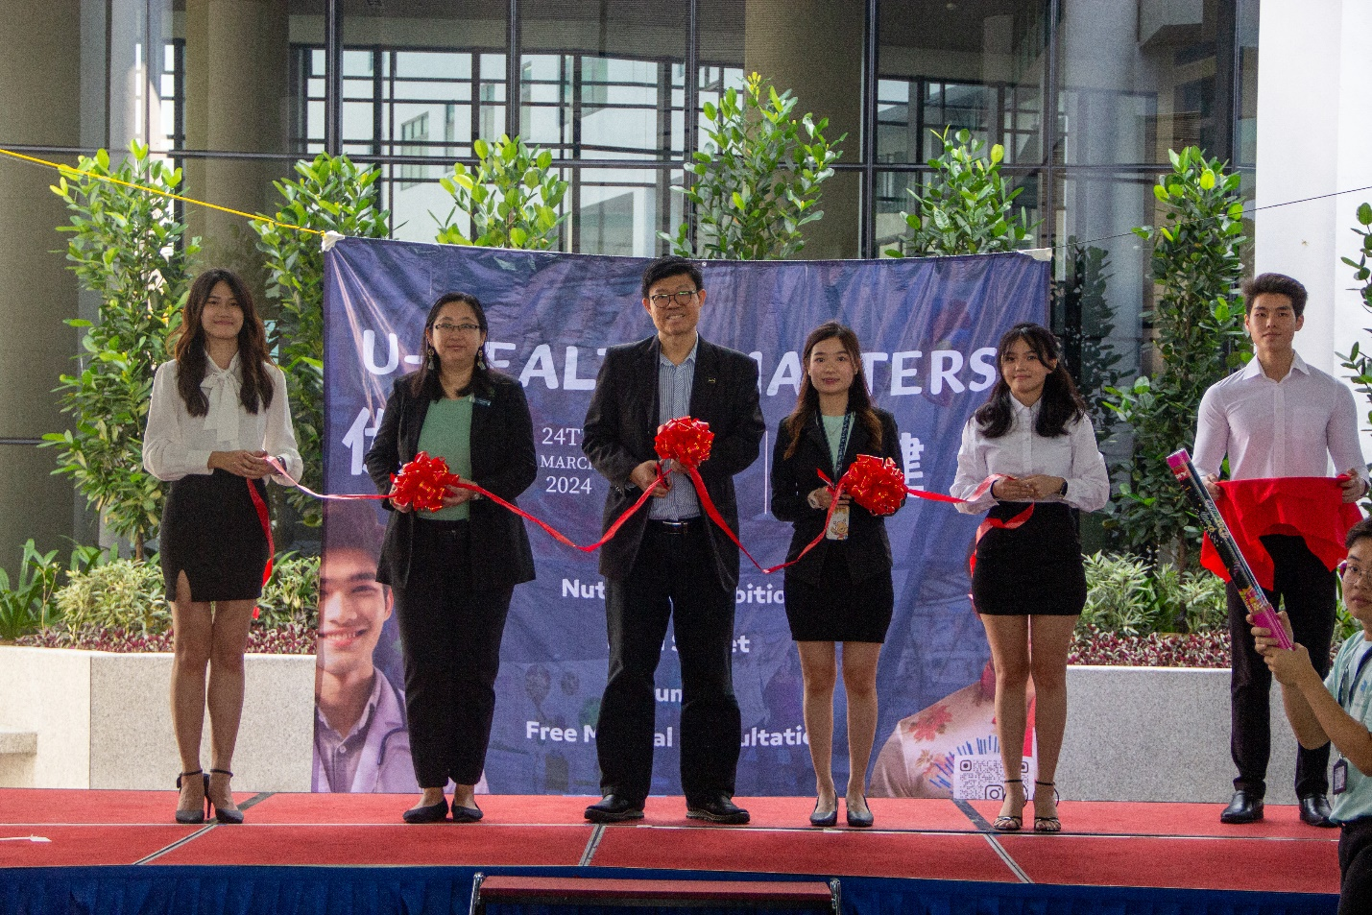
Onwards second from left: Ms Maria Khong, Prof Choong and Ms Cheong inaugurating the health fair
Representing UTAR President Ir Prof Dato’ Dr Ewe Hong Tat, Prof Choong said, “I am delighted to witness the commitment of our PR students in running this event. UTAR appreciates the efforts of PR students, for organising meaningful events almost every trimester. The ability of our students to score this kind of event is a testament to their practical application of classroom knowledge and their ongoing success in organising diverse events. Thank you to the sponsors, the doctors from UTAR Hospital, and not to mention the committee members for elevating UTAR’s name.”
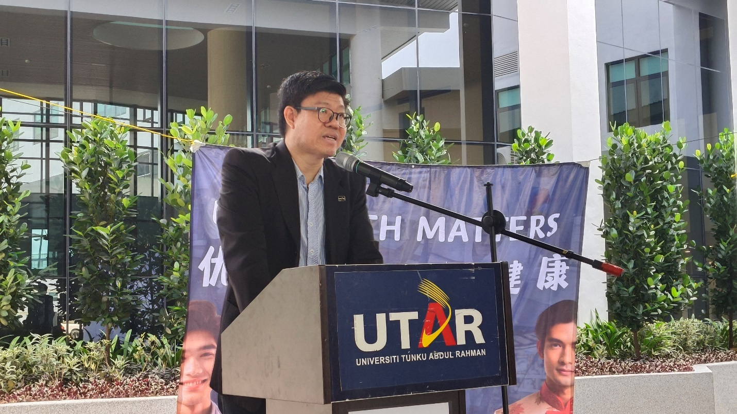
Prof Choong thanking the PR students for organising the meaningful event
UTAR Hospital Deputy CEO Ms Maria Khong said, “I would like to thank the UTAR PR students for having the health fair here at UTAR hospital, as the goal to raise awareness on the importance of health is a passion that is very close to our heart. One of UTAR Hospital’s key objectives is to promote a healthy lifestyle, which is strongly signified by our tagline ‘Enriching and Caring for the Community’. As we navigate the complexities of modern life, it is crucial to prioritise our health and well-being. Hence, it is heartening to see that the UTAR PR students have taken on this challenge to raise the community’s awareness about the importance of health. Besides, I also hope everyone will take the opportunity to learn more about UTAR Hospital, as the hospital is committed to providing affordable medical services to the community.”
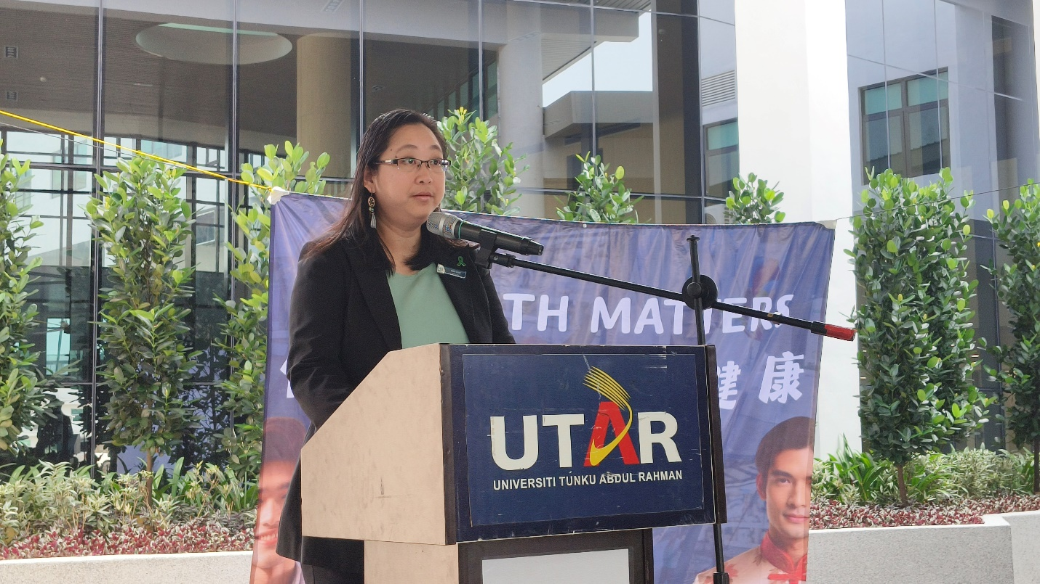
Ms Maria Khong emphasising the commitment of UTAR Hospital in raising health awareness
Grateful towards the commitment given by the student helpers and sponsors, U-Health Matters Project Chairperson Ms Cheong said, “On behalf of U-Health Matters project, I would like to express my sincere gratitude to the sponsors, visitors, committee members, and student helpers for supporting our efforts in raising health awareness. In our four-month preparation process, we not only organised fundraising events but also roadshows at different locations to raise funds and promote this health fair. I believe this health fair will greatly benefit the visitors with its variety of healthy and fun activities. With that, I hope the community would work together and create a healthier and better future.”
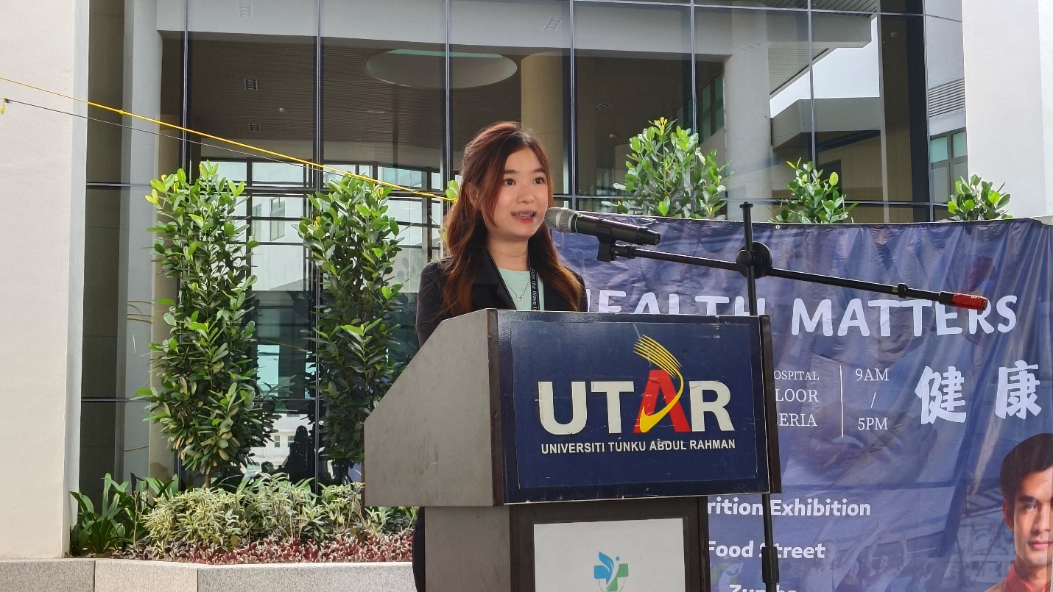
Ms Cheong expressing her gratitude to the committee members
Emphasising the significance of health and good medical support, U-Health Matters Project Vice Chairperson Mr Ruben Raj Marthi Alaghan said, “Today marks an important occasion as we come together to embrace the significance of a healthy life. This health fair is a special event, as it also aims to fight local health crises and promote responsibility for proactive medical support. Creating an environment that encourages suitable and preventive health practices, and raises the awareness of healthy lifestyles would be the first challenge. Let us work together to improve our health because even small changes can have a big impact.”
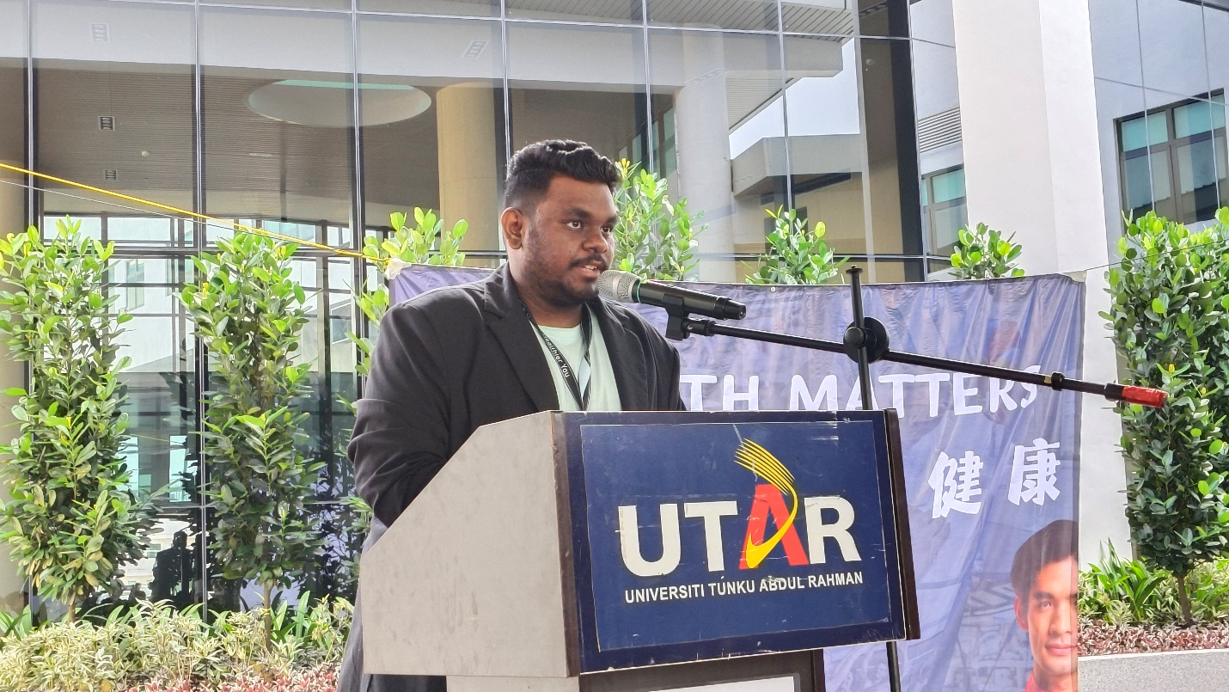
Mr Ruben Raj elucidating the importance of preventive health practices
Also present at the U-Health Matters Health Fair opening ceremony were PSR Partner Solution Sdn Bhd representatives Mr Dorrance Liew and Mr Kenny Heng, CHOMP Enterprise representatives Mr John Song and Mr Jaysen Khoo, U-Health Matters Project Advisor Mr Clarence Anthony Puspanathan, UTAR Hospital staff and UTAR students.
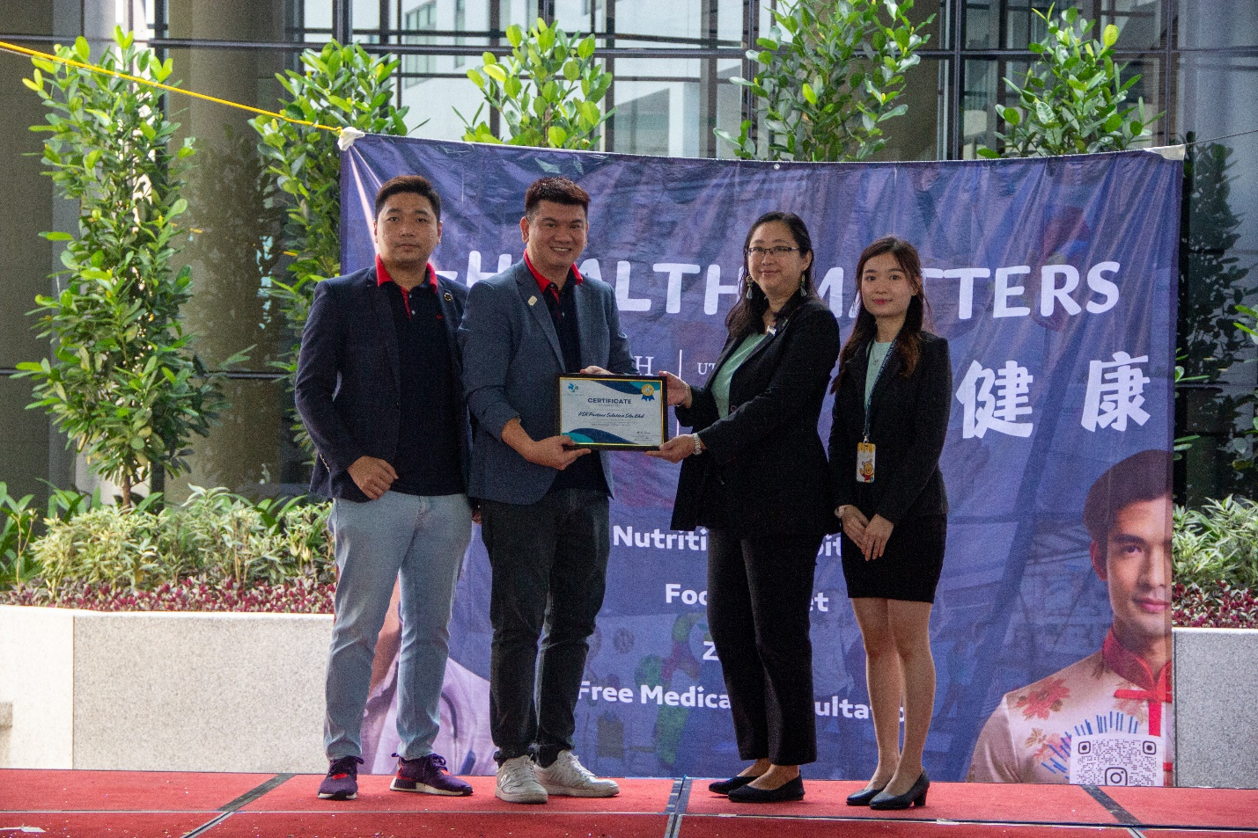
From right: Ms Cheong and Ms Maria Khong presenting a token of appreciation to Mr Dorrance Liew and Mr Kenny Heng
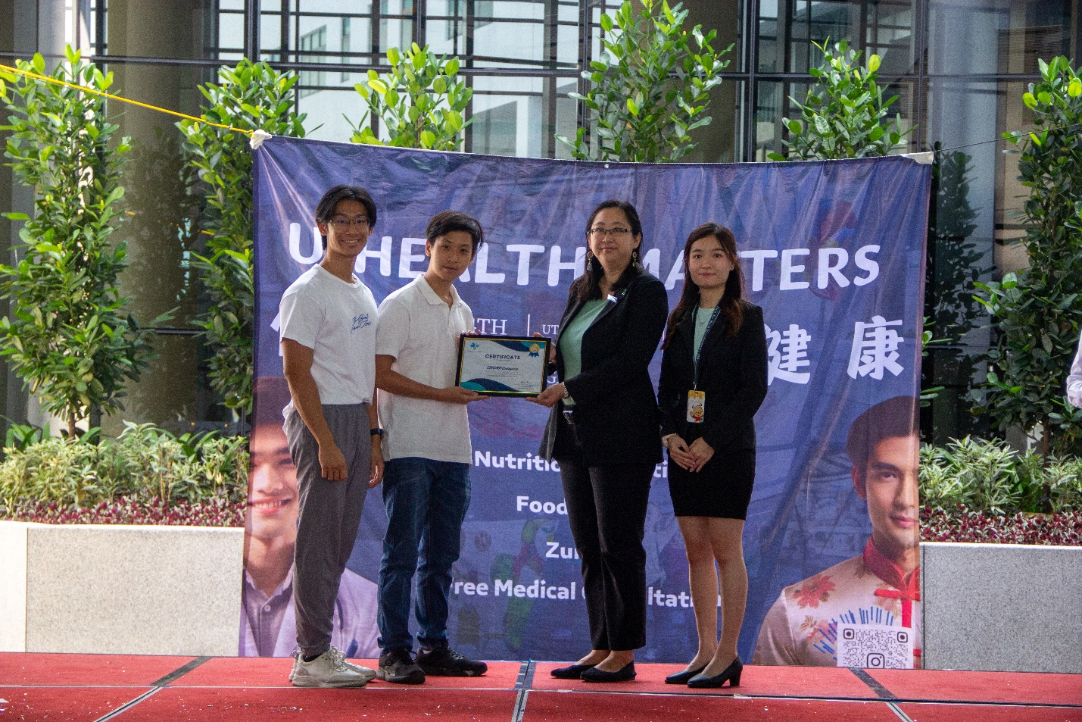
From right: Ms Cheong and Ms Maria Khong presenting a token of appreciation to Mr John Song and Mr Jaysen Khoo
The health fair was sponsored by PSR Partner Solution Sdn Bhd, CHOMP Enterprise, Yakult Malaysia, The Vida World Sdn Bhd, Dong Tai Worldwide Sdn Bhd, and YLT Infinite Branching Sdn Bhd.
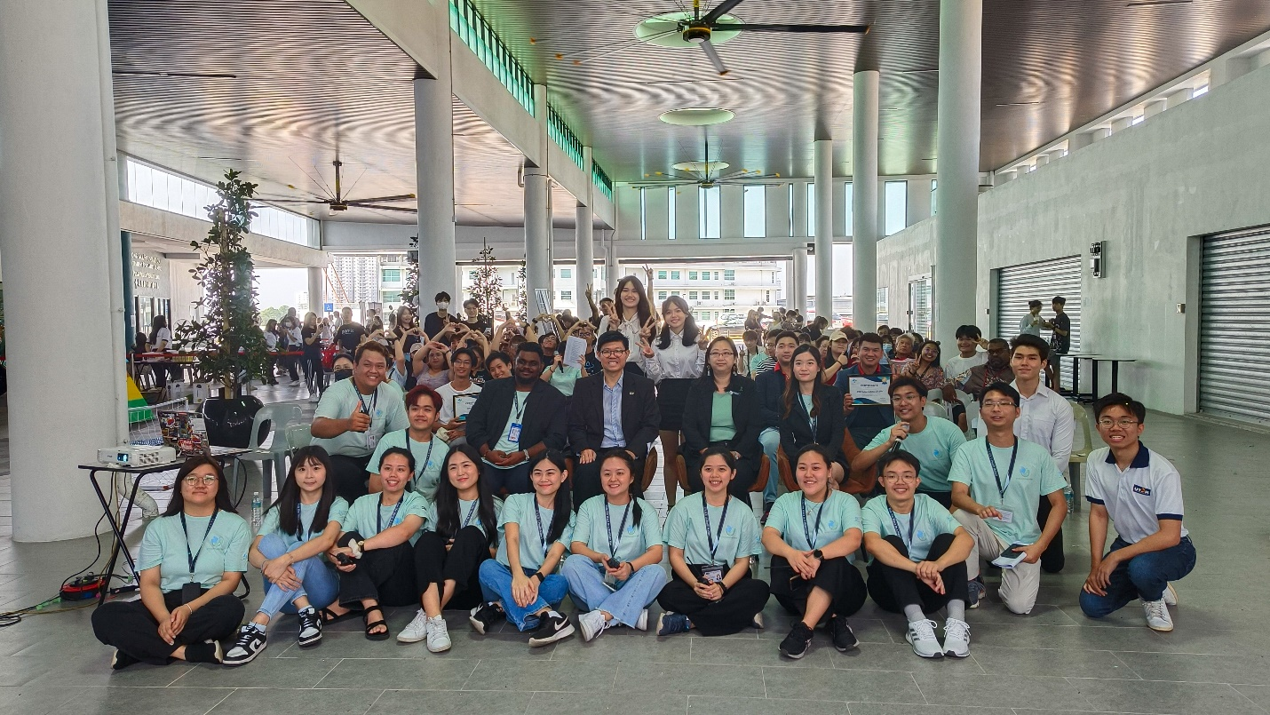
A group photography session at the end of the opening ceremony
The U-Health Matters project by the UTAR PR programme students was advised by UTAR FAS Head of Programme for Master of Strategic Communication Mr Clarence Anthony and FAS academic Ms Teh Su Yen under the UAMP3026 Project II course. It signified UTAR’s steadfast effort in upholding the spirit of giving back to society and encouraging real-life application of classroom knowledge; thus, reinforcing UTAR’s commitment to cultivate competent talents with its holistic education.

