**UTAR CLT Chairperson shares academic insights at DZU, China**

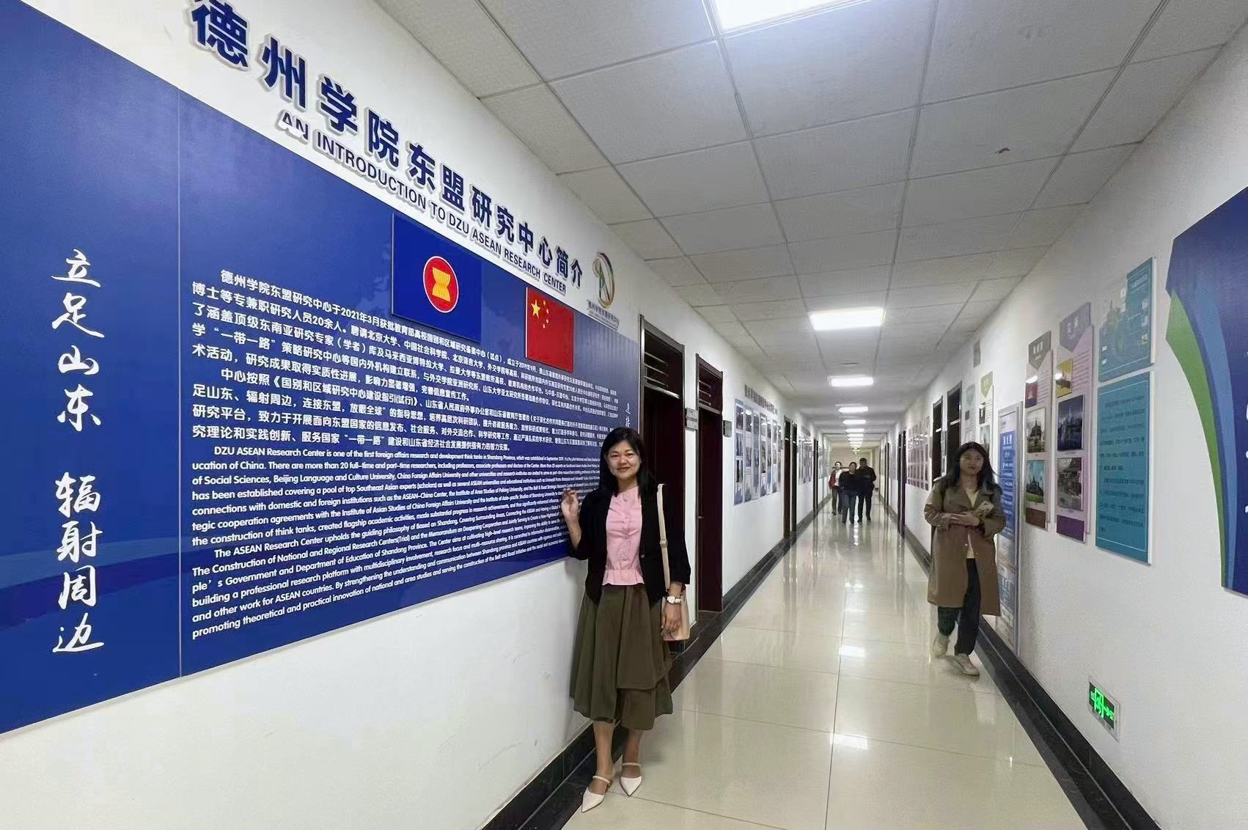

Dr Wei at the DZU Shandong-ASEAN Research Center

Centre for Learning and Teaching Chairperson Dr Wei Chooi Yi, who is also the Head of Department of Finance at the Faculty of Business and Finance (FBF), was invited as a visiting scholar to share her academic insights at the 19th Academic Salon, organised by the Shandong-ASEAN Research Center of Dezhou University (DZU) from 17 to 20 April 2024 at Dezhou University, China.

Dr Wei was received by DZU Shandong-ASEAN Research Center Deputy Director and School of Foreign Languages Secretary of the Party Committee Prof Zhang Guoqiang; Shandong-ASEAN Research Center Deputy Director and School of Foreign Languages Dean Prof Zhang Jinghui; Shandong-ASEAN Research Center Deputy Director Dr Xu Ke, and the researchers from Shandong-ASEAN Research Center.

The four-day academic salon was initiated by Dr Wei’s sharing on the economic development of Malaysia and China on the first day. Titled Harmonious Vision: Leading the Future of Malaysia-China Economic Cooperation, Dr Wei’s talk gave an in-depth exploration of the Malaysia-China bilateral trade as well as Belt and Road Initiative collaborative projects, including industrial parks, railway and subway development statuses. With that, she shared some of her research insights into Malaysia’s advanced technological and industrial needs, which in turn highlighted the focus of future collaborations and research exchange between the two economies.

The second day of the academic salon was filled with a myriad of cultural attractions from Malaysia, as Dr Wei shared the beauties of Malaysia in her talk titled “Exploring Malaysia’s Miracles: Languages, Cuisines, and Landmark”. Through her sharing, DZU academics and students gained an in-depth understanding on the diversity of languages, cuisines, music, customs, and dances among the Malaysian communities.

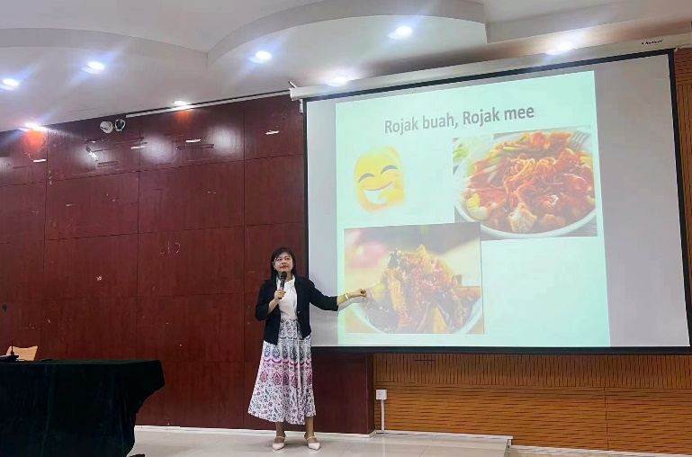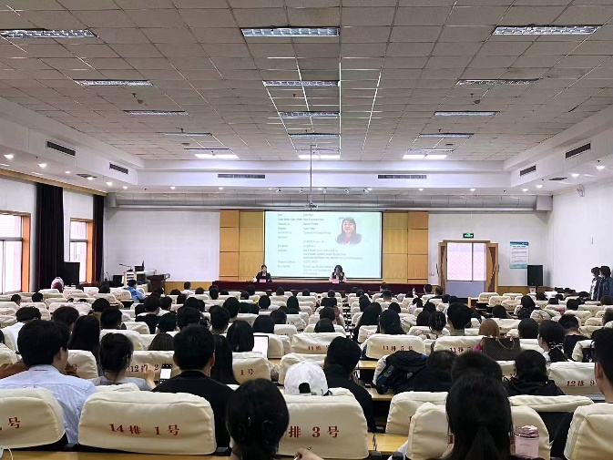

Dr Wei introducing some local delicacies to the DZU academics and students

Besides Malaysia-China collaborative developments, Dr Wei also gave an insightful talk about the marvel of artificial intelligence (AI) in relation to academic development on the third day. Her talk titled The Innovative Impacts of ChatGPT on Higher Education highlighted the multiple layers of ChatGPT such as ways of utilising ChatGPT and challenges brought forth by the AI system to the education system. In her sharing, Dr Wei emphasised the need for the education system to exercise mindful usage of the AI system. In this aspect, she stated that the synergy between AI technology and education could promote education and social sustainability development.

The fourth day entailed a visit to the Shandong Hengyuan Hotel, in which Dr Wei participated in the Shandong Hengyuan Petrochemical Company Limited Industrial Research and Exchange Symposium along with researchers from DZU Shandong-ASEAN Research Center. A brief introduction of the company and its international development statuses were given by Hengyuan Petrochemical Group Company Limited Chairman and General Manager Mr Wang Youde.

A collection of topics was discussed by both parties, including challenges encountered by industries in their international developments; differences in cultures, customs, and adaptability levels between the people of Malaysia and China; differences in law systems between both economies; and protection of China enterprises’ interests.

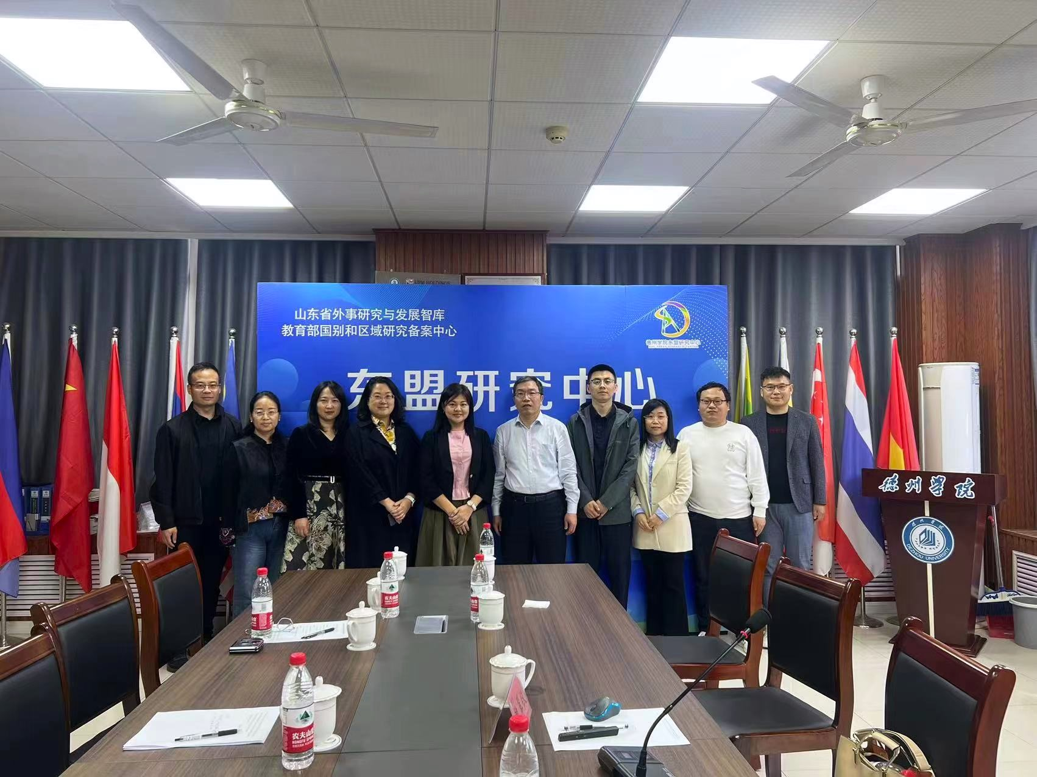

Dr Xu (third from left), Prof Zhang Jinghui, Dr Wei and Prof Zhang Guoqiang with the researchers from DZU Shandong-ASEAN Research Center

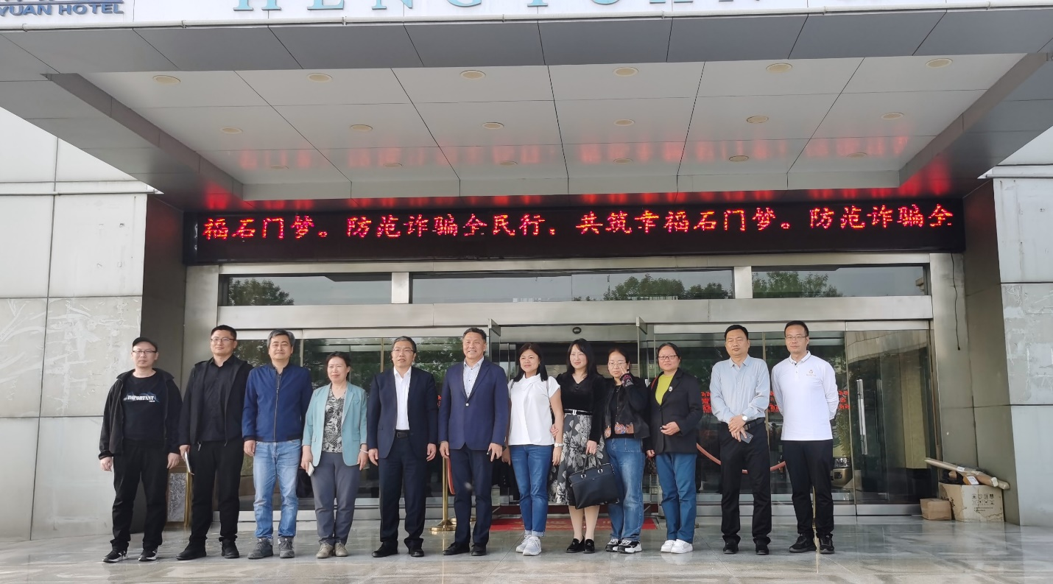

Prof Zhang Guoqiang (fifth from left), Mr Wang, Dr Wei, Dr Xu and delegates from DZU and Shandong Hengyuan Petrochemical Company Limited during the visit to the Shandong Hengyuan Hotel