**UTAR solidifies partnership with IFM Tanzania**

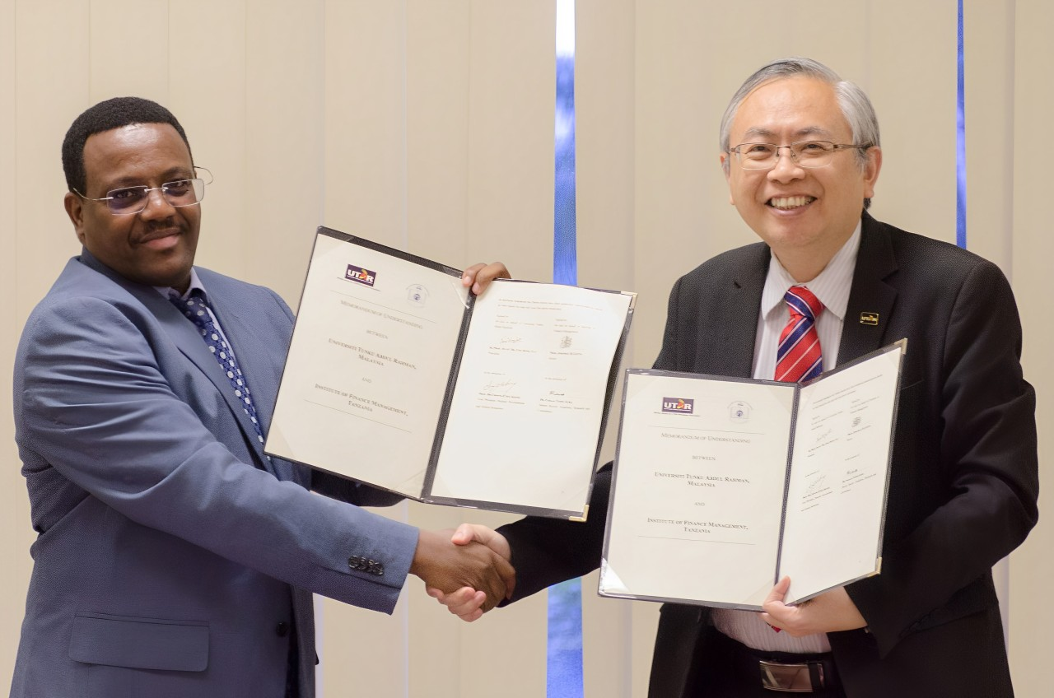

From left: Prof Josephat and Prof Dato’ Ewe displaying the signed MoU documents

The signing of the memorandum of understanding (MoU) with the Institute of Finance Management (IFM) Tanzania is a testimony of another successful collaboration and UTAR’s commitment to substantiate its internalisation efforts. The signing ceremony took place on 29 October 2024 at UTAR Kampar Campus.

Signing on behalf of IFM was its Rector Prof Josephat Daniel Lotto, and the witness was its Deputy Rector for Academic, Research and Consultancy Dr Faraja Teddy Igira. From UTAR, President Ir Prof Dato’ Dr Ewe Hong Tat signed the document, and Vice President for Student Development and Alumni Relations Prof Dr Choong Chee Keong signed as the witness.

Also present were IFM Head of External Linkages Prof Bernard Elieza Mnzava and UTAR academics, namely Faculty of Business and Finance (FBF) Deputy Dean for R&D and Postgraduate Programmes Prof Dr Abdelhak Senadjki, FBF Deputy Dean for Academic Development and Undergraduate Programmes Dr Peter Tan Sin Howe, Office of International Affairs Deputy Director Dr Chen I-Chi, Institute of Postgraduate Studies and Research (Kampar Campus) Assoc Prof Dr Choong Yuen Onn, and FBF PhD and MPhil Programmes Head Assoc Prof Dr Leong Lai Ying, and staff.

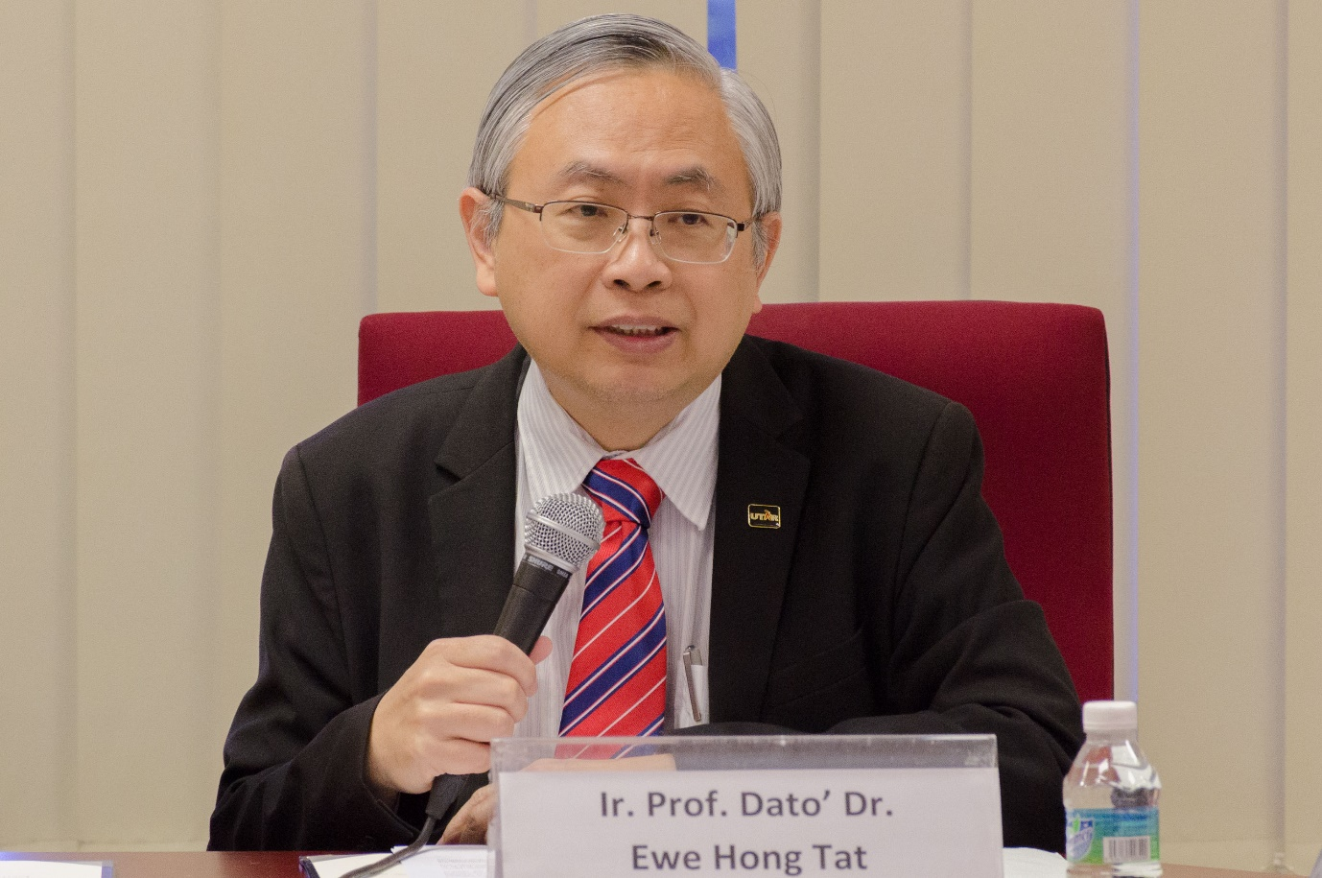

Prof Dato’ Ewe emphasising the need for collaboration

Prof Dato’ Ewe expressed his appreciation to IFM for their continuous support in strengthening the partnership between both institutions. He also said, “We are here today to take this commitment to the next level to enable our students, faculty members, and researchers to expand their horizons, increase exposure, and grow networks. Collaborations as such are truly important for the advancement of knowledge and skills because they enable us to gain different viewpoints. As we work together, I hope our efforts will propel us to achieving excellence in education, research, and innovation that will contribute to the development of both our nations and beyond.”

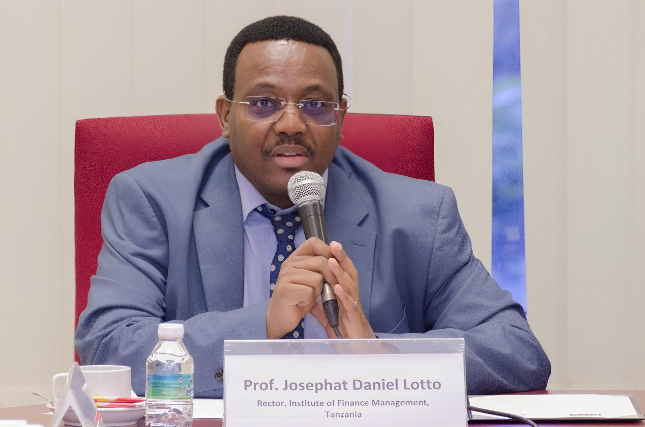

Prof Josephat highlighting their efforts to strengthen MoUs with various institutions

Prof Josephat expressed, “We are happy to be collaborating with UTAR again. We take MoUs very seriously because it is important for the development of our institution. As we join hands, we also put effort to keep the MoU active, with the hope to yield fruitful results that will benefit both institutions, and bring further development that will enrich students’ and staff’s experiences.”

Under this MoU, both institutions will engage in facilitating study visits and student exchange activities for undergraduate and postgraduate students, aiming to enhance students’ learning experiences. Faculty members also benefit from this collaboration, as the academic development exchange activity will enable them to pursue research and participate in seminars, conferences and workshops, which are opportune platforms for gaining insights from various educational institutions and industries. Additionally, the sharing of experience and expertise in areas such as the development of Information Technology (IT) systems and applications will enable efficient administration of academic, research and consultancy activities.

Efforts to strengthen research are further substantiated through joint research projects, visiting scholars, and the pursuit of postgraduate studies. Both institutions believe this to be an opportunity to bring together common interests while allowing for diverse perspectives and specialised skills to enhance research quality and innovation. This collaboration will also foster mutual understanding, enhance cultural intelligence, and foster appreciation for diversity.

The partnership between UTAR and IFM started with their first MoU signed in 2013. It yielded positive outcomes and opened many opportunities. Both institutions then strengthened their partnership by renewing the MoU in 2019, reaffirming their commitment to fostering academic exchange and joint research initiatives.

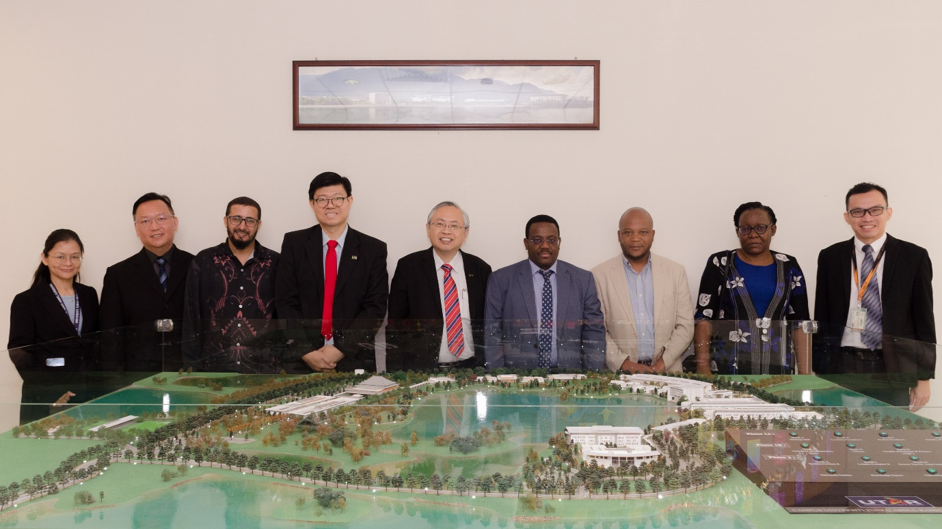

All smiles for strengthening the partnership between UTAR and IFM

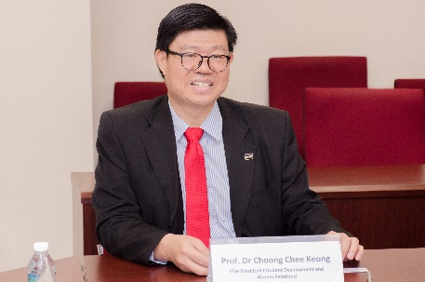 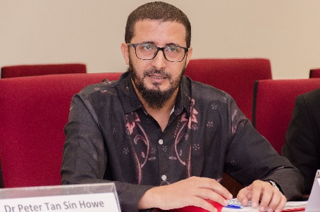 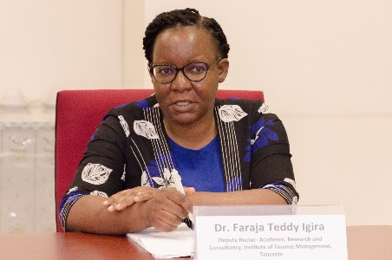 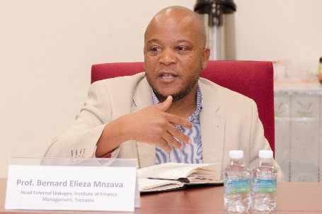 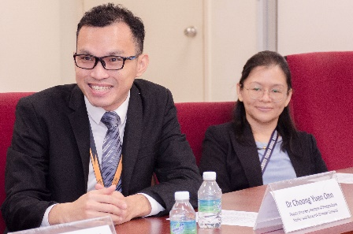

Discussions on potential collaborative projects