**Campus dialogue by TCLC and FCI promotes media and information literacy**

Front row, third from left: Mr Teo, Mr Lim, Dr Chin and Mr Kenneth Lee with participants

The Tun Tan Cheng Lock Centre for Social and Policy Studies (TCLC), in collaboration with the Department of Mass Communication under the Faculty of Creative Industries (FCI), organised an insightful campus dialogue on 6 November 2024 at UTAR Sungai Long Campus to promote the Media and Information Literacy (MIL) among university students. The event aimed to raise awareness about the growing issues of disinformation, fake news, and the importance of fact-checking, especially when engaging with social media.

The campus dialogue, which was conducted physically, featured experienced journalists Mr Lim Eng Kok and Ms Teo Pei Min from The China Press Sdn Bhd. Also present at the event were TCLC Chairperson Assoc Prof Dr Chin Yee Mun, FCI Department of Mass Communication Head Mr Kenneth Lee Tze Wui, FCI lecturers Mr Tan Yang Sheng and Ms Yong Xin Yi, TCLC Assistant Manager Mr Lee Jenn Yuan and students.

UTAR students shared their media usage patterns and information needs, providing insights to media professionals on their target audience. Meanwhile, the media professionals discussed their work and the daily challenges they face, helping students gain a better understanding of the inner workings of the news industry.

A notable highlight of the session was an exercise on disinformation identification, where students and attendees examined case studies involving AI-generated images, fake websites, and misleading social media posts. The activity, centred around real-life observations and experiences, aimed to heighten students’ awareness, critical thinking, and the habit of verifying information before sharing it online.

The session concluded with a discussion on distinguishing parody from fake news and the ethical standards media professionals uphold in their pursuit of truth.

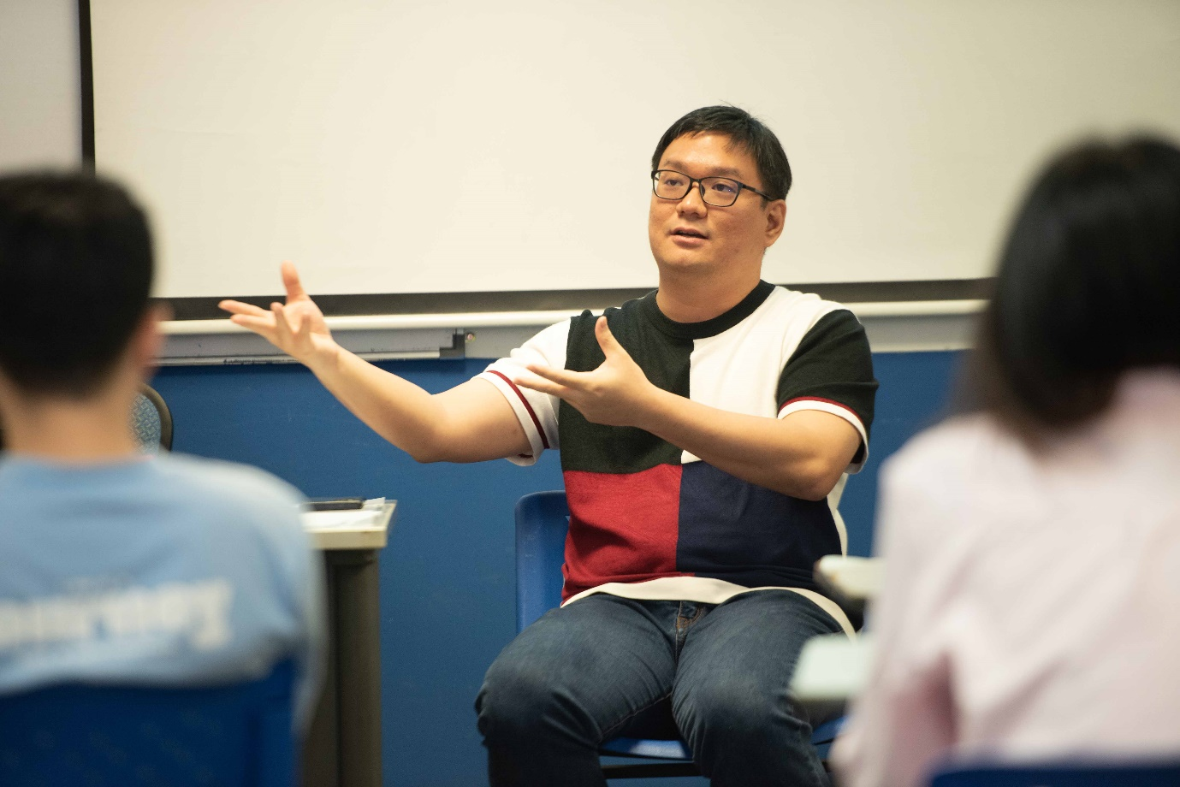

Mr Lim highlighting the signs to spot suspicious posts on social media

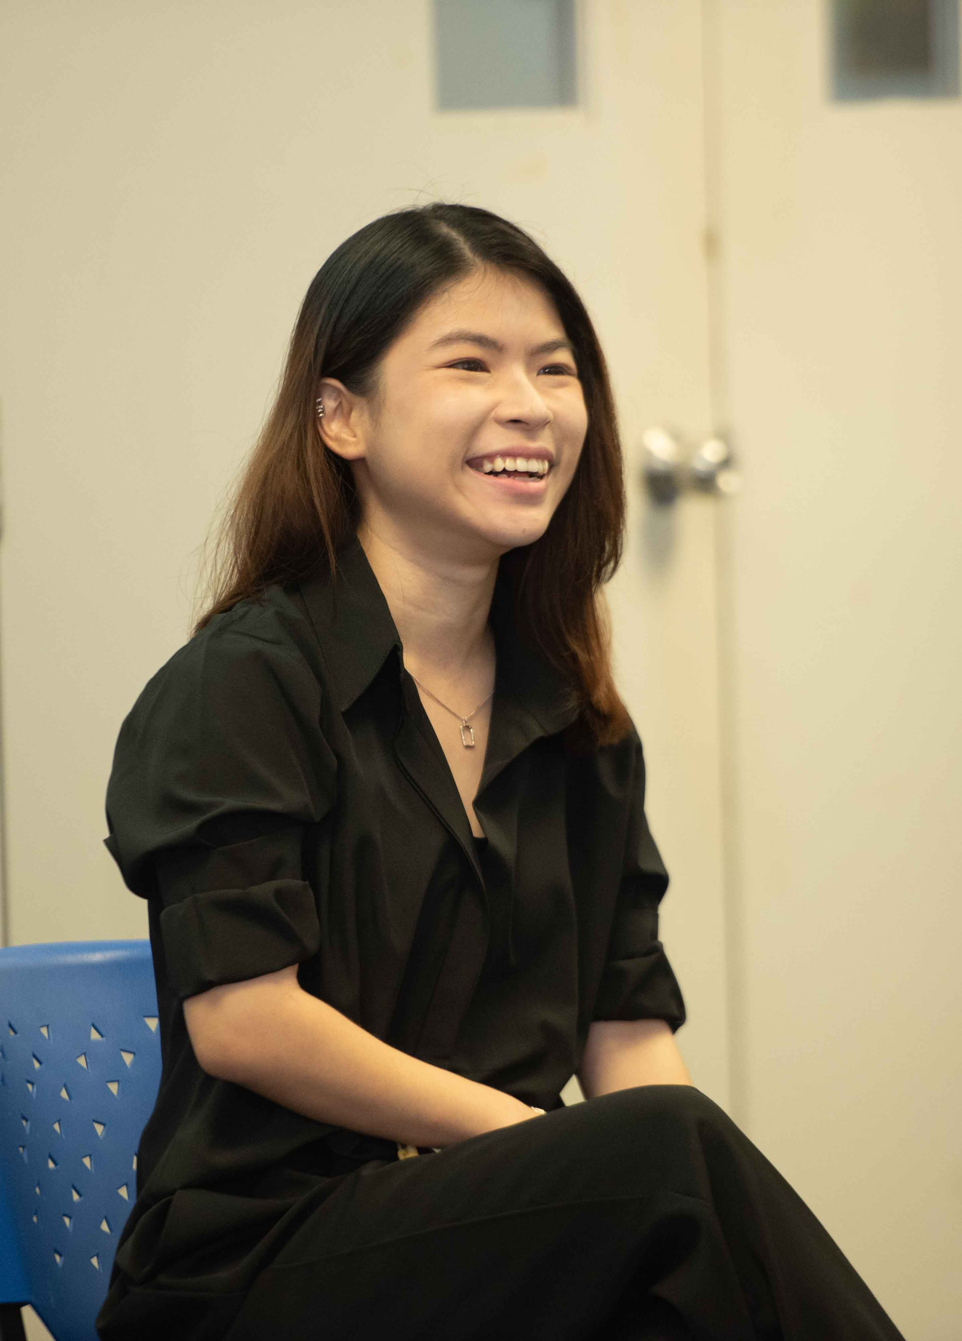

Ms Teo (right) interacting with students

From left: Mr Lee, Mr Kenneth Lee, Dr Chin, Mr Lim, Ms Teo, Mr Jerry Tan and Ms Yong