**MoU with Meiji University, Japan**

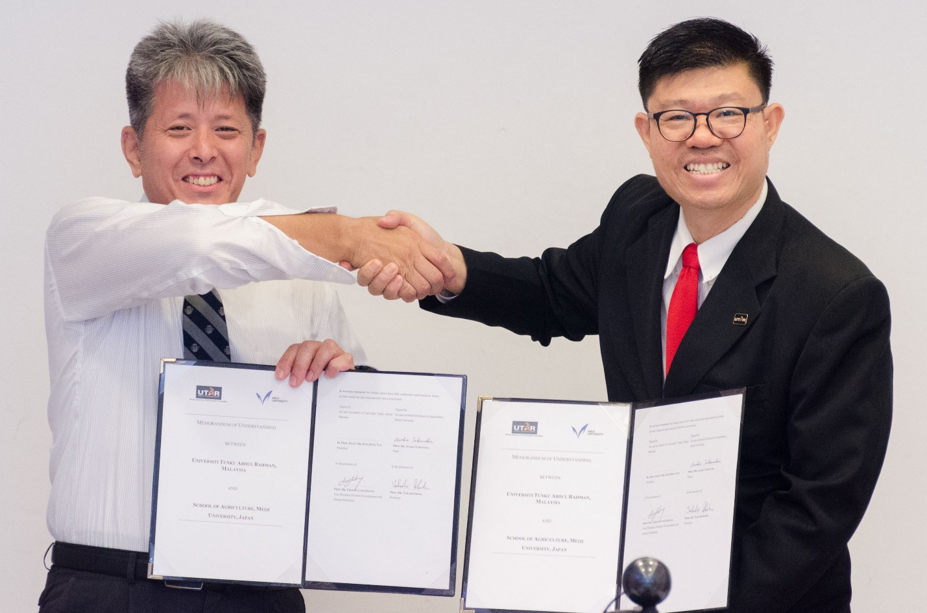

Prof Choong (right) and Prof Ikeda exchanging MoU documents

A partnership between UTAR and Meiji University School of Agriculture in Japan was formalised with the exchange of a memorandum of understanding (MoU) on 5 November 2024 at UTAR Kampar Campus.

The MoU documents were pre-signed by UTAR President Ir Prof Dato’ Dr Ewe Hong Tat and Meiji University School of Agriculture Dean Prof Takenaka Asako. They were exchanged by UTAR Vice President for Student Development and Alumni Relations Prof Dr Choong Chee Keong and Meiji University School of Agriculture Prof Ikeda Takashi.

This new partnership marks the beginning of various potential collaborations in the field of agriculture, which include joint research projects, student exchange programmes, and academic development exchanges.

Prof Choong said in his welcome remarks, “I believe this collaboration is very timely and necessary because agriculture today is far more than food production; it is to bring food security to all, maintain environmental balance through sustainable agriculture practices, and build our economies.”

On behalf of Meiji University School of Agriculture, Prof Ikeda stated their delight as well to collaborate with UTAR, paving ways to foster knowledge exchanges, research, and talents in the field of agricultural innovation.

A discussion was held after the ceremony. The academics from the Faculty of Science (FSc) and Prof Ikeda delved into not only collaborative opportunities but also issues faced by the agriculture sector around the world. The issues discussed included talent shortage, technology limitations, and insufficient financial support from the government.

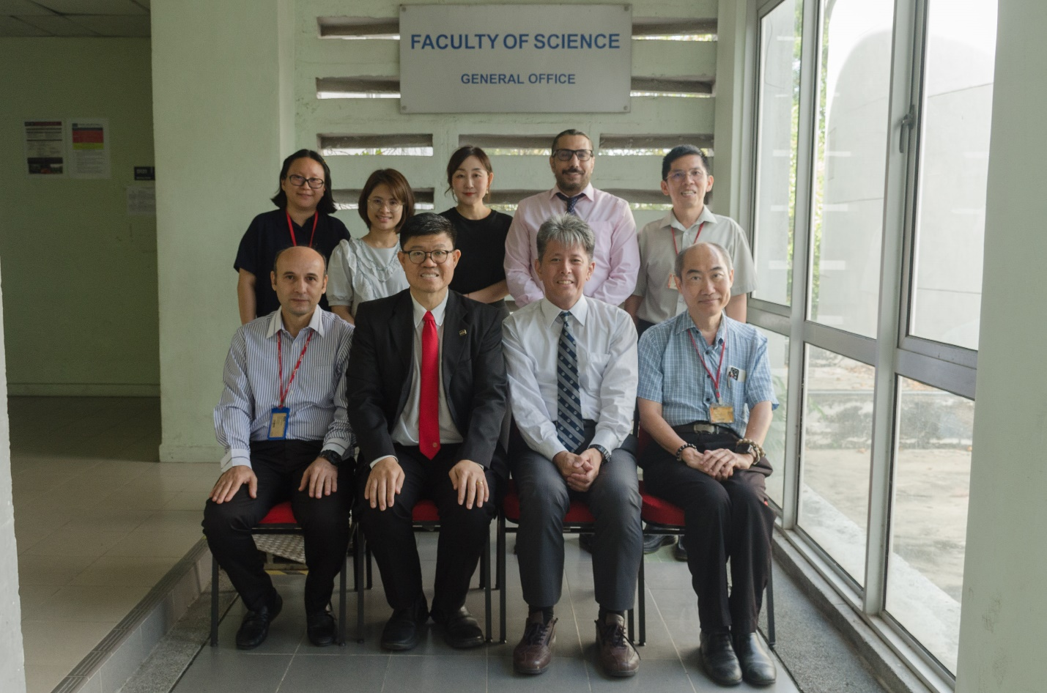

Seated, from left: Dr Ali, Prof Choong, Prof Ikeda and Dr Lim

Standing, from left: Dr Tan, Ms Chin, Dr Chen, Dr Pedram and Dr Sit

During his visit, Prof Ikeda also conducted a scientific talk at FSc, sharing his valuable insights on horticulture in Japan with the UTAR community.

Also present at the exchange ceremony were FSc Dean Assoc Prof Dr Lim Tuck Meng, FSc Deputy Dean for Student Development and Industrial Training Assoc Prof Dr Sit Nam Weng, FSc Head of Department of Agricultural and Food Science Dr Ali Yassoralipour, Centre for Agriculture and Food Research Chairperson Dr Tan Yen Nee, FSC academic Assoc Prof Dr Pedram Kashiani, Office of International Affairs (OIA) Deputy Director Dr Chen, I-Chi, and OIA Senior Assistant Manager Ms Chin Sau Lai.

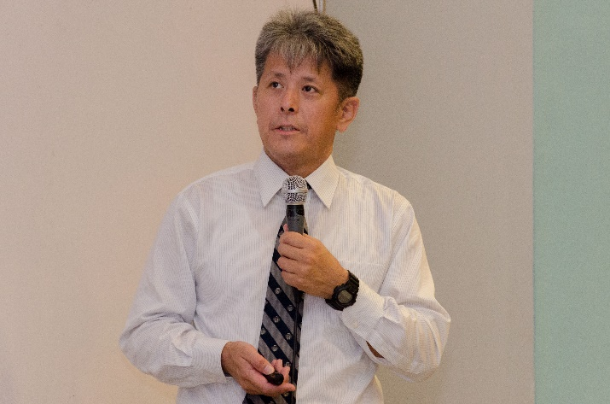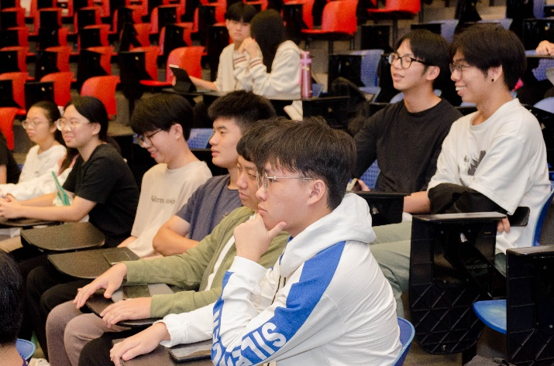

Prof Ikeda (left) explaining issues faced by agriculture players in Japan during his talk