**FBF students explore finance and opportunities at MFPD 2024**



Front row: Dr Wei (most left), Dr Kuah, Dr Chia (second from right), and Ms Liew with Dr Cheah (second row, far right) and FBF students at the Securities Commission Malaysia

Across the ever-changing landscape of the finance sector, staying updated on the latest trends and leveraging networking opportunities has never been more crucial. On 12 October 2024, a group of UTAR Faculty of Business and Finance (FBF) undergraduate students and academics participated in the Malaysian Financial Planning Day (MFPD) 2024, held at the Securities Commission Malaysia, Kuala Lumpur.

Invited to the event by the Malaysian Financial Planning Council (MFPC), the 36 FBF undergraduate students had taken an invaluable opportunity to learn and network with peers, professionals, and potential employers in the finance sector, providing them with knowledge and inspiration pivotal to kickstart their career in the field of financial planning.

The students were led by FBF Deputy Dean for Student Development and Industrial Training Dr Kuah Yoke Chin, Head of Department of Finance Dr Wei Chooi Yi, and academics Dr Cheah Siew Pong, Dr Chia Mei Si, and Ms Liew Feng Mei.

The participants were given a warm welcome by MFPC President Mr Andy Ng Yen Heng. Following the welcome remarks was a keynote address by the Securities Commission Malaysia Director of Corporate Resource and Services Puan Meha binti Kasbun, in which she emphasised the importance of financial learning among youths in today’s ever-evolving world.



FBF students visiting booths of their choice at the exhibition floor

A multitude of exhibition booths was set up by various finance organisations, offering participants the opportunity to engage with potential employers and plan their careers before graduation.

The organisations that participated in the exhibition are as follows:

* Malaysian Financial Planning Council
* Malaysian Financial Planners and Advisers Association
* Advisonomics Sdn Bhd
* FA Advisory Sdn Bhd
* Association of Financial Advisers
* Financial Planning Association of Malaysia
* Alpine Advisory Sdn Bhd
* Fin Freedom Sdn Bhd
* Finwealth Management Sdn Bhd
* Harveston Wealth Management Sdn Bhd
* Uno Advisers Sdn Bhd
* Wealth Vantage Advisory Sdn Bhd
* Resolute Planning Sdn Bhd
* Firmus Financial Sdn Bhd
* Kenanga Investors Berhad
* VKA Wealth Planners Sdn Bhd
* YES Financial Sdn Bhd
* Melbourne Capital Group Sdn Bhd

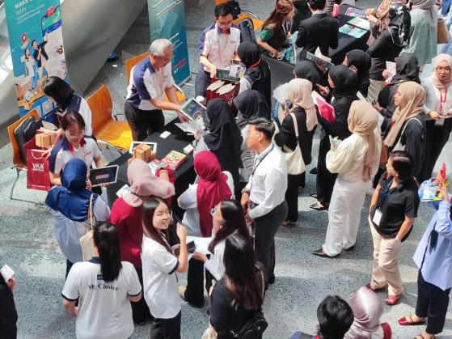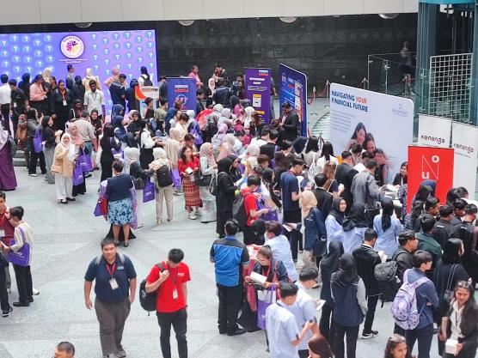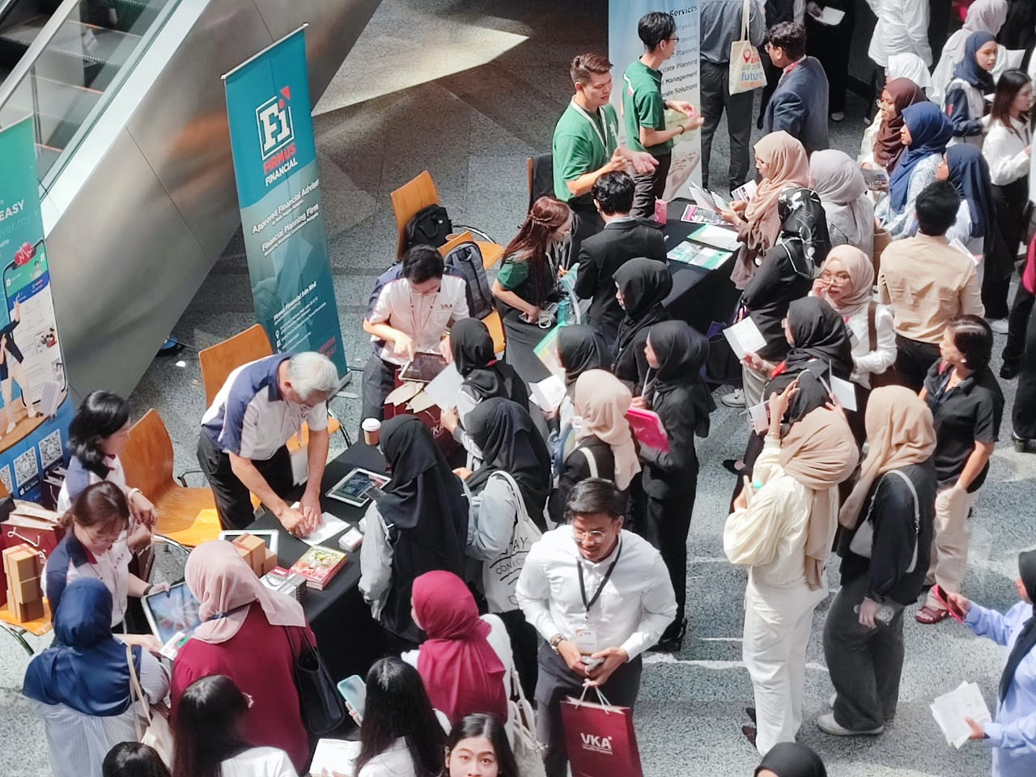

Hundreds of participants thronging the exhibition booths to gain insights on potential careers

Besides networking with professionals at the exhibition booths, the students also took part in a series of insightful talks and seminars, refreshing themselves with the latest trends and insights in the field of financial planning.

The first talk, titled A Career in Financial Planning: What You Need to Know?, by Kenanga Investors Berhad Regional Head Mr Lee Poh Jang, addressed the important aspects of sustainable living, including assets, medical expenses, retirement, children’s education, and leisure. Mr Lee also highlighted a list of financial planning tools such as fixed deposits, unit trusts, shares, insurance, real estate, and alternative investments.

The second sharing was a round table discussion titled The Bolts and Nuts of the Financial Planning Career. Is It for You?. It was conducted by the Financial Planning Association of Malaysia (FPAM) Licensed Financial Planner, Certified Financial Planner and Islamic Financial Planner Ms Tan Lynn Say, along with the Association of Financial Advisers (AFA) Vice President Mr Mohamad Idham bin Mohamad Idris and the Malaysian Financial Planners and Advisers Association (MFPAA) Vice President for External Affairs Mr KR Raju as the panellists.

The third talk, titled Who is Hiring? Opportunities in Financial Planning, was delivered by FA Advisory Sdn Bhd Chief Executive Officer Mr Bryan Zeng. He highlighted the roles in financial planning, which include assisting in client relationship management, long-term wealth management, client strategy development, and providing analysis and technical knowledge on various products. He shared that the demand for financial planners is rising as it offers a wide range of opportunities. Besides that, Mr Bryan Zeng also gave an overview of Malaysians’ financial planning skill level, showing that the majority of Malaysians do not plan their finance well.

The fourth talk, titled The Future of Finance: How AI is Revolutionising Financial Planning, was delivered by Licensed Financial Adviser and MFPC Member of Certification and CPD Board Mr Jack Lin Kok Leong, who shed light on the diverse array of AI applications in financial services. The applications he shared included Robo-Advice, Anti Money Laundering (AML) and fraud detection, chatbot, algorithmic trading, and customer recommendation. During the talk, the participants also learned the significance of AI in overcoming the limitations of human-driven advisory services such as time-consuming, scalability, and bias.

The last talk, Navigating Financial Careers: From College to Corporate, by VKA Wealth Planners Sdn Bhd Licensed Financial Planner Mr Muhammad Hanis bin Zulkefli, emphasised the reality of becoming a financial planner. He also advised the participants, inspiring them to kickstart their journey towards becoming a successful financial planner.

The participation of UTAR in MFPD 2024 presented a great opportunity for students and faculty members, as they not only gained a treasure trove of insights into the latest trends and practices within the financial planning sector, but also a platform to establish meaningful connections with professionals, fostering potential collaborations and mentorship opportunities for students aspiring to embark on a career in financial planning.

As UTAR is constantly strengthening its effort to foster holistic education, this financial event resonated with the University’s commitment to enhancing students’ academic and professional development by providing them with opportunities to engage with industry leaders and professionals.

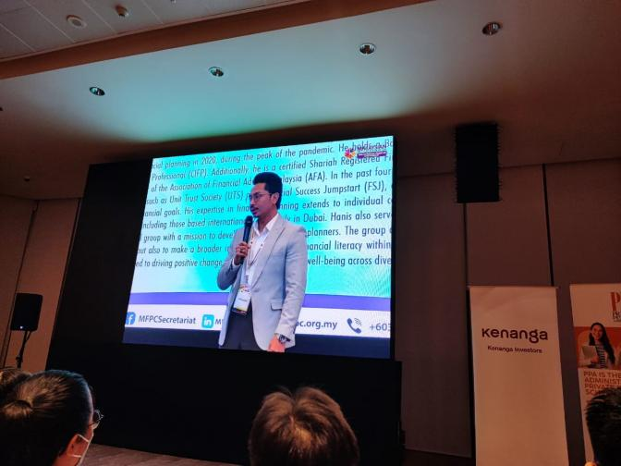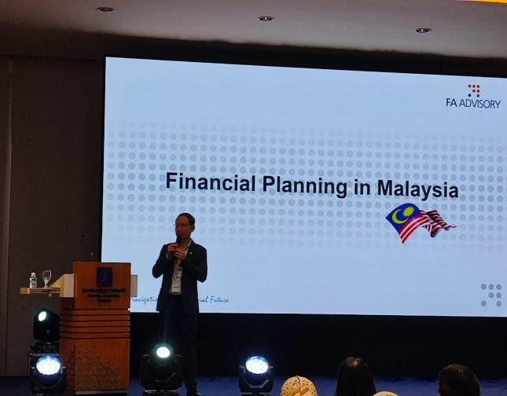

FBF students listening attentively to the talks by industry professionals

**The Malaysian Financial Planning Day 2024**

The Malaysian Financial Planning Day is an annual event jointly organised by MFPC, AFA, FPAM, and MFPAA, aiming to connect Malaysian students with diverse professionals and employers from the financial planning sector and inform students of the latest job opportunities and trends in the finance sector. This year’s event attracted around 1,600 attendees, comprising students from the local institutes of higher learning and members of the public.