**UTAR extends support to BTBU**

The recent attendance of UTAR Vice President for Internationalisation and Academic Development Ir Prof Dr Goi Bok Min at the Global Digital Business Education Conference testified to the strong partnership between UTAR and Beijing Technology and Business University (BTBU), which was forged in 2023. Prof Goi was invited to deliver a speech at the conference. The conference was jointly organised on 20 October 2024 at the Beijing Conference Centre by BTBU, with 20 business colleges and universities.

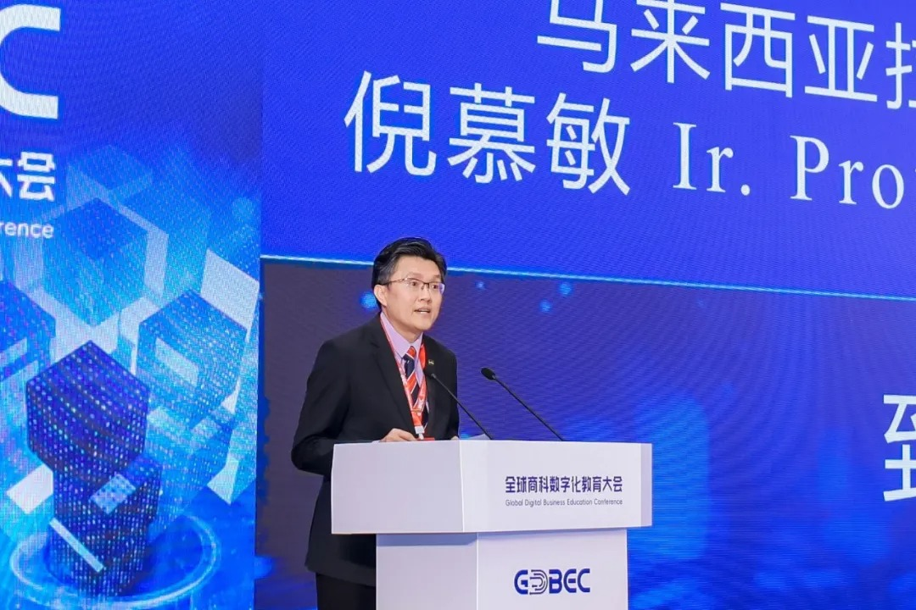

Prof Goi delivering his speech at the conference

He emphasised that UTAR is committed to internationalisation ~~efforts~~ and the development of innovative education, particularly under the “Belt and Road” initiative, which the University uses to actively promote educational cooperation between China and Malaysia. His speech showed that UTAR understood the importance of international collaboration and exchanges in education in the globalised world.

He also highlighted that digital technology is transforming the educational landscape and that this conference is a significant initiative, aligning with current trends and standing at the forefront of educational reform. He also expressed confidence that the conference will spearhead the development of business education and digital transformation, creating a broad platform to cultivate business talent with a global perspective, innovative thinking, and digital skills. He believes the conference will effectively support the competitiveness and influence of international educational cooperation, promote integration across industry, academia, and research in global business digital education, and strengthen related exchanges and collaborations.

The journey to establishing a partnership with BTBU started with a visit to BTBU, by UTAR President Ir Prof Dato’ Dr Ewe Hong Tat and Office of International Affairs Director Assoc Prof Dr Lai Soon Onn, to explore potential collaboration. Prof Dato’ Ewe was invited to deliver a keynote speech at the Digital Empowerment in Higher Education Forum – The Sixth Annual Meeting of the China-ASEAN Innovation and Entrepreneurship Education Alliance of Universities, one of the 2023 CAECW projects. The meeting provided new opportunities for collaboration between both institutions, which led to UTAR signing a memorandum of understanding (MoU) and a student exchange agreement (SEA) in 2023.

This year, the partnership with BTBU continued to solidify, achieving positive results: in January, UTAR and BTBU joined hands to facilitate a short-term study abroad programme, whereby UTAR students and staff visited three villages in China; in April, they discussed a 2+2 programme; and in July, BTBU visited UTAR to further discuss on future collaborations.