**Staff join forces for *One Hour Malaysia Clean Up* at Kampar Campus**

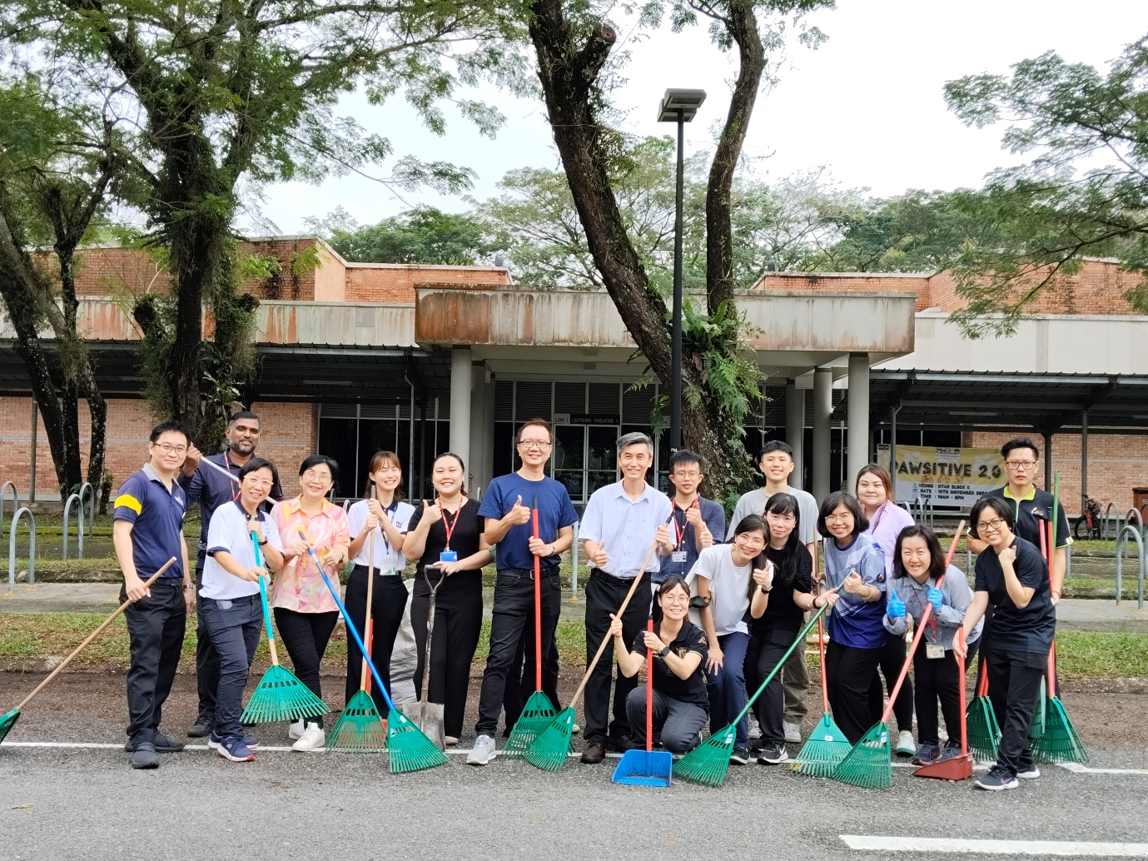

The “One Hour Malaysia Clean Up” activity was held for the second time on 8 November 2024 at UTAR Kampar Campus. It was jointly organised by the Department of General Services (DGS) Kampar, the Department of Soft Skills Competency (DSSC), and the Division of Human Resource (DHR). The event received the support of 20 staff members and academics.

The group united to clean one of the campus parking zones covered with fallen leaves to prevent drain blockages, especially now in the rainy season. This was also done to ensure proper water circulation and prevent any pooling of water that could become breeding grounds for Aedes mosquitos.

DGS Kampar Head Ms Yee Sook Heng said that the gotong-royong was an excellent initiative to support the cleaning staff in maintaining open areas. She also commented, “This activity serves as a valuable reminder of the importance of maintaining cleanliness, keeping our surroundings free from pollution, and ensuring safety. More than that, the effort to promote healthy living and environmental cleanliness reminds us all that it is a joint effort, which is why public participation is central to this government initiative. Through this, we see the young and old unite to make the environment a better place to live in.”

The “One Hour Malaysia Clean Up” activity is part of the Strategic Plan under the Agenda Nasional Malaysia Sihat (ANMS) launched by the Malaysian Ministry of Higher Education (MOHE) and aims to promote healthy living and environmental cleanliness.

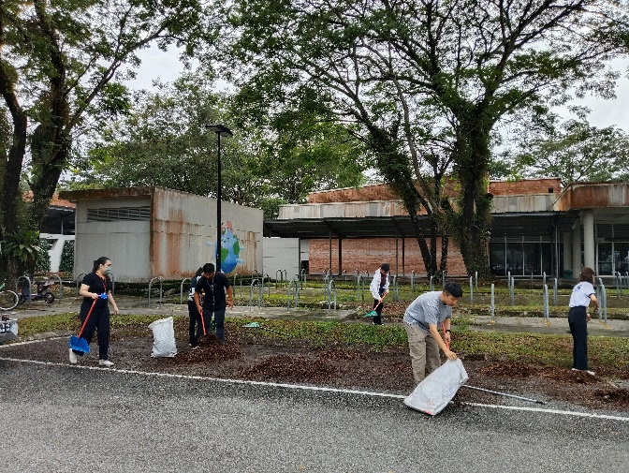 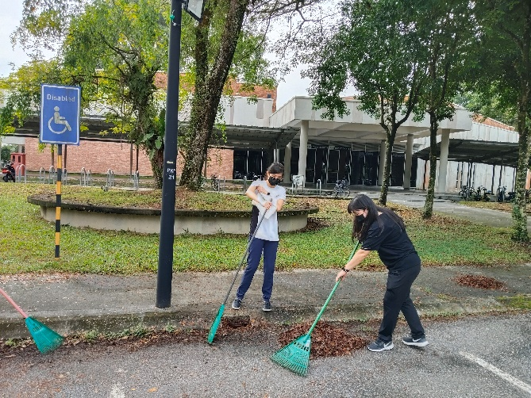 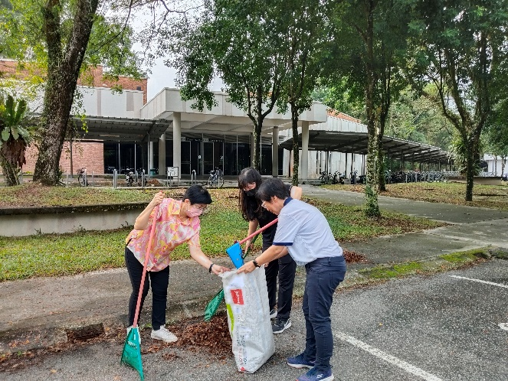 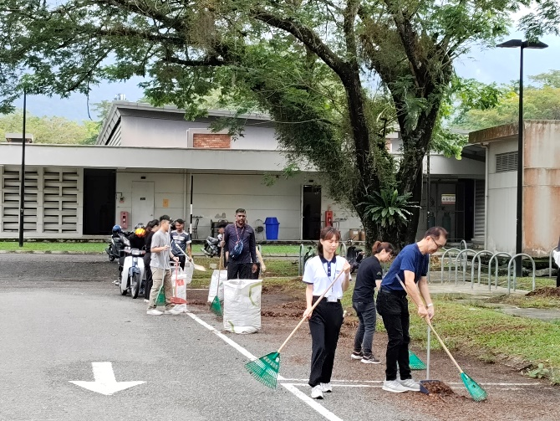 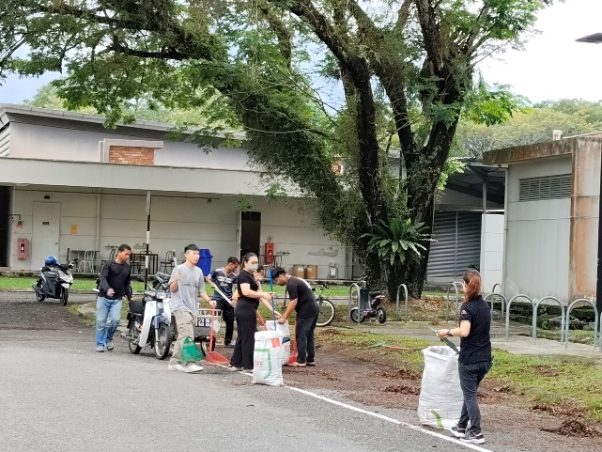 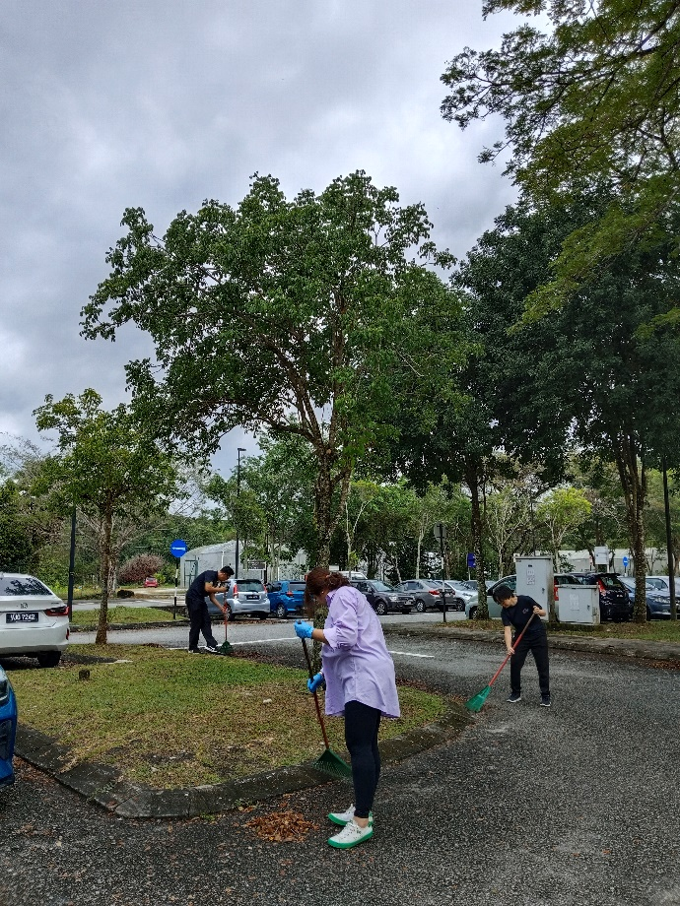 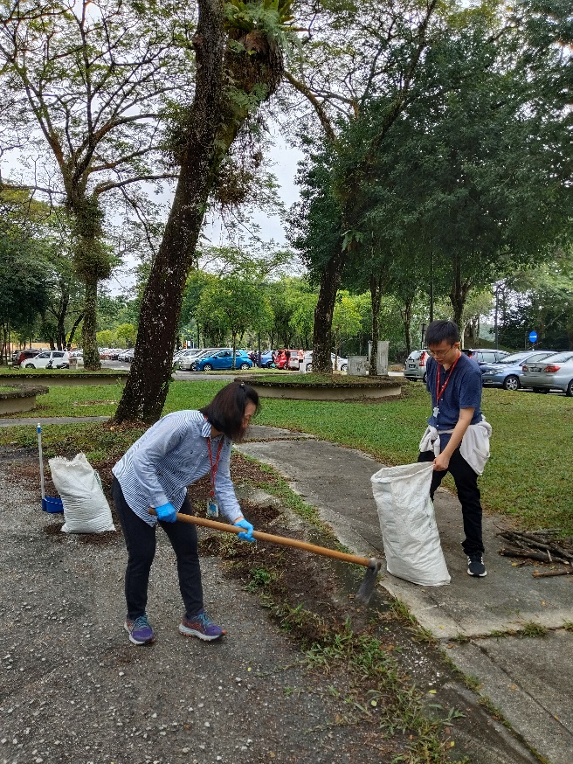 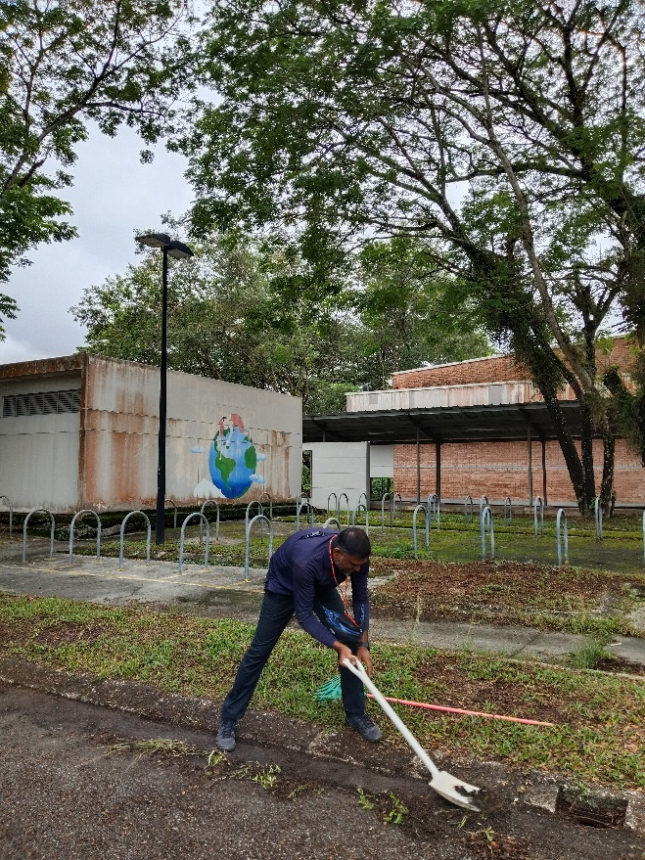

Staff working together to clean the selected parking area