UTAR hosts the PAM Architectural Student Workshop for the first time
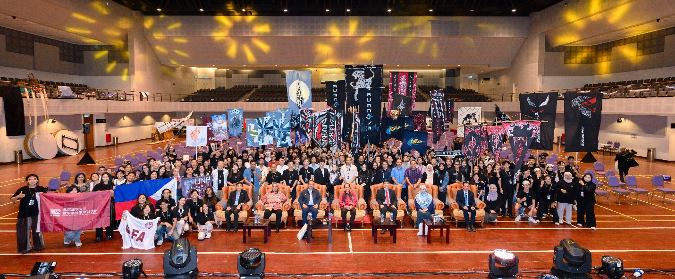
Seated, from left: Mr Hew, Toh Sedewa Raja Dato’ Abdul Talib, Dato’ Ar Zulkhairi, YB Datuk Seri Haji Ahmad, Prof Choong, Dr Siti Rafedah, and Dr Tan with the participating teams during the opening ceremony
Achieving sustainability paves the way for the harmony between human needs and the natural world. However, it involves an assortment of complexities, requiring commitment and collaboration across various disciplines. As the world population rises, issues such as rapid urbanisation, resource depletion, pollution, and climate change become increasingly pressing. Thus, innovative architecture needs to be prioritised to address these contemporary issues, ensuring ample support for both people and ecosystems in the future.
With a quest to discover and unleash creative potential among young architects, the 35th PAM Architectural Student Workshop attracted more than 300 participants from 20 higher education institutions across Asia. The workshop was hosted by UTAR for the first time at UTAR Kampar Campus from 18 to 22 October 2024.
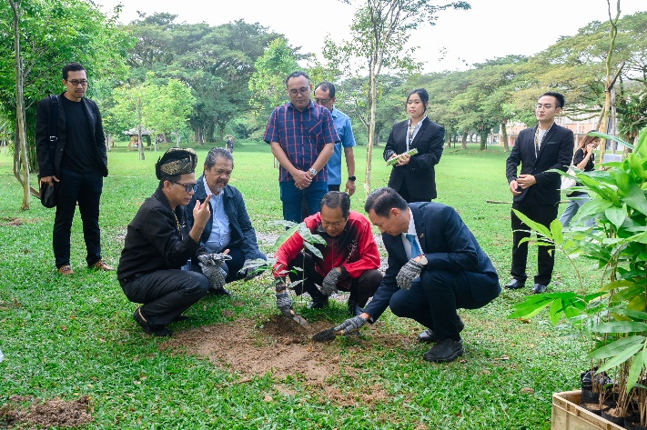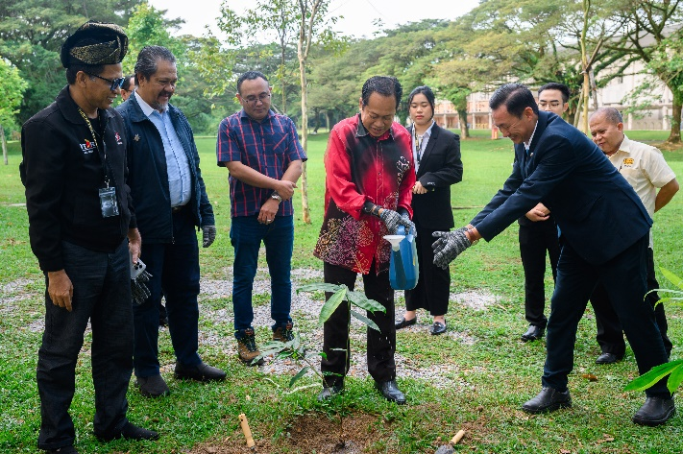
YB Datuk Seri Haji Ahmad (centre) planting a bamboo seedling near the Bamboo Pavilion, signifying Malaysia’s commitment to sustainable development through bamboo architecture
Themed Inception, this year’s workshop was organised by UTAR Architecture Society and Lee Kong Chian Faculty of Engineering and Science (LKC FES) Department of Architecture and Sustainable Design, with support from the Malaysian Institute of Architects (PAM), the Malaysia Architecture Students Alliance (MASA), the Southeast Asia Designer Alliances (SADA), the Malaysian Bamboo Society (MBS), and UTAR Centre for Sustainable Design and Built Environment (COSBE). It not only aimed to facilitate cross-intellectual sharing, learning, networking, and academic collaboration, but also promoted bamboo as a sustainable building material and Malaysian culture among participants, especially the international community.
Inaugurating the 35th PAM Architectural Student Workshop, Malaysia’s Ministry of Works Deputy Minister YB Datuk Seri Haji Ahmad bin Haji Maslan said, “The PAM Architectural Student Workshop has come a long way since its inception in 1987. Over the years, it has evolved into a meaningful annual event with participants across Malaysia and the world, reflecting the workshop’s growing influence and global reach and showcasing the power of global collaboration. This year marks a special milestone for UTAR as they host this workshop for the first time. Their effort in fostering creativity, innovation, and sustainability in architecture is truly commendable and I am excited to see the ideas emerge from this gathering. Events like this workshop are essential for fostering creativity, collaboration, and commitment needed to address challenges such as climate change and rapid urbanisation.”
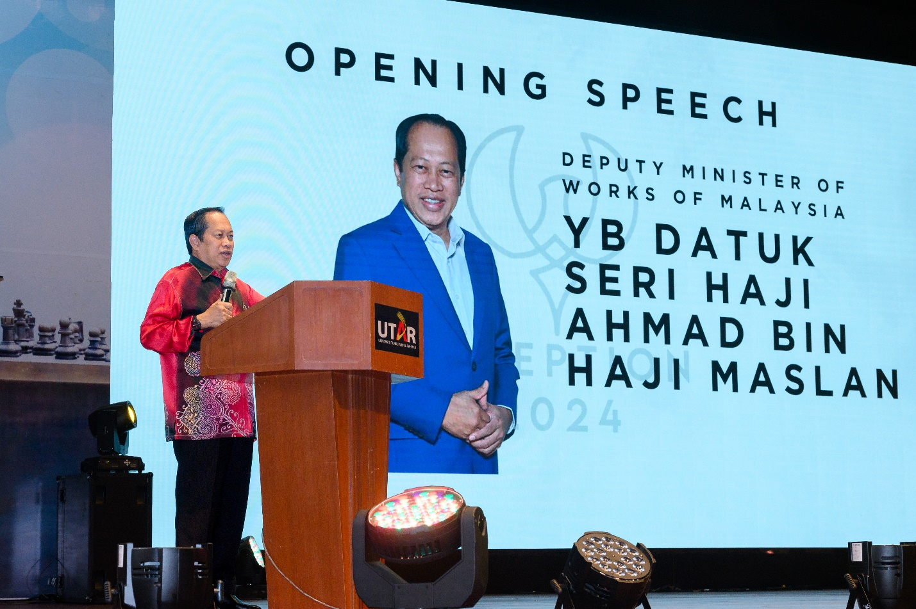
YB Datuk Seri Haji Ahmad highlighting the pressing issues in achieving sustainable development
UTAR Vice President for Student Development and Alumni Relations Prof Dr Choong Chee Keong said, “This workshop reflects UTAR’s dedication to nurturing future architects. The seminars, activities, and competitions featured in this year’s workshop are designed to challenge participants to think creatively and critically. This event encourages the exposure of innovative ideas that align with the Sustainable Development Goals (SDGs). We firmly believe that initiatives like this workshop are essential in equipping young architects with the skills and knowledge needed to address the complex challenges of the 21st century.”
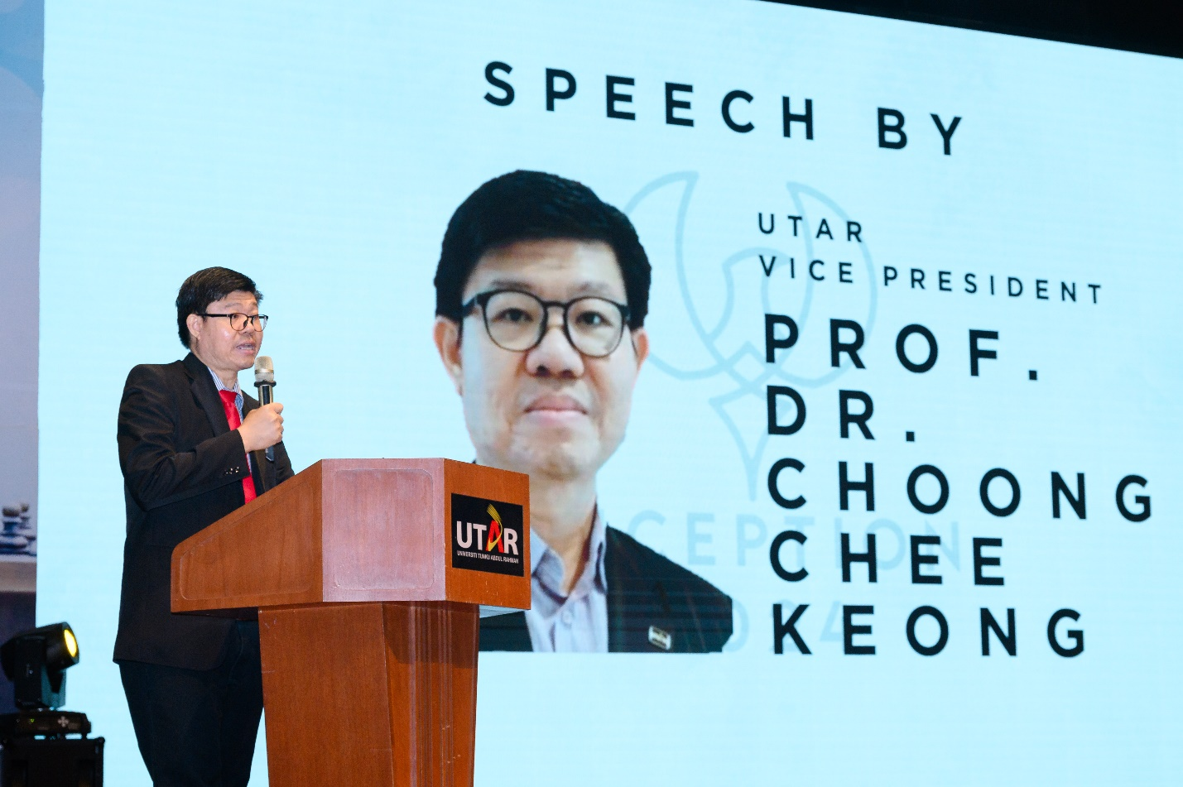
Prof Choong highlighting UTAR’s commitment in addressing sustainable challenges
He also expressed his gratitude to the supporting units, saying, “We are fortunate to have support from PAM, as we are given the opportunity to host this year’s Architectural Student Workshop. Special thanks to the Malaysian Bamboo Society for your continuous support in our programme, because your involvement ensures that this event is not only educational but also a catalyst for many meaningful ideas and collaborations to emerge.”
PAM Education Committee Chairman Dato’ Ar Zulkhairi Md Zain said, “Architecture is not just about creative building, but also about creating environments that enrich people’s lives, respect cultural heritage and embrace sustainability. The 35th PAM Architectural Student Workshop is a platform for academic exchange and professional growth, where students and educators alike learn and inspire one another. An interesting aspect of this year’s workshop is its focus on promoting bamboo as a sustainable building material. Bamboo is deeply rooted in Malaysia’s cultural heritage and is used in modern construction, which speaks to the future architecture as we strive for environmentally conscious and sustainable design solutions. Through this workshop, I believe we can inspire new thinking on how traditional materials like bamboo can contribute to innovative architecture practice worldwide.”
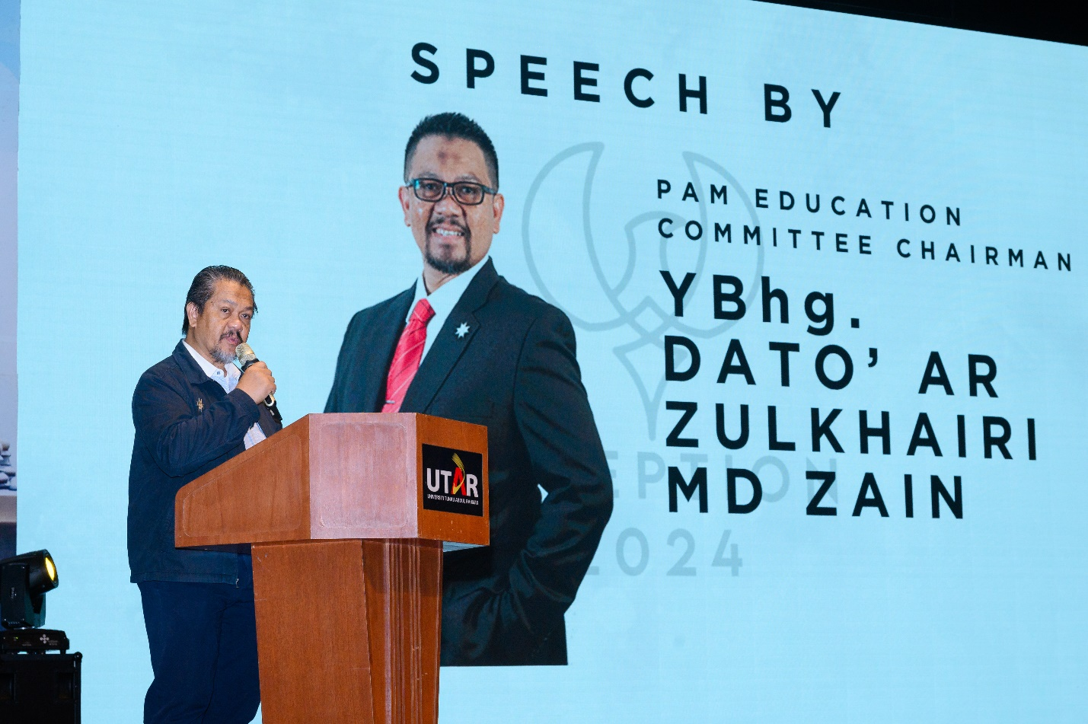
Dato’ Ar Zulkhairi sharing the importance of bamboo in architecture
The 35th PAM Architectural Student Workshop Organising Chairperson Ms Soo Kai Thong said, “This gathering marks a significant moment for the Architecture community, as we come together to share our passions, designs, ideas, and aspirations for the future of design. Inception represents a journey into the unknown or a voyage into a world, where arts and aesthetics have been forgotten. It is up to us to choose whether to break this cover and redefine art. This workshop is not only about learning, it is about pushing ourselves beyond our comfort zone, challenging the unconventional and envisioning new possibilities for architecture. I hope participants make the most out of this experience by engaging with the activities, sharing their ideas, and taking this opportunity to learn not just from experts but from one another. The relationships you build here will extend beyond this workshop, as they will be part of your lifelong journey and social networks in the future.”
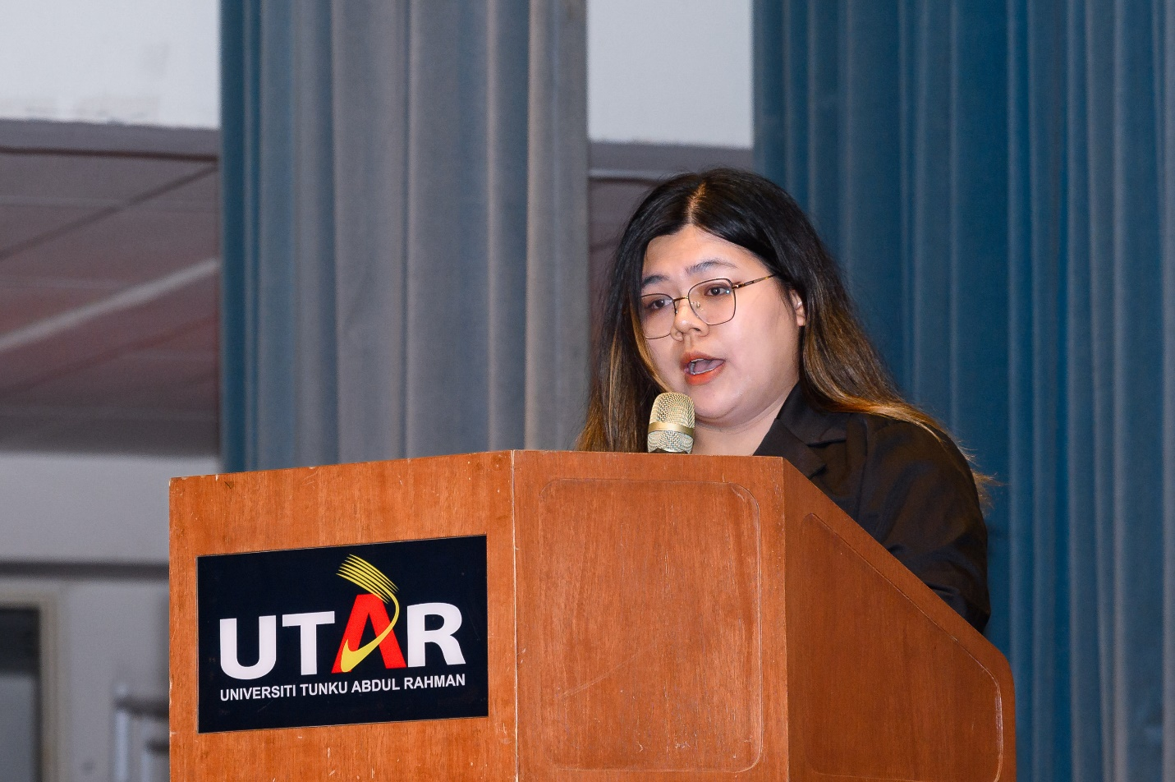
Ms Soo encouraging participants to explore learning opportunities in this workshop
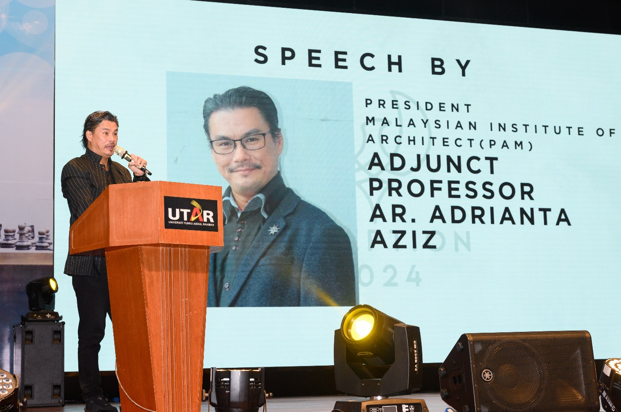
Prof Ar Adrianta expressing his delight at the creativity showcased throughout the workshop during the closing ceremony
The five-day workshop consisted of a wide array of activities such as seminars, talks, games, and parallel workshops, which not only offered deep insights into the world of bamboo architecture and built environment design, but also provided participants with hands-on experiences while they learned from experts and peers about sustainable architecture. The activities included a Bamboo Joinery Workshop, a Sketching (Architectural Sketch / Urban Sketch) Workshop, a Bamboo Lantern Workshop, an Architectural Photography Workshop, a Treasure Hunt game, and an in-depth talk about the architecture designs behind the buildings and environments of UTAR Kampar Campus.
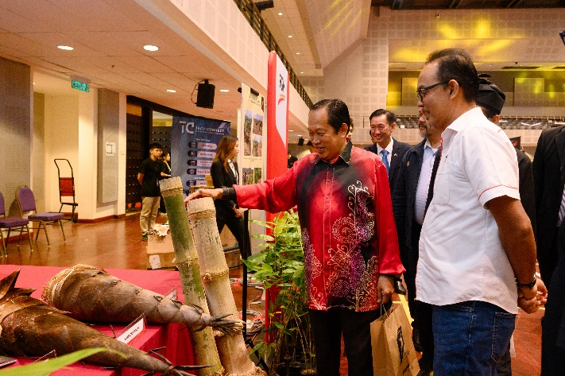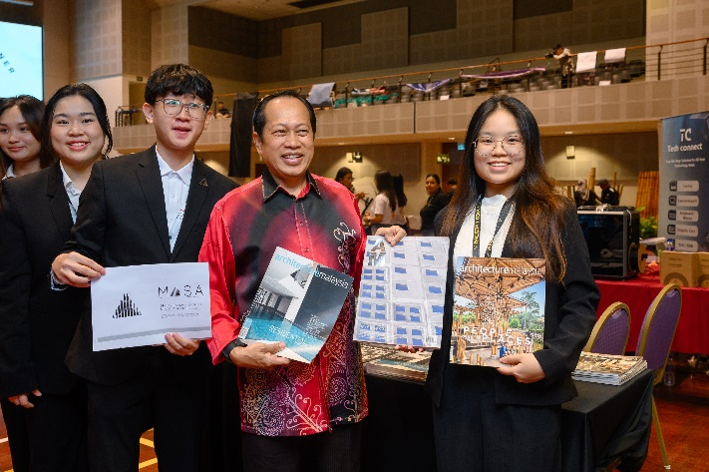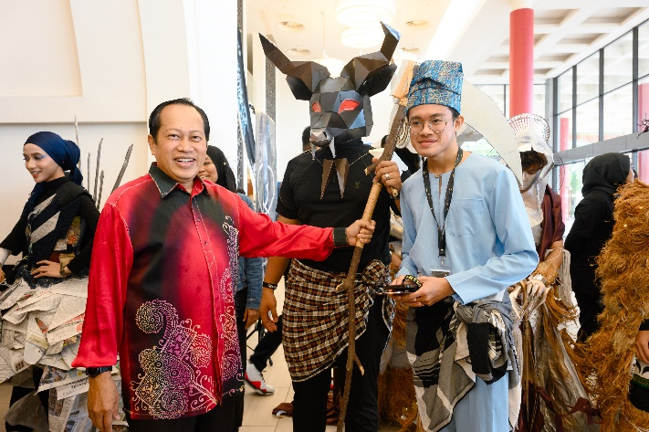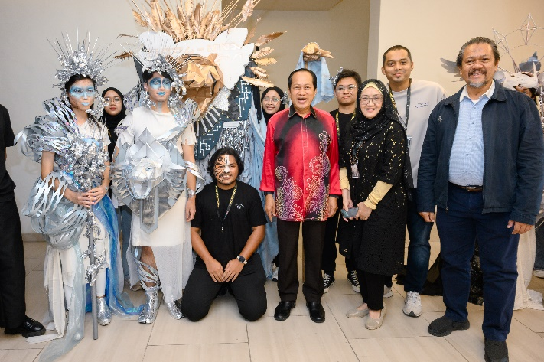
YB Datuk Seri Haji Ahmad interacting with the exhibition booths and participating teams
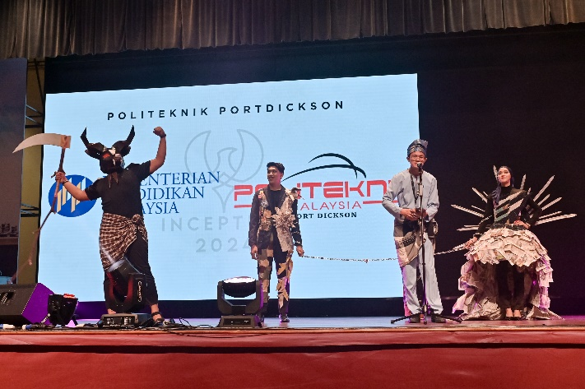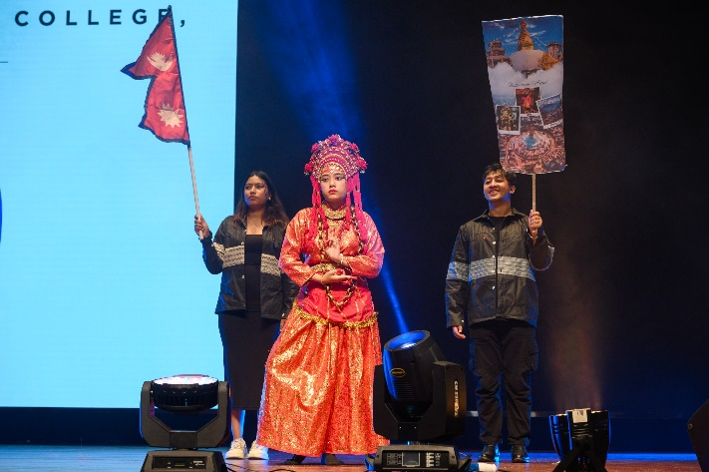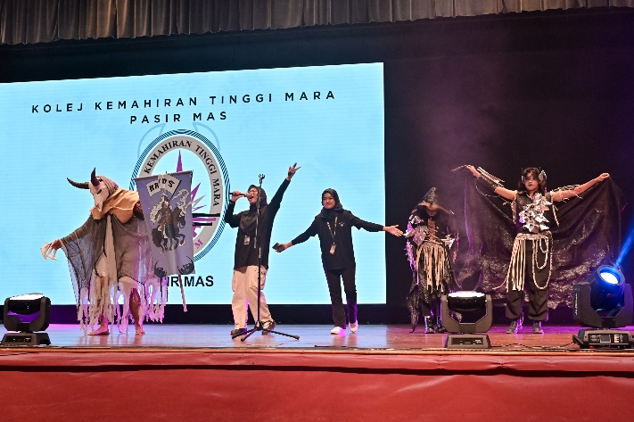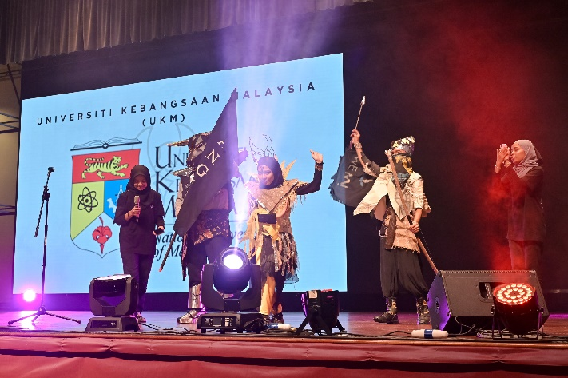
Highlights from the mascot and fashion show
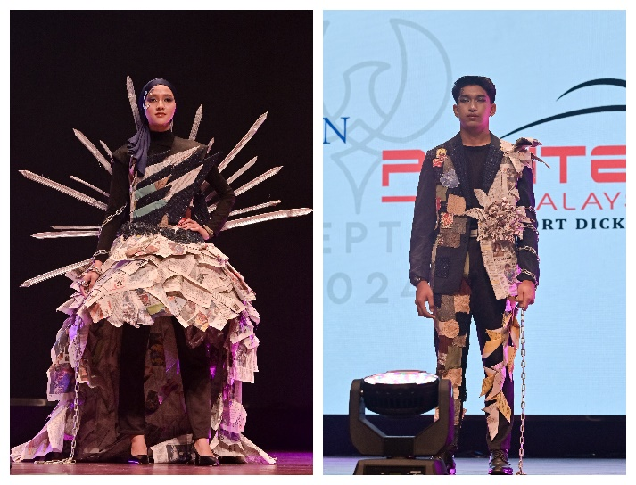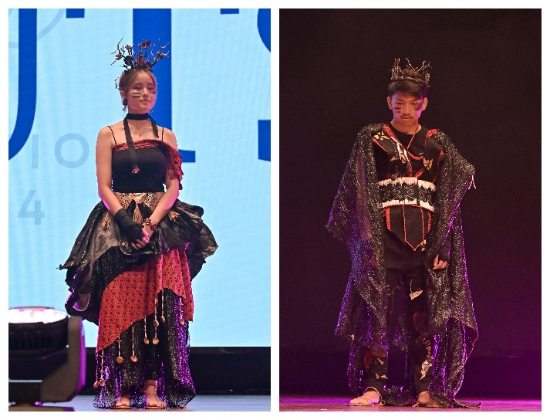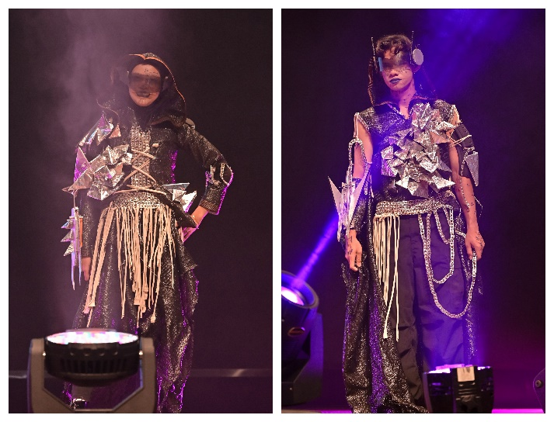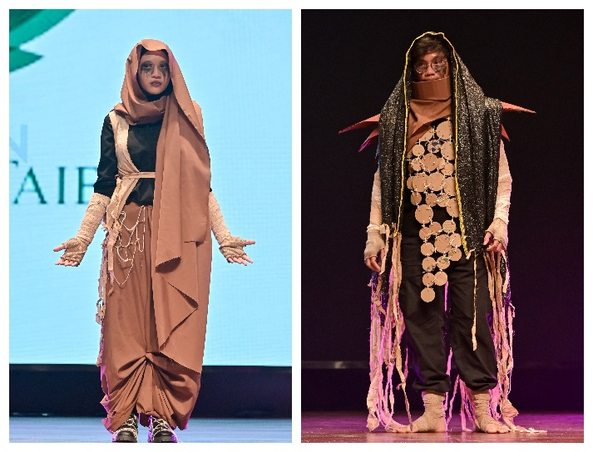
Some outfit designs made from recyclable items by local institutions
One of the main highlights of the 35th PAM Architectural Student Workshop was the diverse competitions that challenged participants to push their creative boundaries in differing disciplines.
Below are the winners of each competition:
Building Structure Competition
No. | Award | Institution
1. | GOLD | UNIVERSITI PUTRA MALAYSIA
2. | SILVER | UNIVERSITI MALAYA
3. | BRONZE | UNIVERSITI SAINS MALAYSIA
4. | CONSOLATION | UNIVERSITI KEBANGSAAN MALAYSIA
5. | CONSOLATION | UNIVERSITY OF TECHNOLOGY SARAWAK
6. | CONSOLATION | UNIVERSITI TUN HUSSEIN ONN MALAYSIA
7. | CONSOLATION | KOLEJ KEMAHIRAN TINGGI MARA PASIR MAS

PAM Design Idea Competition – Part 1
No. | Award | Name | Institution
1. | GOLD | XU MEIYU | BEIJING UNIVERSITY OF CIVIL ENGINEERING AND ARCHITECTURE
2. | SILVER | MIZANUL KUBRA BIN SALIHIN | UNIVERSITI KEBANGSAAN MALAYSIA
3. | BRONZE | LUQIMAN NURKAHIM BIN ROSLAN | UNIVERSITI KEBANGSAAN MALAYSIA

PAM Design Idea Competition – Part 2
No. | Award | Name | Institution
1. | GOLD | LIM CHENG YU | UNIVERSITI MALAYA
2. | SILVER | BOON JING JACK | UNIVERSITI MALAYA
3. | BRONZE | TAY KAR YEN | UNIVERSITI MALAYA

PAM Design Idea Competition – Diploma
No. | Award | Name | Institution
1. | GOLD | MUHAMMAD NASIR BIN MUNSHI ABDULLAH | POLITEKNIK PORT DICKSON
2. | SILVER | MOHAMMAD FIRDAUS B. YUSOF | KOLEJ KEMAHIRAN TINGGI MARA
3. | BRONZE | LIM QI YUAN | MAHSA UNIVERSITY

Wall Art Competition
No. | Award | Institution
1. | FIRST PLACE | UNIVERSITY OF TECHNOLOGY SARAWAK
2. | SECOND PLACE | KOLEJ KEMAHIRAN TINGGI MARA
3. | THIRD PLACE | POLITEKNIK PORT DICKSON

PAM-Got Talent Performance Competition
No. | Category | Institution
1. | DANCE | UNIVERSITI SAINS MALAYSIA
2. | SINGING | POLITEKNIK PORT DICKSON
3. | INSTRUMENTAL | UNIVERSITI MALAYA

Short Video Competition
No. | Award | Institution
1. | FIRST PLACE | UNIVERSITI TUN HUSSEIN ONN MALAYSIA
2. | SECOND PLACE | UNIVERSITI SAINS MALAYSIA
3. | THIRD PLACE | UNIVERSITY OF MINDANAO
4. | FOURTH PLACE | UNIVERSITI MALAYA
5. | FIFTH PLACE | POLITEKNIK PORT DICKSON

Sustainable Fashion Competition
No. | Category | Institution
1. | MALE | UNIVERSITI TUN HUSSEIN ONN MALAYSIA
2. | FEMALE | UNIVERSITI PUTRA MALAYSIA

Banner Competition
No. | Award | Institution
1. | FIRST PLACE | MANUEL S. ENVERGA UNIVERSITY FOUNDATION
2. | SECOND PLACE | KOLEJ LAILA TAIB
3. | THIRD PLACE | UNIVERSITI SAINS MALAYSIA

Best Presenter Award: Universiti Malaya
Adding another layer of excitement to the rich architecture workshop was the announcement of winners for the Harmony Haven by Putrajaya Lake Design Competition 2024 and the 7th Guandong – Hong Kong – Macao Greater Bay Area – ASEAN International Colleges and Universities Design and Construction Competition 2024 – Malaysian Preliminary Round.
Harmony Haven by Putrajaya Lake Design Competition 2024
No. | Award | Design | Institution
1. | CHAMPION | CULTURAL CURRENTS | UNIVERSITI TUNKU ABDUL RAHMAN
2. | 1ST RUNNER-UP | BRANCHING OUT TO HARMONY HAVEN | UNIVERSITI TUNKU ABDUL RAHMAN
3. | 2ND RUNNER-UP | ANYAMAN WARISAN | UNIVERSITI MALAYA
4. | CONSOLATION | FLOWING HARMONY OF PUTRAJAYA LAKE | UNIVERSITAS WARMADEWA
5. | CONSOLATION | ELYSIUM | UNIVERSITY OF MINDANAO
6. | CONSOLATION | ANTA PERMANA HUB | UNIVERSITI KEBANGSAAN MALAYSIA

The 7th Guandong - Hong Kong - Macao Greater Bay Area - ASEAN International Colleges & Universities Design & Construction Competition 2024 – Malaysia Level
No. | Award | Design | Institution | Member
1. | CHAMPION | REMINISCENCE | UNIVERSITI TUNKU ABDUL RAHMAN | RUBY ONG SOOK YONG
 | DESIGN INNOVATION AWARD |  |  | I MADE PAGARAT
 |  |  |  | I MADE GDE ADISATYA ARDIKABAWA
 | POPULAR DESIGN |  |  | CHOW YUEN TING
 |  |  |  | CHO CHI KEI
 |  |  |  | ABD MULUK BIN ABD MANAN (SUPERVISOR)
2. | CHAMPION | CADANCE | UNIVERSITI TEKNOLOGI SARAWAK | DESMOND WONG TIONG IK
 | DESIGN PROCESS & EXPERIMENT AWARD |  |  | ANGEL LIAW CHAI JIUN
 |  |  |  | JOENNA VINISIA JOHNNY JUINIS
 |  |  |  | TOM SUN JIA HONG
 |  |  |  | SEO MING HUA
 |  |  |  | WONG LIN SZE (SUPERVISOR)
3. | 1ST RUNNER-UP | BREATHING PETALS | UNIVERSITI TEKNOLOGI MARA | IRSYAD NAQIUDDIN BIN IDRUS
 | STRUCTURE CONSTRUCTION AWARD |  |  | MUHAMMAD AMIRUL BIN MOHD SUHAILI
 |  |  |  | KARMILAQISTINA AISHA BINTI MOHD NASIR
 |  |  |  | MEGAT AQIL HARITH BIN ABDUL MUHAIMIN
 |  |  |  | MUHAMMAD FAEEQ BIN ZAIDAN
 |  |  |  | SAYED MUHAMMAD AIMAN BIN SAYED ABUL KHAIR (SUPERVISOR)
4. | 1ST RUNNER-UP | ECHOES OF WIND’S EMBRACE | UNIVERSITI TUNKU ABDUL RAHMAN | CHOO YING HONG
 |  |  |  | CHUA JUAN XIA
 |  |  |  | CHEAH TIAN YOW
 |  |  |  | TEE SHU TENG
 |  |  |  | WONG TIONG JIE
 |  |  |  | RAHMAWATY (SUPERVISOR)
5. | 2ND RUNNER-UP | THE BLOOMING LOTUS | UNIVERSITI SAINS ISLAM MALAYSIA | WAN ANIS SOFEA BT WAN ABD MALEK
 |  |  |  | AIN AMIRAH BT SHARIFUL ADLI
 |  |  |  | FUDHLA BT AMINUDDEEN
 |  |  |  | NUR SABRINA ILYANA BT SIDEK
 |  |  |  | NUR SABRINA BT MOHD SHUKRI
 |  |  |  | AR AHMADSYAFII’EI ABDUL KUDOS (SUPERVISOR)
6. | 2ND RUNNER-UP | VOYAGES | UNIVERSITI TUNKU ABDUL | CHAN ZHENG HAN
 |  |  |  | CHEE KAI MENG
 |  |  |  | CHONG SHENG ONN
 |  |  |  | GOH SHIEN HUNG
 |  |  |  | HANG WEI MING
 |  |  |  | LIM YEKEY (SUPERVISOR)
7. | HONORABLE MENTION | A LOONG STORY | UNIVERSITI TUNKU ABDUL RAHMAN | POH YEN ZI
 |  |  |  | JACKY SOO LI HENG
 |  |  |  | KEE JIA KE
 |  |  |  | LIM WANJING
 |  |  |  | TANG YING HUI
 |  |  |  | AR SAM CHIN SING (SUPERVISOR)
8. | HONORABLE MENTION | TUO DONG FENG XI | UNIVERSITI SAINS MALAYSIA | HOW SEE CONG
 |  |  |  | NURIN HASYA BINTI MOHD SARISFFUDDIN
 |  |  |  | NUR ALIATUL AINA’ BT MOHD AYOB
 |  |  |  | NURAMIRA IZZATI BINTI HAZIR SHAM
 |  |  |  | MUHAMMAD NAZIR HAKIM BIN AHMAD SHUKERI
 |  |  |  | AR ZALENA BINTI ABDUL AZIZ (SUPERVISOR)
9. | HONORABLE MENTION | DRIFTING HEW | POLITEKNIK PORT DICKSON | MUHAMMAD AIMAN FARHAN BIN TARMIZI
 |  |  |  | MUHAMMAD ANAS HAKIMI BIN RAUB
 |  |  |  | MUHAMMAD IKHMAL HAQIEMY BIN RIDUAN
 |  |  |  | NUR A’LIAH A’TIRAH BINTI ROSDI
 |  |  |  | NUR HIDAYAH BTE ROSMAN (SUPERVISOR)
10. | HONORABLE MENTION | RISE | UNIVERSITI SAINS MALAYSIA | WAN MUHAMMAD HAZIQ BIN ABDUL KARIM
 |  |  |  | MUHAMAD NIZAR BIN ZULKARNAIN
 |  |  |  | MUHAMMAD ASYRAF AIMAN BIN ZULNAJMI
 |  |  |  | LIM MING EN
 |  |  |  | KOAY YI HONG
 |  |  |  | DR NOORIATI BINTI TAIB (SUPERVISOR)
11. | HONORABLE MENTION | ZEPHYRBORNE | UNIVERSITI SAINS ISLAM MALAYSIA | SYAZA FARWIZAH MUHAMAD YUNUS
 |  |  |  | AKMAL AZIM BIN MOHD SUHAIMI
 |  |  |  | FARISA MUNIRAH BINTI AWANG HAT
 |  |  |  | MUHAMMAD ROYYAN BIN MOHD FATHI’
 |  |  |  | MUHAMMAD SYAKIR AZFAR BIN MOHD NADZRI
 |  |  |  | AR IDR DR WAN NORISMA WAN ISMAIL (SUPERVISOR)
12. | HONORABLE MENTION | FLOATING SYMPHONY | UNIVERSITI TUNKU ABDUL RAHMAN | KHOO KE XUAN
 |  |  |  | CANDY CHAN TENG MIN
 |  |  |  | LEONG SHIN YEE
 |  |  |  | LEW WEN RUI
 |  |  |  | AR ONG HUN BOON (SUPERVISOR)

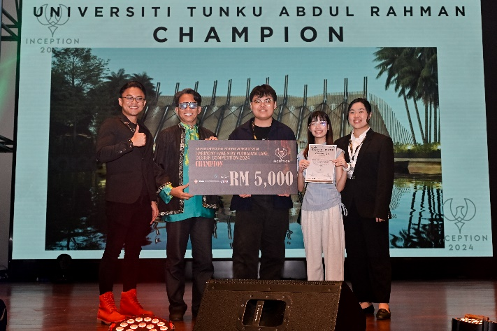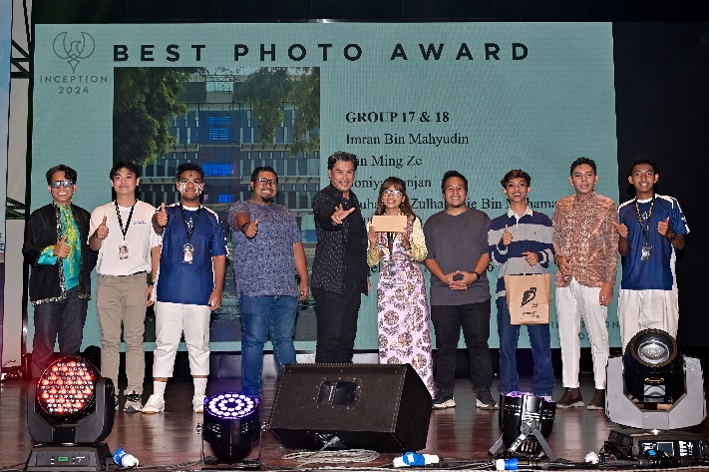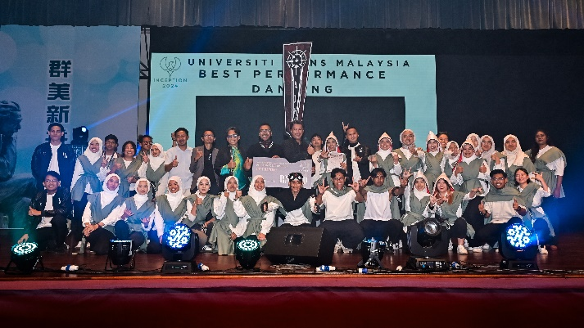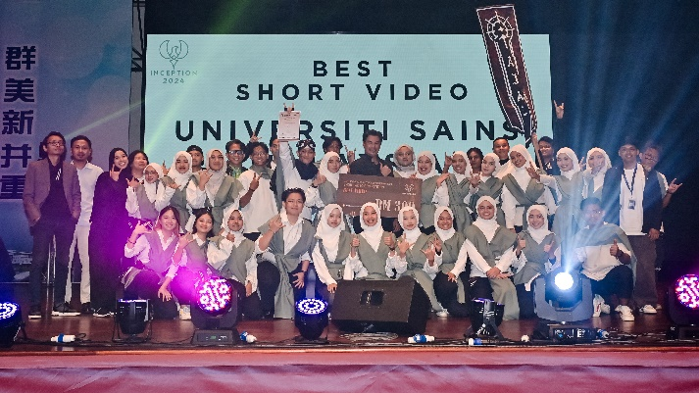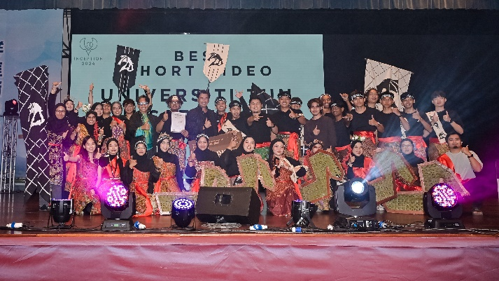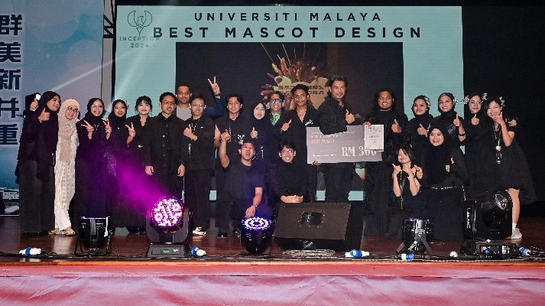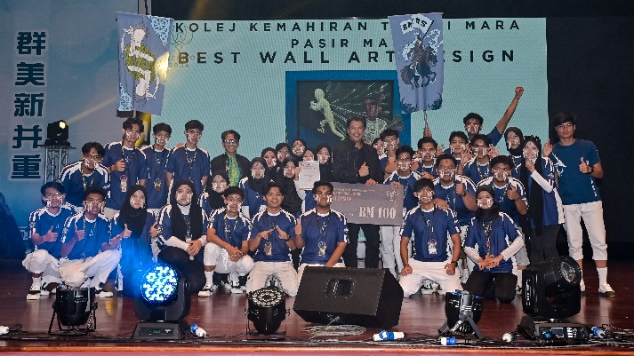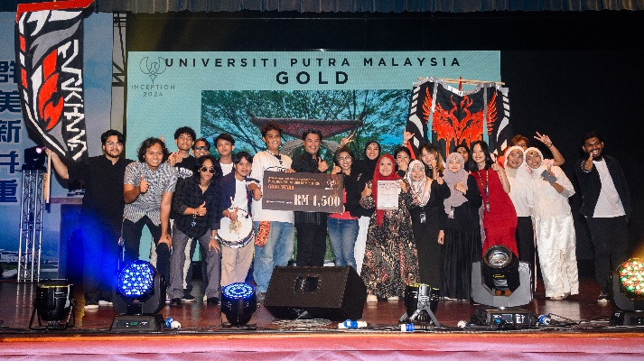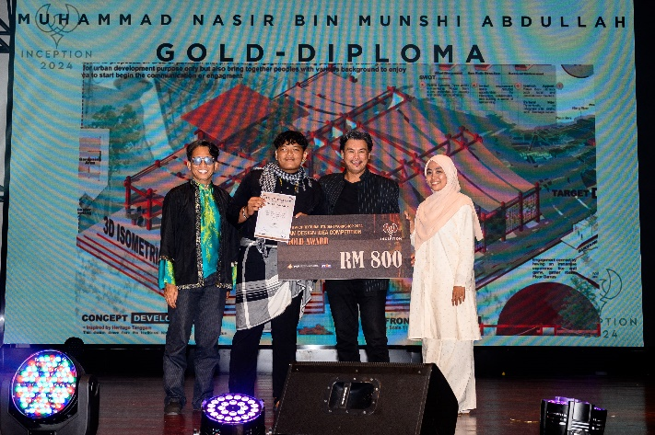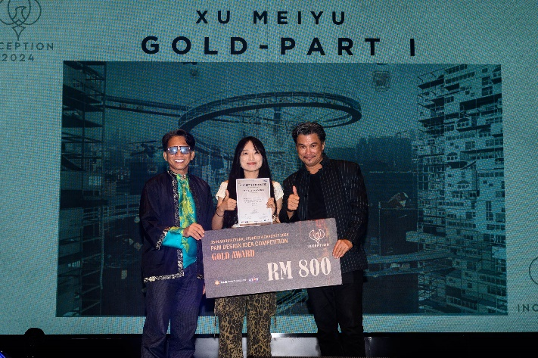
Winning teams celebrating their success while receiving prizes from Prof Ar Adrianta and En Abd Muluk

Participating students enjoying local delicacies during the gala dinner
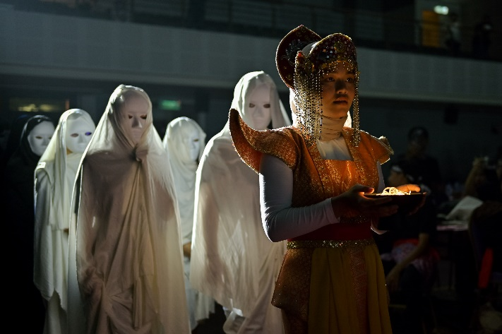
Sensational performances to commemorate the architecture students’ growth
Also present at the opening ceremony were Orang Besar Jajahan Kampar Toh Sedewa Raja Dato’ Abdul Talib bin Abd Fahmi, Malaysian Bamboo Society Vice President Dr Siti Rafedah Abdul Karim, UTAR Council Member Mr Hew Fen Yee, UTAR Lee Kong Chian Faculty of Engineering and Science (LKC FES) Head of Department of Architecture and Sustainable Design Ts Dr Tan Kok Hong, the 35th PAM Architectural Student Workshop Convenor En Abd Muluk bin Abd Manan, the workshop’s Advisers Dr Lim Poh Im, organising committee members, and participating academics and students from various institutions.
Meanwhile, the closing ceremony was attended by PAM President Adjunct Prof Ar Adrianta Aziz, Dr Lim, En Abd Muluk, organising committee members, and participating academics and students from various institutions.
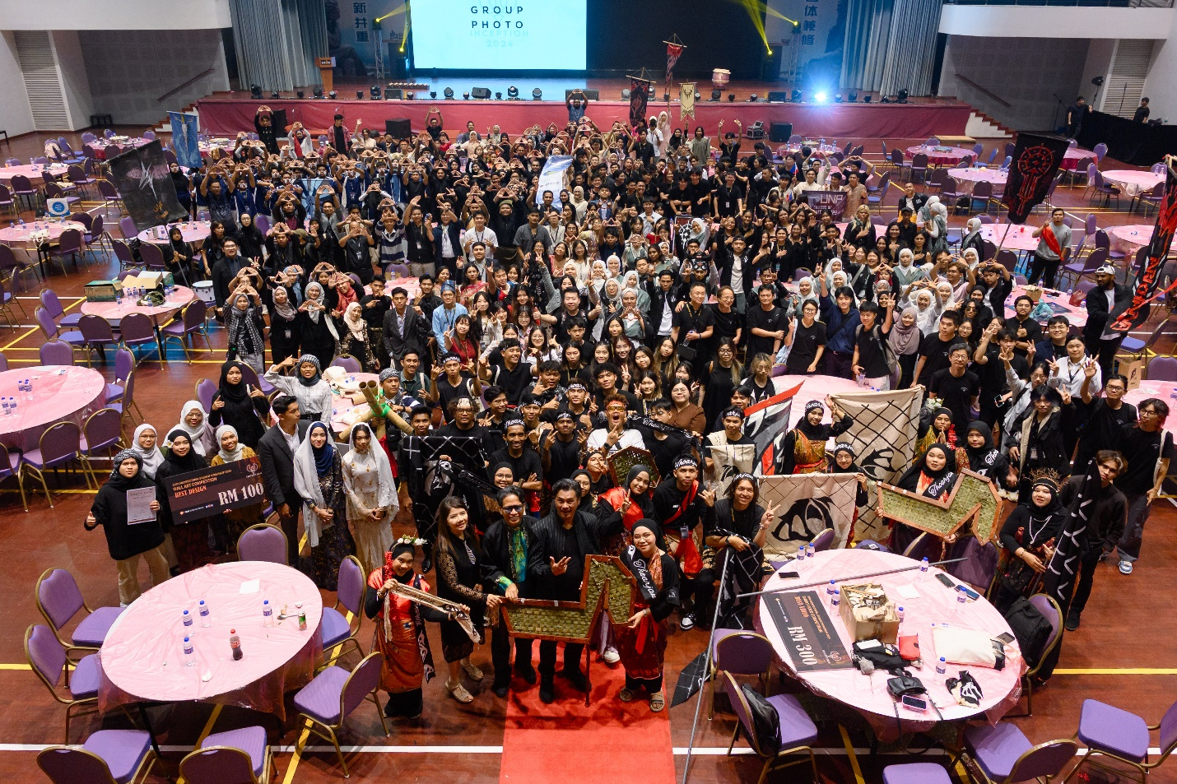
Front row: Dr Lim (second from left onwards), En Abd Muluk, and Prof Ar Adrianta with participating teams and committee members during the closing ceremony
The PAM Architectural Student Workshop is an annual event with a humble beginning in 1987. It started as a local gathering, aiming to foster knowledge exchange and strengthen bonds among Malaysian architecture students, with three participating institutions, namely Universiti Teknologi Malaysia (UTM), Universiti Teknologi MARA (UiTM), and Universiti Sains Malaysia (USM). Over the decades, it evolved into an international event that not only serves as an avenue to enhance architectural innovation, but also offers collaborative opportunities among participating institutions across the world, familiar to the architecture experts today.
Each year, the PAM Architectural Student Workshop is hosted by different higher education institutions from Malaysia. It mainly features a diverse assortment of activities such as workshops, talks, seminars, projects, games, competitions, and challenges, providing hands-on experience to young architects to redefine conventional and unconventional designs. As it continues to grow, the workshop remains committed to gathering the next generation of architecture students from around the world, empowering them to tackle global issues through sustainable innovation and collaboration.
The 35th PAM Architectural Student Workshop was sponsored by the Everly Hotel Putrajaya, Putrajaya Holdings Sdn Bhd, Bajooby System Sdn Bhd, Swissma Building Technologies Sdn Bhd, Tech Connect, Printcious, Rekaphosis Interior Sdn Bhd, IRAMO Bamboo Resources, Land & General Berhad, FGV Holdings Berhad, and Eupe Corporation Berhad.

