**25th AgriTech seminar explores bamboo resources, cultivation and utilisation**

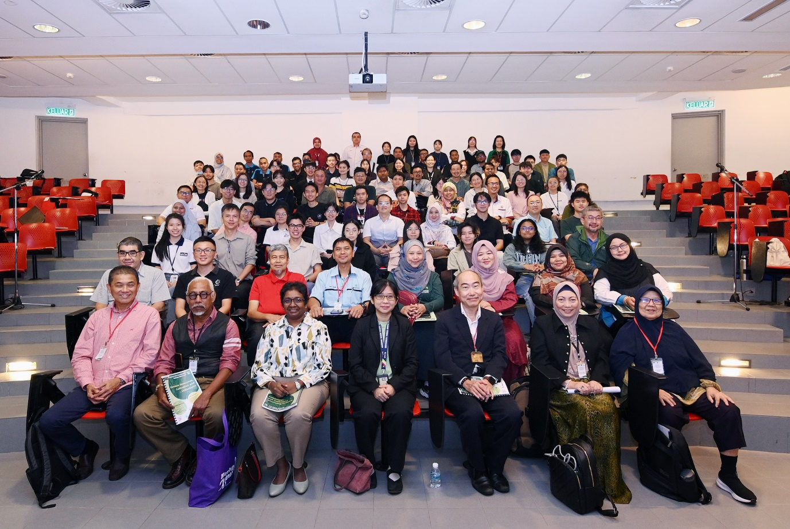

Gathering of great minds to explore bamboo cultivation

Bamboo was the topic of the day at the 25th Agriculture Technology Seminar Series XXV, jointly organised by UTAR Faculty of Science (FSc), UTAR Centre for Agriculture and Food Research (CAFR), and the Malaysian Bamboo Society (MBS), on 9 November 2024 at UTAR Kampar Campus.

Organising Chairperson Dr Goh Wei Lim emphasised, “Bamboo is an amazing plant. It has long been cultivated by the peoples of temperate and tropical Asia for its cultural importance and thousand-uses in their daily lives. As society conveniently turned to using industrial materials, bamboo became less appreciated in many places, including Malaysia. In recent decades, however, bamboo has come into the spotlight again for its potentials to be used as green and sustainable materials, echoing the calls for environment protection.”

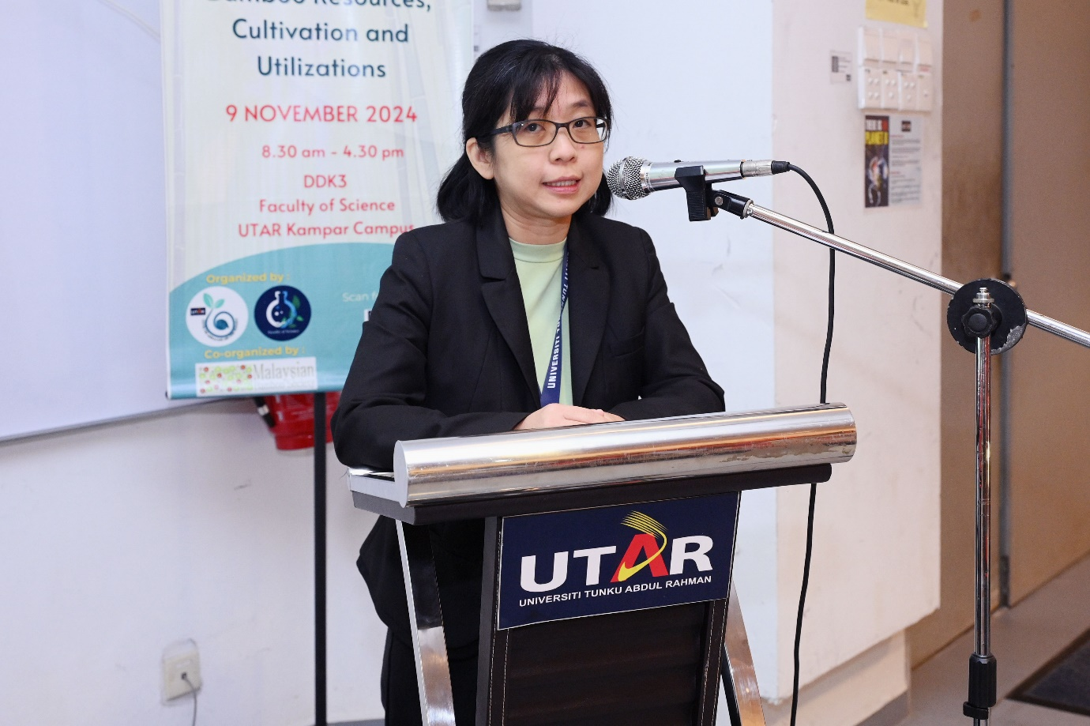

Dr Goh highlighting the importance of bamboo cultivation

The “Bamboo Resources, Cultivation and Utilisations” seminar provided participants with fundamental knowledge of the bamboo diversity in Southeast Asia, bamboo plantation management, and contemporary usage of bamboo. This also saw the gathering of experts, namely Lifetime Advisor to the Malaysian Bamboo Society Dato’ Dr Marzalina Mansor; Founder & CEO of Tadom Hill Resort Sdn Bhd and Vice President of the Malaysian Bamboo Society Dato’ Lai Yeng Fock; Special Project Manager who leads a large-scale betung bamboo plantation of Land & General Mr Abdul Hamid Mohd Yusof; Mr Mohd Ramadhan Abdul Hamid, who has completed many famous bamboo constructions, including the Bamboo Playhouse at Lake Garden in Kuala Lumpur; and prominent bamboo botanist Dr Elizabeth Widjaja, who is now actively involved in the bamboo community farming and landscape restoration project through the Environmental Bamboo Foundation.

Institute of Postgraduate Studies and Research (Kampar Campus) Deputy Director Prof Dr Sumathi Sethupathi commended the seminar on bringing this topic to light, as bamboo is rich in various applications and a sustainable asset. More than reflecting UTAR’s commitment and continuous effort towards agriculture and sustainability, the seminar was an opportune platform for fostering potential collaborations on cultivating bamboo.

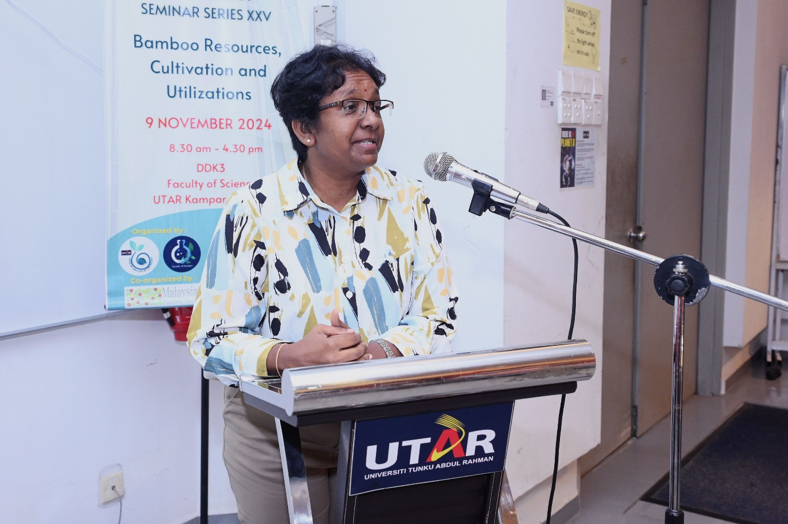

Prof Sumathi speaking on bamboo cultivation for sustainability

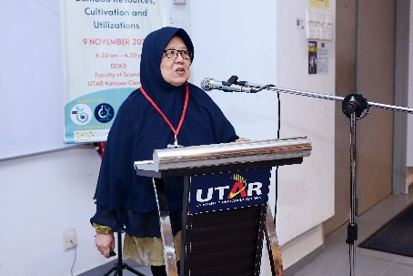 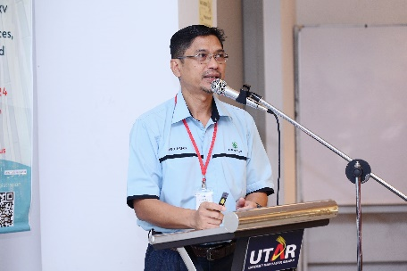 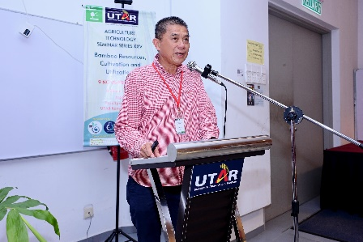

From left: Dr Elizabeth Widjaja, Mr Abdul Hamid and Dato’ Lai presenting their insights on bamboo cultivation and its impact on sustainability

The session started with an enlightening presentation titled Bamboo Agroecology to Support the Bamboo Industry in West Flores by Dr Elizabeth Widjaja. Participants learnt that bamboo agroecology plays a crucial role in fostering a sustainable bamboo industry by integrating ecological principles into the cultivation, management, and harvesting of bamboo. The speaker highlighted that implementing bamboo agroecology ensures the long-term viability and economic stability of the bamboo industry while contributing to environmental conservation and climate change mitigation. In West Flores, bamboo agroecology offers significant economic benefits to local communities.

“Bamboo Plantation and Management” by Mr Abdul Hamid helped participants understand that establishing a bamboo plantation requires proper research, resources, planning, execution and determination to make bamboo as an alternative crop to oil palm, rubber, pineapple and coconut, and an alternative source for timber. He then elucidated on the efforts by the Malaysian Timber Industry Board (MTIB), under Malaysia Bamboo Industry Development Action Plan 2021-2030, Land & General Berhad through its wholly owned subsidiary Clarity Crest Sdn Bhd, on replacing the old rubber trees with bamboo with assistance by the expertise from the Forest Research Institute Malaysia (FRIM) at Sungai Jernih Estate. It was made known that the area of Kerling, Kuala Kubu Bharu Selangor is now home to the largest private bamboo plantation in Peninsular Malaysia, covering an area of almost 300 hectares. As planting bamboo on a large scale requires adequate financial resources, as well as knowledge, Mr Abdul Hamid encouraged collaboration and networking with peers as well as with local universities to make bamboo plantations a success.

The third presentation, titled What Bamboo Biochar Can Do to Mitigate Climate Change by Dato’ Lai, highlighted the potential of biochar, especially bamboo biochar, as an effective climate change mitigation tool. Created from biomass waste through pyrolysis or gasification in low-oxygen environments, biochar locks carbon into a stable form that can last hundreds or even thousands of years, serving as a long-term carbon dioxide removal (CDR) solution. In addition to carbon sequestration, biochar enhances soil fertility by retaining water and nutrients, lowers greenhouse gas emissions, reduces reliance on chemical fertilisers, and decreases agricultural runoff and pollution. Dato’ Lai further elaborated on biochar’s wide-ranging applications across industries, including biogas production, wastewater treatment, construction, cosmetics, and medicine. Bamboo biochar, in particular, offers a scalable, nature-based solution that not only mitigates climate change but also contributes to sustainable agricultural practices and environmental restoration.

Later at the forum on “Bamboo Industry in Malaysia: Current Status and Prospects”, moderated by Mr Mohd Ramadhan, the speakers and panellists discussed the modern applications of bamboo materials, challenges and prospects of supply chain in the bamboo industry, and lessons to learn from neighbouring countries on their success on bamboo cultivation and potential cross-border joint ventures.

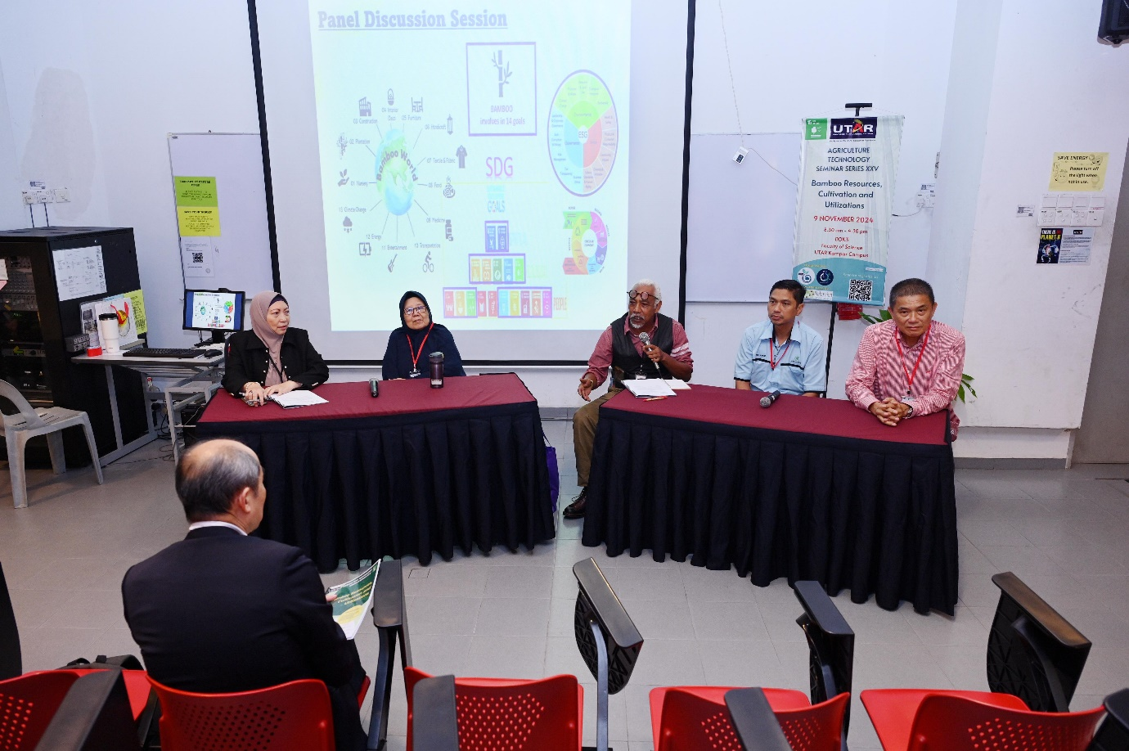

From left: Dato’ Dr Marzalina, Dr Elizabeth Widjaja, moderator Mr Mohd Ramadhan, Mr Abdul Hamid and Dato’ Lai discussing the prospects of bamboo cultivation

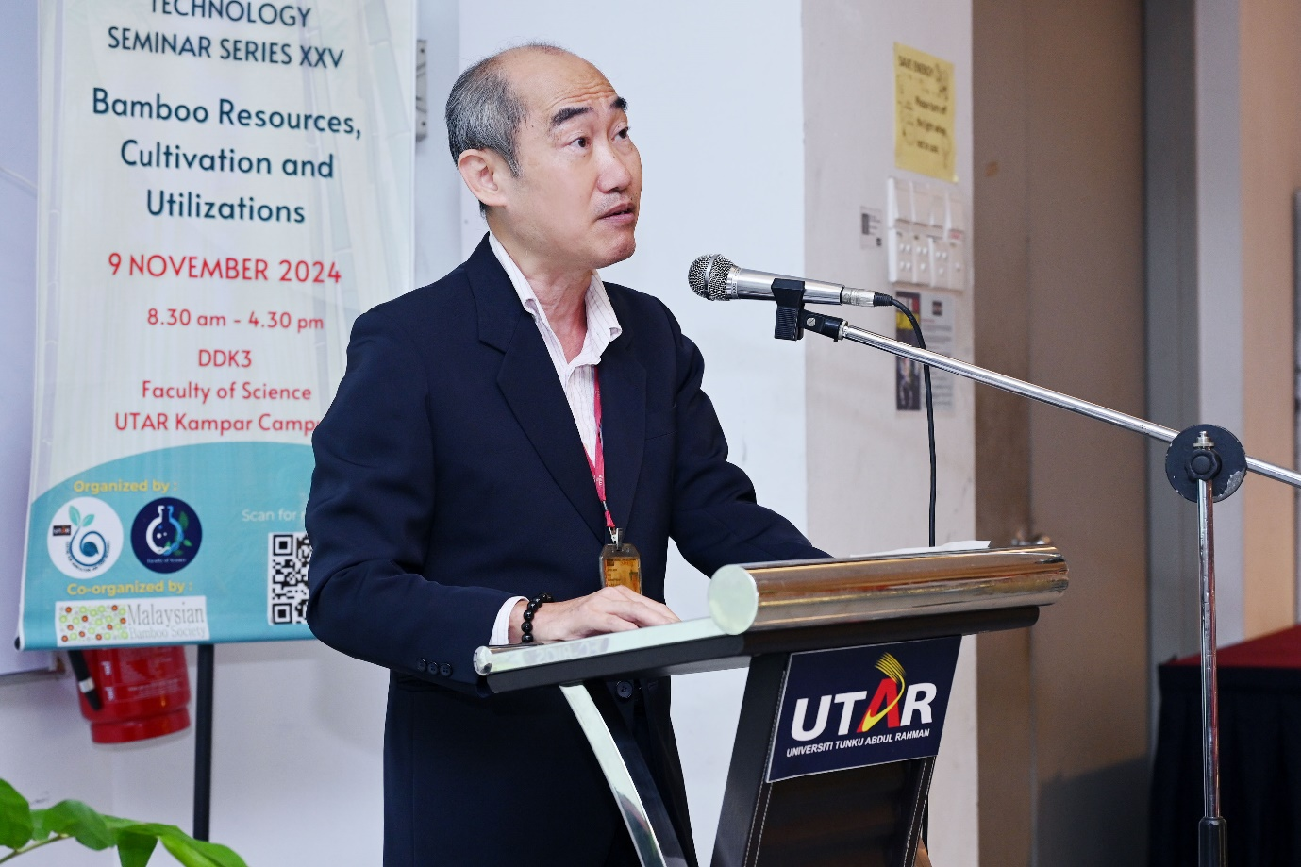

Dr Lim encouraging participants to explore the many ways bamboo can drive sustainable development

The closing of the seminar saw FSc Dean Assoc Prof Dr Lim Tuck Meng mentioning, “Since our inaugural seminar in 2011, this annual event has served as a vital platform for advancing sustainable agricultural practices. This year, under the theme ‘*Bamboo Resources, Cultivation, and Utilisations’*, we are thrilled to explore the many ways bamboo can drive sustainable development. I hope each participant finds this seminar both enriching and inspiring, offering valuable insights that will advance our shared journey toward a sustainable, bamboo-integrated future.”

Excitement was heightened with the experiential learning of the traditional Lemang Rice and Glutinous Rice Dumpling preparation, as well as a complimentary workshop on “Bamboo Propagation Techniques” conducted during the seminar.

The seminar was sponsored by FGV Agri Services Sdn Bhd, Land & General Berhad, Surechem Sdn Bhd, Next Gene Scientific Sdn Bhd, and FC-BIOS Sdn Bhd.

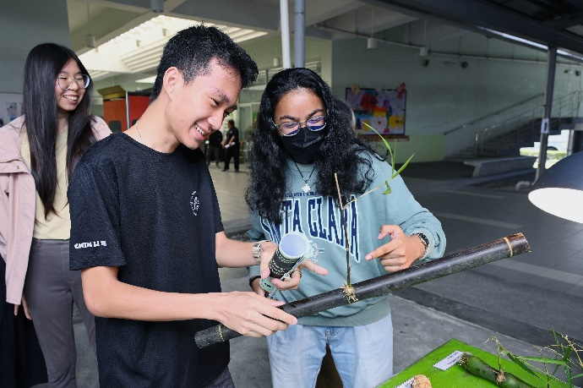 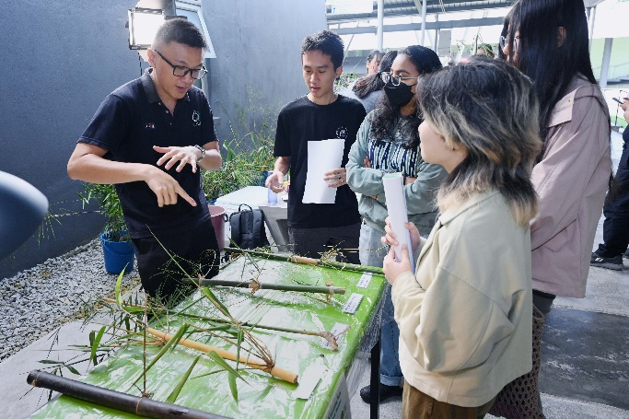 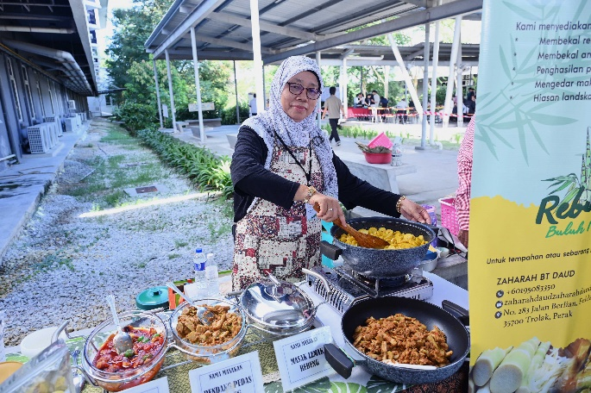 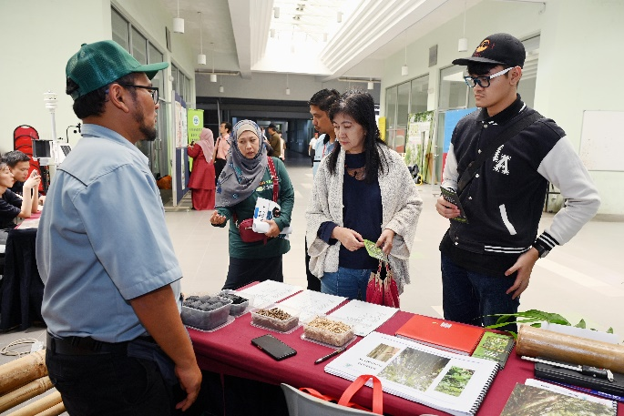

Participants and speakers checking out the booths and workshop stations

View more photos here. (embed FB album link)