UTAR Green Ambassador Programme 2024 honoured at River Care Awarding and Recognition Ceremony
UTAR was honoured at the River Care Awarding and Recognition Ceremony, Kinta River Basin 2024, for its significant contributions to environmental sustainability through the UTAR Green Ambassador Programme 2024. The event, held on 26 September 2024, celebrated the efforts of various stakeholders in promoting green practices to protect the Kinta River Basin.
Organised by the Global Environment Centre (GEC), in collaboration with Jabatan Pengairan dan Saliran (JPS) Negeri Perak and Yayasan Hasanah (YH), the ceremony marked the successful conclusion of the project, “Pengawasan Kelestarian Lembangan Sungai Kinta Melalui Amalan Hidup Hijau”. This initiative, which ran from September 2021 to August 2024, engaged local communities to foster sustainable practices within the Tadahan Sungai Kinta (TSK) area.
UTAR’s recognition at the ceremony highlights the impact of its Green Ambassador Programme, coordinated under the UTAR Green Campus Committee (UGCC), Kampar Campus. Led by Faculty of Business and Finance academic Assoc Prof Dr Leong Lai Ying, with key support from Senior Assistant Manager of the Department of Student Affairs (Kampar Campus) Ms Ma Foong Mei, and Chairperson of the UTAR Green Campus Committee Assoc Prof Ir Ts Dr Toh Pey Yi, the programme mobilised 12 Green Ambassadors to lead environmental projects across the community.
In acknowledgement of the programme’s meaningful contributions, Ms Ma received an appreciation certificate on behalf of UTAR, highlighting the university’s commitment to environmental conservation.
Throughout the year, UTAR Green Ambassadors spearheaded a range of impactful activities in collaboration with GEC, all aimed at fostering sustainable practices:
- River Health Index Monitoring
The Green Ambassadors conducted several monitoring sessions for Sungai Kampar on 2 March, 22 June, and 31 August 2024. These sessions evaluated the ecological health of the river, providing critical data for ongoing conservation efforts.
- River Treatment Initiatives
On 31 August 2024, the Green Ambassadors released 90 units of mudballs into Sungai Kampar. This natural treatment method helped improve water quality, reflecting UTAR’s dedication to ecological restoration.
- River Ranger 2.0 Training Workshop
To enhance river conservation skills, GEC invited the Head of the Department of Estates and Facilities Encik Mohd Azman bin Abdullah and Dr Toh to participate in the River Ranger 2.0 Training Workshop on 5 March 2024. The workshop equipped UTAR representatives with advanced knowledge of river care practices.
- Educational Trip to the Kinta River Basin Environmental Education Hub
In an effort to raise awareness about water resource conservation, the Green Ambassadors organised a trip on 27 April 2024 for 35 UTAR students and four staff members to the Kinta River Basin Environmental Education Hub. The hands-on experience helped participants better understand the significance of protecting water sources.
- Community Outreach at Malim Nawar
UTAR’s Green Ambassadors teamed up with GEC and Rukun Tetangga Malim Nawar to conduct an outreach event for the local community, spreading awareness about environmental protection and encouraging active involvement.
More details on these activities are available here.
UTAR extends its heartfelt gratitude to GEC, JPS Negeri Perak, and YH for their support and funding. The UTAR Green Ambassador Programme 2024 has empowered volunteers to take meaningful action in preserving the environment, reinforcing UTAR’s commitment to a sustainable future for the benefit of all.
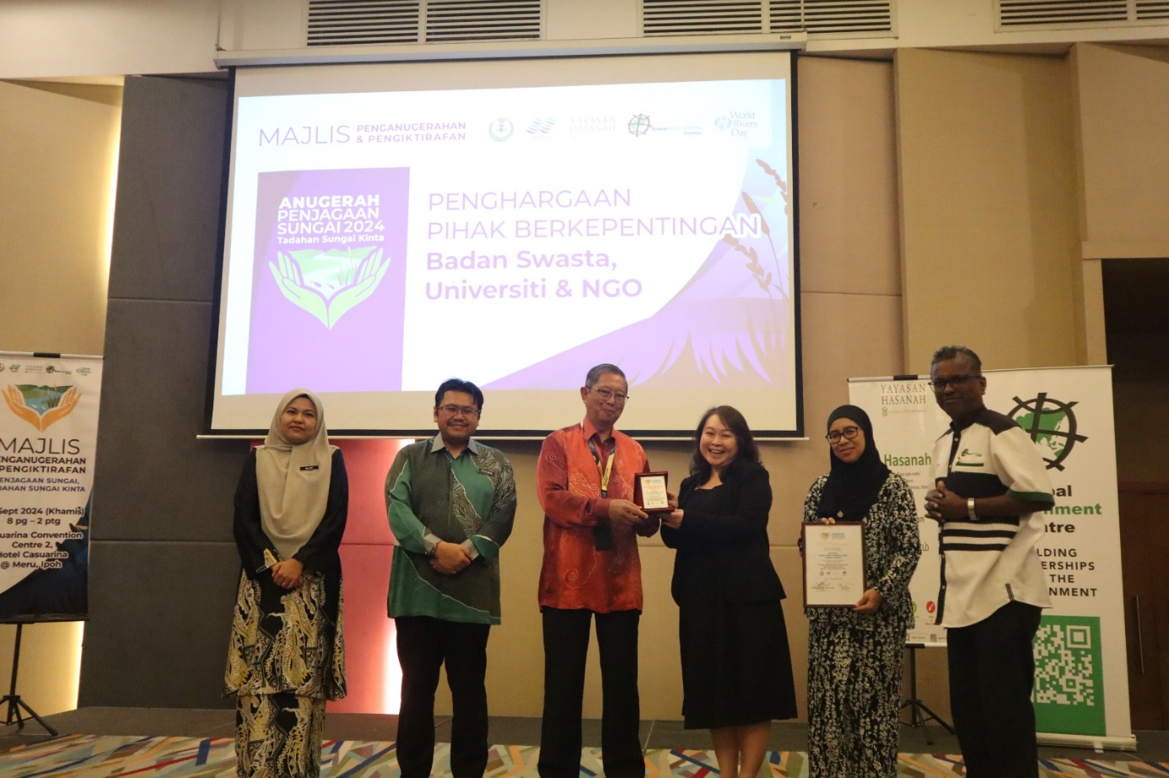
Ms Ma (third from right) receiving the award from Pengerusi Jawatankuasa Infrastruktur, Tenaga, Air dan Pengangkutan Awam Negeri Perak Dato’ Seri Ir Mohammad Nizar bin Jamaluddin
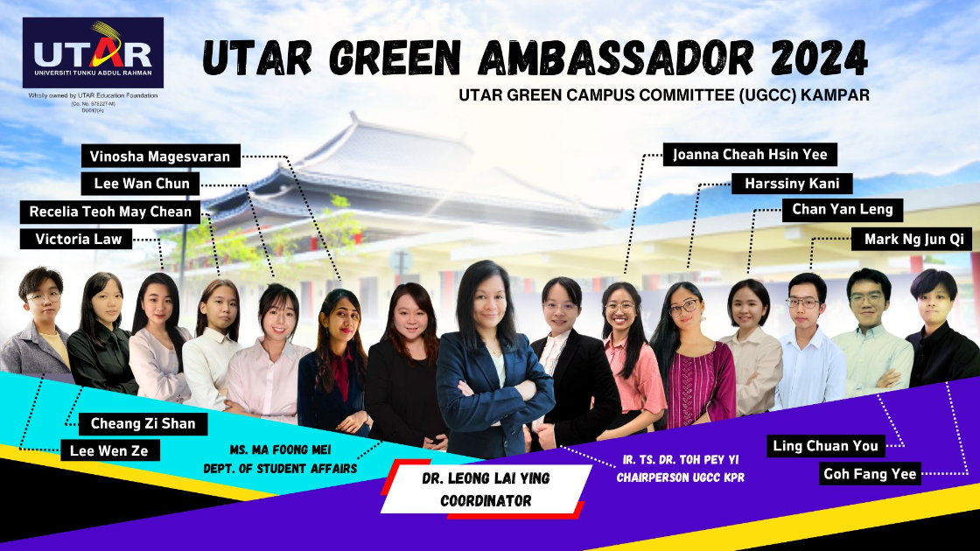
UTAR Green Ambassador 2024 Committee

