Rediscovering the tale of tin: The 8th Tin Mining Festival
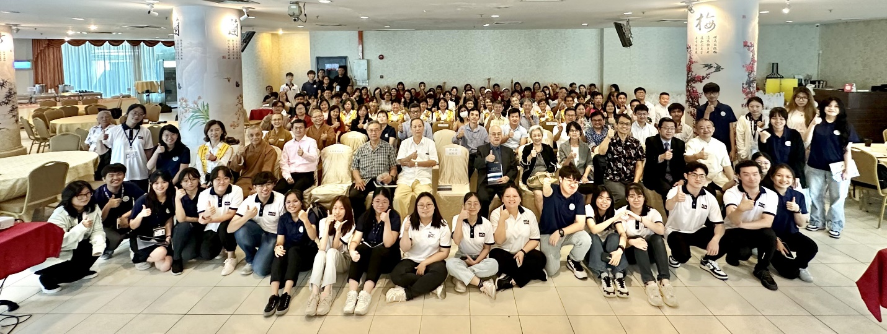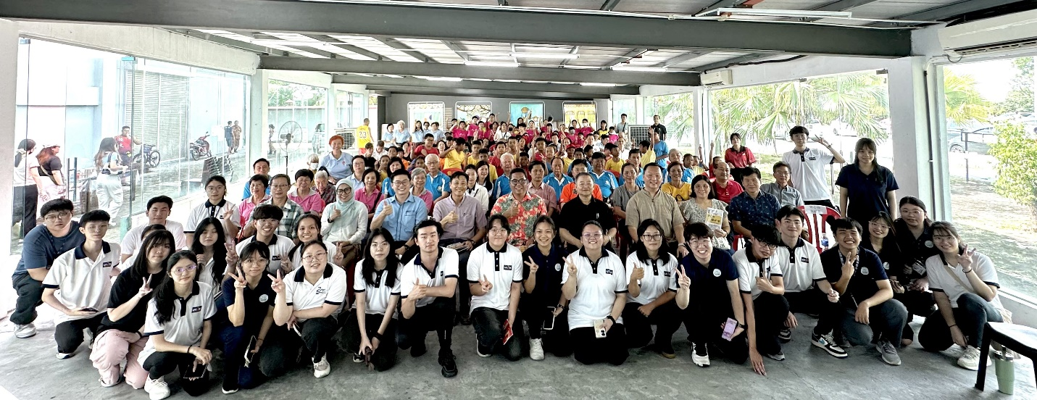
Merry moments as the participants celebrated the legacy of tin mining heritage during the first day (top) and the second day
Tin mining will always be a defining topic that comes to mind during conversations about Kampar, Perak. It is a history deeply rooted in not just Kinta, but also Malaysia’s identity as one of the world’s largest tin exporters in its golden age. Today, the rich heritage of tin mining is celebrated occasionally in various areas of Malaysia, one of them is Kampar, a town built and developed from tin mining.
As the “Tin Mining Festival 2024 – The Tale of Tin (鍚暉璀璨)” brought its festive spirit to Kampar, Perak, from 9 to 10 November 2024, the rich history of Kinta District shined once again. Each day was held at different venues, namely the Grand Kampar Hotel (first day) and the Kinta Tin Mining (Gravel Pump) Museum (second day).
“The Tale of Tin” marked the 8th iteration of the annual Tin Mining Festival, which began its tale in 2015 in the town of Kampar. This year’s festival was jointly organised by I Culture Berhad, UTAR Institute of Chinese Studies (ICS), Kinta Tin Mining (Gravel Pump) Museum, Gopeng Museum, Perak Chinese Mining Association, and Grand Kampar Hotel.
The 8th Tin Mining Festival aimed to raise public awareness about the history of tin mining and commemorate the industry’s pioneers in Malaysia’s economy. Through its diverse and unique activities by local communities, the festival also helped to promote cultural tourism and foster a creative cultural economy related to tin mining history, creating new opportunities for Malaysia’s development.
Emphasising the cultural significance of tin mining, UTAR Vice President for Student Development and Alumni Relations Prof Dr Choong Chee Keong said, “As a town born from tin mining, it was not only the economic source of Kampar, but also an important history of Malaysia. The Tin Mining Festival is held to commemorate the contribution of the tin mining industry, and at the same time to preserve and explore the precious cultural heritage left behind, so that it will not fade in the torrent of history. I think this is the attitude that all of us should have towards history, as it will guide the posterity in remembering the precious values left by our ancestors.”
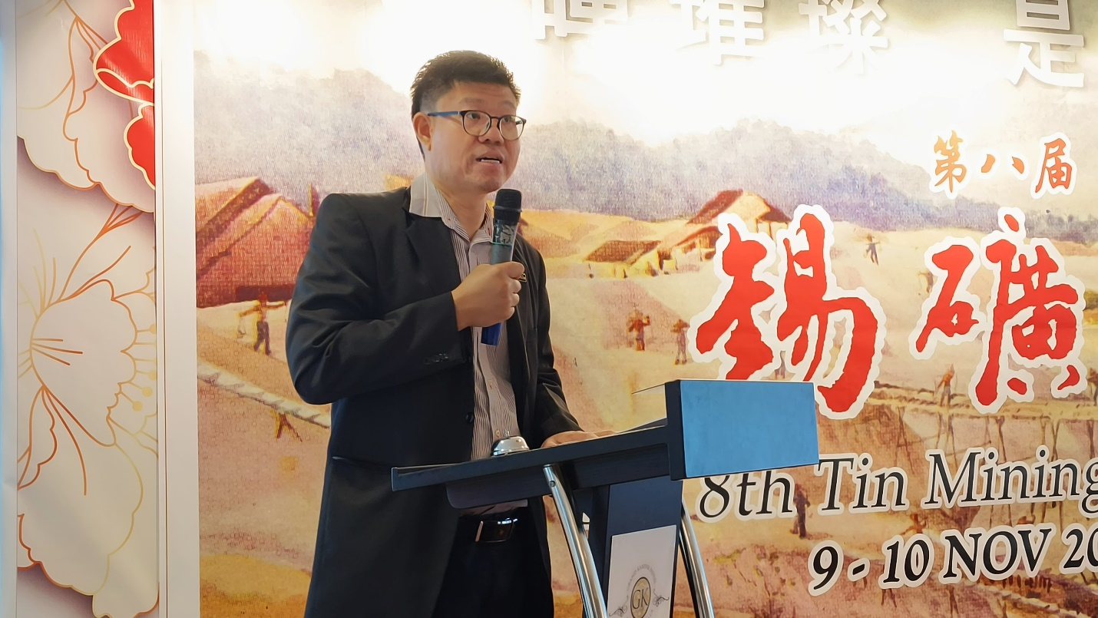
Prof Choong retelling the contributions made by the late Tan Sri Dato’ Hew See Tong
He added, “We hope to connect with the community and try our best to share knowledge with them through various activities, creating a learning atmosphere and improving the knowledge level of Kampar and nearby communities. Therefore, UTAR is proud to work together with the organisers to hold this meaningful festival, transforming Kampar, a former tin mining town, into a ‘city of knowledge’ in the future.”
Resonating with the festival’s core commitment towards local history, the Tin Mining Festival featured various talks and sharing sessions by experts and scholars, covering different layers of tin mining through the diverse stories of industry pioneers and local communities. This year, “The Tale of Tin” featured historical narratives such as the inspiring story of the late Dato’ Seri Lau Pak Khuan, a pioneer in the Malaysian tin mining industry, who dedicated his lifetime to the development of Kinta District (conducted by UTAR ICS Deputy Dean for R&D and Postgraduate Programmes Assoc Prof Dr Chin Chong Foh). During one of the sharing sessions, ICS Adjunct Prof Dr Lo Yuet Keung shared his take on the importance of celebrating local figures and local history. The sessions were moderated by ICS Deputy Dean for Academic Development and Undergraduate Programmes and Organising Chairperson Assoc Prof Dr Wong Wun Bin and UTAR Faculty of Arts and Social Science (FAS) academic Mr Lim Kar Loke respectively.
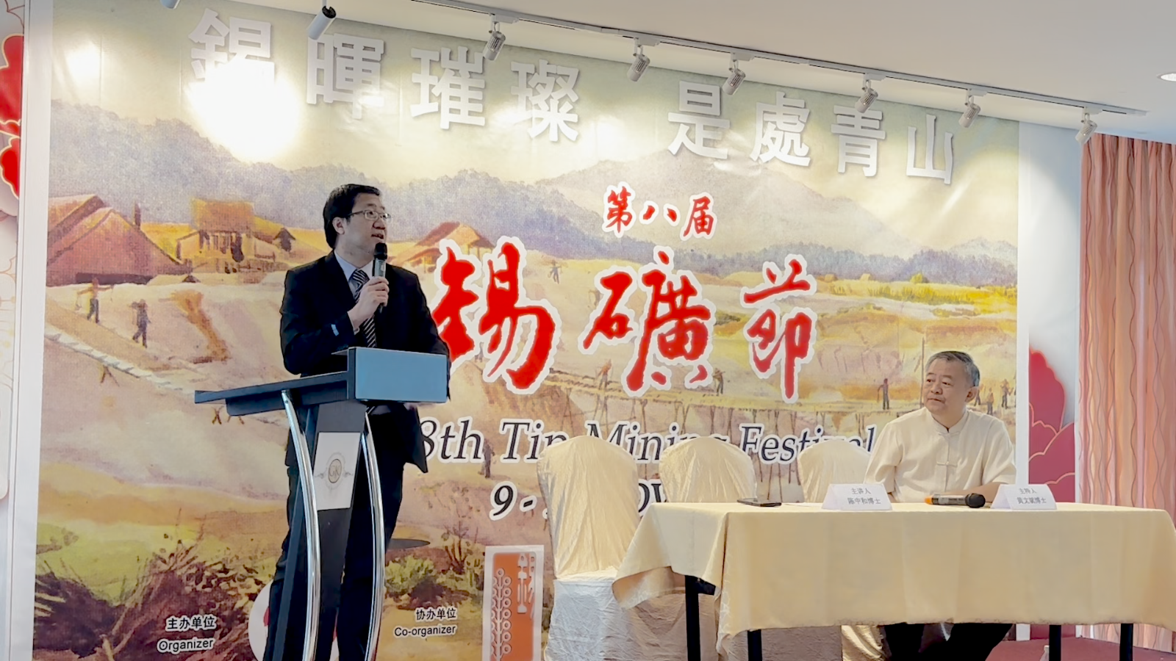
Dr Chin (left) sharing his research findings on the late Dato’ Seri Lau Pak Khuan, moderated by Dr Wong
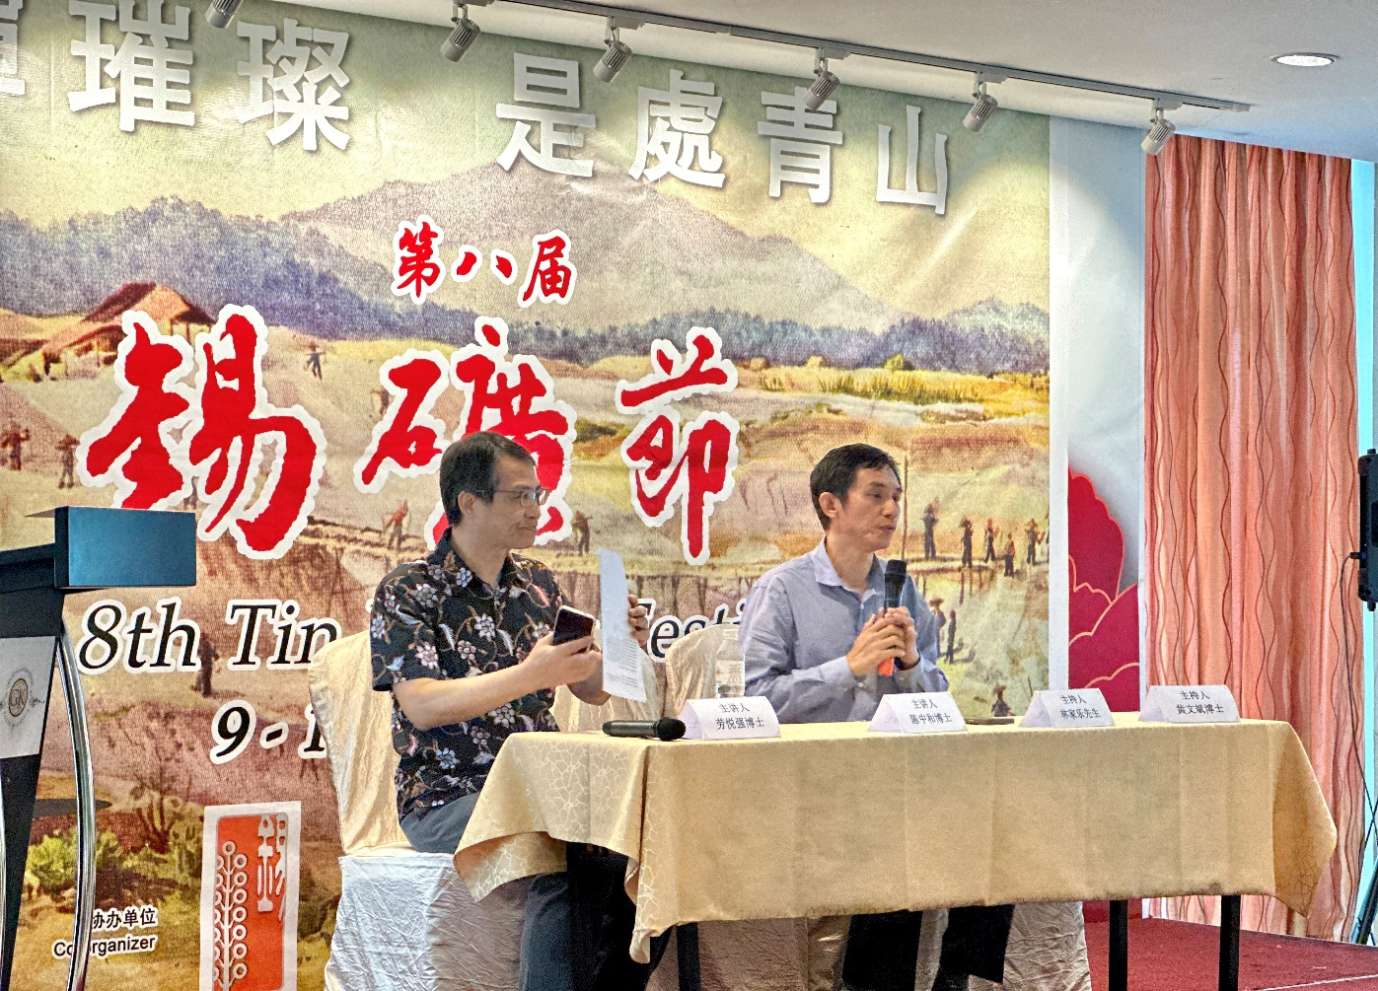
Prof Lo (left) highlighting the significance of local cultural identity, moderated by Mr Lim
The festival even served as a platform to launch a new book, titled The Green Mountains Around Town: Three Generations of the Chye Family in Kampar, Perak. 1886 – 2014. Written by Ms Goh Fi Chan, the book delves into the biography of the late Chye Kooi Loong, a respected war historian who dedicated his lifetime to preserving not only Kampar but also Malaysia’s history. An in-depth introduction of the book was presented by Tunku Abdul Rahman University of Management and Technology (TAR UMT) Institute of Social Economic Research Head Assoc Prof Dr Yap Hon Lun and the author.
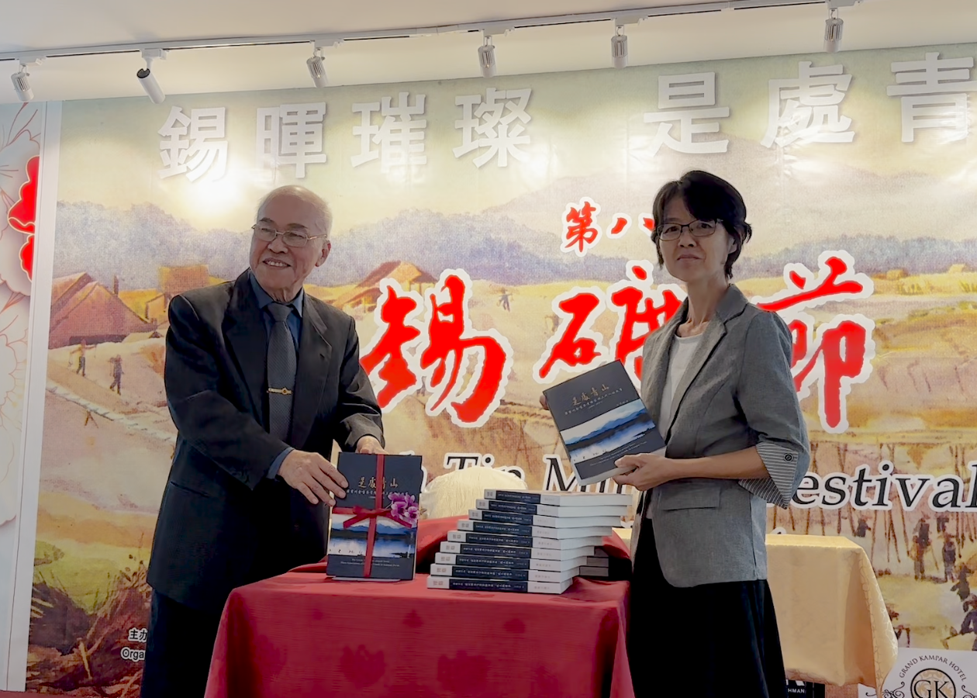
Prof Datuk Lim Chooi Kwa (left) launching the new book with the author Ms Goh
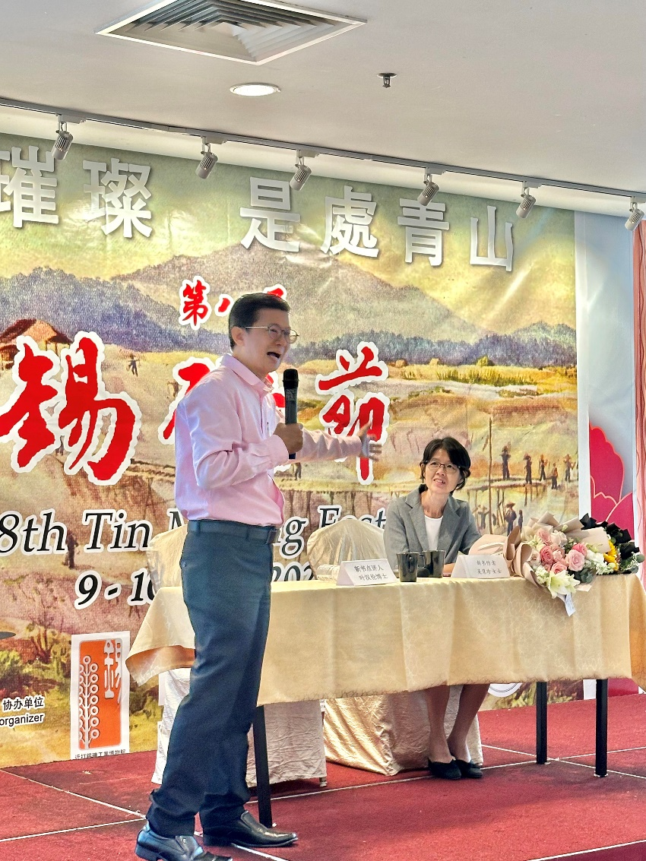
Dr Yap (left) sharing his after-thought on Ms Goh’s book
Besides the scholarly explorations of the history of tin mining and Perak, the organisers of the festival also invited a bevy of groups from the local community to showcase their talents through a series of light-hearted cultural performances. The diverse heritages of the performances coruscated and tugged at the participants’ heartstrings, as the jolly performers displayed their unique heritages amidst the effervescent celebration.
The performances comprised flat drum performance (by Pei Yuan High School), Hakka folk songs and Chinese orchestra (by Perak Kaying Association and Pertubuhan Kebudayaan dan Orkestra Cina Perak); 24 Festive Drums (by SJK(C) Kampar Girls), lion dance performance (by UTAR Kampar Campus Wushu Club), song performance (by SJK(C) Sin Min Sungai Siput Selatan), and drama performance (by Kampar Volunteer Fire Department).
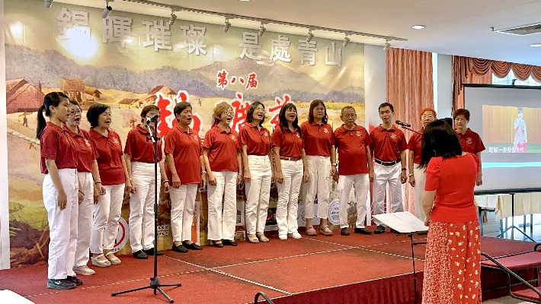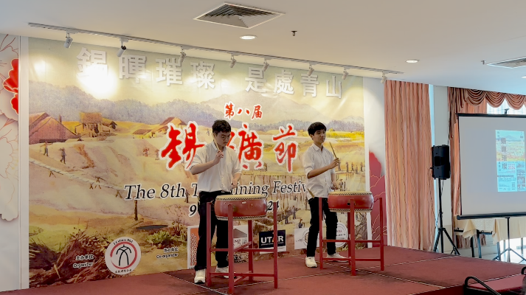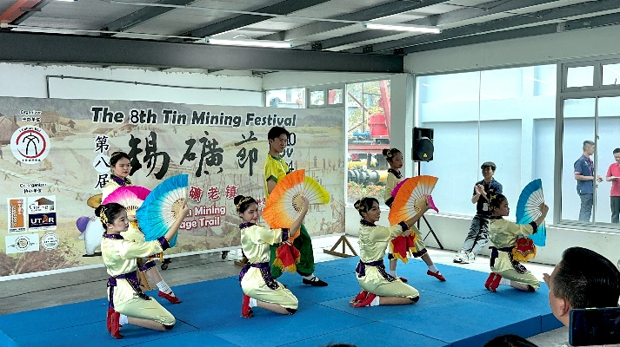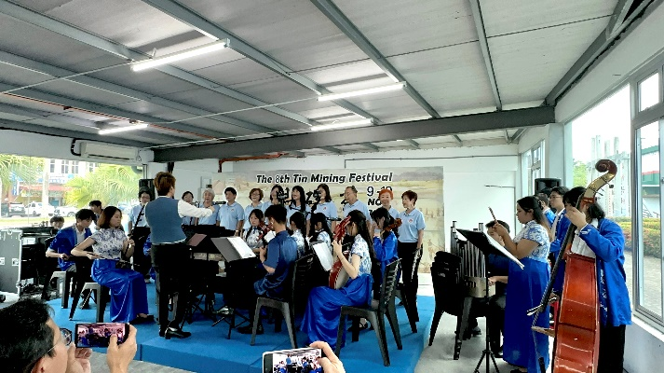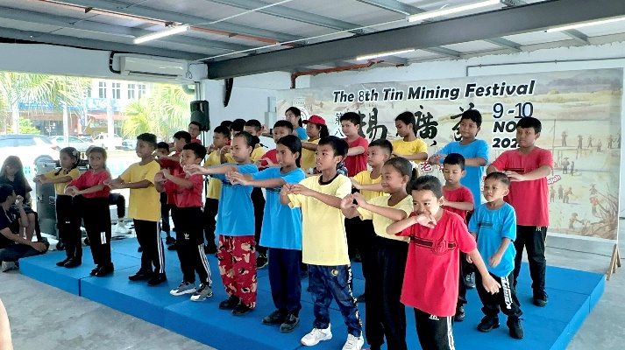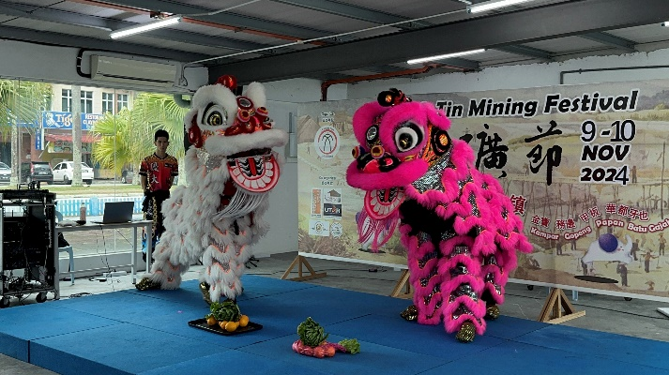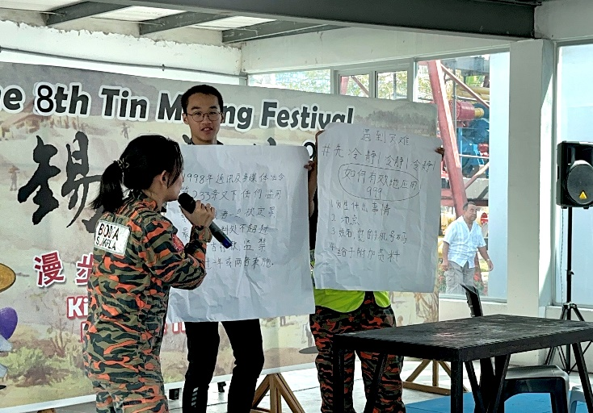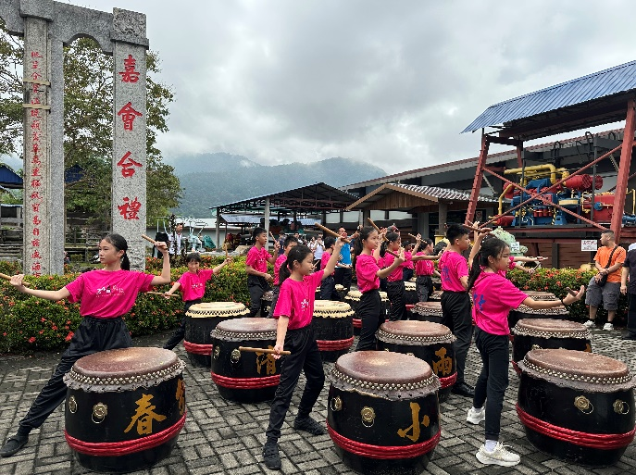
Local groups lending their talents to elevate the atmosphere, displaying the uniqueness and bonds shared in one big community
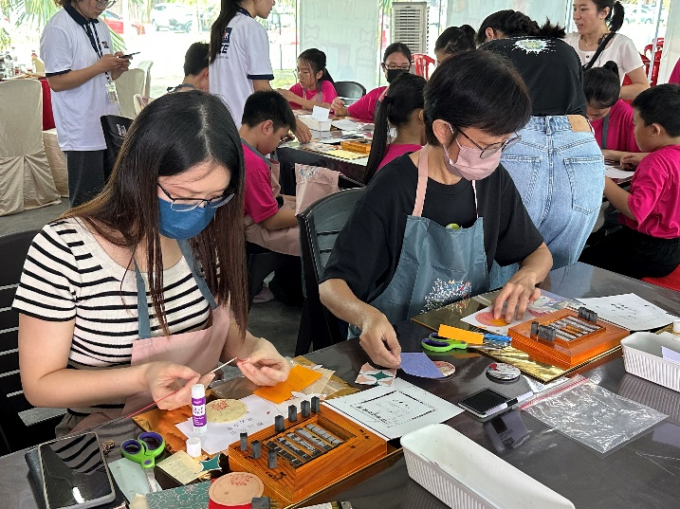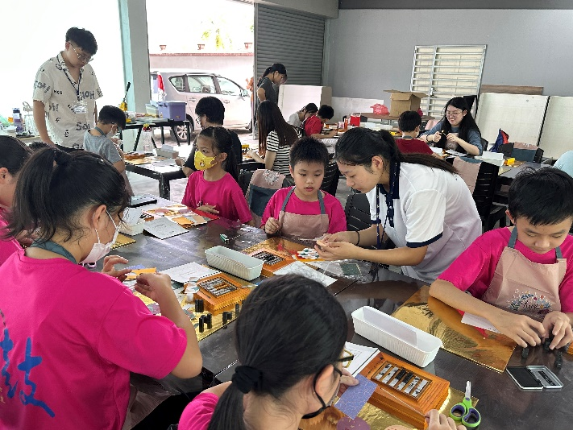
Participants exploring the delicate process of printing in the Letterpress Printing Workshop
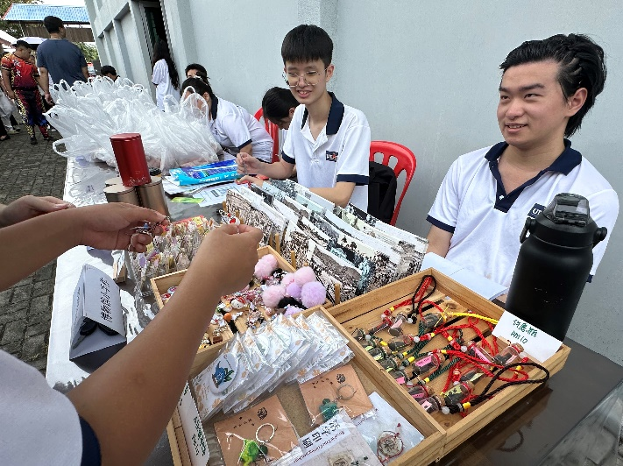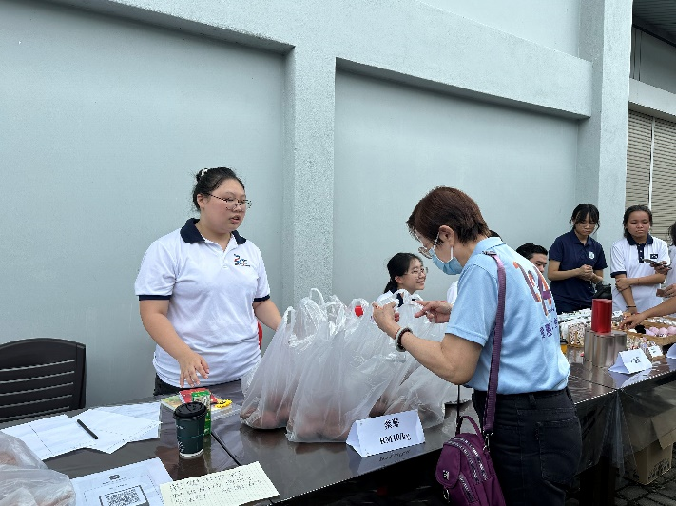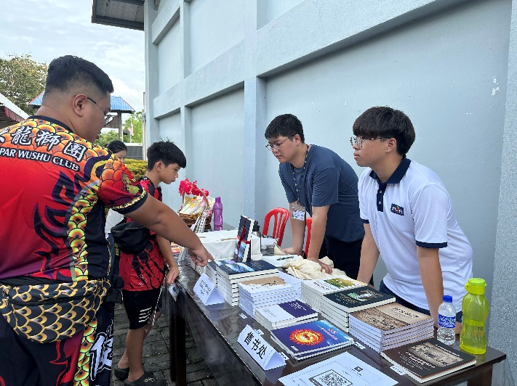
Participants visiting the booths selling handmade crafts, purple sweet potatoes, and books at the Kinta Tin Mining (Gravel Pump) Museum
Bridging the gap between participants and Kinta’s rich history, tour sessions were conducted at the two-day festival around former tin mining areas such as Kampar, Gopeng and Papan. The visited landmarks included Kinta Tin Mining (Gravel Pump) Museum, UTAR Kampar Campus, Kampar Gu Miao Temple, Len Fatt Tin-Ore Dealers, Kopisan and Lawan Kuda New Village, Gopeng Museum, Paip Besar Gopeng, Gopeng Kon Yin Temple, and Papan Heritage Village.
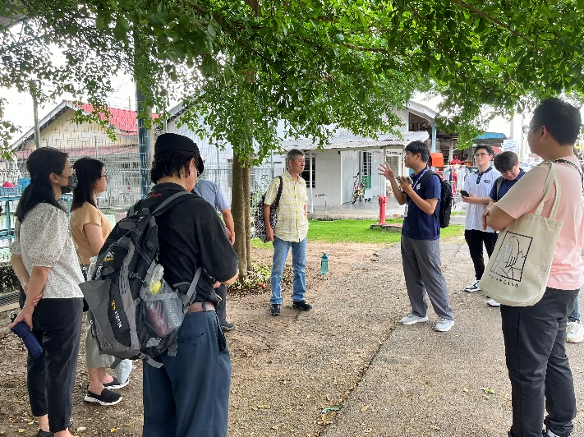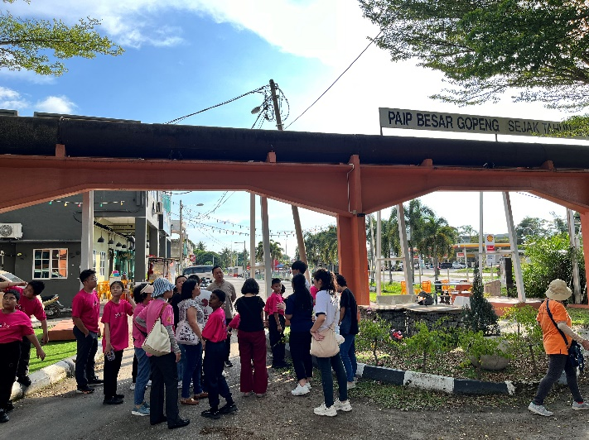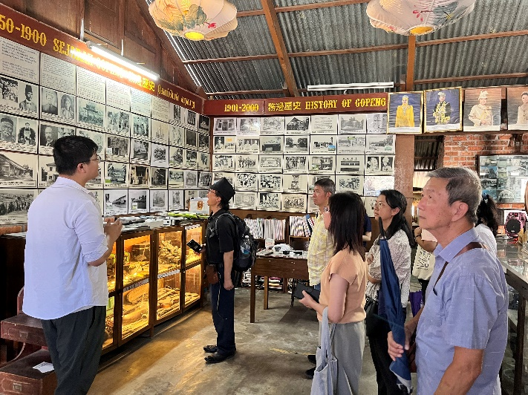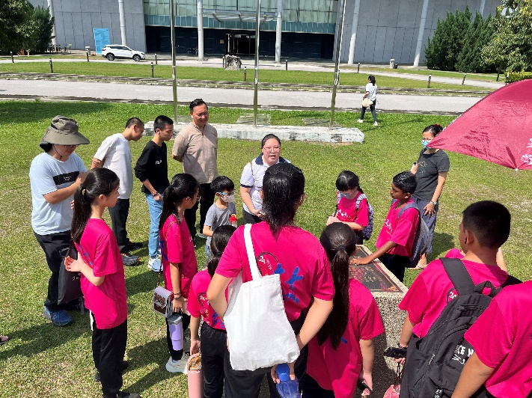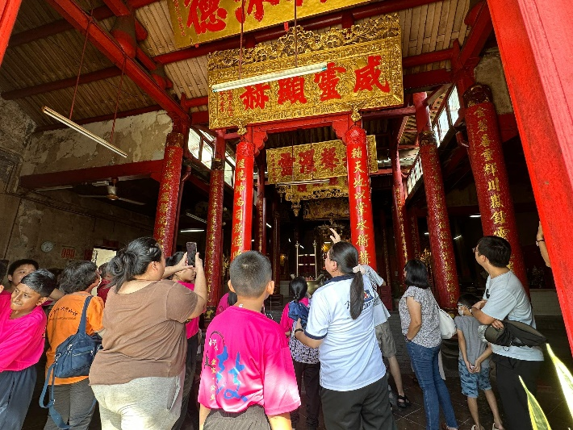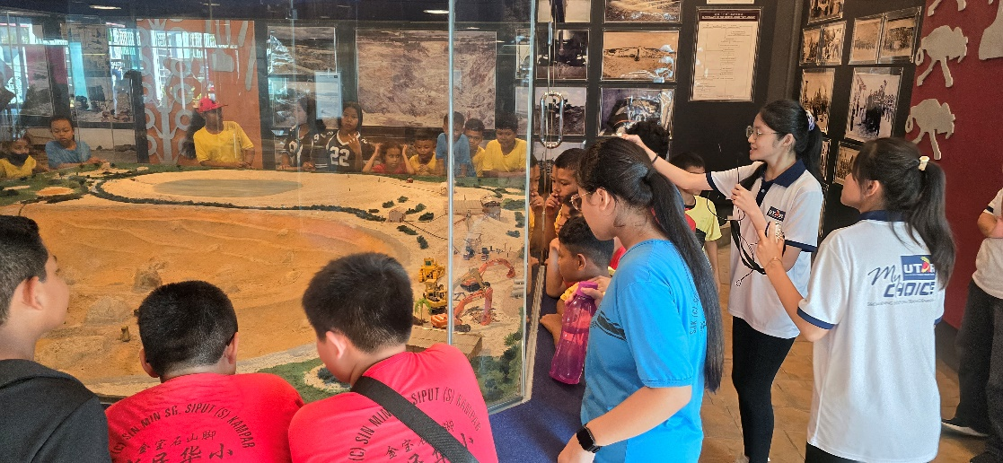
Tour sessions around the landmarks in Kampar, Gopeng, and Papan
Also present at the festival were UTAR Council Member and Kinta Tin Mining (Gravel Pump) Museum Director Mr Hew Fen Yee, Majlis Daerah Kampar Representative Pn Siti Azura binti Haji Juki, Kinta Tin Mining (Gravel Pump) Museum Deputy Director Mr Jacky Chew, Koperasi Pembangunan Kampar Chairman Mr Daniel Wa Wai How, Perak Chinese Mining Association (PCMA) Former President and Honorary Secretary Dato’ Chin Lean Choong, PCMA Deputy President Mr Lim Chin Khai, I Culture Berhad Executive Director Ms Tan Hui Sean, ICS Adjunct Prof Datuk Dr Lim Chooi Kwa, Fo Guang Shan Ipoh Chairperson Ms Tan Guat Nga, Fo Guang Shan Ipoh Superintendent Venerable Hui Shing, and UTAR Faculty of Business and Finance Deputy Dean for Academic Development and Undergraduate Programmes Dr Peter Tan Sin Howe.
Once a thriving tin mining town, Kampar is brimmed with not just an abundance of history and heritage, but also a diverse pool of potential talent and knowledge. With a growing pool of talent from various regions, the prospect of transitioning into a vibrant hub for innovation and heritage is more promising than ever. As the Tin Mining Festival continues its path towards the future, it remains committed to highlighting the uniqueness of the Kinta District and UTAR will continue to be part of the driving force behind this enriching initiative.
Tin Mining Festival
Officially started in 2015 by UTAR Institute of Chinese Studies (ICS), the Perak Chinese Mining Association (PCMA) and the Kinta Tin Mining (Gravel Pump) Museum, the Tin Mining Festival mainly aims to enhance the younger generation’s knowledge of the country’s rich tin mining history as well as to commemorate the contribution of forerunners of the early tin mining industry. It has since become an annual event for communities to gather and exchange knowledge related to tin mining in Malaysia, showcasing Kinta District’s specialities and drawing more development opportunities to the former tin mining towns in the process.

