**UTAR alumni reconnect in Beijing**

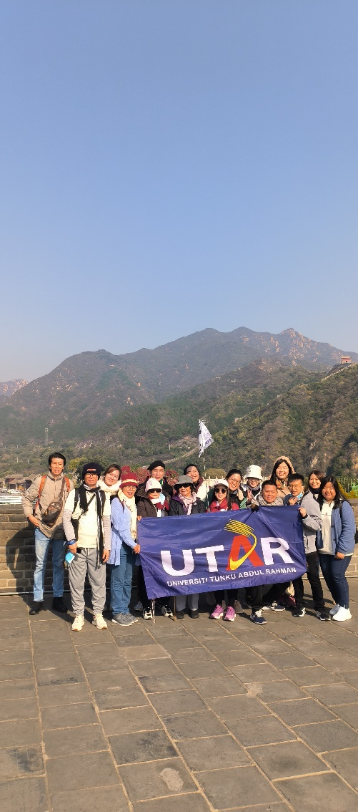

Making a stop at the Juyongguan Great Wall

A week filled with fun, food, reconnecting, and revisiting history were the highlights of the UTAR Alumni International Social Trip to Beijing, China 2024. The event, organised by the Department of Alumni Relations and Placement, took place from 19 to 25 October 2024.

The aim was to facilitate meaningful interaction and build relationships between alumni, current students, and staff and to foster alumni loyalty while strengthening their emotional connection to their alma mater.

Consisting of 15 people, the group embarked on a private tour; revisiting historical and cultural landscapes in Beijing and Tianjin, China. The group marvelled at various architectural wonders, ancient sites, and modern attractions. The most anticipated moment of the trip was reconnecting with alumni at the special alumni dinner. They also had the opportunity to meet with alumnus Mr Jeffrey Yu Kern Liang, who currently works in Beijing. He shared his career experiences and working conditions in Beijing and offered valuable perspectives for personal and professional growth. The insightful interaction also enabled other alumni to consider the prospects of working abroad and encouraged them to expand their learning beyond their comfort zones.

The trip received some positive feedback, and though some of the alumni expressed for longer visits to certain locations, the overall experience was memorable and fulfilling. They also suggested some other places that DARP can consider for the next overseas alumni trip.

The group visited Tiananmen Square and Forbidden City, Wangfujing Shopping Street, Juyongguan Great Wall, the Bird’s Nest & Water Cube, Sanlitun Street, Summer Palace (UNESCO World Heritage site), Beijing Zoo Panda House, Silk & Pearl Market, Cultural Street and China House, Hai He River & Tientsin Eye, and Temple of Heaven & Qianmen Street.

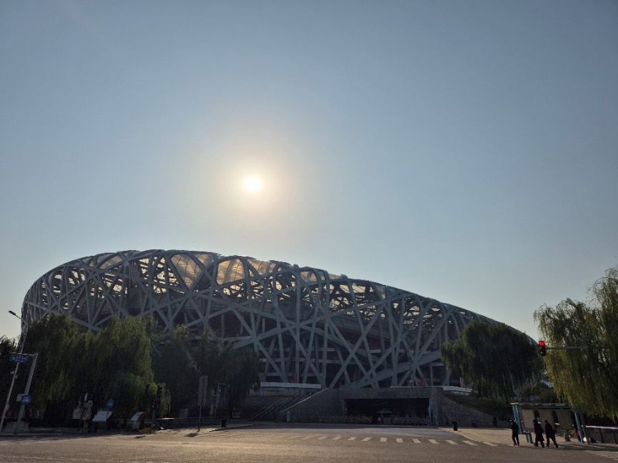 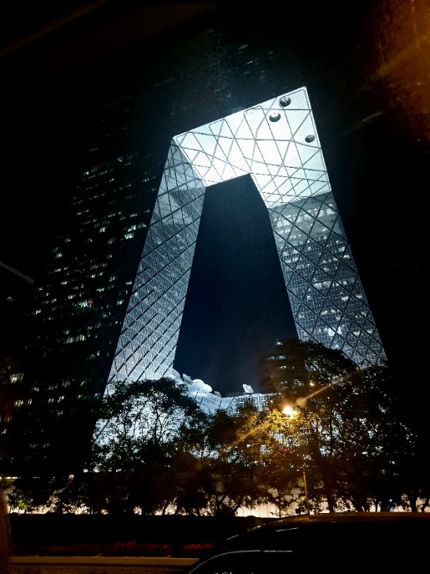 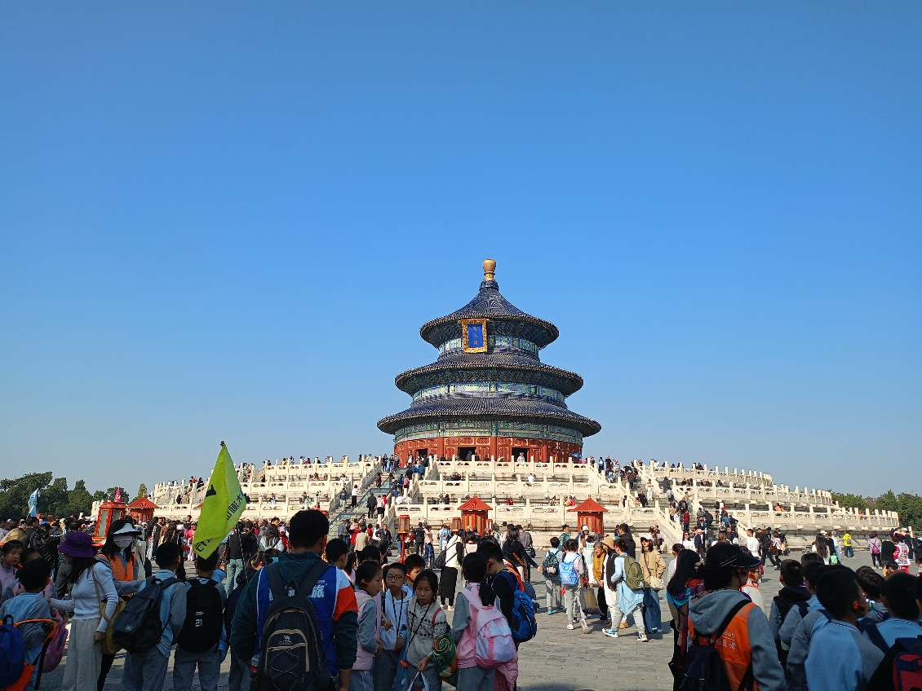 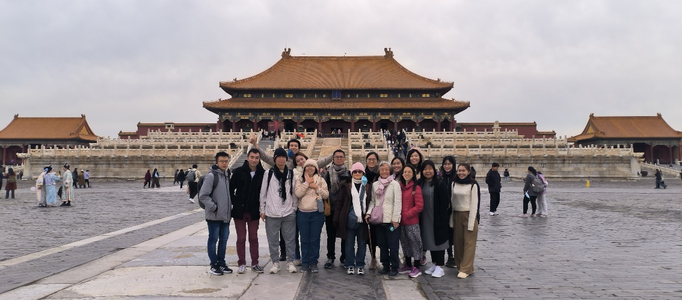 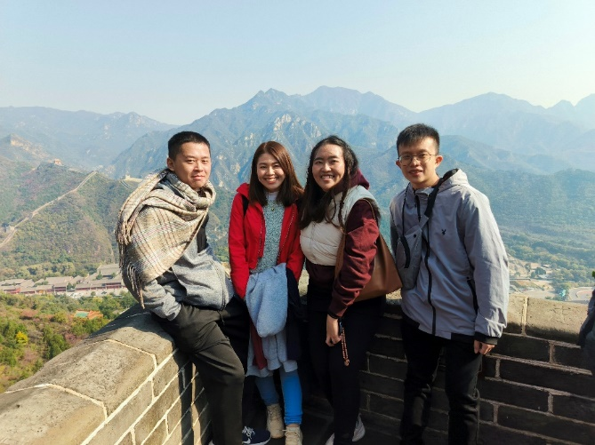 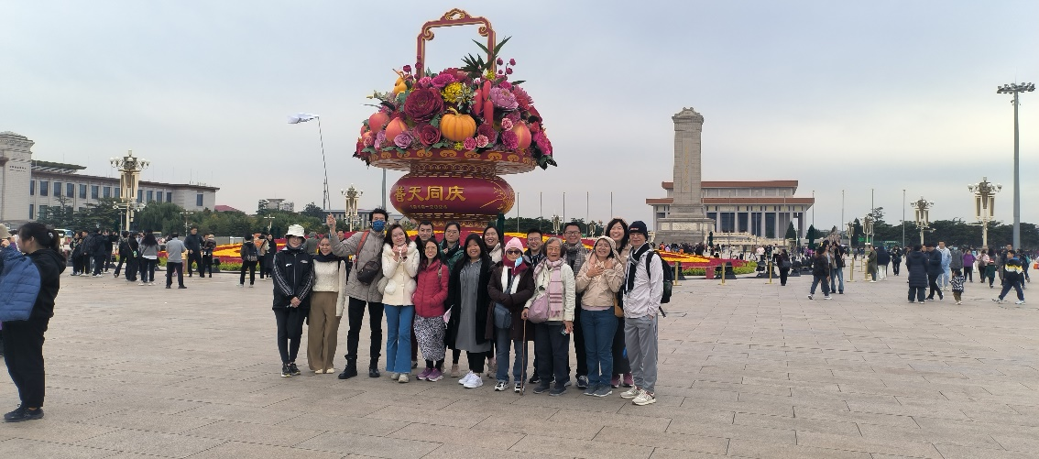

Some of the places visited during the trip

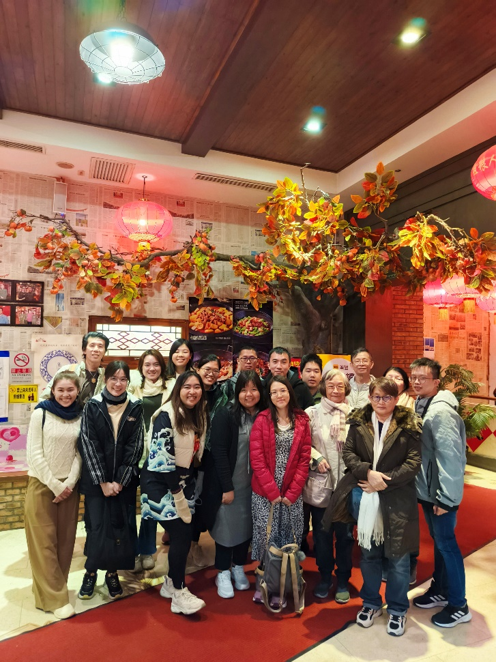

Special dinner with fellow alumni