**Experts discuss AI’s role in revolutionising education at symposium**

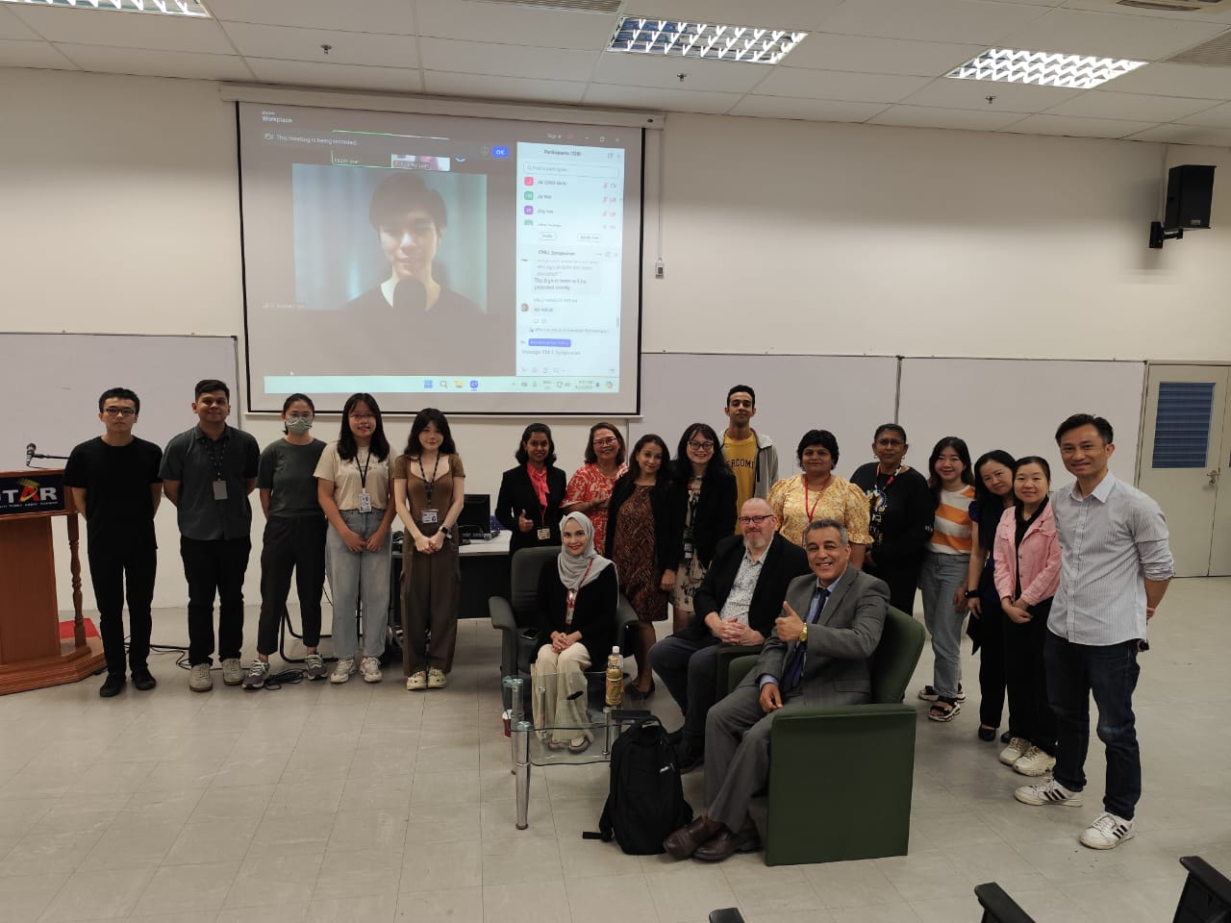

An insightful symposium on AI

Putting forth the idea of Artificial Intelligence (AI) revolutionising education, the symposium titled Shaping the Future of Language Education and Research through Artificial Intelligence, gathered experts to discuss the impact of AI in reshaping teaching and learning in higher education institutions, transforming pedagogy, assessment and student engagement.

The symposium was organised by the Centre for Modern Languages and Literature (CMLL) on 9 November 2024 at UTAR Sungai Long Campus and via Zoom. The symposium targeted teachers, academics, and researchers. It offered timely insights into the evolving role of AI in shaping the future of education and research. The event also highlighted AI’s potential to support Sustainable Development Goal (SDG) 4: Quality Education, which focuses on reducing disparities and inequities in education while ensuring inclusive, equitable quality education and lifelong learning opportunities for everyone.

Experts, namely The Third Degree Chief Executive Officer Dr Craig J Selby, CEO Jom Mahir, Mr Herryan Syah Tupan Surian, and University of Malaya Senior Lecturer Dr Ali Sorayyaei Azar shared insights on AI enhancing personalised learning, improving teaching efficiency, and transforming assessment and student engagement. The discussions enabled participants to explore the transformative impact of AI across various educational levels, beginning with AI’s integration in school education, examining the utilisation of AI for both language teachers and students to improve learning experiences and outcomes. It also allowed participants to explore AI-driven innovations in academic research and the broader implications for education.

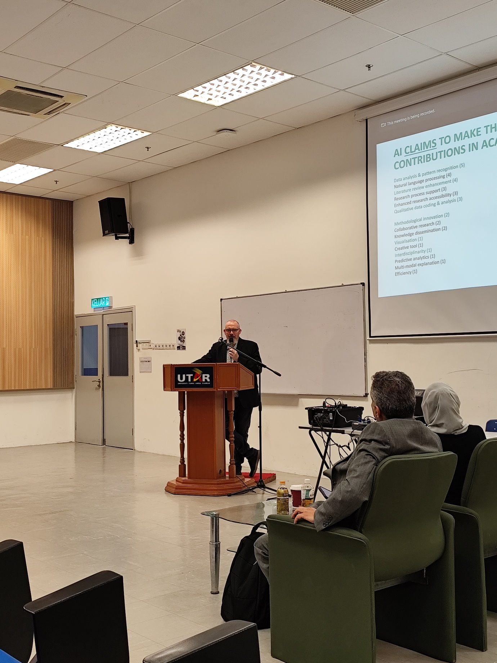

Dr Craig Shelby advising participants to learn about AI

Dr Craig Shelby’s presentation titled Leveraging AI for Academic Research enlightened participants on the challenges faced by researchers with the utilisation of AI, such as ethical considerations and bias, skills and resource gaps, epistemological considerations, methodological challenges, dependence on technology, and human-AI collaboration, as well as, ways to leverage on AI. On utilising AI as a tool for research, he advised participants to learn more about AI, including its shortcomings, failings, and the skills required, but not forgetting to engage it ethically. He reminded participants to develop clear protocols for AI use in research.

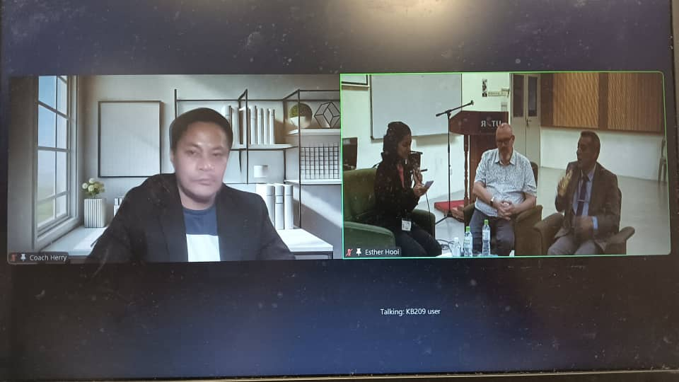

Mr Herryan (left screen) explaining the practical approaches of AI in language classroom

Meanwhile, the presentation titled Integrating AI in Language Learning: Practical Approaches by Mr Herryan explored practical ways to harness AI’s power in the language classroom. He explained that the integration enables customised lesson planning with AI, interactive AI-powered activities, tailored language exercises, streamlined grading and feedback, AI-powered conversational practice, pronunciation enhancement with AI, and vocabulary expansion tools. He then shared his perspective on the future of AI in language learning, highlighting that AI will create immersive environments, whereby it will create hyper-realistic virtual worlds for authentic language practice. He also pointed out that AI will personalise learning paths with the use of advanced algorithms, so curricula are tailored to suit individual student needs. Participants also learnt that AI will establish cross-cultural understanding because it facilitates deeper cultural insights alongside language acquisition.

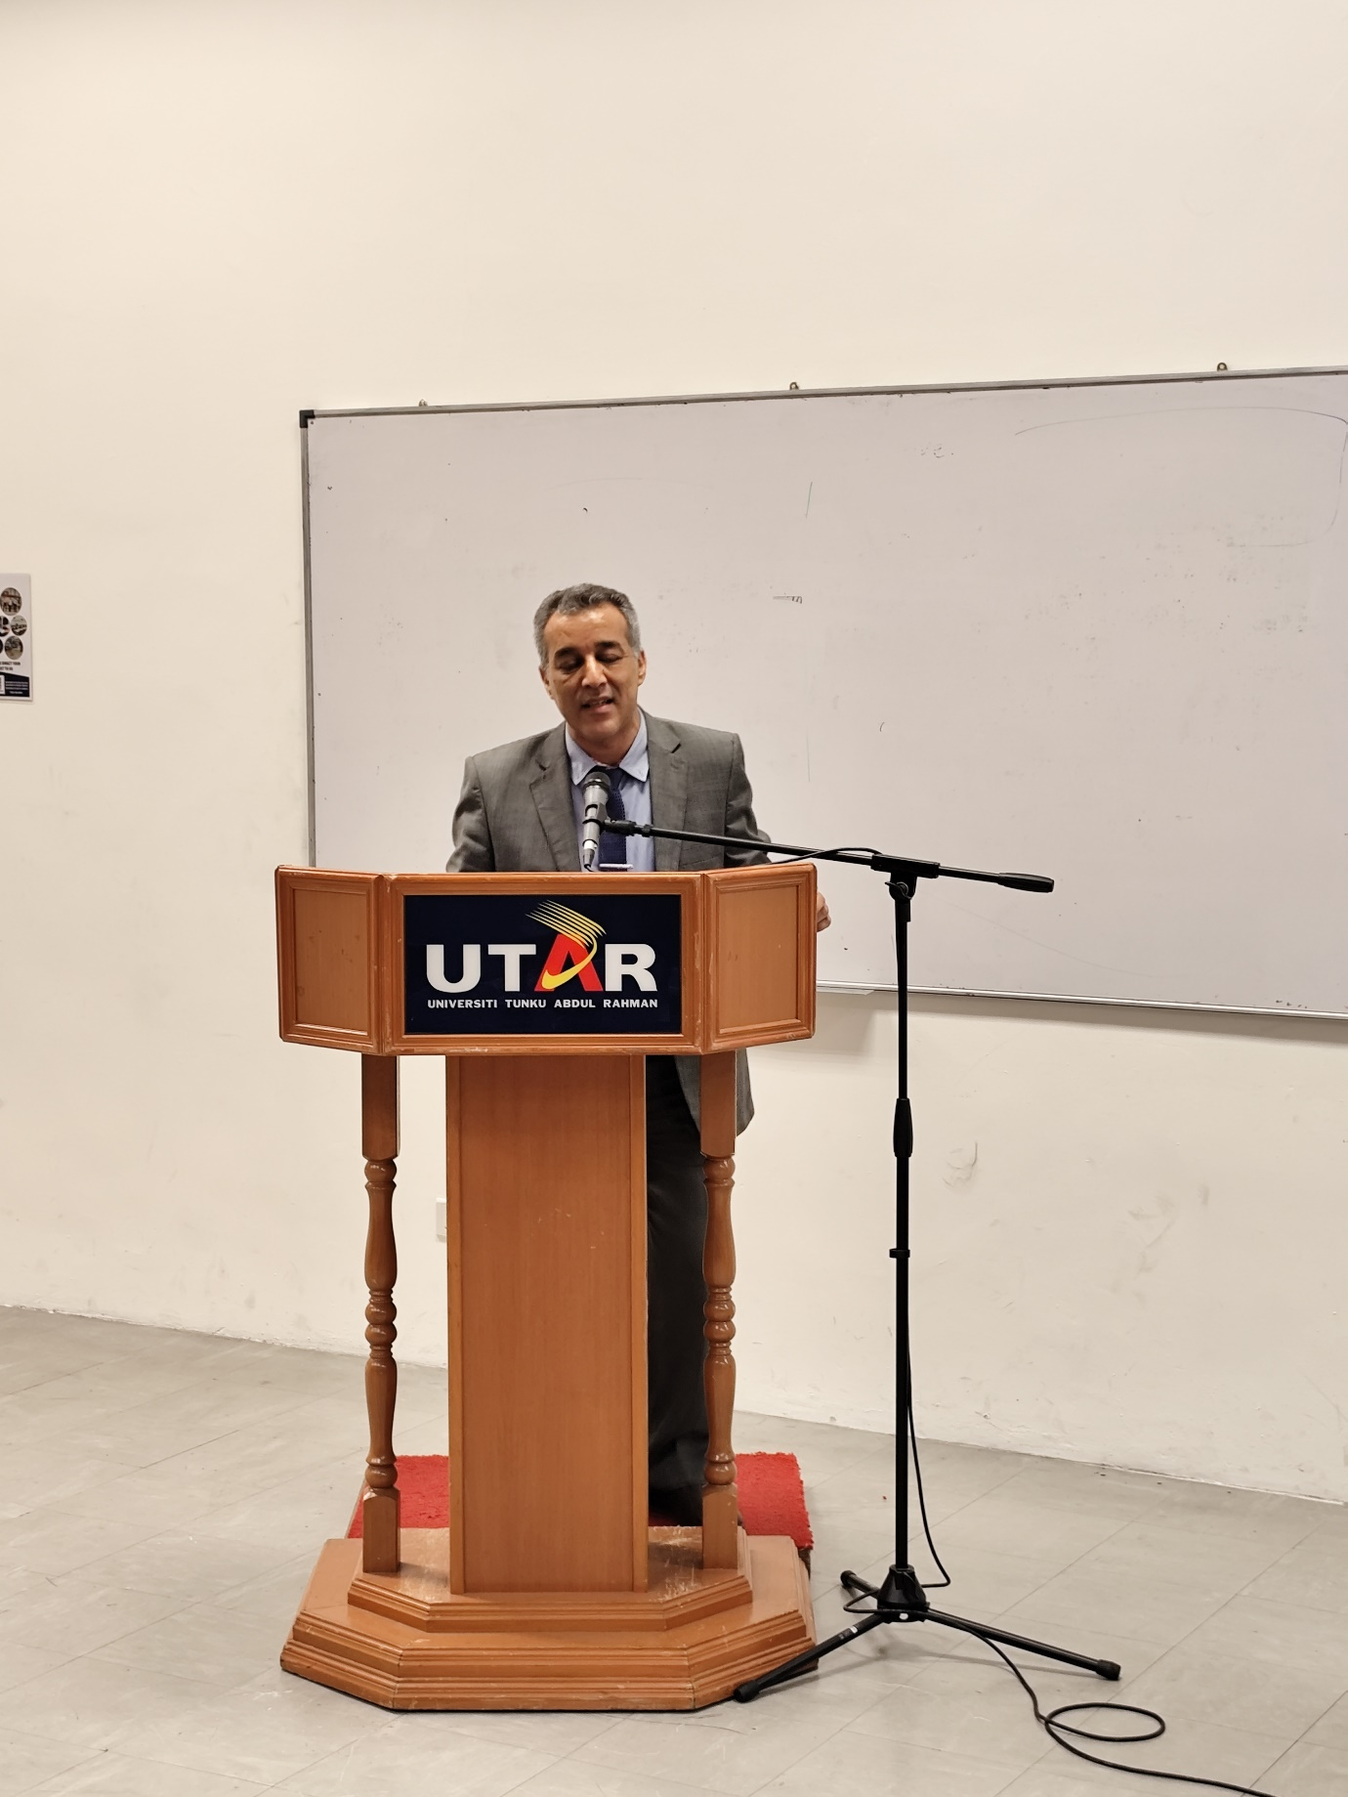

Dr Ali explaining the benefits and limitations of AI-enhanced learning environments

The final speaker, Dr Ali, delivered a presentation titled “AI & Revolutionising Language Education Through AI and The Metaverse for Sustainable Futures”. His presentation enabled participants to understand the transformative role of AI in language education and its alignment with sustainable practices. He also discussed the innovative AI and Metaverse tools that enhance interactive language learning while promoting accessibility, as well as, the benefits and limitations of AI-enhanced learning environments and their implications for sustainable education. The closing noted that AI and the metaverse hold great potential to revolutionise language education, offering engaging, personalised, and sustainable learning experiences, and the integration of these technologies can foster a global community of language learners, promoting cross-cultural understanding and effective communication skills.

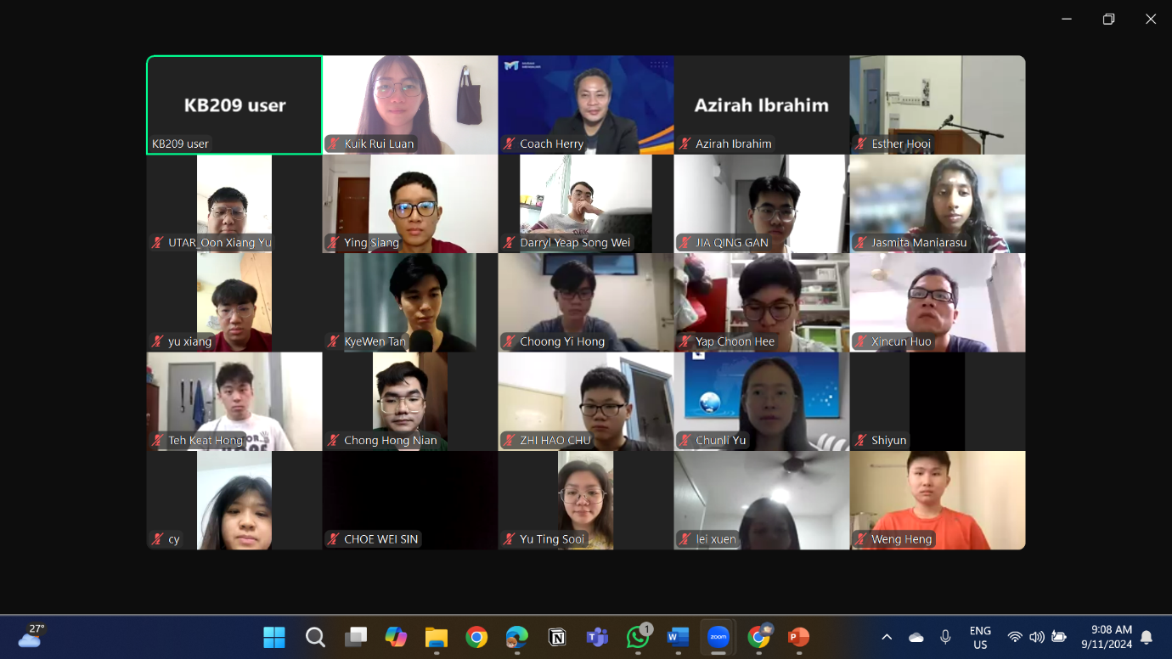

Online participants