Exploring food education through experiential learning at Sekinchan
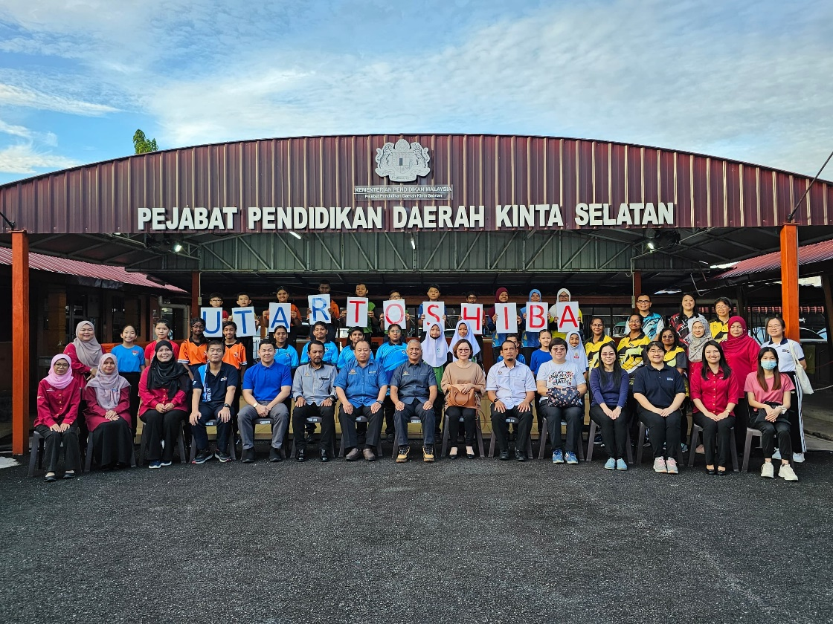
Participants and organisers at the Pejabat Pendidikan Daerah (PPD) Kinta Selatan, highlighting the collaboration between UTAR, Toshiba International Foundation and PPD
A group of 24 students from six primary schools in the Kinta Selatan District participated in an enriching field trip to Sekinchan, a charming town in Selangor renowned for its scenic rice fields and coastal landscapes on 16 October 2024.
The tour was organised by the Centre for Learning and Teaching (CLT) in collaboration with Pejabat Pendidikan Daerah (PPD) Kinta Selatan and was fully funded by the Toshiba International Foundation.
Accompanying the students on this educational journey were six UTAR lecturers, six schoolteachers, and five PPD officers. The primary objective of the trip was to provide the students with valuable insights into Malaysia’s agricultural and fisheries industries, fostering a deeper understanding of these vital sectors.

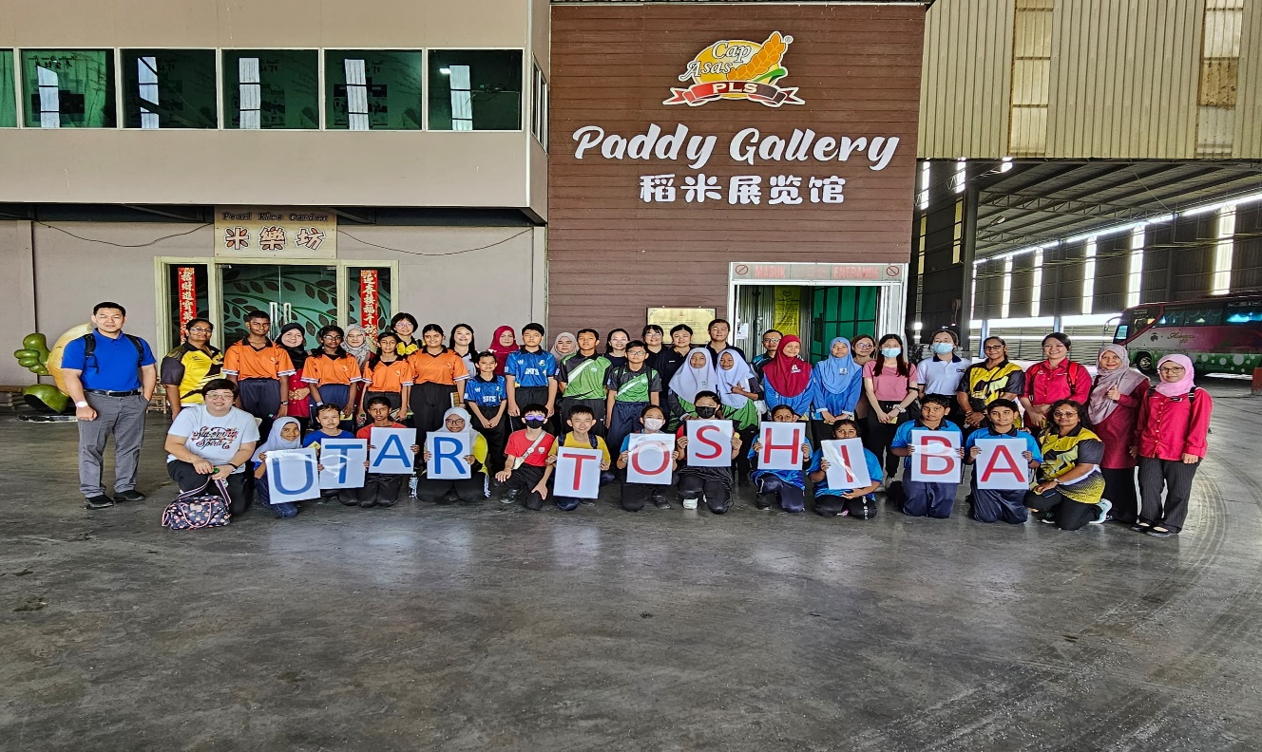
A visit to Paddy Gallery
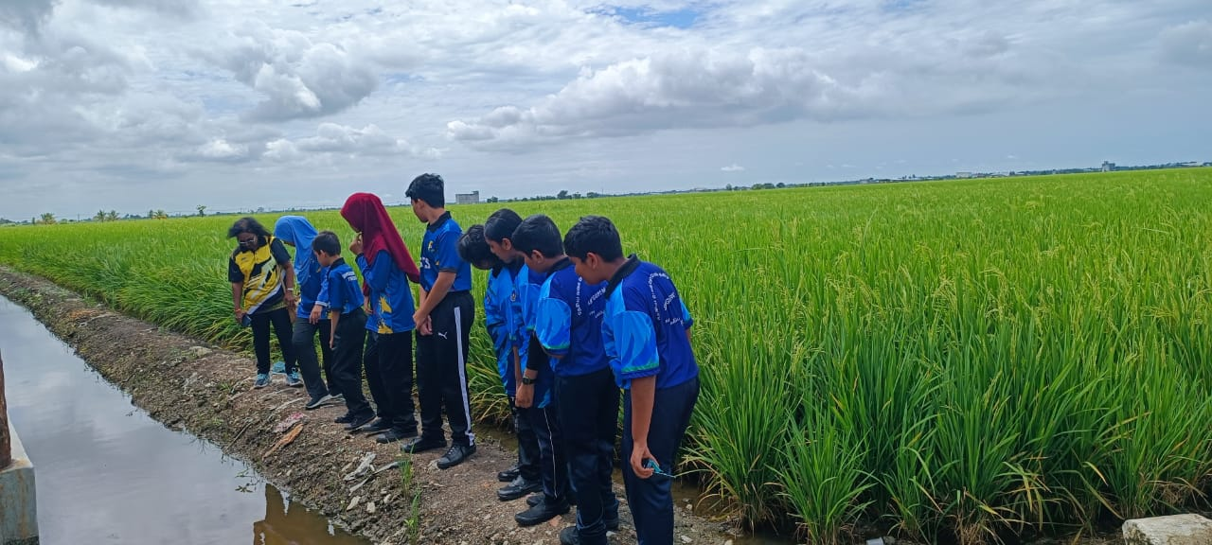
Students observing Sekinchan rice fields
The first stop of the tour was the Sekinchan Rice Mill Factory, where students visited the Paddy Gallery. There, they were introduced to the rich history of rice cultivation in Malaysia. The gallery featured a variety of exhibits showcasing rice farming, ranging from traditional methods to modern techniques. Students had the opportunity to learn about the life cycle of rice and its vital role in Malaysia’s economy and culture.
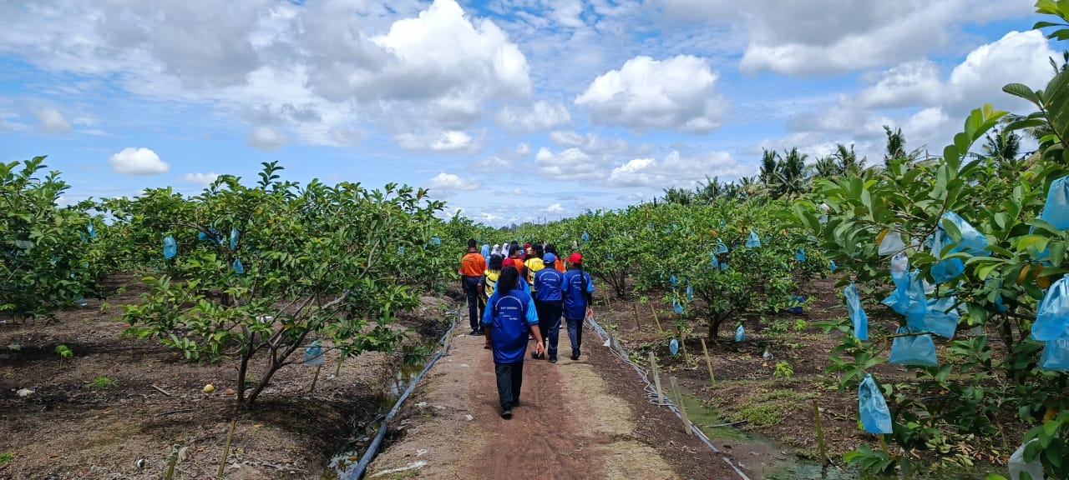
Students exploring Sekinchan guava orchard
The next stop was the Sekinchan guava orchard, where students observed the cultivation of guava, a popular tropical fruit in Malaysia. The farmer generously provided samples of freshly picked guavas for the students to taste, offering them a firsthand experience of the sweetness and freshness of local produce.
As they walked through the orchard, students observed the different stages of fruit production, from planting to packaging. This hands-on experience provided valuable insights into the agricultural practices involved in cultivating one of Malaysia’s most beloved fruits.
The final station of the day was the seafood collection and supply area, a local fisheries hub. Students observed the process of fish and seafood collection and distribution, learning about the importance of sustainable fishing practices in preserving Malaysia’s rich marine biodiversity. The visit included a demonstration of how fresh seafood is collected, processed, and prepared for the market.
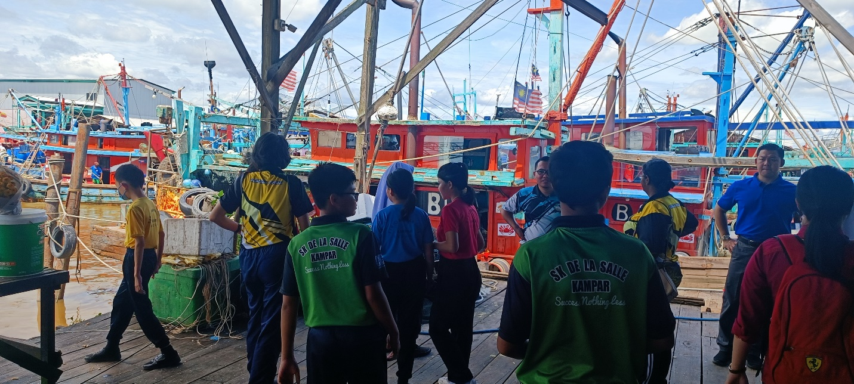
Students exploring the seafood collection and supply area in Sekinchan
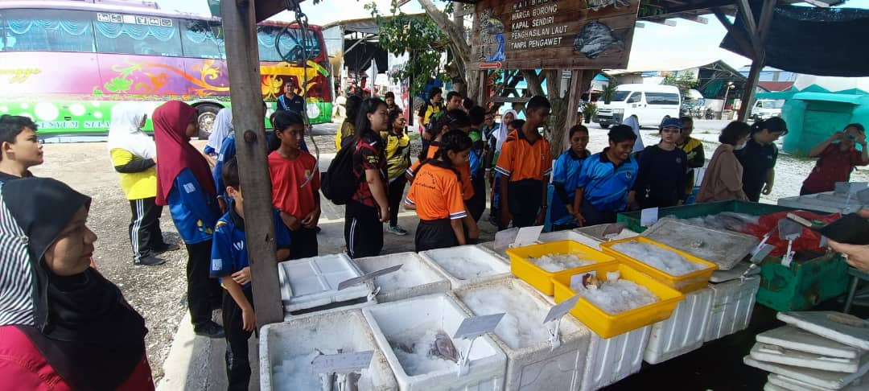
Participants in the seafood collection and supply area
The Sekinchan trip provided an impactful learning experience, allowing students to connect classroom knowledge with real-world practices. By engaging directly with activities such as crop cultivation and seafood processing, they developed a deeper awareness of sustainable food education practices and their significance in daily life. The collaboration among various stakeholders highlighted the importance of creating opportunities that broaden students’ perspectives and inspire curiosity about their surroundings. This immersive experience deepened students’ understanding of food education, fostering sustainability, environmental responsibility, and appreciation for local agricultural practices.

