**UTAR academic participates in 24th Animation Academy Awards by Beijing Film Academy**

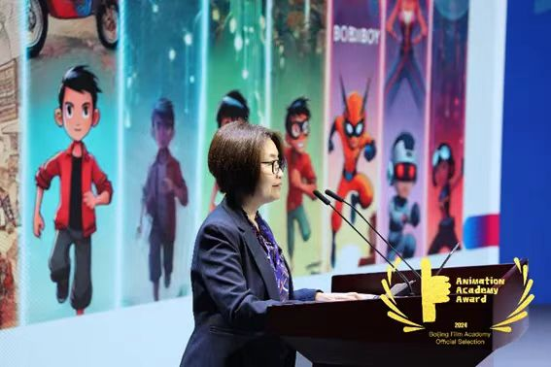

Dr Cynthia Lau presentingat the international forum

From 30 October to 3 November 2024, representatives from various universities from Europe, Oceania and Asia participated in the 24th Animation Academy Awards hosted by the Beijing Film Academy (BFA). The event brought together animation professionals, educators, and students from renowned universities worldwide, including UTAR, to celebrate excellence in animation and discuss emerging trends in the industry.

One of the key highlights of the trip was UTAR’s participation in the International Forum on Advanced Animation Education—Innovation in the Cultivation of Animation Talents & Educational Concepts in the AI Era. Dr Cynthia Lau Pui-Shan from the Faculty of Creative Industries delivered a presentation titled *From Folklore to Futurism*, showcasing how Malaysian animation trends weaving traditional storytelling with futuristic innovation. Dr Cynthia Lau was also appointed as a visiting professor for the Beijing Film Academy. During the visit, UTAR engaged in productive discussions with BFA regarding potential collaborative initiatives such as online talks and seminars, and visits by the faculty.

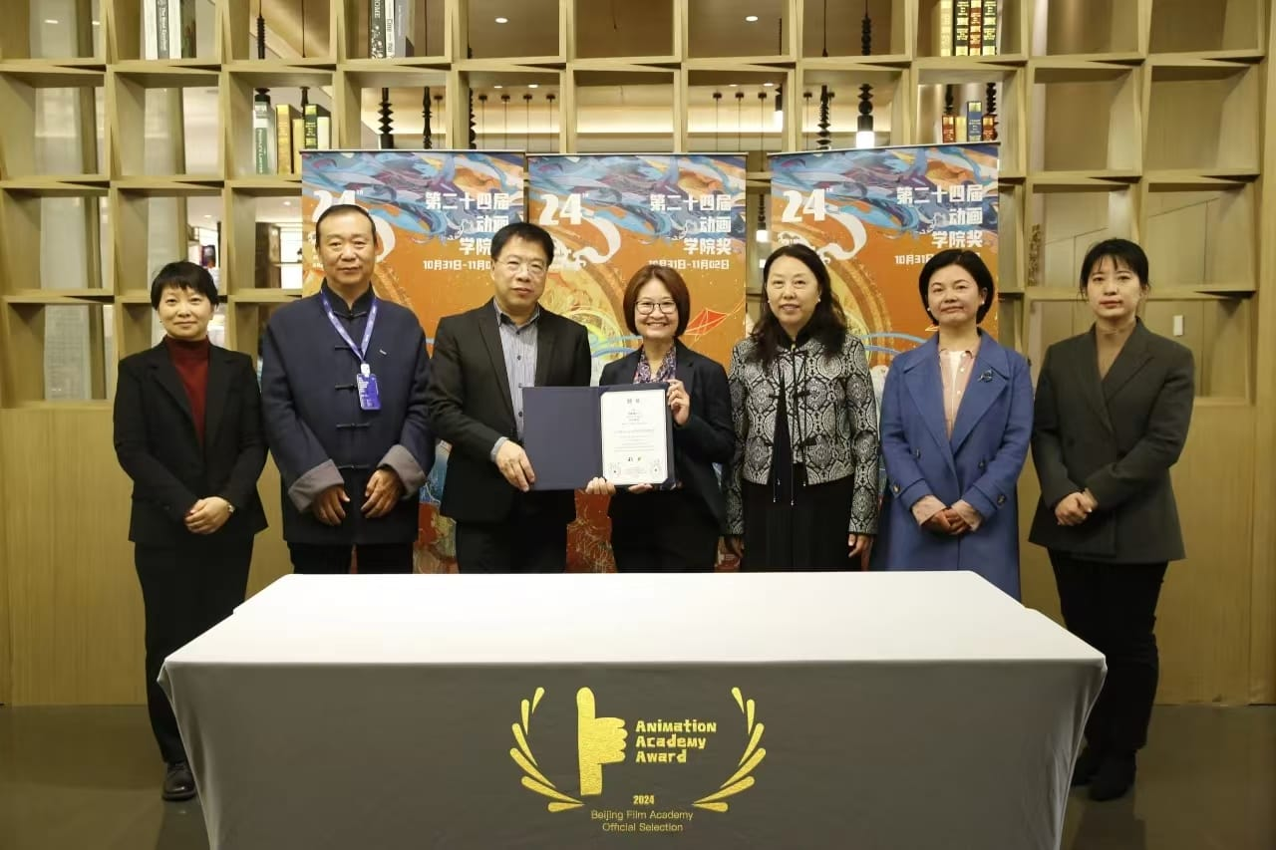

Certificate presentation ceremony: Dr Cynthia Lau being appointed as Visiting Professor at the Beijing Film Academy

The event also featured a variety of enriching activities for participants, including expert talks and lecture series on film, storytelling, and animation. These sessions provided valuable insights into the evolving landscape of animation education and practice. In addition, the organisers arranged a guided tour of the Beijing Film Academy campus, allowing participants to explore its state-of-the-art facilities and gain a deeper appreciation of the academy’s contribution to the animation industry.

The event was an invaluable experience that reinforced UTAR’s connections with global animation educators and highlighted its commitment to advancing creative education in the AI-driven era.

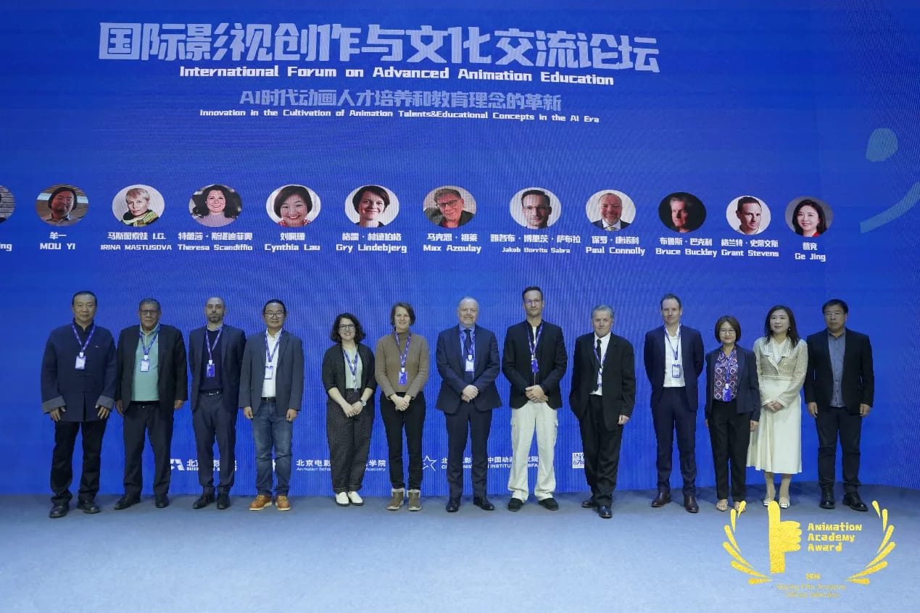

Third from right: Dr Cynthia Lau with fellow presenters of the International Forum on Advanced Animation Education

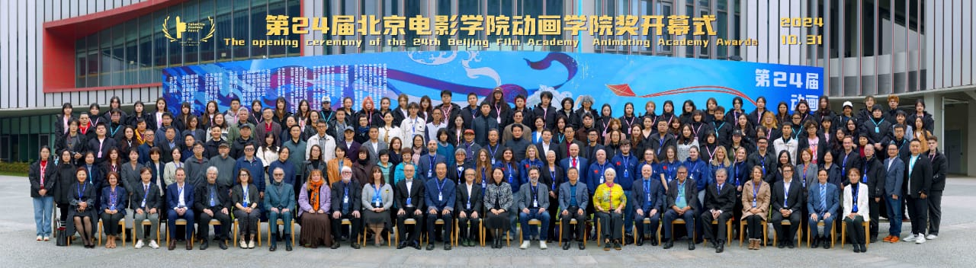 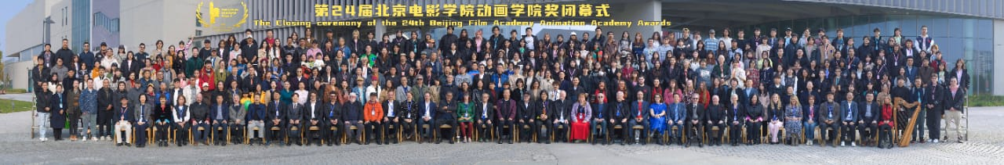

The opening (top) and closing (bottom) ceremonies of the 24th Animation Academy Awards by Beijing Film Academy