UTAR hosts the GREAT Challenge 2024 Weekend Hackathon
The Faculty of Information and Communication Technology (FICT) at UTAR successfully hosted the Hackathon Weekend for The Grand Robotics Engineering and Technology (GREAT) Challenge 2024 from 20 to 22 September 2024. This event was part of a two-phase competition aimed at fostering innovation in robotics technology, bringing together talented students from UTAR and UniKL to showcase their creative solutions to real-world problems.
The Hackathon Weekend at UTAR was one of six such events held at universities across Malaysia, including Asia Pacific University, Universiti Teknologi Petronas, Universiti Tun Hussein Onn Malaysia, Universiti Sultan Zainal Abidin, and Universiti Malaysia Pahang Al-Sultan Abdullah.
Throughout the weekend, participants engaged in a series of intensive sessions, beginning with an opening address on the National Robotics Grand Challenge 2024, followed by robotics tutorials using SCUTTLE-Pi and SCUTTLE-Intel AMR. The key highlight was the pitching session, where 40 students formed 10 teams to present their innovative ideas and solutions.
At the end of the pitching session, six teams were selected to advance to phase two of the challenge: prototype development. These top teams will continue to refine their projects, aiming for the grand finale, which is scheduled for February 2025.
During UTAR’s Hackathon Weekend, six teams, namely four from FICT, one from the Faculty of Engineering and Green Technology (FEGT), and one from the Lee Kong Chian Faculty of Engineering and Science (LKC FES), were shortlisted for the grand finale. A student from the Faculty of Science (FSc) also joined a team consisting of FICT students.
These teams, representing UTAR’s FICT, FEGT, and LKC FES, mentored by FICT academics Dr Teoh Shen Khang and Ms Tan Lyk Yin, and LKC FES academic Ir Dr Danny Ng Wee Kiat, will now move forward to the prototype development phase, where they will have the opportunity to further refine and test their ideas.
The GREAT Challenge 2024 was launched during the Malaysia Commercialisation Year (MCY) Summit, held on 12 and 13 August 2024 at the Kuala Lumpur Convention Centre. Bearing the theme Leading the Regional Innovation, the challenge was part of an initiative by the Industrial Technology Innovation Centre (ITIC), a collaboration between the Malaysian Research Accelerator for Technology and Innovation (MRANTI) and the Ministry of Science, Technology, and Innovation (MOSTI).
The GREAT Challenge 2024 aims to accelerate the innovation process by providing a platform for participants to develop their skills and apply robotics technology in addressing industry and community challenges.
The UTAR teams shortlisted for the grand finale are:

Team | Participants | Faculty
G5 | - Leow Yu Hong  - Lee Kang Wei  - Tan Wei Zhi  - Ong Yi Hang  - Chan Tze Keet | FICT
Matrix | - Ho Jun Han  - Tan Kai Jun  - Tan Kok Fu  - Yap Chin Yi  - Chin Li Wei | FICT, FSc
KaliLunix | - Alvin Chia Teck Kheng  - Chai Jun Yong  - David Ng Wen Chuan  - Wong Yeh Hern  - Tan Chi Jing | FICT
Wall-e | - Guang Yao  - Joseph Lau Yi Zhe  - Chuah Kai Shen | FICT
WRG | - Tan Yon Ern  - Ng Yan Hao  - Soh Jin Wei | FEGT
URS 1 | - Ooi Soo Jack  - Lim Zi Quan  - Lim Zi Jun | LKC FES

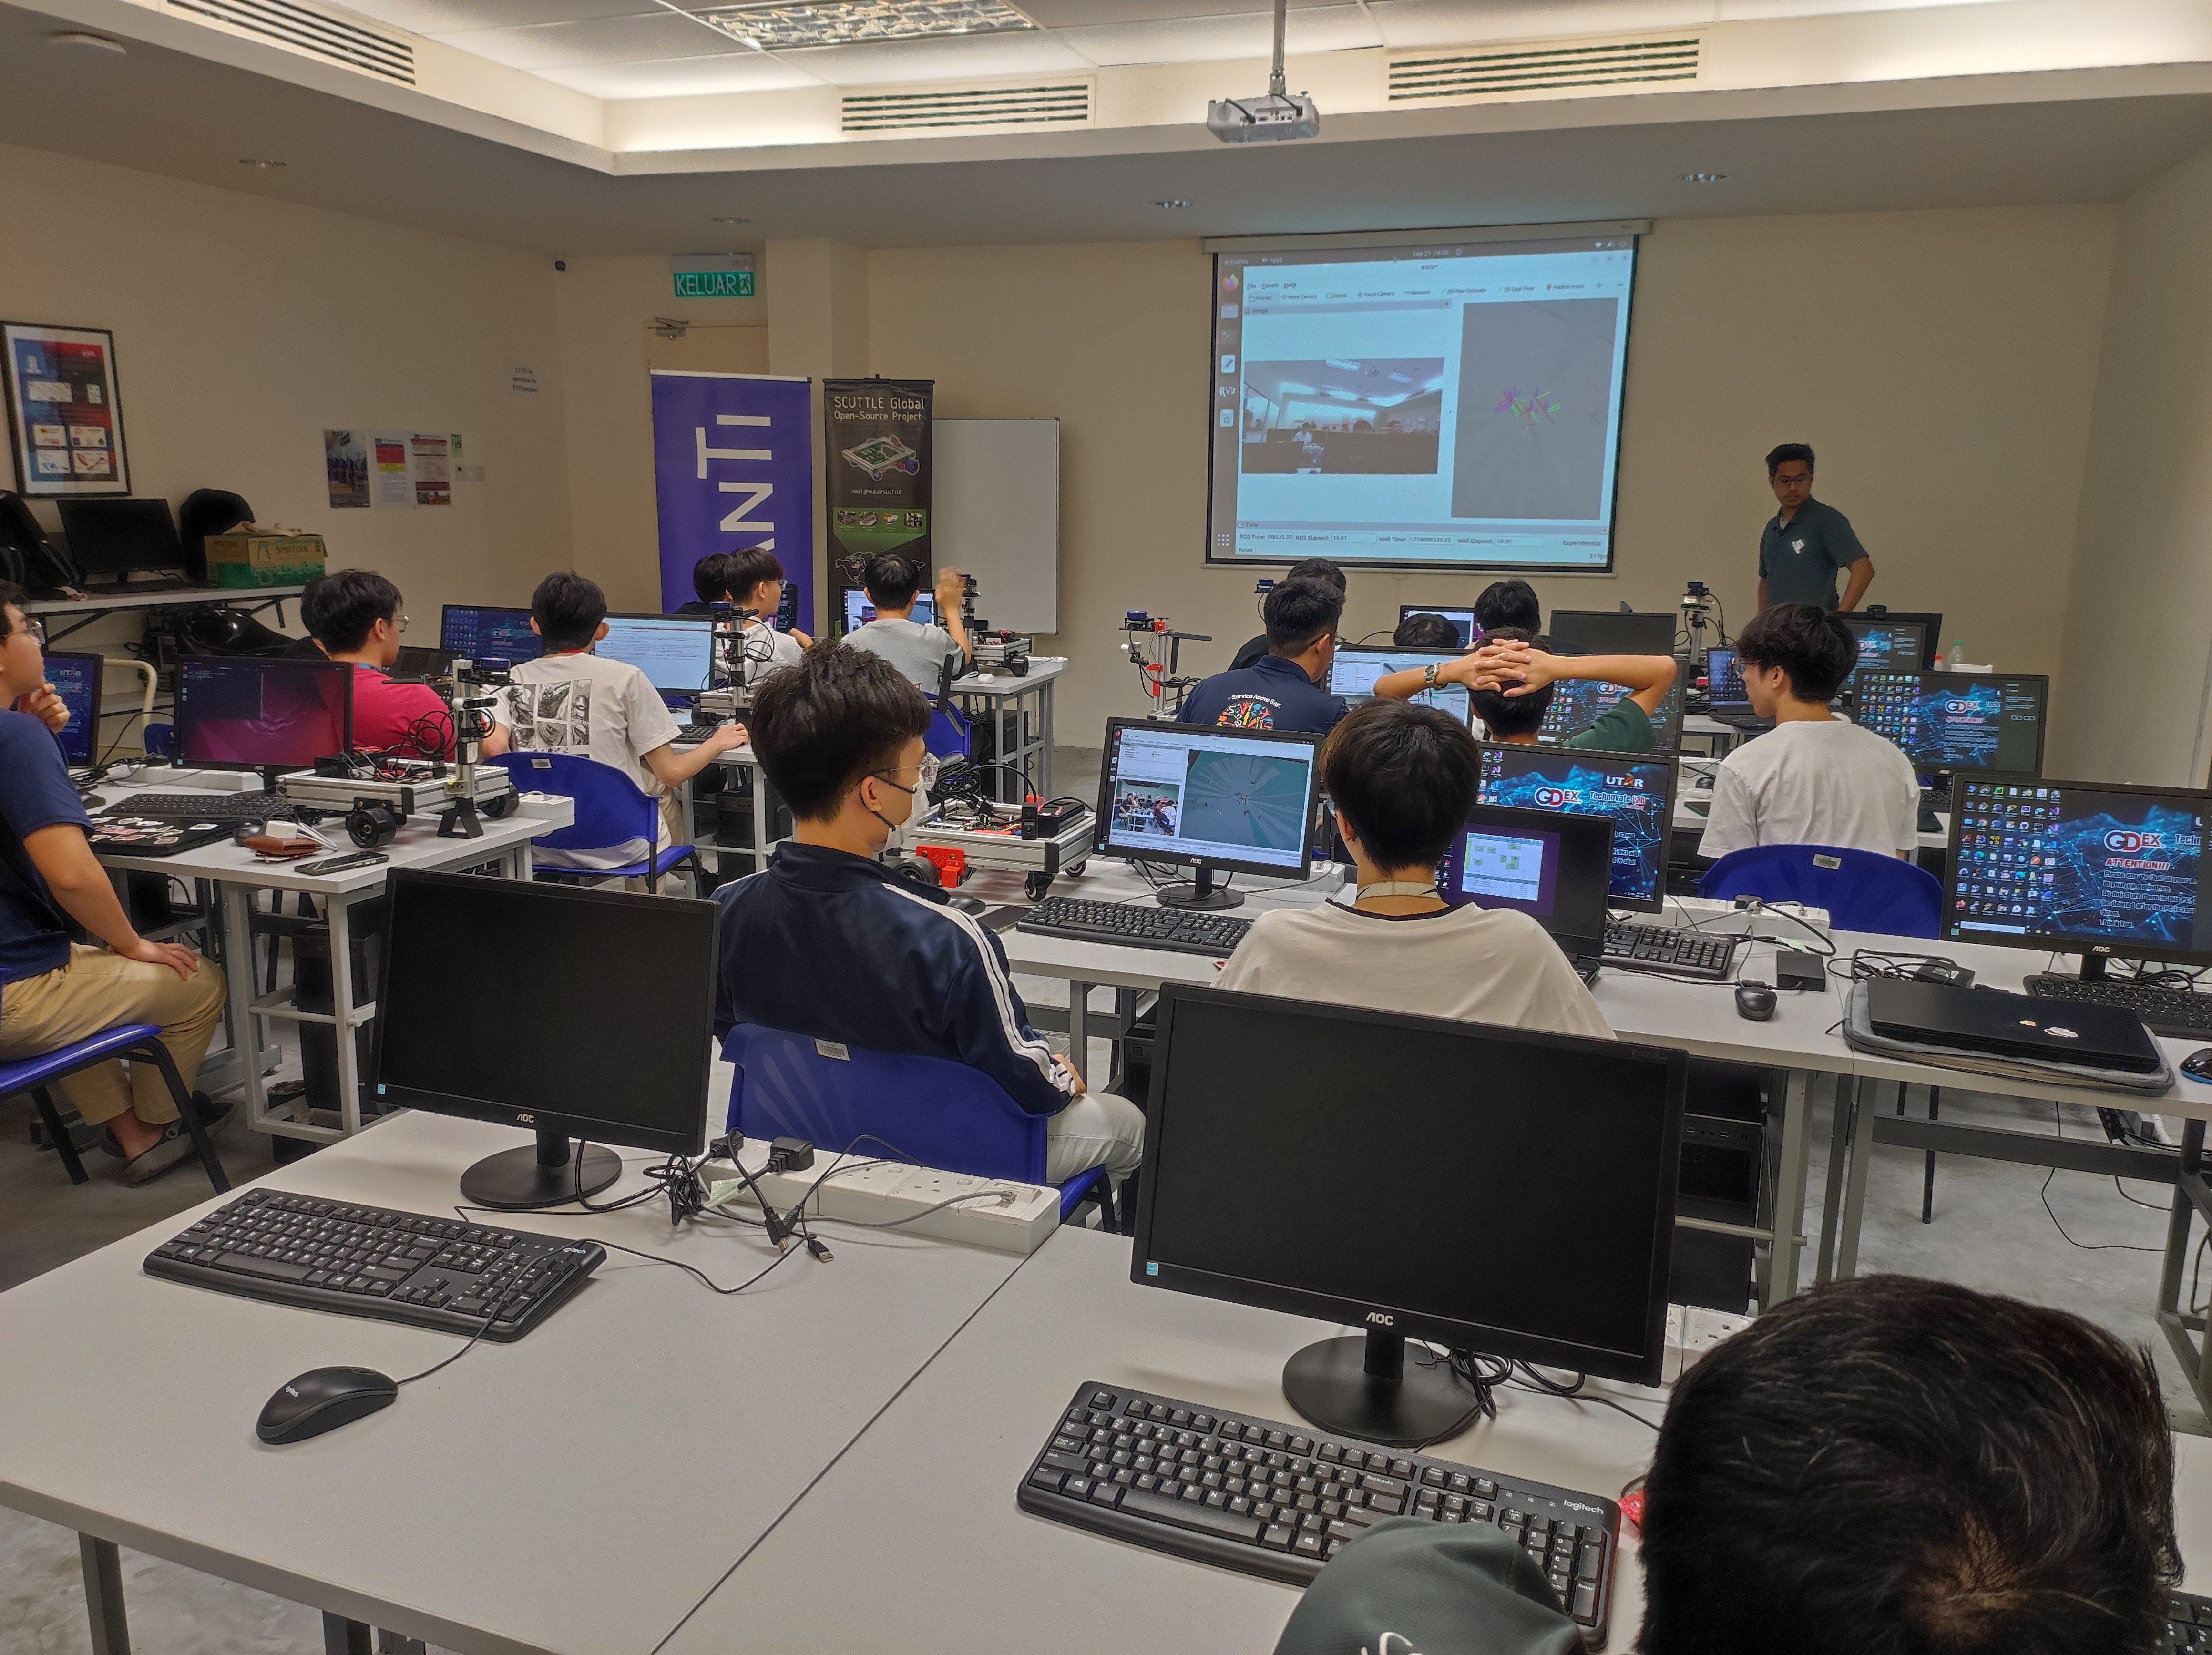
Robotic tutorial session using SCUTTLE-Intel AMR
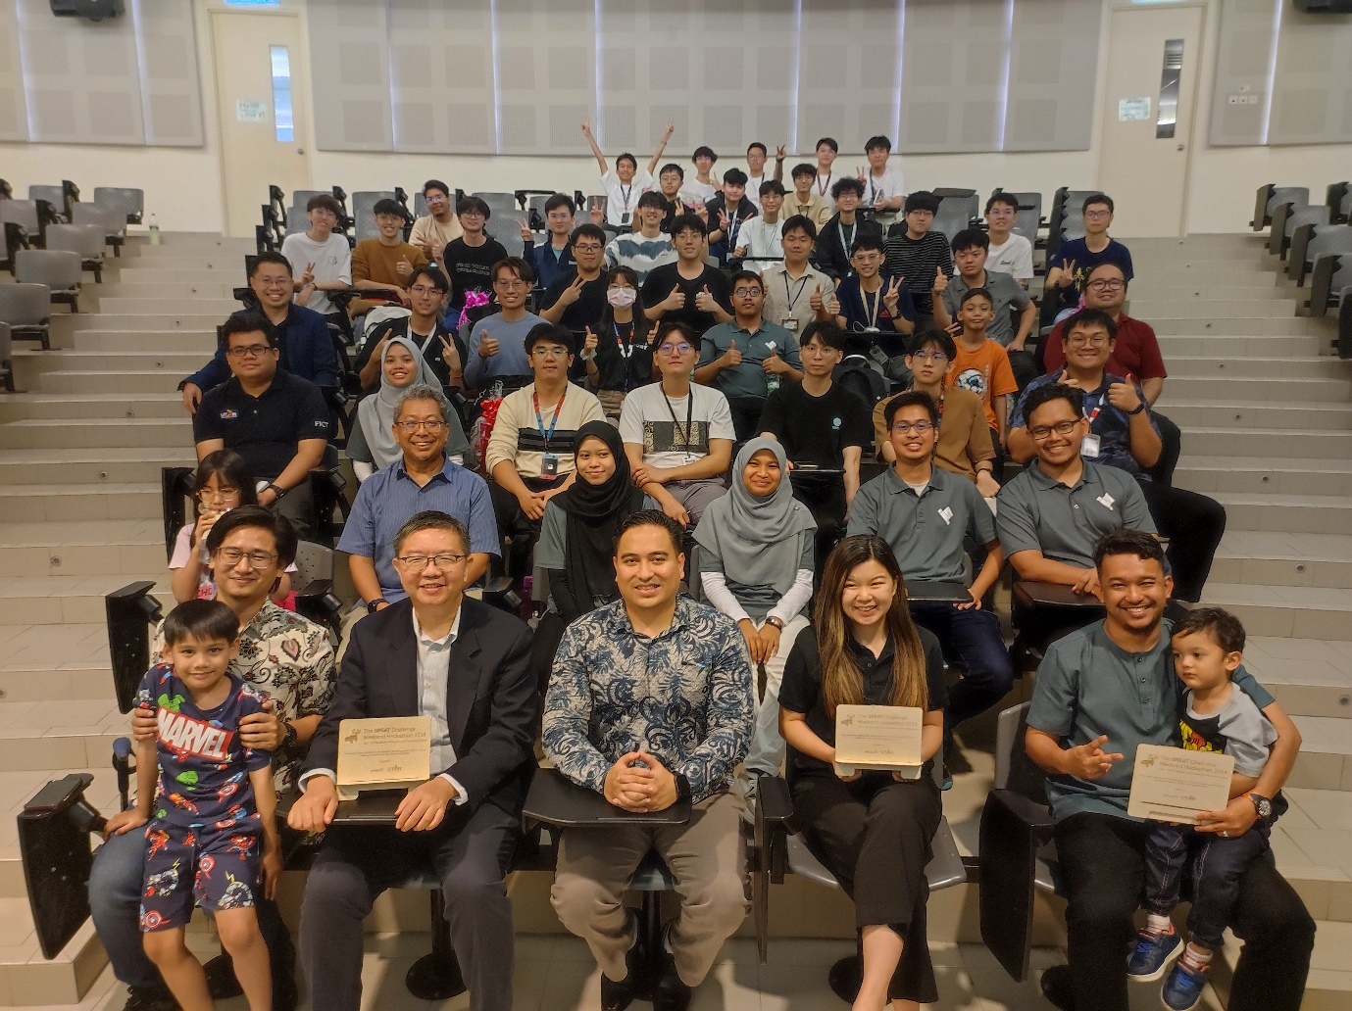
Front row, from left: Innovation Ecosystem Head, MRANTI Mr Wan Muhammad Farhan; FICT Dean Prof Ts Dr Liew Soung Yue; 4IR Tech, Ecosystem Analyst, MRANTI Ts Mohd Qayyum Akbar Abdul Halim; Smartsense (Malaysia) Chief Marketing Officer Dr Vivian Ho; Tasek Corporation Berhad Raw Mill Department and Cement Mill Department Manager Mr Muhammad Aiman bin Hamzah with Katapult Asia Sdn Bhd Co-founder Dr NorAzmi Alias (second row, second from left), and participants and guests

