**Virtual talk enriches academic writing skills for students and academics**

Dabbling in different fields of expertise requires varying sets of skills. Writing, for one, is an activity that almost all people around the world have a hand in, whether as a hobby or a daily task. Overall, the world of writing is a vast tapestry woven by countless threads of style, purpose, and audience.

Even for a logophile armed with an extensive and witty vocabulary, without the proper tools, even the most vivid literary expressions can lose their impact. Academic writing serves as a case in point. It requires not only a strong command of language but also the ability to organise findings systematically. The right diction and structure are essential to convey ideas clearly and effectively to the intended audience.

To enhance scholars’ understanding of effective research writing, UTAR Centre for Learning and Teaching (CLT) organised an online talk titled “Academic Writing for Researchers” on 8 August 2024 via Zoom. The talk garnered more than 50 participants, including UTAR students and academics.

Dr Puteri Zarina Megat Khalid, a senior lecturer from the Faculty of Language and Communication, Universiti Pendidikan Sultan Idris (UPSI), was invited to be the main speaker of the talk. Graduated with a doctoral degree in the field of English language from the University of Glasgow, United Kingdom, Dr Puteri Zarina has more than 10 years of research and teaching experience in the education field. Her research interests mainly consist of Technical and Vocational Education and Training (TVET), Teaching of English as a second language (TESL), discourse analysis, genre analysis, modality analysis, and pragmatics.

The talk explored the correct pathways of research writing as well as the key concepts revolving around academic writing with the participants.

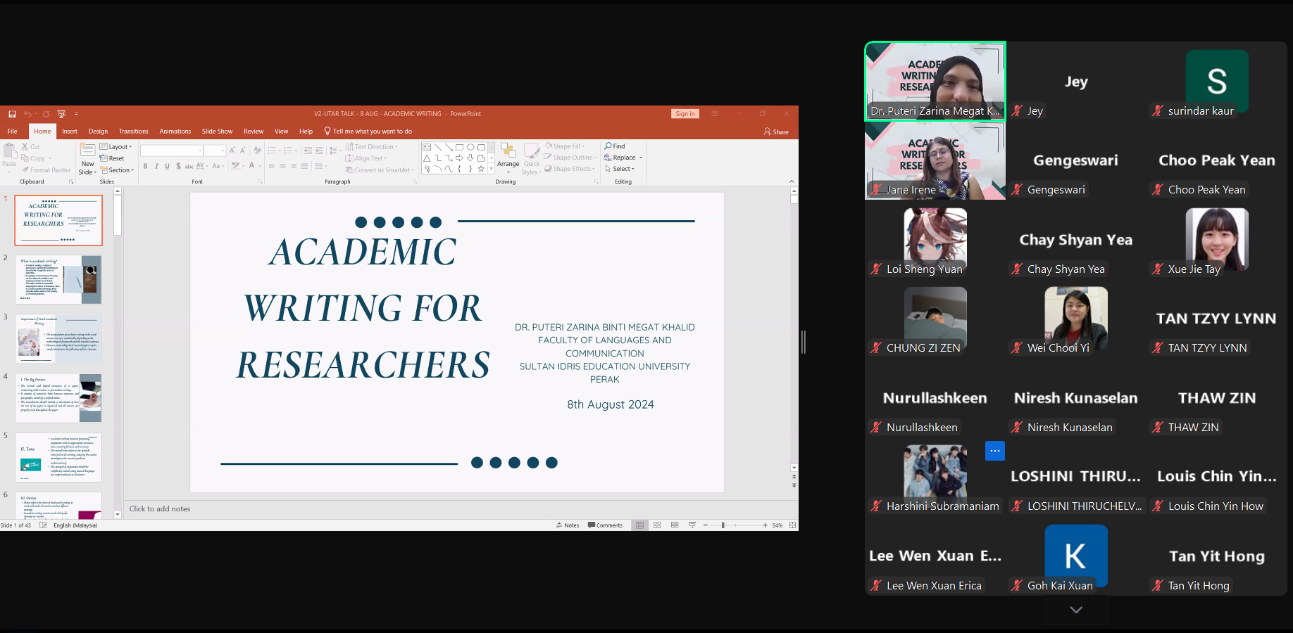

Dr Puteri Zarina introducing the concept of academic writing

During the talk, Dr Puteri Zarina elucidated the main difference between academic writing and other formats, explaining styles and tones of expression, methodological ways to express a complex idea and the concept of intellectual boundaries. Besides that, she also shared valuable tips on academic writing, including logical structures of research writing, proper strategies and correct use of words for effective research writing, further enhancing the participants’ understanding of effective communication in their scholarly pursuits.

Also present at the talk were CLT Chairperson Dr Wei Chooi Yi, organising committee members Dr Surindar Kaur Gurmukh Singh, Dr Loshini Thiruchelvam, Ms Jane Irene P J Antony, and Mr Jeya Sarkunan Jayathilagaratnam.

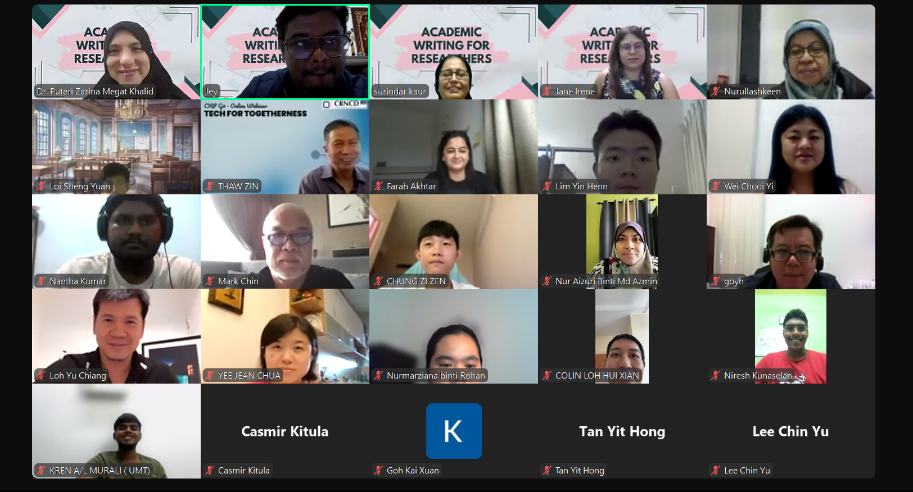

A group photograph at the end of the talk

Top row, from left: Dr Puteri Zarina, Mr Jeya Sarkunan, Dr Surindar Kaur, Ms Jane Irene, and Dr Wei (second row, most right) with the participants