FBF’s wellness outreach event at SJK(C) Chung Huah educates students on healthy living
The “Healthy Kids, Bright Futures” initiative brought an impactful health and wellness event to the primary students of SJK(C) Chung Huah in Kampar on 14 August 2024. Organised by lecturers from UTAR Faculty of Business and Finance (FBF), the project focused on educating young students about healthy living. Supported by UTAR Hospital, the initiative aimed to equip children with vital health knowledge and skills, ensuring they were the primary beneficiaries of this meaningful community outreach.
The day commenced with a warm welcome from the event organisers, setting the stage for an engaging and informative experience. To help the students feel at ease, UTAR staff and students led a series of fun ice-breaking activities, followed by simple warm-up exercises to promote physical activity and prepare the students for the day ahead.
A highlight of the event was a series of health talks delivered by medical professionals from UTAR Hospital. Dr Ng Jun Jie and Dr Sam Jia Xian shared essential insights on child health and dental care, while Dr Peter Tan Sin Howe from UTAR FBF discussed dengue fever prevention. These talks were carefully crafted to be both informative and engaging for the young audience.
To reinforce the messages from the talks, students in Standards Four to Six participated in interactive quizzes and games that tested their understanding of the health topics covered. These activities were both educational and enjoyable, with prizes awarded to those who demonstrated exceptional knowledge.
Meanwhile, students in Standards One to Three engaged in creative colouring sessions focused on themes such as healthy eating, dental hygiene, and dengue prevention. These activities were designed to help younger students absorb health information in a fun and memorable way. The event concluded with a prize-giving ceremony for the winners of the creative colouring sessions, followed by a summary of the key health messages from the day.
The “Healthy Kids, Bright Futures” event was a collaborative effort, bringing together organisers from FBF and medical experts from UTAR Hospital. This partnership was crucial in ensuring a well-rounded educational experience. SJK(C) Chung Huah, the main beneficiary of the initiative, played a key role by hosting the event and facilitating the participation of 457 students.
The event was supported by ten FBF staff members from various departments, including Marketing, Business and Public Administration, Economics, and Banking and Risk Management, along with eight student helpers. Their combined efforts reflected UTAR’s strong commitment to community engagement and the holistic development of its students.
The impact of the “Healthy Kids, Bright Futures” event on the students of SJK(C) Chung Huah was significant. The health talks and activities helped the students gain a deeper understanding of personal health and hygiene. Their active participation in the quizzes and creative sessions demonstrated not only an improved understanding of health care but also a positive change in their attitudes toward maintaining good health. The students’ enthusiasm and their ability to answer questions correctly highlighted the effectiveness of the event’s educational approach.
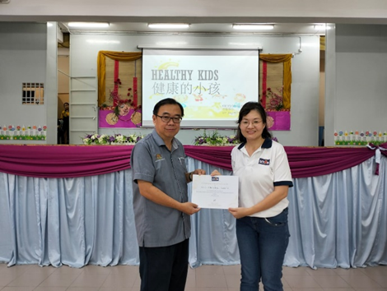
From right: Project Leader Ms Yip Yen San from FBF presenting a certificate of appreciation to the Principal of SJK (C) Chung Huah Mr Chai Chee Leong
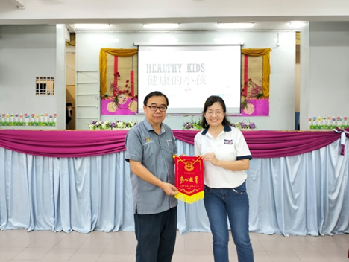
From right: Ms Yip receiving a token of appreciation from Mr Chai
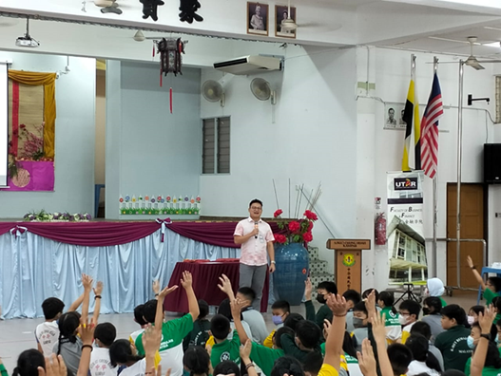
UTAR Hospital Paediatrician Dr Ng delivering his talk
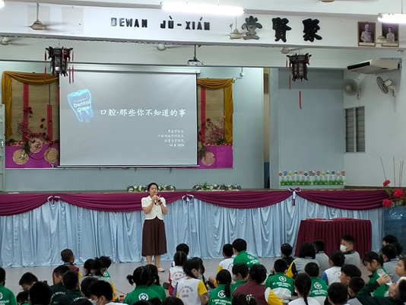
UTAR Hospital Senior Dentist Dr Sam delivering her talk
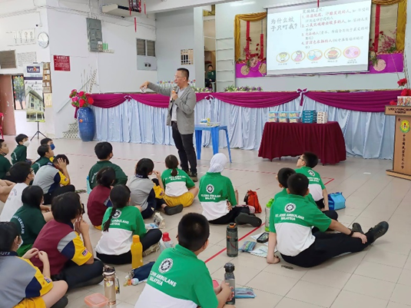
Dr Tan, Deputy Dean of FBF delivering his talk
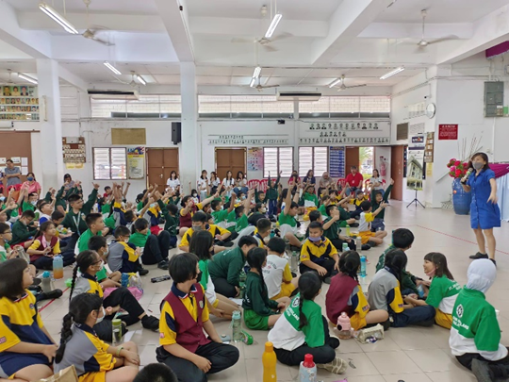
SJK (C) Chung Huah students during interaction games and Q&A sessions
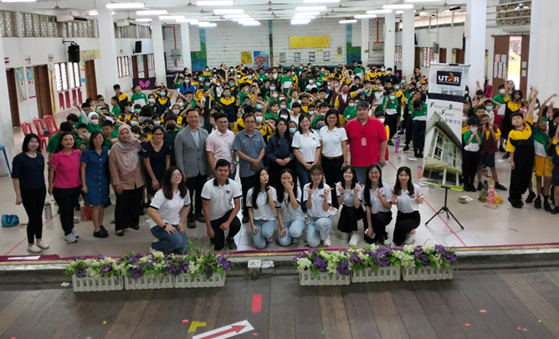
FBF lecturers, student helpers, principal and vice principals and the students from SJK (C) Chung Huah, Kampar

