UTAR Chess Open Competition 2024 showcases strategic brilliance
In conjunction with Malaysia’s Independence Day, UTAR Centre for Foundation Studies (Kampar Campus) organised a Chess Open Competition on 31 August 2024, attracting 136 participants across various categories, including Open, IPT, U17, U12, Best Lady, and Best UTAR. Held at UTAR Kampar Campus and organised by the Centre Student Development Committee, the 10-hour event provided participants with an opportunity to showcase their chess skills and strategic thinking.
The competition began with a briefing by the Arbiter and an overview of the Swiss system, followed by seven rounds of chess. Participants, ranging from young enthusiasts to experienced players, demonstrated their dedication and skill throughout the event.
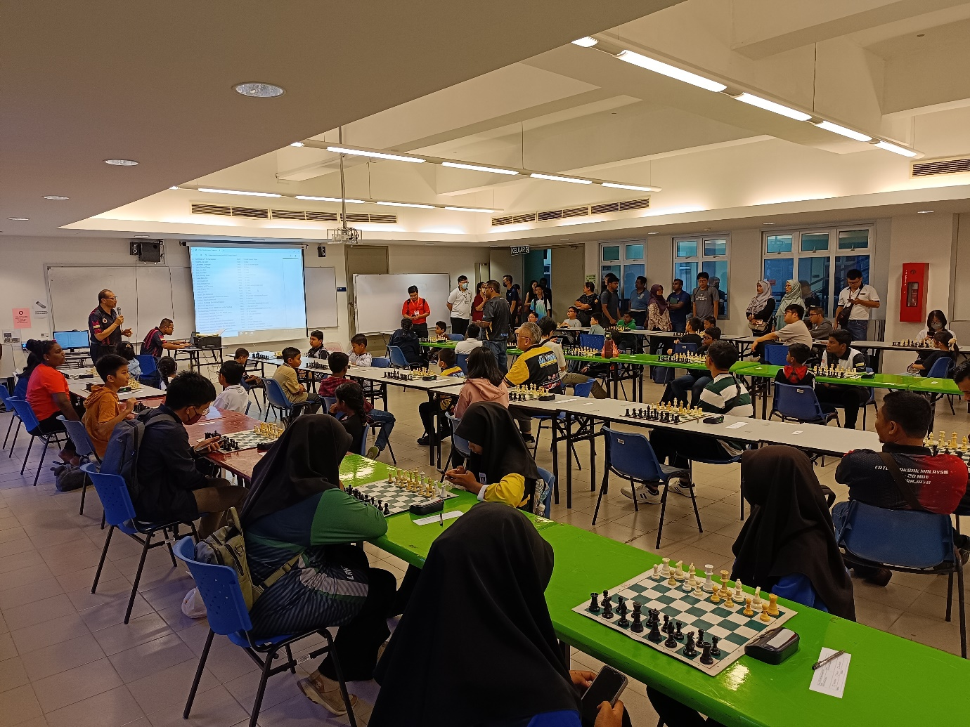
Arbiter giving a briefing before the commencement of the competition
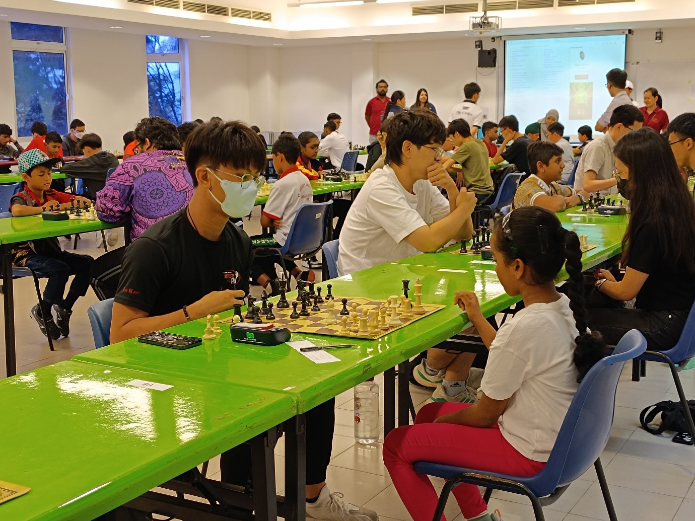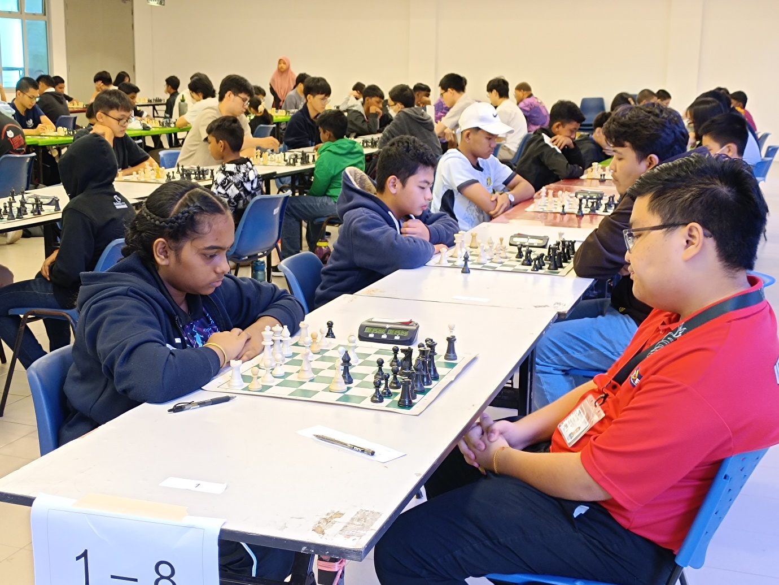
Ongoing matches between players
In his closing remarks, Mr Tan Jun Bin, the chairperson of the event, reflected on the success of the day. He said, “We have witnessed incredible strategic brilliance and deep passion for chess on this special day, which coincides with Malaysia’s Independence Day. Your dedication and skill made today’s competition memorable. Whether victorious or having gained valuable lessons, your love for the game shone brightly, embodying the perseverance that defines our nation.”
Acknowledgments were given to key individuals who played important roles in ensuring the competition’s smooth execution, including CFS Kampar Director Ts Tan Lee Siew, and Deputy Director Mr Alan Lim Khiew Loon who led the Centre Student Development Committee. Special thanks were extended to the organising committee, volunteers, and the arbiter, who ensured fairness and structure throughout the event.
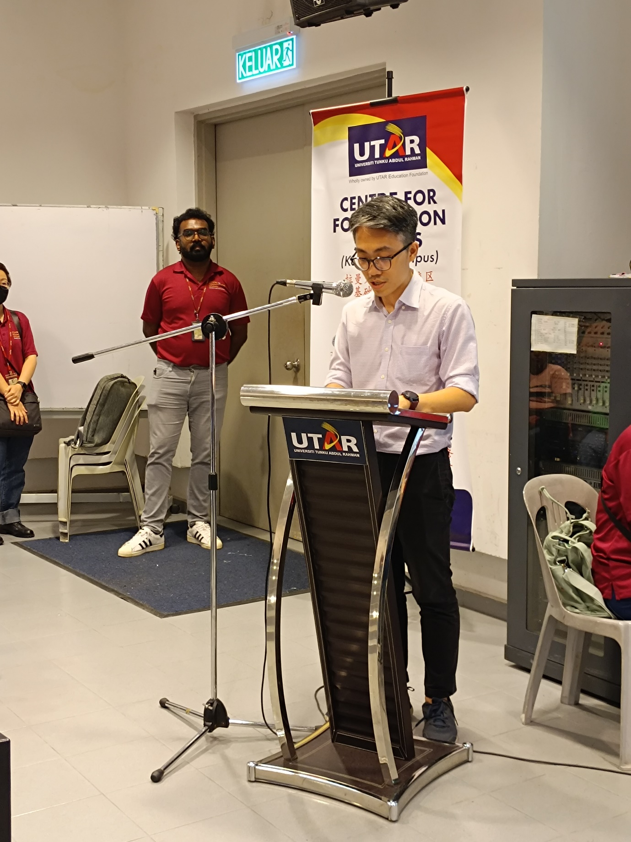
Mr Tan delivering the closing remarks
The event highlighted UTAR’s dedication to fostering critical thinking, integrity, and the pursuit of excellence. Beyond the chessboard, UTAR remains committed to organising activities that nurture the holistic development of its students, equipping them with essential life skills.
The winners of the UTAR Chess Open Competition 2024 were recognised across all categories:
Category | First Place | Second Place | Third Place
Open | Yeoh Yuan Hui | Yip Yong | Ng Shu Heng
IPT | Vinod Selva Raja | Teoh Siang Yew | Muhammad Azri Hakimi bin Shamsul Bahrim
U17 | Taj Prasshad Nambiyar Chanthiran | Syed Muhammad Azeem bin Syed Mohd Azman | Muhammad Danish Haiqal bin Mohd Shahrul Annuar
U12 | Iishwar Nanthakumar | Chan Ee Qi | Harrshan Rao Sugas
Lady | Abby Tan Li Shuen | Hoviyeamathy Thamil Selvan | Asma’ Umairah binti Amiluddin
UTAR | Chin Li Wei | Tan Kok Fu | Yew Jun Yi

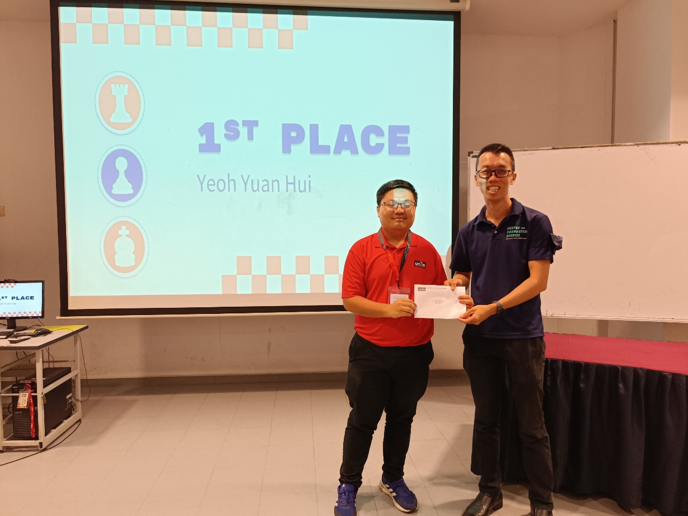
Open category first-place winner, Yeoh Yuan Hui (left)
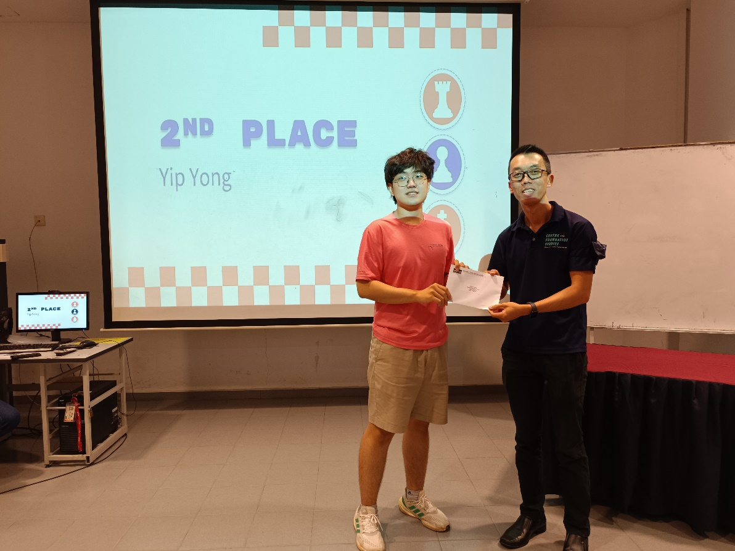
Open category second-place winner, Yip Yong (left)
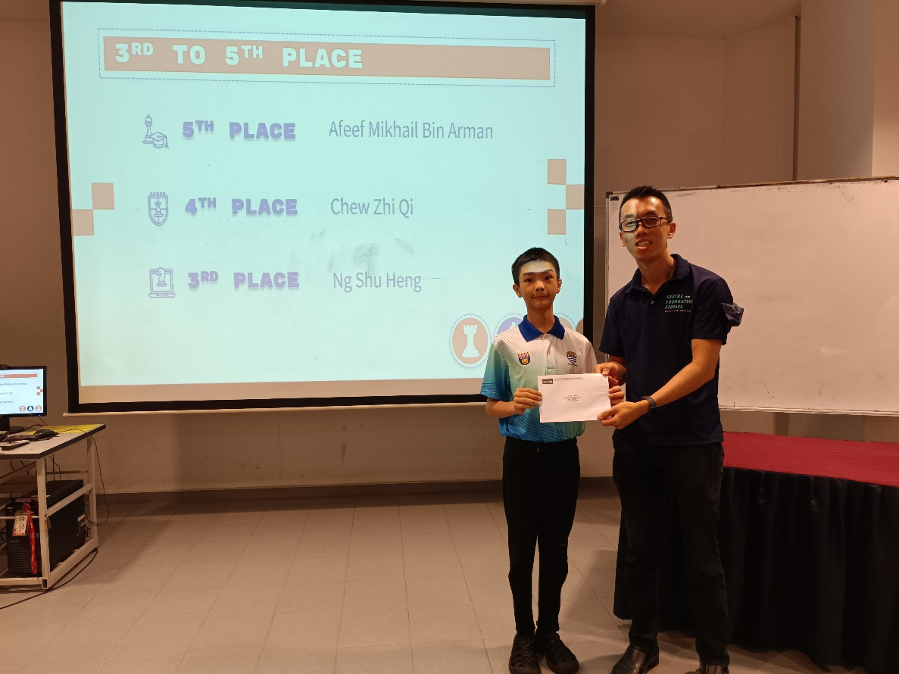
Open category third-place winner, Ng Shu Heng (left)
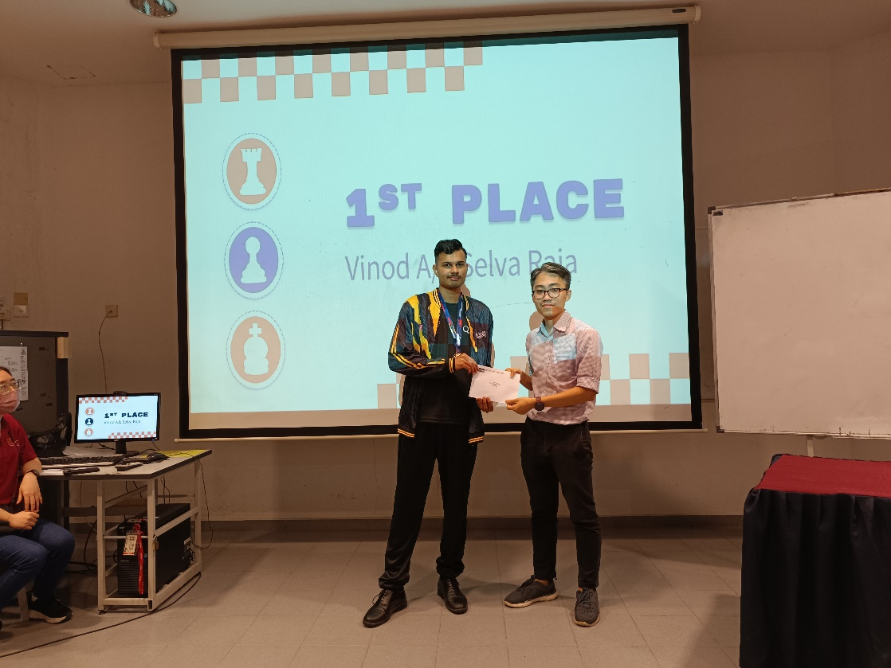
IPT category first-place winner, Vinod Selva Raja (left)
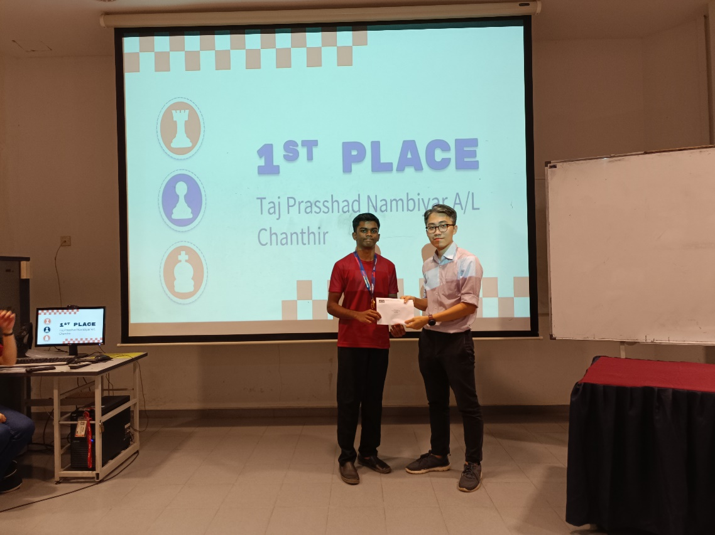
U17 category first-place winner, Taj Prasshad Nambiyar Chanthiran (left)
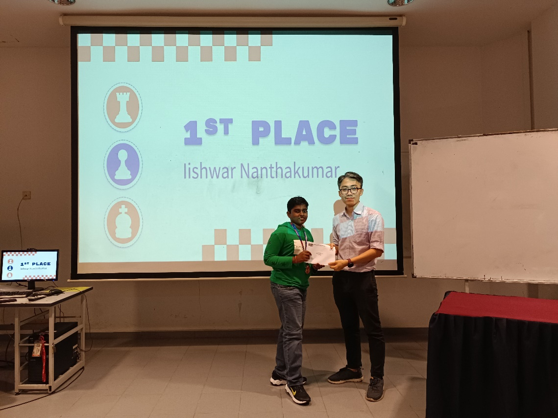
U12 category first-place winner, Lishwar Nanthakumar (left)
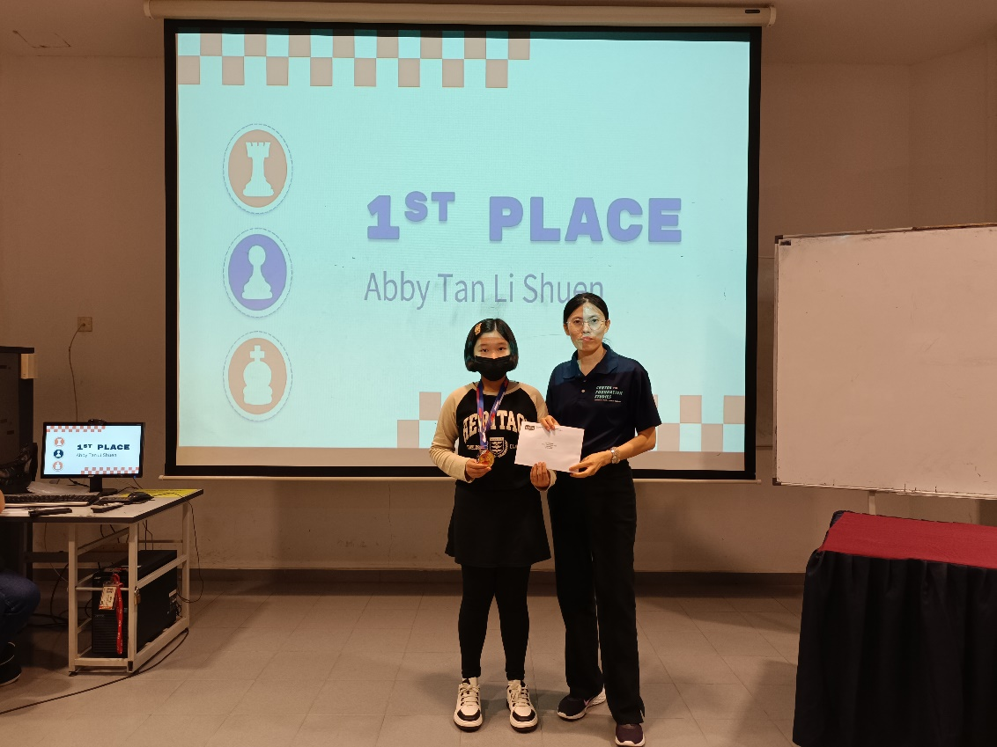
Lady category first-place winner, Abby Tan Li Shuen (left)
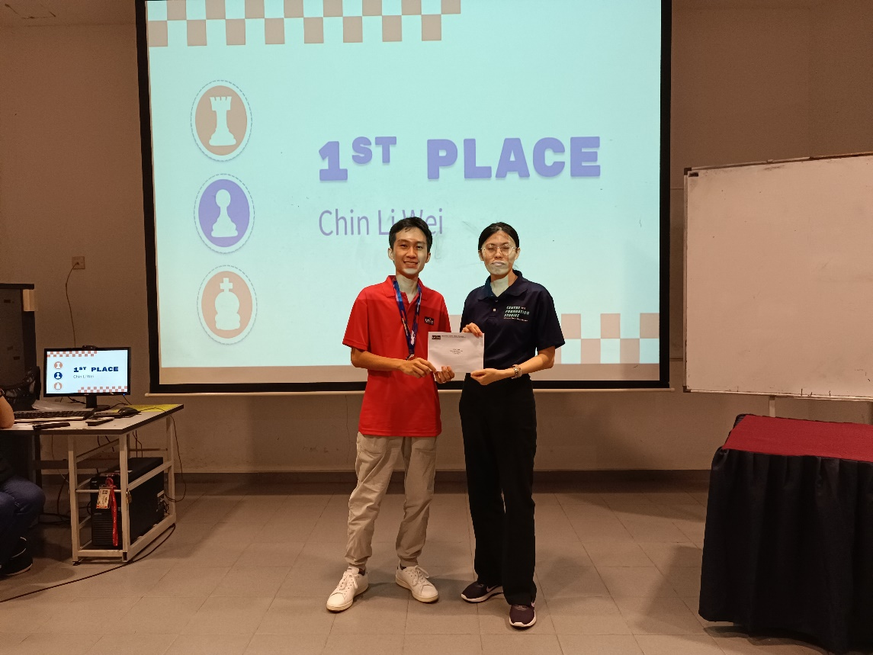
UTAR category first-place winner, Chin Li Wei (left)
As the competition concluded, Mr Tan encouraged participants to take the lessons of foresight, patience, and adaptability beyond the chessboard. He concluded, “Chess is life in miniature. The challenges we face on the chessboard, like in life, teach us resilience and the importance of every move we make.”
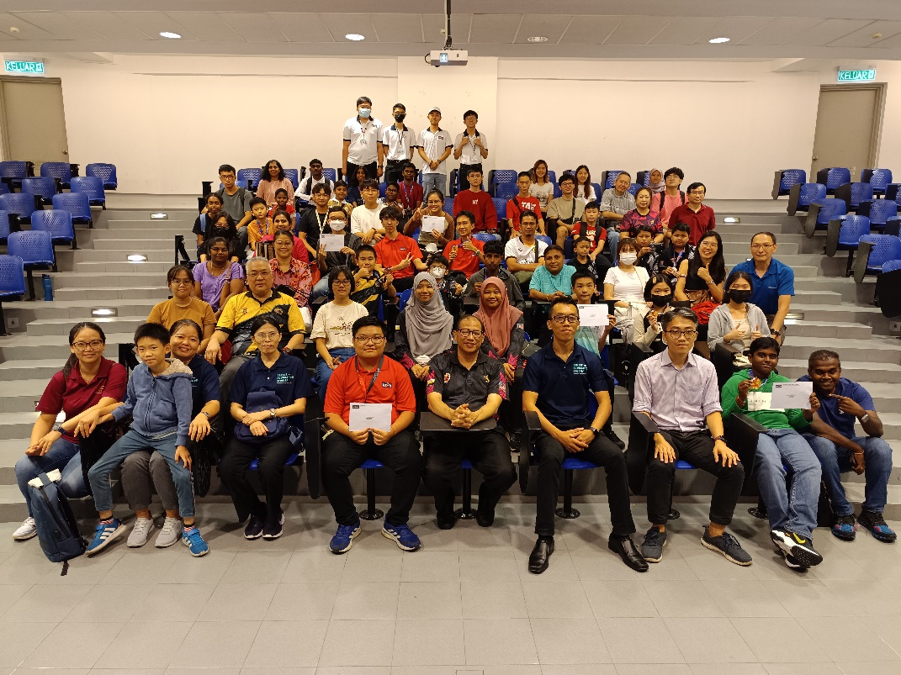
Organising committee with the winners of the competition

