PR students promote sustainability with fashion show and exhibition
UTAR’s “We Want No Plastic” CSR project brought the “Spice to Fantastic Exhibition and Recyclable-themed Fashion Show” to life at Straits Quay, Penang, from 15 to 17 September 2024. The event, led by 62 Public Relations students under the guidance of project advisor and Faculty of Arts and Social Science academic Ms Diong Fong Wei, attracted over 2,749 participants and highlighted the critical issue of single-use plastic pollution.
The exhibition featured a variety of interactive zones, including DIY workshops, station games, a flea market, and live performances by the students. A notable attraction was the Plastic Bottle Tunnel, a 4-metre-long installation made of plastic bottles and PVC pipes, designed to raise awareness of plastic waste and its environmental impact.
The event’s highlight was the Recyclable-themed Fashion Show, which showcased 30 innovative outfits made from upcycled materials. The show, featuring designs by Creative Department member Lee Jie Xi, aimed to inspire attendees to adopt sustainable practices by reimagining how discarded materials can be repurposed.
Deputy Director Wong Ket Kian shared, “Our project aims to inspire society to reduce plastic use by offering eco-friendly alternatives and supporting the government’s roadmap towards a zero-plastic future. Collaboration between private organisations and educational institutions is essential in leading this effort.”
This initiative, which marks the project’s first major event outside Perak, was organised in partnership with Zantat Holdings Berhad and Zaneco Sdn Bhd. “We Want No Plastic” Project also partnered with Straits Quay, Tanjung Tokong, HOGA, Gaharu Tea Valley Gopeng, Majlis Daerah Kampar (MDKpr), and Green Energy Asia (GEA) to address the single-use plastics pollution in Malaysia in support of the government policies as outlined in Malaysia’s Roadmap Towards Zero Single-Use Plastics 2018-2030.
The project demonstrated UTAR’s commitment to promoting environmental sustainability and community engagement.
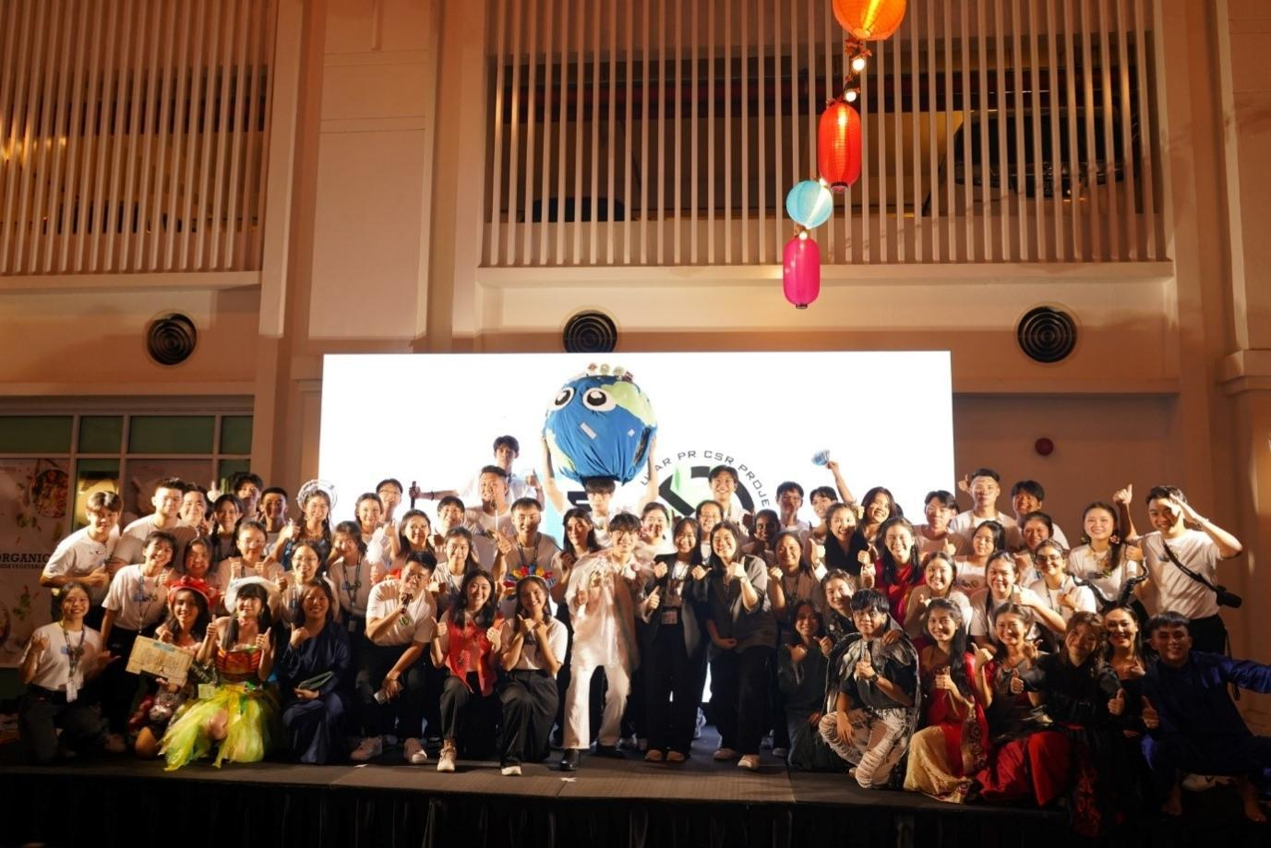
The committee members of We Want No Plastic Project at the end of “Spice to Fantastic Exhibition and Recyclable-themed Fashion Show”
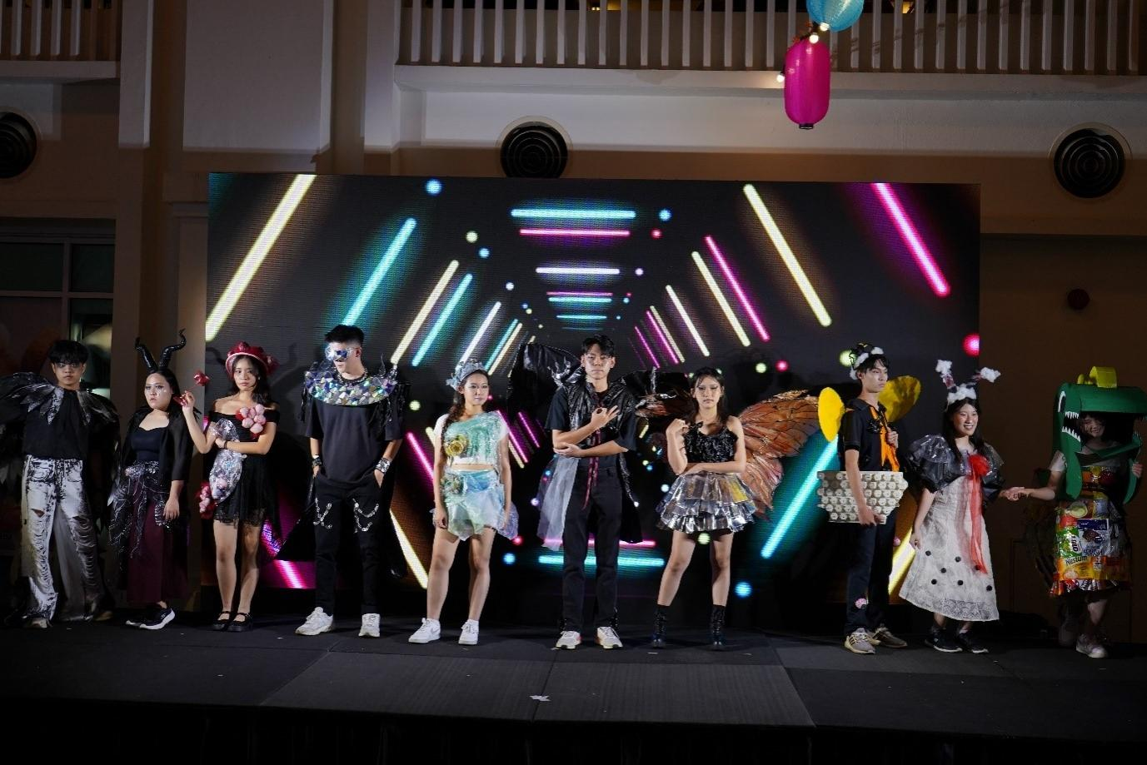
Models of the We Want No Plastic Project showcasing the Mutation-themed outfits on stage at the Recyclable-themed Fashion Show
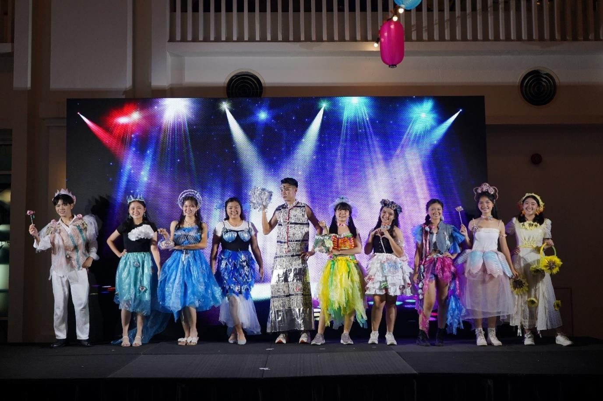
Models of the We Want No Plastic Project showcasing the Future-themed outfits on stage at the Recyclable-themed Fashion Show
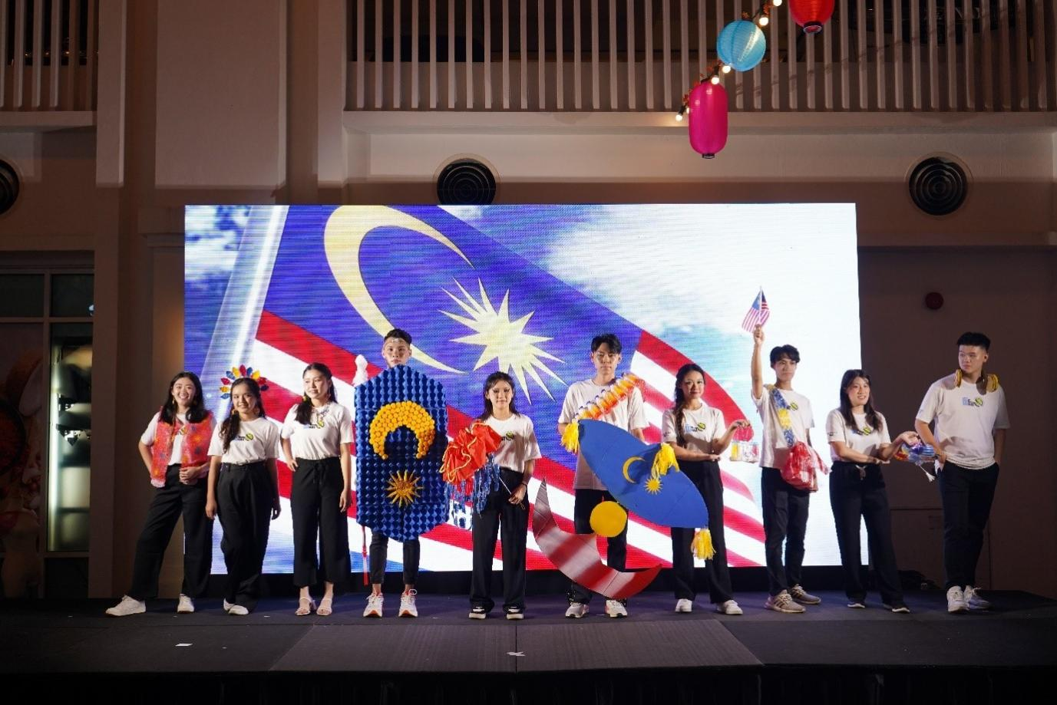
Special outfits and accessories modelled by members of We Want No Plastic Project in celebration of Malaysia Day at the Recyclable-themed Fashion Show
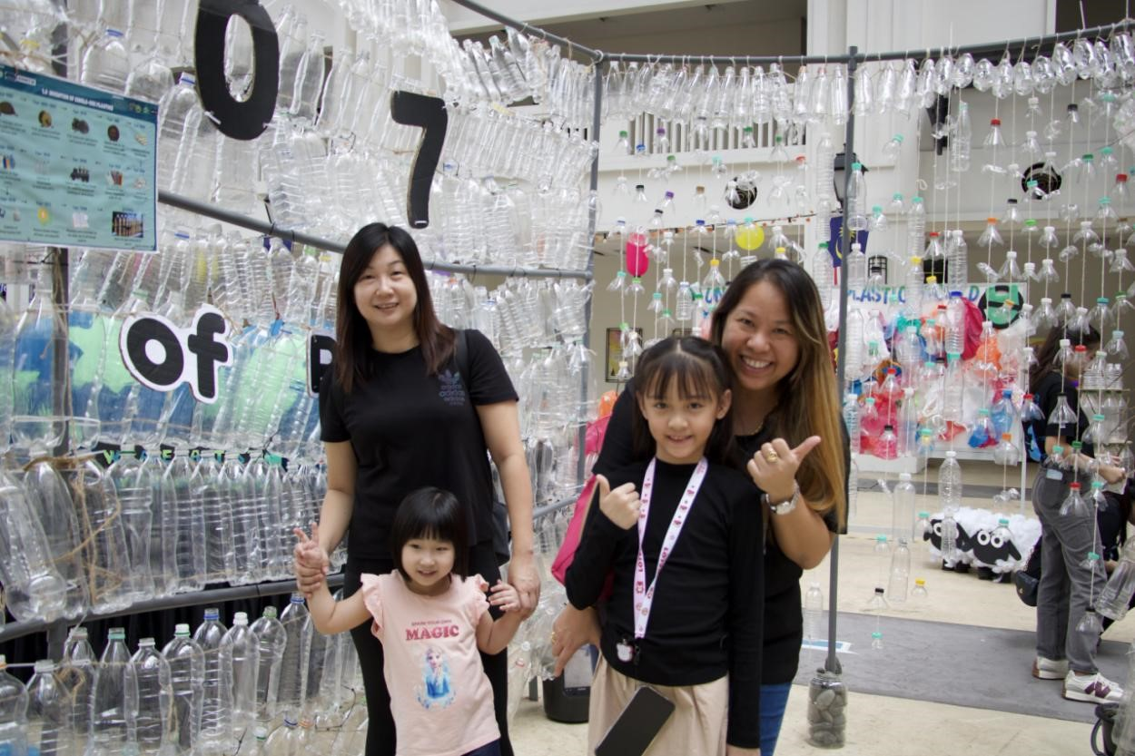
Attendees of “Spice to Fantastic Exhibition and Recyclable-themed Fashion Show” posing in front of the Plastic Bottle Tunnel made by the members of We Want No Plastic project

